Pigment biosynthesis
Taken from Sheehan et al. 2013 (doi:10.1101/sqb.2013.77.014712)
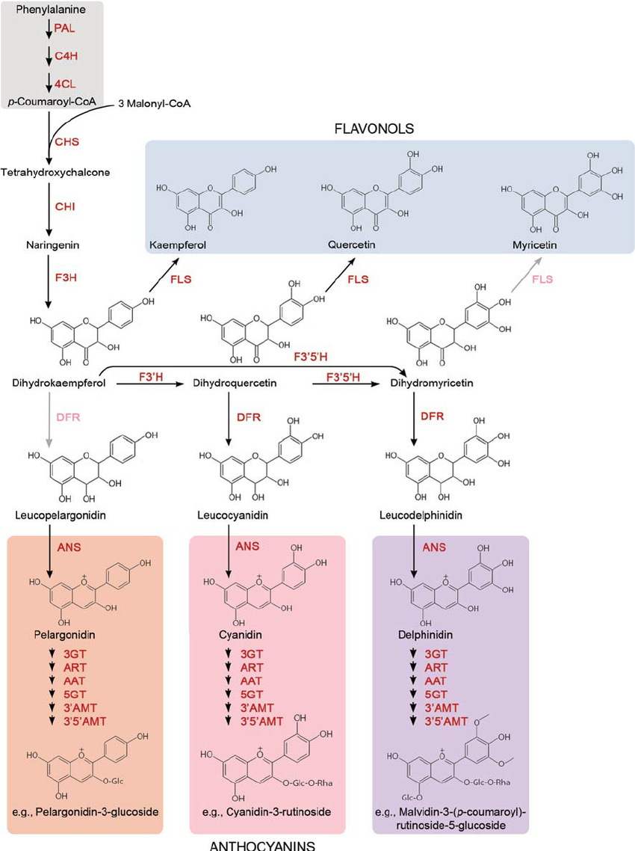
Taken from Winkel-Shirley 2001 (https://doi.org/10.1104/pp.126.2.485)
