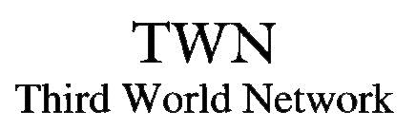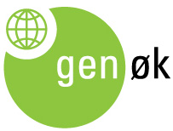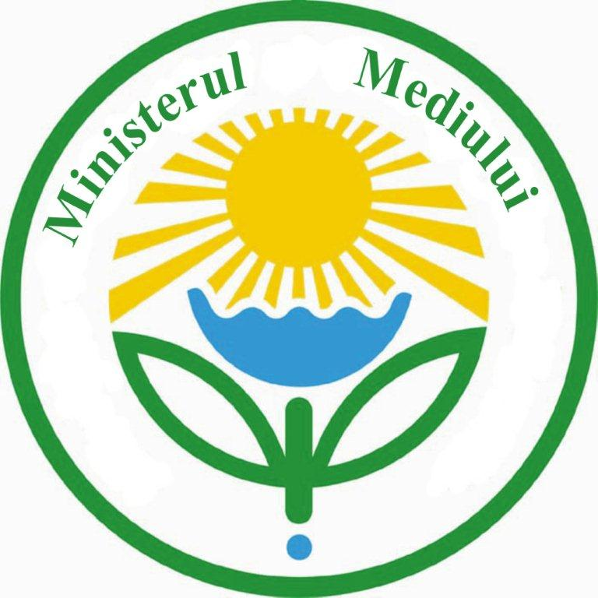

APPLICATION FORM

Eastern European Regional Course on Impact Assessment of LMOs under the Cartagena Protocol
“Advancing LMO assessment: Principles, Practice and Progress”

Surname(s): |  | First name(s): |  |  |  | Male/Female
Date of birth (day/month/year): | Country of birth: |  |  | Nationality:
Name of organisation:

Present position(s) (type and level): |  | Telephone:
 |  | E-mail:
Postal address of your organisation:

Working language(s) (in order of fluency):

State the reasons for your interest in the course:

How will your work benefit from your participation in the course?

Academic qualifications:

Work experience:

Special requirements (dietary, wheelchair access, other): |  |  |  |  | Sponsorship required:  Yes No
Date: | Signature: (not necessary if you send by e-mail)
In addition to this form, the application should also include a brief CV; listing your education (degrees etc.), your work experience, and, if applicable, a list of publications.

The working language for the course will be English. Simultaneous translation into Russian will be available.
The regional course is open to individuals from Central and Eastern European countries.

While individuals from the region will be invited to apply, full sponsorship for participation is only available to applicants from ODA countries, due to requirements from the funding agency.

From the applications 40 will be invited for participation. The sponsorship will cover curricular materials, course-associated economy-fare travel, visa-fees, accommodation and meals.

ODA countries include:
Albania, Armenia, Azerbaijan, Belarus, Bosnia and Herzegovina, Georgia, Kazakhstan, Kosovo, Kyrgyz Republic, Macedonia, Moldova, Montenegro, Serbia, Tajikistan, Turkmenistan, Ukraine and Uzbekistan.

For information about ODA-countries visit, http://www.oecd.org/dataoecd/32/40/43540882.pdf

Applicants from non-ODA Central and Eastern European countries, are invited to apply, yet are not eligible for financial support.

These include:
Bulgaria, Croatia, Czech Republic, Estonia, Hungary, Latvia, Lithuania, Poland, Romania, Russia, Slovakia, Slovenia

Your application should be received by GenØk no later than 12th December 2013.

Submit your application:

By e-mailing this form to: biosafety2014@genok.no

For further information you can contact:
Angela Lozan
Biosafety Office, Ministry of Environment, Moldova
E-mail:lozan@mediu.gov.md
or
Katrine Jaklin
GenØk – Centre for Biosafety
E-mail: katrine.jaklin@genok.no

