Head of Unit
GMO Unit
European Food Safety Authority (EFSA)
Via Carlo Magno 1A
Parma, PR
Italy, 43126
Phone: | +39 0521 036 566
Email: | Elisabeth.Waigmann@efsa.europa.eu
Url: | EFSA
http://www.efsa.europa.eu/

Monsanto - Bayer Agriculture BVBA, Frank Linger
Syngenta Crop…., Esteban Alcalde
BASF SE – Carl Bosch str 30, Germany
DOW France – Ms Lydie da Col

soybean MON 87708 × MON 89788 × A5547‐127

- EFSA Opinion of the event (PART A):
- Title: EU Risk Assessment soybean MON 87708 × MON 89788 × A5547‐127
- EFSA Opinion
- Adopted: 22 May 2019
- Original Title: Assessment of genetically modified soybean MON 87708 × MON 89788 × A5547‐127, for food and feed uses, under Regulation (EC) No 1829/2003 (application EFSA‐GMO‐NL‐2016‐135)
- Website: https://efsa.onlinelibrary.wiley.com/doi/10.2903/j.efsa.2019.5733
- Title of the web: European Food Safety Authority (EFSA)

- EU Detection Method of the event (PART A and B):

- Title:
EU Detection Method soybean MON 87708
https://gmo-crl.jrc.ec.europa.eu/summaries/EURL-VL-02-11_VM.pdf
EU Detection Method soybean MON 89788
https://gmo-crl.jrc.ec.europa.eu/summaries/MON89788_validated_Method.pdf
EU Detection Method soybean A5547‐127
https://gmo-crl.jrc.ec.europa.eu/summaries/A5547_validated%20Method.pdf

(take the validated method "… Using Real-time PCR" "protocol")
- Web:

- Methodology and points to consider (PART A, page 2):

  - LMO detection and identification methods proposed (Copy paste of the line Method for detection as it is in GMO Register)

Detection methods for the soybean MON 87708 × MON 89788 × A5547‐127
respectively validated and verified by the European Union Reference Laboratory for GM Food and Feed (EURL GMFF) available at http://gmo-crl.jrc.ec.europa.eu/StatusOfDossiers.aspx

- EU Decision of the event (PART B):
- Title: EU Decision
- Adoption Date:
- Original Title:
- Link :
- Title of the link: EUR-Lex

- Scope of the risk assessment (PART A, page 2):

According to EFSA Opinion (under "Terms of Reference")
- LMOs for direct use as food
- LMOs for direct use as feed
- LMOs for processing

- EU Register of DG SANTE of the event (PART B):
- Title EU register of GM Food and Feed
- Link of the event:

- Subject of the Decision (PART B, page 2):

  - Common decisions:
According to the EU Decision (Art.2, Authorisation)
- Decision on LMOs for direct use as food or feed, or for processing (Article 11, LMOs-FFPs)

  - LMOs for direct use as food or feed, or for processing (LMOs-FFPs):
According to the EU Decision (Art.2, Authorisation)
- LMOs for direct use as food
- LMOs for direct use as feed
- LMOs for processing

  - Result of the decision:

According to the EU Decision (???? – ask authorisers)
- Approval of the import/use of the LMO(s) without conditions
- Approval of the import/use of the LMO(s) with conditions

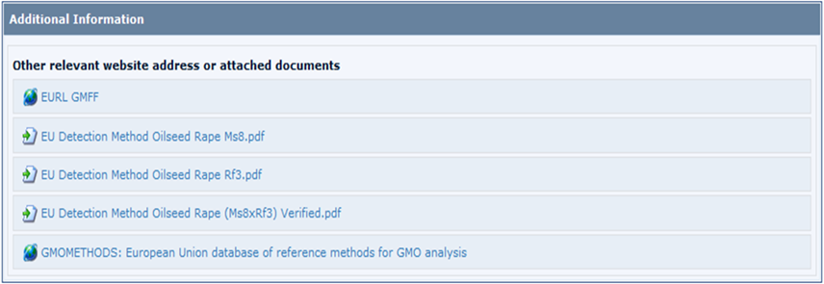
- Any other relevant information (PART B, page 3)

Detection methods for the soybean MON 87708 × MON 89788 × A5547‐127

respectively validated and verified by the European Union Reference Laboratory for GM Food and Feed (EURL GMFF) available at http://gmo-crl.jrc.ec.europa.eu/StatusOfDossiers.aspx)

Additional Information
- Other relevant website address or attached documents:

Add Websites:
- EURL GMFF
http://gmo-crl.jrc.ec.europa.eu/default.htm
- GMOMETHODS
European Union database of reference methods for GMO analysis:
http://gmo-crl.jrc.ec.europa.eu/gmomethods/

EU Register of GM Food and Feed
(of the event!)

Attach Files:
Title: EU Detection Method soybean MON 87708 × MON 89788 × A5547‐127

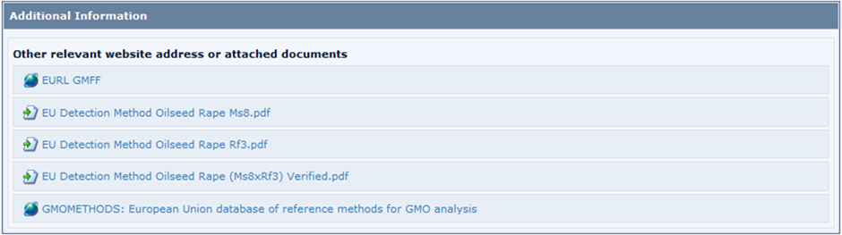

- Save Changes

- Submit the record for publication + SEND LINK TO AUTHORISER

