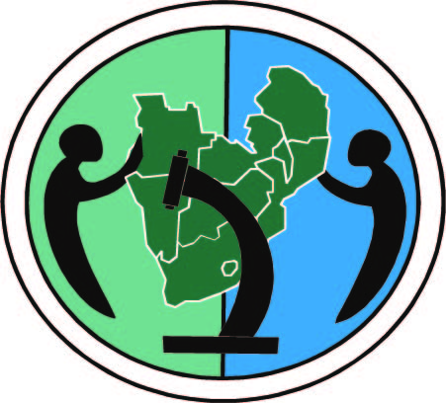
RAEIN-Africa
Capacity building Activities on Biosafety Socio-Economic Considerations

The Regional Agricultural & Environmental Initiatives Network-Africa (RAEIN-Africa), a Southern Africa-based, not for profit organization is currently implementing a programme aimed at creating an enabling environment for innovative interventions that enhance poverty reduction and sustainable development in the region. The programme is funded by Netherlands Ministry of Foreign Affairs (DGIS). Through this programme, RAEIN-Africa has been supporting a number of initiatives aimed at enhancing the capacity for assessing socio-economic impacts of GMOs. This was in response to a desire by partner countries to include socio-economic considerations in biosafety decision-making as elaborated in National Biosafety Frameworks against the general lack of guidelines of how this can be done. These initiatives include:

- In-country studies aimed at enhancing the understanding of socio-economic issues that would need to be considered in adoption of GM technologies. These studies were carried out in Botswana, Malawi, Namibia, Swaziland, Tanzania, Zambia and Zimbabwe. The main outcome of these studies was list of socio-economic factors considered important for subsistence farmers in the region
- A Training workshop on Biosafety Socio-economic Considerations held in February 2010. The Workshop was organized in partnership with the University of Pretoria. Presenters included Jose Falck-Zepeda (Program for Biosafety Systems, IFPRI) and Worku Damena Yifru, CPB secretariat. The workshop was attended by 31 participants representing regulators, decision-makers and academics from 13 SADC countries i.e. (Angola, Botswana, Malawi, Namibia, South Africa, Swaziland. The three day workshop shed light on the scope, approaches, methods and experiences on conducting a socio-economic impact assessment studies and how it relates to genetically modified crops and regulation their regulation.
- In partnership with the University of Pretoria and with technical backstopping from Jose Falck-Zepeda, RAEIN-Africa, through a multi-disciplinary team established following the training workshop composed of members from South Africa, Zimbabwe, Malawi and Namibia, been carrying out a project aimed at developing a guideline for the assessment of socio-economic impacts of GMOs. This project had a number of components as follows:
- An ex ante Bt cotton study carried out in Balaka and Chikwawa districts, Malawi in April 2010 aimed at identifying potential socio-economic impacts on the farming community and cotton sector.
  - Ex post study on Bt cotton and Bt and HT maize studies in Makhathini, Hlabisa and Simdlangenthsa areas of KwaZulu Natal, South Africa with the aim of identifying the actual socio-economic impacts of GM crops on smallholder farmer communities.
  - Preliminary findings from the two case studies and a framework of the guideline was presented at a stakeholder’s workshop in September 2010
  - The guideline was further developed by drawing information from the country studies and feedback from the regional consultative workshop.
  - The guideline development process and lessons learned were shared at a RAEIN-Africa side event at COP/MOP5 in Nagoya and feedback further enhanced the substance and development of the document. The side event was supported by the Ministry of Housing, Environment and Spatial Planning (VROM) of the Netherlands.

A synthesis report and a preliminary guideline have been compiled and will be shared upon further interrogation by partners in the region

