 |  | CBD
 |  |  |  | Distr.  GENERAL  UNEP/CBD/BS/WS-LMO/1/INF/2  12 November 2013  ORIGINAL: ENGLISH
WORKSHOP OF THE NETWORK OF LABORATORIES FOR THE DETECTION AND IDENTIFICATION OF LIVING MODIFIED ORGANISMS
Ispra, Italy, 25 - 27 November 2013

Interim Analysis of the capacity of the parties to detect and identify living modified organisms
- INTRODUCTION
- Article 33 of the Cartagena Protocol on Biosafety requires Parties to monitor the implementation of their obligations under the Protocol and report, at intervals to be determined by the Conference of the Parties serving as the meeting of the Parties to the Protocol (COP-MOP), on measures taken to implement the Protocol.
- In decision BS-V/14 on monitoring and reporting (Article 33), Parties to the Protocol adopted a new reporting format and requested the Executive Secretary to make it available to Parties online through the Biosafety Clearing-House (BCH). Furthermore, in decision BS-V/16, the Parties, also adopted the Strategic Plan for the Cartagena Protocol on Biosafety for the period 2011-2020 as well as a multi-year programme of work for the sixth, seventh and eighth meetings of the COP-MOP.
- With the view to augment the baseline data for measuring progress in the implementation of the Protocol, in particular the mid-term evaluation of the implementation of the Strategic Plan, the Parties requested the Executive Secretary, in decision BS-VI/15, to conduct a dedicated survey to gather information corresponding to indicators in the Strategic Plan.
- In this context, the second national reports and the survey provide the baseline data for the level of implementation of the Protocol.
- The present document was prepared to assist in the discussions during the Workshop of the Network of Laboratories for the Detection and Identification of Living Modified Organisms to be held in Ispra, Italy from 25 to 27 November 2013. The following sections summarize the data contained in the second national reports and also data from the dedicated survey on the detection and identification of living modified organisms (LMOs).

- SUmmary of responses from the second national report
- During the reporting period for the second national report, ending on 31 December 2011, the Secretariat had received submissions from 143 Parties, representing 89% of the total number of Parties to the Protocol at that time (i.e. 161 Parties). The submissions received were regionally distributed as follows:
- Africa: 49 reports (100% of the Parties in the region);
- Asia and the Pacific (AP): 35 reports (85% of the Parties in the region);
- Central and Eastern Europe (CEE): 19 reports (86% of the Parties in the region);
- Latin America and the Caribbean (GRULAC): 21 reports (75% of the Parties in the region);
- Western Europe and Others Group (WEOG): 19 reports (90% of the Parties in the region).

- The following paragraphs summarize the answers to questions in the second national report that are relevant to the detection and identification of LMOs.
- In response to Question 33, 71 Parties (50% of the respondents to this question) reported that they have established a mechanism for monitoring potential effects of LMOs that are released into the environment. The percentages of respondents from the different regions/economic groups that reported having established such a mechanism are as follows: 42% of respondents from Africa, 34% in Asia and the Pacific, 68% in CEE, 33% in GRULAC, 100% in WEOG.
- In response to Question 34, 35 Parties (24% of the respondents to this question) reported that they have the capacity to detect and identify LMOs and an additional 52% reported that such capacity exists to some extent. The percentages of respondents from the different regions/economic groups that reported not having the capacity to detect and identify LMOs are as follows: 43% of the respondents from Africa, 20% in Asia and the Pacific, 29% in GRULAC.
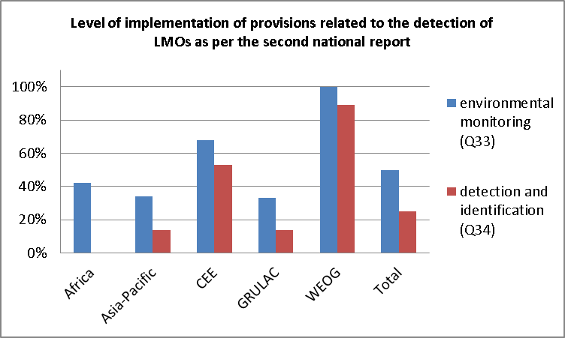
- In responding to Question 114, 39 Parties (27% of the respondents to this question) reported that they have established procedures for the sampling and detection of LMOs; 40 Parties (28% of the respondents to this question) to some extent; and 64 Parties (45% of the respondents to this question) reported not having done so. The percentages of respondents from the different regions/economic groups reporting the latter are as follows: 63% of the respondents from Africa, 51% in Asia and the Pacific, 11% in CEE, 57% in GRULAC, 5% in WEOG.
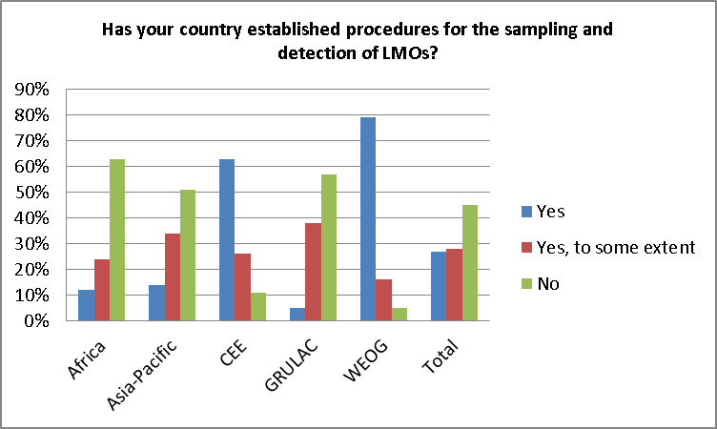
- Furthermore, in relation to question 114, the European Union reported that, in accordance with a recommendation by the Informal Advisory Committee of the BCH, the European Commission database on “GMO detection methods” was interlinked with the BCH for an automated exchange of information regarding detection methods. A European Union member State reported that it “organized 2 meetings of the National Focal Points and Competent National Authorities of the European Union Parties to the Cartagena Protocol to exchange views and experiences with regard to the implementation of the requirements of the Cartagena Protocol and the submission of information to the Biosafety Clearing House data base”.
- In Question 144, among the Parties that had undertaken capacity-building activities in biosafety, 50% had carried out activities related to the identification of LMOs, including their detection, and 42% had undertaken capacity-building activities for scientific, technical and institutional collaboration at subregional, regional and international levels.
- In Question 147, among the Parties that indicated that they still have capacity-building needs, 87% indicated the need for capacity building for the identification of LMOs, including their detection, 80% in scientific, technical and institutional collaboration at subregional, regional and international levels, and 82% in measures to address unintentional and/or illegal transboundary movements of LMOs.
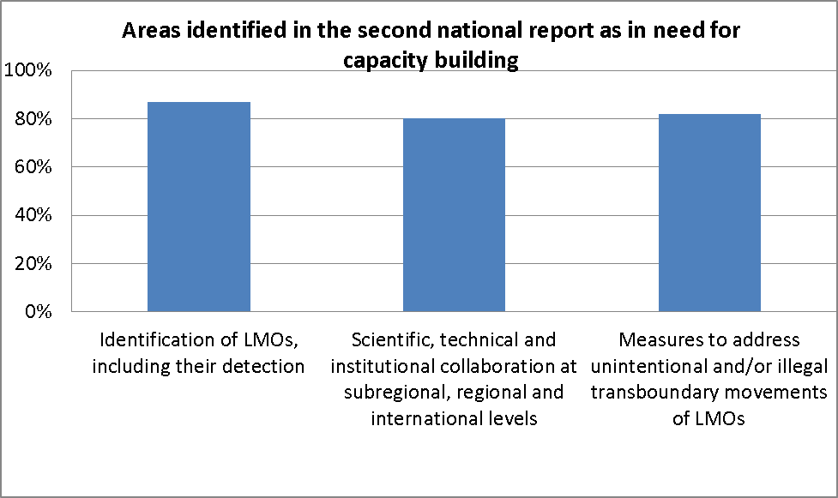

- Furthermore, with regards to capacity-building in detection and identification of LMOs, one Party from Asia reported that it has approved the establishment of a biotechnology laboratory which will have facilities to detect and analyse LMOs. It reported that through an ongoing biosafety project LMO detection equipment along with rapid test kits will be acquired and training of relevant technicians and inspectors will be done. Another Party from Asia reported that it has developed plans for extensive scientific and technological capacity development in biosafety in the medium and long-term. A Party from GRULAC also reported that three Competent National Authorities have an LMO detection laboratory which supports national LMO surveillance and monitoring activities. Some Parties from Africa reported challenges in accessing GEF funds for capacity-building.
- Finally, in response to Question 169, 52 Parties (37% of the respondents) reported having established a strategy for detecting illegal transboundary movements of LMOs. This includes: 17% of the respondents in Africa, 35% in Asia and the Pacific, 58% in CEE, 19% in GRULAC, 89% in WEOG.
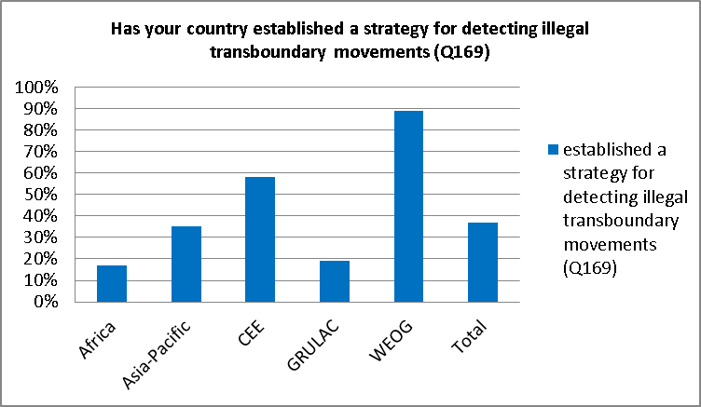
- INTeRIM Summary of responces from the Survey to gather information corresponding to indicators in the Strategic Plan
- As of 12 November 2013, the Secretariat had received submissions from 80 Parties to the “Survey to gather information corresponding to indicators in the Strategic Plan” (hereafter “the Survey”). This represents 48% of the 166 Parties to the Protocol. The submissions received are regionally distributed as follows:
- Africa: 21 submissions (43% of the Parties in the region);
- Asia and the Pacific (AP): 15 submissions (37% of the Parties in the region);
- Central and Eastern Europe (CEE): 13 submissions (65% of the Parties in the region);
- Latin America and the Caribbean (GRULAC): 16 submissions (62% of the Parties in the region);
- Western Europe and Others Group (WEOG): 15 submissions (79% of the Parties in the region).

- An interim analysis of the submissions to the Survey was carried out with a focus on the questions that are relevant to the detection and identification of LMOs as well as related articles of the Cartagena Protocol on Biosafety.
- In response to Question 18, 49 Parties (61%) reported that they have the capacity to take appropriate measures in the event that an LMO is unintentionally released. Among these: 43% of the respondent Parties were in Africa, 53% in Asia and the Pacific, 85% in CEE, 38% in GRULAC and 100% in WEOG.

- In elaborating on the kind of measures in place, several Parties indicated extensive documentation and notification procedures; however no specific information regarding the use of detection and identification methodologies was included in the responses.
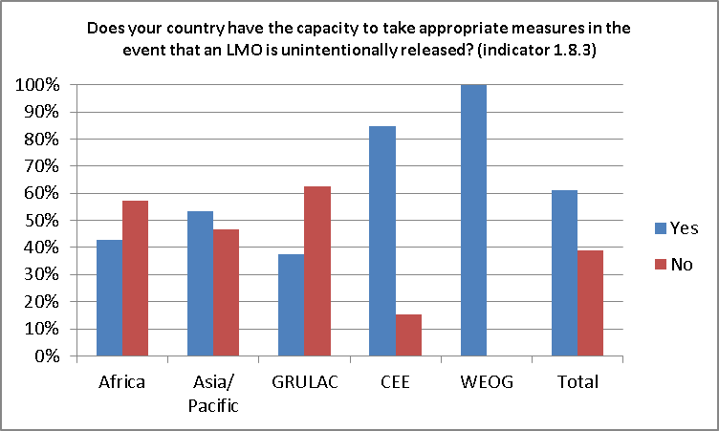

- In response to Question 24, Parties reported on the number of laboratory personnel in your country have received training in detection of LMOs. 20% of Parties reported that they have no laboratory personnel that are trained in the detection of LMOs. This includes 33% of respondents in Africa, 33% in Asia and the Pacific, 8% in CEE, 19% in GRULAC and none in WEOG.
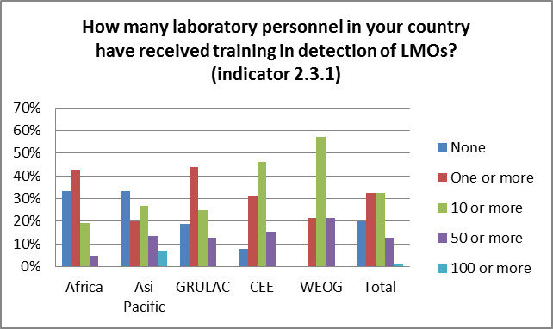
- In reporting on whether or not Parties have reliable access to laboratory facilities for the detection of LMOs in Question 25, 31% of Parties reported that they have no access to the required facilities for LMO detection. Among the Parties that reported that they have no access to laboratory facilities, 43% were in Africa, 33% in Asia and the Pacific, 13% in CEE, 56% in GRULAC and none of the Parties in WEOG.

- Parties reported that the laboratory facilities for the detection and identification of LMOs range from government laboratories to laboratories in an academic setting. Moreover, in elaborating on the nature of these laboratories, some Parties noted that although the equipment necessary to carry out some basic LMO detection techniques may be available, the laboratory facilities are not necessarily dedicated to LMO detection.
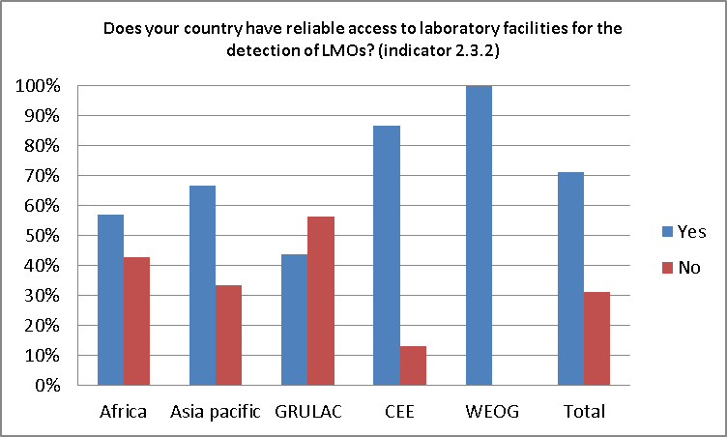
- In Question 26 parties were asked about the number of laboratories in their country that are certified for LMO detection. 33 Parties indicated that they have no certified laboratories in their country. The regional breakdown included 62% of Parties in Africa, 40% in Asia and the Pacific, 15% in CEE, 75% in GRULAC and no Parties in WEOG.
- Further in regard to having “certified laboratories”, one Party noted that it has several laboratories operating under high quality assurance and quality control standards but that are not ultimately interested in obtaining a certification. Furthermore another Party noted that there is no clear definition of the term “certified” and, therefore, could not elaborate on the answer to this question.
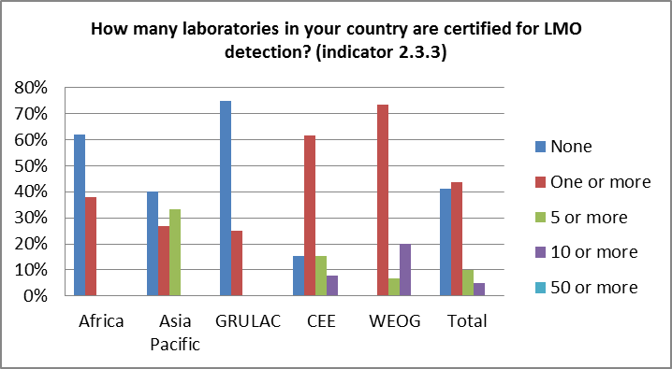
- In assessing how many of the certified laboratories in question 26 are operational 35 Parties indicated that their laboratories are not operational which accounts for 44% of respondents. Of these Parties 67% were in Africa, 47% in Asia and the Pacific, 15% in CEE, 75% in GRULAC and none of the Parties in WEOG.
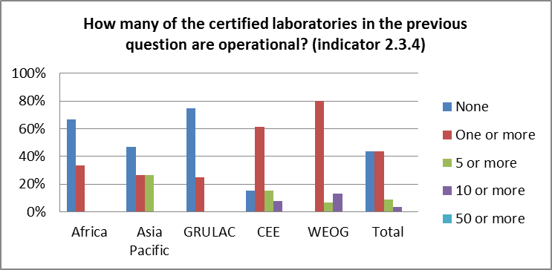
- GEneral considerations
- While the second national report indicated that several Parties have not yet developed their capacity to detect and identify LMOs, relevant data from the Survey suggests a trend towards the development of capacity in this area.
- As indicated in the second national report, Parties recognize the importance of capacity building activities in the area of LMO detection and identification.
- The majority of Parties in Asia and the Pacific, Africa, CEE and WEOG reported that they have reliable access to laboratory facilities. Further assessment of the use of regional networks for access to laboratory facilities remains to be investigated. Nevertheless, such networks may offer opportunities for access to laboratories in most regions. The networks could also facilitate the establishment and/or further strengthening of regional networks of LMO detection laboratories.
- The majority of Parties in Africa and GRULAC do not have any certified laboratory for the detection of LMOs. The results suggest that Parties could benefit from further support in establishing certified laboratories.
- The majority of Parties in CEE and WEOG have the capacity to take appropriate measures in the event of an LMO being released unauthorized or unintentionally into the environment. However Parties in other regions have yet to develop capacity in this area. Capacity building activities in the detection and identification of LMOs unintentionally released into the environment was also identified as an area of interest by Parties as indicated in the second national report.
- Furthermore, data from the Survey indicated that of the Parties that have capacity to deal with an event where an LMO is unintentionally released, their procedures involve documentation and notification strategies; no elaboration was made as to the involvement of technical methodologies and monitoring procedures in the process. Additionally, while the protocol refers to unintentional release of LMOs, in their responses some Parties, and in literature on the topic, discuss measures for unauthorized release, advantageous presence or low level presence of LMOs.

----

Available at http://bch.cbd.int/protocol/issues/cpb_stplan_txt.shtml.
Available at http://www.cbd.int/doc/notifications/2013/ntf-2013-042-bs-en.pdf.

