Module 3
Sample Preparation and Extraction

Contents of this module

Introduction
Sample management
Sample submission
Considerations for sample size
Sample storage
Sample homogenisation
Sample preparation procedure
Considerations for QA/QC during sample homogenisation
Sample DNA extraction
Extraction methods
Purification methods
DNA quantification
Spectrophotometric quantification
Fluorometric quantification
References

Introduction
Analytical testing of LMOs detectable and/or quantifiable by scientifically validated methods are carried out following a stepwise process in genetics laboratories; agricultural fields, e.g. experimental, developmental, commercial and private; shipping and storage vessels and facilities; production and manufacturing facilities; the wholesale and retail distribution marketplace and private, commercial and government testing laboratories. Because, sampling and analysis are the complimentary and inseparable halves of the estimation of a material batch composition, a probability-based sampling scheme developed through the scientific method is essential for good analytical results (Sussman, 2017; Gy, 1990). Both the stakeholder submitting the samples and the analytical laboratory will require a sampling plan and sampling procedures wherever samples are taken (ISO/IEC, 17025:2017). How sampling plans and analytical methods are applied often depends on the limitations of the tests and the materials themselves. Because different levels of competence and technology are required for sampling and tests in different contexts, analysts need to evaluate their sampling and testing processes within the scope of their customer’s needs to ensure standardised testing and laboratory criteria are not only reproducible and technically sound with defined patterns and known nomenclatures, but also cost-effective with respect to the products that are sampled and tested.
The validity of procedures for obtaining samples submitted to the laboratory, subsampling in the laboratory, sample preparation and extraction are important in obtaining reliable results regarding the presence of LMOs in a sample. Therefore, appropriate procedures must be followed to ensure that a representative sample of known heterogeneity is obtained prior to submission to the laboratory and as the sample is prepared for analysis.

Sample Management
Laboratories involved in the detection and identification of LMOs need to have procedures in place for sample management, including the steps to follow for a sampling plan, laboratory submission, sample receipt, labelling, storage, laboratory sample preparation and destruction, including an outline of the procedures for documenting each step. Suitable standards for these procedures can be found in ISO 17025.
Sampling Plan and Procedure
Many sampling plan standards are available for commercial agricultural products. In many cases, they are also applicable to LMOs. Some are produced from regulatory authorities. Securing a representative sample requires equal portions to be taken from evenly distributed parts of the quantity of leaves, stems, fruits, seeds, grains or screenings to be sampled. As batches are sampled, each portion should be examined. If it appears to lack of uniformity, the portions should be retained as separate samples or combined to form individual-container samples to determine the apparent heterogeneity. When the portions are uniform, they can be combined to form a composite sample. Included with published methods are provisions for the collection and documentation of traceable records to ensure the preservation of the samples’ integrity and minimising contamination. Below is a description of several steps to consider for sample management.
Sample Submission
All samples accepted by the Laboratory should be accompanied by an official laboratory form requesting an examination in either hardcopy or electronic format as specified by the laboratory. These forms, as a minimum, should include the following information:
- Data about the person from the relevant competent national authority that is submitting the information. This data would include their name, location of employment and contact information. This information is used by the laboratory to direct them to the correct contact person in the event the laboratory has any questions that may come up during sample processing. It also provides information regarding who to send the final report to and payment procedures. This section must also include the submitter’s signature.
- Information about the sampling plan.
- A description of each sample submitted to the laboratory is provided by the submitter, including information on the type of sample, for example if it is food, feed or seed as well as its weight and composition.
- An indication of what the target organism may be and what type of analysis is requested.
- Information how the samples were delivered to the laboratory, including as appropriate, the name of the person who delivered the sample and/ or shipping labels if the sample arrived by mail.
- Any required regulatory permit information (such as phytosanitary or LMO movement permits)
Once the documentation is checked and verified for completeness, the laboratory personnel should inventory the sealed sample packages and compare the number and descriptions of the samples received with the information in the official laboratory form to ensure that all samples are present. If there is a discrepancy in the number or description of the samples, the submitter should be contacted to clarify and reconcile the discrepancy. Any changes to the submission information should be documented in laboratory case file.
Furthermore, the condition of the sample packaging should be evaluated. If the sample packaging has been compromised or damaged during shipping, for example a tear in the packaging that resulted in the cross-contamination of samples, then this must be recorded in the case file. If the compromised packaging affects the suitability of a sample to be tested, then laboratory personnel should contact the submitter to inform them. This information should also be recorded in the case file.
Following the verification of documentation, a verification of the sample size (see section on Considerations for Sample size) must be made. The sample is weighed, and a note is made if the weight of the sample is in accordance with the specifications set out by the laboratory. If the sample size is too small this will be documented in the laboratory case file and the submitter will be informed, according to laboratory policy, whether this sample will be processed. If the sample size is larger than the specifications set out by the laboratory, then a representative mass reduction (see Box 1) may need to be carried out in accordance with laboratory policy. In either case a note would have to be issued in the laboratory report
BOX 1: MASS REDUCTION
Mass reduction is the part of the sample preparation procedure to reduce the mass of a laboratory sample through subsampling (ISO/FDIS 6498:2011). This would need to be carried out if the laboratory sample that was submitted for analysis is bigger than the sample size required by the laboratory.
There are several techniques that can be used to reduce the mass of the sample in such a way that the resulting subsample that will be carried forward during processing continues to be representative of the whole laboratory sample. These include:
1. Pre-grinding: if the laboratory sample is composed of lumps, or its particle sizes are above 6 mm, the whole sample should be pre-ground before mass reduction.
2. Subsampling: Several methods can be used to reduce the size of the laboratory sample:
a. Fractional shovelling
b. Spoon method
c. Long pile method
d. Coning and quartering
e. Splitters and dividers
Adapted from JRC’s “Guidelines for sample preparation procedures in GMO analysis”
Once these checks for documentation, sample condition and sample size have been carried out the samples should be registered within the laboratory’s information management system.
A sequentially generated lab number can be assigned to the case upon receipt of the first official laboratory form requesting an examination. Any supplemental sample submission(s) should be assigned the same Laboratory number as the original submission. These laboratory file numbers are unique identifiers and can be placed on all documents relating to a case. Furthermore, each individual sample that is submitted for a case should be assigned a consecutive item number and/or barcode label. If a subsample and/ or multiple test portions of a sample are created during processing, a sub-item number should be generated using the sample’s unique numeric sequence separated by a hyphen (e.g., 1-1, 1-2, etc.).
BOX 2: Sequentially generated numbering
When selecting a numbering system for samples it would be useful to follow a system that is intuitive and meaningful, for example: “LYYYY###”, where
•L - is the laboratory acronym. This would be particularly useful if the lab storage space is shared and the samples need to be identified as belonging to the LMO/ GMO testing laboratory.
• YYYY - are the four digits of the calendar year.
• ### - is a sequentially assigned three-five digit number, beginning with the number one (001) assigned to the first case submitted in the calendar year
Once the review is complete, the laboratory personnel that received the samples and carried out the check should sign or initial the documentation in the designated area and mark the date the samples were received in the case file. The samples can now be placed in storage until further processing.
Considerations for Sample size
The minimum size of any given sample depends on the statistical confidence required, the lowest concentration of LMO that is to be detected and on the sample type and matrix which is usually defined by number of seeds, kernels, grains or by weight. Below is a table recommending appropriate laboratory sample sizes based on the type of matrix.
Table 1: Recommended laboratory sample sizes according to the type of matrix (Adapted from the JRC’s “Guidelines for sample preparation procedures in GMO analysis”)
Products | Recommended laboratory sample size
Leaves | 10 different leaves
Seeds | Mass equivalent of 3000 kernels
Commodity grains | Mass equivalent of 10000 grains
For seeds and commodity grains, the recommended laboratory sample size corresponds to the mass equivalent of a certain number of kernels or grains. Table 2 provides information on the mean mass of 1000 kernels of various plant species from which the appropriate laboratory sample size can be extrapolated.
Table 2: Data concerning the mean mass of 1000 kernels for different plant species (Adapted from the JRC’s “Guidelines for sample preparation procedures in GMO analysis”)
Plant species | Mean mass of 1000 kernels (in g)
Barley (Hordeum vulgare) | 37
Linseed (Linum usitatissimum) | 6
Maize (Zea mays) | 285
Millet (various species) | 23
Oat (Avena sativa) | 32
Rapeseed (Brassica napus) | 4
Rice (Oryza sativa) | 27
Rye (Secale cereale) | 30
Soybean (Glycine max) | 200
Sugar beet (Beta vulgaris) | 11
Sunflower (Helianthus annuus) | 100
Tomato (Solanum lycopersicum) | 4
Wheat (Triticum. aestivum) | 37
It should be noted that for each plant species there may be many varieties that are encountered in the laboratory. Each of these varieties may have different sized kernels, therefore a variety with bigger kernels (compared to the average values of maize kernels), may contain less than 1000 kernels in in a mean sample mass.
In certain cases where samples that have been submitted to the laboratory with a mass equivalent that is lower than the recommended laboratory sample size or a sample with bigger kernels it would be good practice to, on a case-by-case basis as appropriate, check the number of kernels that are present in those samples. This can be done by weighing the mass of 100 kernels and extrapolating an estimate of the number of seeds present based on the mass of whole sample.
In addition to establishing minimum size requirements of the laboratory sample, it is also advisable to fix a maximum size. This will facilitate the need to perform a mass reduction step on large laboratory samples. Maximum numbers should not be fixed in a single unit for all samples but should be adapted to the kind of matrix analysed.
Sample Storage
Storage of the samples prior to and during sample preparation, as well as after its analysis should be performed under appropriate conditions (e.g. at room temperature, refrigerated, frozen). It is the responsibility of laboratory personnel to ensure, insofar as possible and reasonable, that samples do not experience loss, cross-contamination, or deleterious change while in the laboratory.
While seed and grain samples may be stored at room temperature without any negative effect on the sample’s quality, it is important to ensure that the environmental conditions are appropriate to do so. For example, if the room environment is warm and humid this may lead to the growth of mold in the sample, leading to a deleterious change in the quality of the sample. Therefore, samples that may experience a deleterious change without refrigeration should be placed in a refrigerator or freezer as soon as possible until such time that they will be prepared for analysis. Furthermore, in the case of seed samples, care must be taken that there is no accidental release of the seeds into the environment. In this case it is advisable to homogenise the sample as soon as possible to eliminate the risk of an accidental release, unless it is necessary to grow the seed out to perform the required test

Sample Homogenisation
In general, the whole laboratory sample is used to obtain a homogenised test sample for the analysis, if the size of the sample conforms to the laboratory’s requirements. Homogenisation is required for two reasons:
- to achieve sufficient efficiency of analyte extraction; and,
- to ensure homogeneity and an equal representation of LMO-derived particles in the test samples.
The aim of homogenisation is particle size reduction. Size reduction permits a wider distribution of each kernel in the sample, making it more likely that a small subsample will contain the target. Furthermore, homogenization improves DNA and protein extraction. Homogenisation is the step with the highest risk of error and contamination.
The risk of error arises because, as indicated in Tables 1 and 2 above, a laboratory sample can range from 100 g – 3 kg in mass, depending on the plant species. Whereas the resulting test potion that will be used to carry out the analysis can range from 200 mg – 1 g in mass. This represents a 200- 10,000-fold difference in mass and, potentially the biggest possible source of error. Therefore, a specific procedure should be followed during the sample homogenisation to manage and reduce the likelihood of error.
The contamination risk that occurs during the homogenisation procedure is largely due to the formation of a fine dust that often appears during the grinding step. This dust could contaminate subsequent laboratory samples, if appropriate laboratory practices are not in place. Therefore, all the sample preparation steps should be done under stringent conditions to avoid cross-contamination while minimising the degradation of the target analyte, be it DNA or proteins, in the test sample.
The homogenisation of samples must be carried out in a room or area dedicated primarily to that purpose following strict procedures for sample processing and the subsequent cleaning of surfaces and equipment. This procedure is outlined in further detail in the next section.
Sample preparation procedure
The choice of method used to carry out the particle size reduction also depends on the physical and chemical composition of the material, its quality and the laboratory’s capacity. Particle size reduction may be achieved with mills, homogenizers, immersion blenders, coffee grinders, or other suitable equivalent device, depending on the size and the structure of the laboratory sample, as indicated in the table below.
Table 3: Various commonly encountered sample matrices and possible equipment / method used for their homogenisation (Adapted from ŽEL et. al. Extraction of DNA from different sample types - a practical approach for GMO testing)
Species | Matrix | Possible Homogenisation method | Test portion
Soybean | Grain / seed | Retsch ZM200 rotor mill | 2 x 200 mg
Soybean | Leaves | Small pieces from different leaves, combined and homogenized as one sample with FASTprep instrument or manually crushed with LN₂ | 100 pieces
Maize | Grain / seed | Retsch ZM200 rotor mill | 2 x 200 mg
Maize | Leaves | Small pieces from different leaves, combined and homogenized as one sample with FASTprep instrument or manually crushed with LN₂ | 100 pieces
Rapeseed | Grain / seed | Retsch GM200 knife mill + LN₂  or coffee grinder + LN₂ | 2 x 200 mg
Rapeseed | Leaves | Small pieces from different leaves, combined and homogenized as one sample with FASTprep instrument or manually crushed with LN₂ | 100 pieces
Flax | Grain / seed | Retsch GM200 knife mill + LN₂  or coffee grinder + LN₂ | 2x 200 mg
Flax | Leaves | Retsch GM200 knife mill + LN₂ , | 100 pieces
Rice | Grain | Retsch ZM200 rotor mill | 2 x 200 mg
Potato | Tuber | Bioreba | 2 x 500mg
Tomato | Fruit | Bioreba | 2 x 500mg
Tomato | Leaves | Small pieces from different leaves, combined and homogenized as one sample with FASTprep  instrument or manually crushed with LN₂ | 100 pieces
Wheat | Grain | Retsch ZM200 rotor mill | 2x 200 mg
Sunflower | Grain | Retsch ZM200 rotor mill | 2x 1 g
However, grinding using a mill with an integrated sieve gives you control and uniformity over particle size. In the case of difficult samples, such as fatty samples, that may be prone to degradation during the homogenisation step, the use of successive grinding steps with sieves of decreasing mesh sizes or repeated grinding with the same mesh size sieve may be appropriate. Furthermore, difficult samples can also be treated with liquid nitrogen before grinding. This serves to reduce the generation of heat that is produced during the grinding process, thus reducing the chances of analyte degradation and maintaining sample integrity.
In the case of certain samples such as large fruits, tubers or seeds, it may be necessary to take an equally sized sample of each item and combine these in order to obtain the test sample (for example grinding 1000 sugar beets would be impracticable, and as the beets are not homogenous in size they would not contribute equally to the test sample).
After grinding, the test sample should be thoroughly mixed, or blended, to obtain a very homogeneous analytical sample. In cases where the test sample is flour or liquid, homogenization is not needed but thoroughly mixing or shaking the sample is necessary. This is carried out by placing the homogenised sample in a disposable plastic bag or other suitable container, that is, at a maximum, half full and inverting the contents of the container 20 times.
Once the sample is homogeneous, following grinding and mixing, if required, the test portion is obtained through “grab sampling”. The grab sampling must be carried out immediately after the mixing procedure to minimise gravitational segregation of the homogenised particles, which may affect the homogeneity of the sample. For each sample, two 200 mg test portions are taken from the prepared sample. A back up aliquot of the prepared sample is also preserved if a reanalysis of the sample is needed in the future. If the backup aliquot is ever used, the homogeneity of the sample would have to be re-established using the bag mixing technique.
All samples taken during the grab sampling procedure must then be stored in an environment that is conducive to the maintenance of the sample’s integrity. The most appropriate storage depends highly on the sample type and the length of time that the sample will be stored for. For example, the two test portions can be stored at 4 degrees for a few days until they are further processed. On the other hand, the backup aliquot, which is normally kept for longer periods of time (e.g. 3 months), would need to be stored at -20 degrees for the period time specified before it is either used or destroyed.
Once the test portions are successfully processed and analysed the resulting DNA, or protein and back up aliquot will have to be appropriately labelled and stored for the length of time specified by the laboratory. Once the time has elapsed it would be authorized to destroy the samples. Any sample destruction would have to be appropriately documented in the sample case file. This includes documenting the date of destruction and the identity of the person who destroyed the sample.
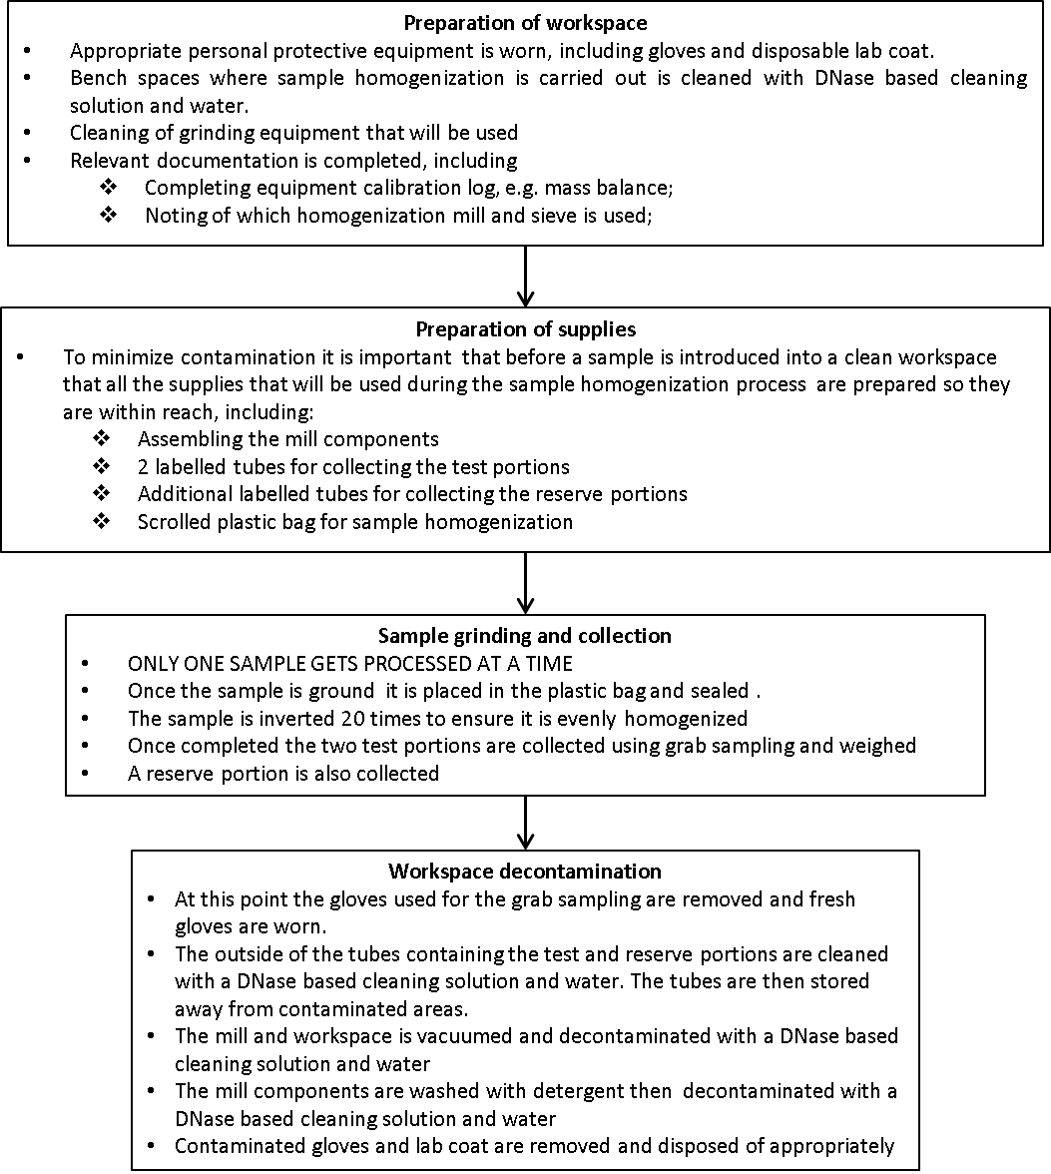
Figure 1: step by step guide on practical, hands on procedures that can be followed in order to successfully homogenise a sample.
Considerations for Quality Assurance and Quality Control during Sample Homogenisation
The application of stringent Quality Assurance and Quality Control (QA/QC) procedures during the sample homogenisation step is vital since, as previously indicated, it is the step with the highest contamination risk and the quality of the homogenisation will affect the efficiency of downstream processes. Suitable procedures are outlined in ISO 17025. In addition to the measures described above that can be put in place during sample preparation, the following considerations should also be kept in mind:
Maintaining homogenised particle size: Ensuring that the particles produced during the homogenisation step are of a consistent and specific size can be done by using a grinder with an integrated sieve. However, with time, the size of the openings within the sieve can increase. Routinely calibrating and inspecting the sieve should be done to ensure that at least 95% of particles produced during the homogenisation procedure are at the correct size.
Carry over: To validate whether the decontamination procedure that has been adopted by your laboratory is adequate in ensuring that the surfaces and equipment are analytically clean and free of material that can be carried over into the next sample, a test can be performed to validate the procedures. This involves either:
- Processing an LMOsample followed by a non-LMO sample then analytically testing for the presence of any traces of LMO material in the sample; or
- Processing a sample of species A (for example corn) followed by a sample of species B (for example soybean) then analytically testing for the presence of traces of species A, in this case corn, in the test portion of species B, the soybean.
Representativeness of test portion: As previously indicated, a laboratory sample can range from 100 g – 3 kg in mass, depending on the species, whereas the resulting test potion that will be used to carry out the analysis can range from 200 mg – 1 g in mass. Due to this large difference in size between the lab sample and the test portion, validation tests must be carried to ensure the representativeness of the test portion. Similarly, to the approach provided above, this involves either:
- Processing a sample that has been spiked with 1 LMOgrain in 10,000 non-LMO grains of the same species; or
- Processing a sample that has been spiked with one grain from species A (for example corn) in 10,000 grains of species B (for example soybean). Grains from species A and B should be of similar size.
In both cases six test portions are tested for the presence of the spiked grain. The testing procedure is considered representative if all six test portions test positive for the presence of the spiked grain. If not, then possible ways forward may include either increasing the test portion size or decreasing the particle size of the homogenised samples.

Sample DNA Extraction
Extraction and purification of nucleic acids is the first step in most molecular biology studies and in all recombinant DNA techniques. The objective of nucleic acid extraction methods is to obtain purified nucleic acids from various sources with the aim of conducting specific analyses using, for example, the Polymerase Chain Reaction (PCR). The quality and purity of the extracted nucleic acids are critical factors when it comes to PCR analysis. Therefore, suitable extraction methods should be applied to obtain highly purified nucleic acids free from any residues of the extraction reagents and other cellular content, such as proteins, polysaccharides, lipids and RNA, that may inhibit the performance of a PCR analysis. Examples of such inhibiting contaminants are listed in Table 4.
Table 4: Examples of PCR inhibitors.
Inhibitor | Inhibiting concentration
SDS | > 0.005%
Phenol | > 0.2%
Ethanol | > 1%
Isopropanol | > 1%
Sodium acetate | > 5 mM
Sodium chloride | > 25 mM
EDTA | > 0.5 mM
Haemoglobin | > 1 mg/ml
Heparin | > 0.15 IU/ml
Urea | > 20 mM
Reaction mixture | > 15%
In order to avoid false negative results arising from the presence of PCR inhibitors in the sample, it is recommended to perform a control experiment to test for the presence of PCR inhibition using a plant or species-specific PCR analysis.
A number of methods exist for the extraction and purification of nucleic acids therefore the choice of the most suitable technique can be based on the following criteria:
- Target nucleic acid
- Source organism
- Starting material (tissue, leaf, seed, processed material, etc.)
- Desired results (yield, purity, purification time required, etc.)
- Downstream application (PCR, cloning, labelling, blotting, RT-PCR, cDNA synthesis, etc.)
The principles of some of the most common methodologies that are currently used for the extraction and purification of nucleic acids for the purposes of LMO detection are described below.
Extraction methods
The extraction of nucleic acids from biological material serves to achieve 3 basic goals: (i) cell lysis; (ii) inactivation of cellular nucleases; and (iii) separation of the desired nucleic acid from cellular debris.
The ideal cell lysis procedure must be rigorous enough to disrupt the complex starting material and cellular structures, yet gentle enough to preserve the target nucleic acid.
Some common lysis techniques include:
- Mechanical disruption (e.g. grinding, hypotonic lysis)
- Chemical treatment (e.g. detergent lysis, chaotropic agents, thiol reduction)
- Enzymatic digestion (e.g. proteinase K)
These techniques can be combined to achieve the desired results, for example, by using a single solution that contains detergents to solubilise cellular membranes and strong chaotropic salts to inactivate intracellular enzymes. One such solution is cetyltrimethylammonium bromide (CTAB), a well characterized detergent that is often used for the extraction and purification of DNA from plants and plant derived foodstuff. It is particularly suitable for the elimination of polysaccharides and polyphenolic compounds that would otherwise affect DNA purity and quality.
The CTAB extraction method has been widely applied in the field of plant molecular genetics and has already been tested in validation trials for LMO detection. Several variations of this method have been developed and adapted to a wide range of raw and processed matrices.
The principles of this method make use of the chaotropic properties of CTAB to disrupt cellular membranes and form insoluble complexes with nucleic acids in a low-salt environment. Furthermore, under these conditions, polysaccharides, phenolic compounds and other contaminants remain in the supernatant and can be washed away during downstream purification techniques. The theory and steps of the CTAB method are further detailed below.
Cell Lysis using the CTAB method
The first step of any DNA extraction procedure is the disruption of the cell wall and cellular membranes, including the nuclear and organelle membranes. All biological membranes have a common overall structure comprising of a continuous phospholipid bilayer embedded with integral membrane proteins that are held together by non-covalent interactions, as shown in Figure 1.
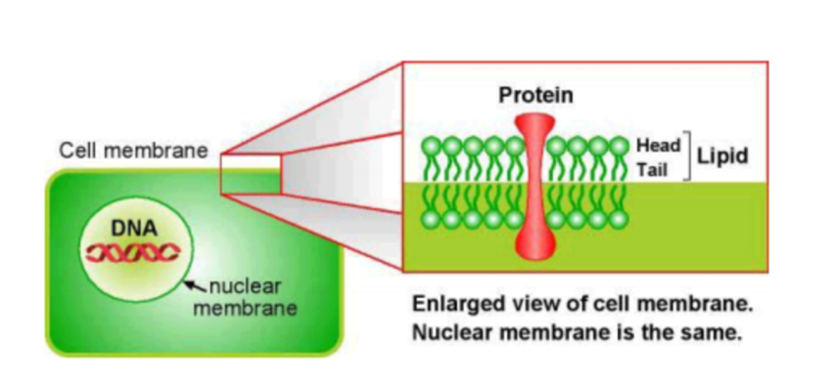
Figure 1: Simplified representation of cellular membranes. (Source: JRC User Manual "The Analysis of Food Samples for the Presence of Genetically Modified Organisms")
In the CTAB method, disruption of the cellular membrane is achieved by treating the homogenised sample with an extraction buffer containing CTAB. The polar nature of the CTAB component of the extraction buffer makes it an ideal chaotropic agent and allows it to lyse and bind to the membrane components such as phospholipids, lipoproteins, polysaccharides and inhibits their co-precipitation with the DNA. A schematic representation of the mechanism of lipid solubilisation using a detergent is shown in Figure 2.
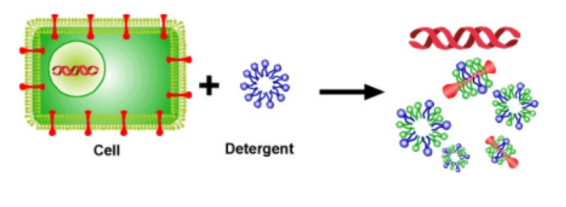
Figure 2: Schematic representation of the disruption of the cellular membrane and extraction of genomic DNA. (Source: JRC User Manual "The Analysis of Food Samples for the Presence of Genetically Modified Organisms")
Additional components of the extraction buffer include sodium chloride, EDTA and Tris/HCl, each of which serves a specific function to facilitate the extraction process.
- Sodium chloride facilitates the formation of an insoluble complex between CTAB and nucleic acids.
- EDTA, which is a chelating agent that binds magnesium ions, amongst others. Magnesium ion is a DNase cofactor therefore the presence of EDTA reduces the amount of bioavailable magnesium ions and, therefore, minimises the activity of any DNase.
- Tris/HCl maintains the pH buffering capacity of the extraction buffer since extreme fluctuations in pH leads to DNA damage.
It is important to note that at this stage of the extraction process, nucleic acids are highly susceptible to degradation, as such the time elapsed between sample homogenisation and addition of the CTAB buffer should be minimised.
Purification methods
Various methods are available for the purification of the target nucleic acids from cellular debris once the cell membranes have been lysed. This step focuses on the removal of contaminants such as polysaccharides, phenolic compounds, lipids and proteins. The elimination of such contaminants is particularly important due to their capacity to inhibit downstream enzymatic reactions, including PCR reactions (see table 4). The purification step makes use of a combination of techniques that have been developed to employ the biochemical properties of the target nucleic acids as compared to the contaminants. Such techniques include:
- Solvent extraction and nucleic acid precipitation
Solvent extraction is often used to eliminate contaminants from nucleic acids. For example, a combination of phenol and chloroform is frequently used to remove proteins. Subsequently, precipitation of the nucleic acids with isopropanol or ethanol is carried out. If the amount of target nucleic acid is low, then an inert carrier, such as glycogen, can be added to the mixture to increase precipitation efficiency. Other nucleic acid precipitation methods include selective precipitation using high salt concentrations, also known as “salting out”, or precipitation of proteins using changes in pH.
IN THE LAB: Phenol: Chloroform extraction
This is also known as an organic extraction. The cell lysis step is carried out using an aqueous extraction buffer, whereas the phenol: chloroform mixture is organic and therefore immiscible with aqueous solutions. The addition of the phenol-chloroform to the mixture of lysed cells allows for the partitioning of contaminants such as polysaccharides, phenolic compounds, lipids and proteins into the organic phase therefore facilitating the purification of the DNA, which remains in the aqueous phase.
To separate the two phases from each other the sample is centrifuged, resulting in the formation of distinct aqueous and organic phases. Due to the difference in density between the two phases, the aqueous phase will normally form the upper layer. However, under certain circumstances the phases may be inverted if the density of the aqueous phase increases due to altered salt concentrations that are greater than 0.5 M. Furthermore, the nucleic acid may partition into the organic phase if the pH of the aqueous solution has not been adequately equilibrated to a value of pH 7.8 - 8.0.
If needed, the phenol: chloroform extraction step can be performed several times to increase DNA purity. In addition, to increase DNA recovery, the organic phase can be back-extracted with an aqueous solution that is then added to the previous extract. It is also common that following the completion of a phenol: chloroform extraction that one final extraction is carried out using chloroform: isoamyl alcohol mixture. This is done to remove any residual phenol, which may be an inhibitor to PCR as stated in the table 4 above. An alternative to phenol:chloroform is the use of chloroform:octanol (24:1) for avoiding the handling of phenol. Once the nucleic acid complex has been purified, the DNA can be precipitated.
In this final stage, the nucleic acid is liberated from the detergent complex. For this purpose, the aqueous solution is first treated with a precipitation solution comprised of a mixture of CTAB and NaCl at elevated concentrations, greater than 0.8M. The salt is needed to facilitate the formation of the nucleic acid precipitate. Sodium acetate may be preferred over NaCl due to its buffering capacity.
Following the NaCl treatment, 95% alcohol is added to the sample mixture. Under these conditions, the detergent, which is more soluble in alcohol than in water, can be washed away, while the nucleic acid will precipitate out of solution. The only use of cold isopropanol (-20°C) also allows DNA precipitation when NaCl is incorporated from the beginning in the CTAB-based extraction buffer.
The nucleic acid precipitate is then collected using high speed centrifugation which forces it to collect at the bottom of the sample tube. The supernatant is aspirated, leaving a pellet of crude nucleic acids. The successive treatments, or washes, with 70% ethanol allows for additional purification of the nucleic acid from any residual salts. The nucleic acids can then be resuspended into solution by adding water or other appropriate buffers and is ready to use in downstream applications.
- Chromatography
Different chromatographic methods are based on many separation techniques as outlined below:
- Gel filtration: exploits the molecular sieving properties of porous gel particles. A matrix with a defined pore size allows smaller molecules to enter the pores by diffusion, whereas bigger molecules are excluded from the pores and eluted at the void volume. Thus, molecules are eluted in order of decreasing molecular size.
- Ion exchange: is a technique that utilises an electrostatic interaction between a target molecule and a functional group on the column matrix. Nucleic acids, which are highly negatively charged, linear polyanions, would interact with a positively charged ion exchange column and can subsequently be eluted with simple salt buffers.
- Adsorption chromatography: utilised the properties of solutes in a mobile liquid or gaseous phase to selectively adsorb onto the surface of a stationary solid phase. Nucleic acids, for example, adsorb selectively onto silica or glass in the presence of certain salts while other biological molecules do not. A low salt buffer or water can then be used to elute the nucleic acids, producing a sample that may be used directly in downstream applications.
- Affinity binding: utilises the specific biochemical binding interactions between molecules. A specific ligand is bound to a solid phase support. Any molecules in the mobile phase that have specific binding affinity to the ligand become bound to it. After other sample components are washed away, the bound molecule is eluted from the support.
IN THE LAB: Spin column based extraction
Spin column based extraction involves the use of any of several commercially available columns that contain a membrane that is impregnated with silica to facilitate the nucleic acid purification process. Under the right conditions the silica membrane selectively attracts, or “binds” the nucleic acids in the cell lysate through electrostatic interactions that allow for their adsorption onto the silica. The remaining contaminants in the cell lysate, such as polysaccharides, phenolic compounds, lipids and proteins are washed through the column.
The purification of nucleic acids using spin column based extraction consists for several distinct steps following cellular lysis. While components of the buffers and solutions used are different based on the choice of commercial kit, they all serve similar purposes at any step.
1. Binding: a “binding buffer” is added to the cellular lysate to equilibrate it such that the conditions, such as pH or salt concentrations, are optimal for the binding of the nucleic acids to the silica membrane in an efficient manner. The sample mixture is then passed through the silica membrane using a centrifuge, which forced the mixture through the column. Nucleic acids are bound to the membrane while any remaining solution, or “flow through” is discarded.
2. Washing: subsequent to the binding step a wash buffer is passed through the membrane in order to remove any residual contaminants that may have inadvertently bound to the silica. This may be done 2-3 times in order to ensure that the maximum number of contaminants have been removed from the membrane.
3. Elution: Water or another appropriate elution buffer is added to the membrane which results in the nucleic acids separating from the membrane and resuspending into solution. The final eluate containing the nucleic acid is centrifuged off of the membrane and can be used for downstream applications.
- Centrifugation
Selective centrifugation is a powerful purification method. For example, ultracentrifugation in self-forming CsCl gradients at high g-forces has long been used for plasmid purification. Frequently, centrifugation is combined with another method. An example of this is spin column chromatography that combines gel filtration and centrifugation to purify DNA or RNA from smaller contaminants (salts, nucleotides, etc.), for buffer exchange, or for size selection. Some procedures combine selective adsorption on a chromatographic matrix (see above paragraph “Chromatography”) with centrifugal elution to selectively purify one type of nucleic acid.
- Magnetic separation
In recent years, more and more purification methods have combined affinity binding with magnetic separation. For instance, streptavidin-coated magnetic particles linked to biotin-labelled oligo(dT) tag can be used purify mRNA as a result of the tag’s affinity with the mRNA the poly(A) tails. The particle complex is then removed from the solution with a magnet, leaving behind any unbound contaminants. This solid phase technique simplifies nucleic acid purification since it can replace several steps of centrifugation, organic extraction and phase separation with a single, rapid magnetic based separation step.

DNA Quantification
Following the extraction and purification of DNA from a sample it is useful to get an assessment of the nucleic acid concentration. There are several methods that can be used to measure nucleic acid concentrations. The theory and practical application of some of the more commonly used methods is presented below.
- Spectrophotometric quantification
All molecules absorb radiant energy at a specific wavelength, including nucleic acids, which absorb radiant energy in the ultraviolet range. Therefore, nucleic acid concentration can be quantified directly in aqueous solutions by using a spectrophotometer to measure the amount of ultraviolet light absorbed by the sample. The nucleic acid concentration can then be calculated using the Beer-Lambert law, which describes a linear relationship between absorbance and the concentration of the target macromolecule using the following equation:
A: Absorbance
OD: Optical Density
A = OD = εlc where: ε: Molar extinction coefficient
c: Concentration
l: Cuvette path length
The maximum absorbance of DNA and RNA solutions is at a wavelength of 260 nm. Therefore, their concentration is determined by measuring absorbance by the sample at 260 nm against a blank. It is important to mention the fact that spectrophotometry cannot be used to distinguish between the concentration of DNA or RNA present in a solution. If the sample has been well purified, and is without significant amounts of contaminants such as proteins, carbohydrates or phenols, the spectrophotometric measurement of the amount of ultraviolet irradiation absorbed by the nucleic acids is simple and accurate. For this method, aqueous buffers with low ion concentrations, such as TE buffer, are ideal.
However, contaminants may continue to be present in spite of the purification process, which will influence the accuracy of the quantification process. Interference by such contaminants can be recognised by the calculation of a “ratio” as follows:
- Proteins, like nucleic acids, absorb light in the ultraviolet range with a maximum absorbance at 280nm. Since, nucleic acid solutions partially absorb light at 280 nm, and protein solutions partially absorb light at 260 nm, the ratio between the readings at 260 nm and 280 nm (A₂₆₀/A₂₈₀) can be used to provide an estimate of the purity of the nucleic acid solution. Well-purified DNA and RNA solutions have A₂₆₀/A₂₈₀ values of 1.8 and 2.0 respectively. If there is protein contamination the A₂₆₀/A₂₈₀ ratio will be significantly lower.
- Similarly, absorption at 230 nm indicates the presence of contaminants such as carbohydrates, peptides, phenols or aromatic compounds. Well-purified samples should have an A₂₆₀/A₂₃₀ ratio of approximately 2.2.
- An absorbance at 325 nm can be used to indicate the presence of debris in the solution or that the cuvette itself is dirty.
Spectrophotometers
A spectrophotometer is a piece of laboratory equipment that transmits light through a solution to determine the concentration of a target solute. The apparatus operates on the basis of a simple principle in which light of a known wavelength is passed through a cuvette containing a sample and the amount of light energy transmitted is measured with a photocell on the other side of the cuvette.
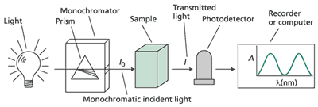
Figure 4: Schematic representation of the components of a spectrophotometer http://6e.plantphys.net/topic07.01.html
As shown in figure 4, the design of the single beam spectrophotometer involves a light source, a prism, a sample holder and a photocell. Connected to each are the appropriate electrical or mechanical systems to control illumination intensity, desired wavelength and for the conversion of energy received at the photocell into a voltage fluctuation. The voltage fluctuation is then displayed on a meter scale, or is recorded via connection to a computer for analysis.

IN THE LAB: Spectrophotometric determination of DNA concentration
Choice of the cuvette
The amount of nucleic acid solution needed to measure absorbance depends on the cuvette’s size and capacity, which can range from 1 ml to microvolume cuvettes with a capacity of 5 to 70 μl. The choice of cuvette should therefore be based on the sample concentration range, dilution factor and available sample volume.
Spectrophotometer Calibration
Prior to analysing any samples, the spectrophotometer needs to be calibrated in order for the machine’s software to take into account the presence of background absorbance that may result from the elution buffer. The following steps provide a general description of the steps to follow during the calibration process; however they may vary slightly depending on the specific machine being used.
- Select the correct cell path length based on the choice of cuvette being used.
- Set the target molecule; dsDNA, ssDNA or RNA
- Measure a solution blank, which consists of water or an appropriate buffer solution, to set the calibration reference. It is important that the solution blank is renewed periodically.
- Measure a known amount of pure nucleic acid in order to verify the reliability of the solution blank.
Measurement of an unknown sample.
Depending on the capacity of the cuvette used, a specific amount of the DNA extract is used to evaluate the solution’s concentration, for example if the cuvette has a capacity lower than 0.2 ml then 5 μl of DNA extract is diluted in 195 μl of water to measure absorbance. After calibrating the spectrophotometer and adding the nucleic acid solution to the cuvette, it is capped, the solution mixed, and the absorbance measured. In order to reduce pipetting errors, the measurement should be repeated at least twice and at least 5 μl of the DNA solution should always be added to the cuvette.
It is recommended that A₂₆₀ readings lower than 0.02 or between 1 and 1.5 (depending on the instrument used) are disregarded due to the possibility of a high margin of error.
The concentration c of a specific nucleic acid present in a solution is calculated using the following equations:
- Single-stranded DNA: c(pmol/μl) = A₂₆₀/0.027
- Double-stranded DNA: c(pmol/μl) = A₂₆₀/0.02
- Single-stranded RNA: c(pmol/μl) = A₂₆₀/0.025
- Oligonucleotide: c(pmol/μl) = A₂₆₀*100/1.5NA+0.71NC+1.2NG+0.84NT
For example the absorbance readings of highly purified calf thymus DNA suspended in 1x TNE buffer assuming that the reference DNA is dsDNA, with an A₂₆₀ = 1, the concentration of DNA was nominally 25μg/ml.
For a 10 mm path length cuvette and a 260 nm wavelength, an absorption A = 1 corresponds to approximately 50 μg/ml of dsDNA, approximately 37 μg/ml of ssDNA, 40 μg/ml of RNA or approximately 30 μg/ml of oligonucleotides.
Spectrophotometry is a method that continues to be commonly used in many laboratories due to the relative ease with which the process is performed. Furthermore it also provides an estimate of DNA purity through the A₂₆₀/A₂₈₀ measurement.
On the other hand, some of the drawbacks of the use of spectrophotometry in the need for a relatively large volume of DNA sample in order to take an accurate measurement. In addition, the signal obtained from a spectrophotometer is more susceptible to contaminants, such as proteins and RNA, which may lead to an overestimation of DNA concentration.
Technological advances in spectrophotometric instruments have led to the development of microvolume spectrophotometers, such as the NanoDropTM. Such instruments require a sample size of 1–2µL and do away with the need for a cuvette.
- Fluorometric quantification
Fluorometric quantification of DNA concentration relies on the use of dyes that selectively bind to DNA. Upon binding, the dye undergoes a conformational change leading to the emission of fluorescent energy, which can be detected by the appropriate equipment. Examples of such dyes include ethidium bromide, SYBR® Green, Hoechst (bis-benzimide) dyes and PicoGreen®. The amount of fluorescence emitted by these dyes is directly proportional to the concentration of DNA present in a sample. Therefore, concentration can be estimated by comparing the intensity of the fluorescence emitted by the sample with a series of concentration standards using, for example, a mass ladder on a gel or using a calibration curve established using a fluorometer, as shown in figure 5.
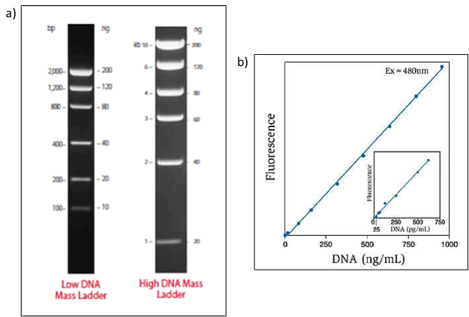
Figure 5: a) DNA mass ladders consist of equimolar mixtures of DNA fragments for the estimation of the mass of unknown DNA samples on gels. https://www.thermofisher.com/ca/en/home/life-science/dna-rna-purification-analysis/nucleic-acid-gel-electrophoresis/dna-ladders/dna-size-markers-mass-ladders.html b) Calibration curve showing the linear quantification of calf thymus DNA at concentrations ranging from 25pg/ml to 1000ng/ml using the PicoGreen® dsDNA quantitation reagent. https://www.thermofisher.com/order/catalog/product/P7589
The advantages of using fluorometric DNA quantification methods over the use of absorbance are due to the selectivity of the dyes in binding to DNA to the exclusion of contaminants that may be present in the DNA solution. This selectivity reduces the interference that can be observed from proteins and carbohydrates that may be present in the DNA extract, therefore leading to a misestimation of the actual concentration of DNA. The use of DNA specific dyes also allows fluorometric DNA quantification methods to distinguish between DNA and RNA. Furthermore, the high affinity of the dyes to DNA and the ability to measure signals from low DNA concentrations makes fluorometric DNA quantification methods more sensitive than spectrophotometric methods and therefore lower concentrations of DNA can be measured with greater accuracy.
However, some drawbacks include the relatively greater expense of using fluorometric DNA quantification methods due to the need to purchase the dyes in order to perform the test as well as the potential health risks associated with the possible misuse of some of the fluorometric dyes.
- Quantification using Gel Electrophoresis
Electrophoresis through an agarose gel is another possible method of estimating the concentration and quality of extracted DNA (see section 4 for more information on Gel Electrophoresis). This method relies on the use of DNA mass ladders which DNA fragments that are of known quantity. To estimate the quantity of DNA that is present in a sample a comparison is made between the intensity of the fluorescence emitted from the band in a sample to a band in the DNA mass ladder.

References
Sussman, M.D. (2017) ISO/TC 34/SC 16 horizontal methods for molecular biomarker analysis: Molecular biomarker analysis and sampling management system, Eighth World Conference on Sampling and Blending, 9-11 May 2017, Perth, Western, Australia.
Gy, P M, 1990. Do not forget the sampling theory!, Process Control and Quality, 1:15–22.
ŽEL, Jana, DEMŠAR, Tina, ŠTEBIH, Dejan, MILAVEC, Mojca, GRUDEN, Kristina. Extraction of DNA from different sample types - a practical approach for GMO testing. Acta biologica slovenica, ISSN 1408-3671. 2015, vol. 58, no. 2, p. 61-75
ENGL ad hoc working group on “sample preparation procedures”, Guidelines for sample preparation procedures in GMO analysis, Publications Office of the European Union, 1018-5593 (print), 1831-9424 (online), 2014
Terry et al., Detection of Genetically Modified Crops and Their Derivatives: Critical Steps in Sample Preparation and Extraction Journal of AOAC International Vol. 85, No. 3, 2002
ISTA (2016), International Rules for Seed Testing, Vol. 2016, Chapter 2, i–2-40 (46)
Freese et. al., Sampling of grain and seed to estimate the adventitious presence of biotechnology-derived seeds in a lot, Cereal Foods World V60, No.1, 2015
Hotzel, H., Müller, W. and Sachse, K. (1999). Recovery and characterization of residual DNA from beer as a prerequisite for the detection of genetically modified ingredients. European Food Research Technology 209, 192-196.
Hupfer, C., Hotzel, H., Sachse, K. and Engel, K.H. (1998). Detection of the genetic modification in heat-treated products of Bt maize by polymerase chain reaction. Zeitschrift für Lebensmittel-Untersuchung und -Forschung A 206, 203-207.
Freese, L., Chen, J., and Shillito, R. Sampling of Grain and Seed to Estimate the Adventitious Presence of Biotechnology-Derived Seeds in a Lot. Cereal Foods World 2015, v60, No1. pp 9-15. DOI http://dx.doi.org/10.1094/CFW-60-1-0009
Lipp, M., Bluth, A., Eyquem, F., Kruse, L., Schimmel, H., Van den Eede, G. and Anklam, E. (2001). Validation of a method based on polymerase chain reaction for the detection of genetically modified organisms in various processed foodstuffs. European Food Research Technology 212, 497-504.
Lipp, M., Brodmann, P., Pietsch, K., Pauwels, J. and Anklam, E. (1999). IUPAC collaborative trial study of a method to detect genetically modified soy beans and maize in dried powder. Journal of AOAC International 82, 923–928.
Meyer, R. and Jaccaud, E. (1997). Detection of genetically modified soya in processed food products: development and validation of PCR assay for the specific detection of glyphosate-tolerant soybeans. In Amadò, R. Battaglia (Eds.). Proceedings of the ninth European conference on food chemistry (Vol. 1). Authenticity and adulteration of food-the analytical approach. 24-26 September 1997. Interlaken 1, 23-28. ISBN: 3-9521414-0-2.
Murray, M.G. and Thompson, W.F. (1980). Rapid isolation of high molecular weight plant DNA. Nucleic Acids Research 8, 4321–4325.
Poms, R.E., Glössl, J. and Foissy, H. (2001). Increased sensitivity for detection of specific target DNA in milk by concentration in milk fat. European Food Research Technology 213, 361-365.
Wagner, D.B., Furnier, G.R., Saghay-Maroof, M.A., Williams, S.M., Dancik, B.P. and Allard, R.W. (1987). Chloroplast DNA polymorphisms in lodgepole and jack pines and their hybrids. Proceedings of the National Academy of Science USA 84, 2097–2100.
Zimmermann, A., Lüthy, J. and Pauli, U. (1998). Quantitative and qualitative evaluation of nine different extraction methods for nucleic acids on soya bean food samples. Zeitschrift für Lebensmittel-Untersuchung und -Forschung A 207, 81–90.
Turner Biosystems (2007) The Picofluor™ Method for DNA Quantitation Using PicoGreen. Application note. Available at : https://www.promega.com/~/media/files/products%20and%20services/instruments/detection/tbs%20technical%20support%20docs/s-0041.pdf. (Last accessed 22 January 2018)

Bonasera, A., Alberti, S., and Sacchetti, A. Protocol for high-sensitivity/long linear-range spectrofluorimetric DNA quantification using ethidium bromide. BioTechniques, Vol. 43, No. 2, August 2007, pp. 173–176

Ahn, S.J., Costa, J. Emanuel, J.R., PicoGreen Quantitation of DNA: Effective Evaluation of Samples Pre-or Psost-PCR. Nucleic Acids Research, Volume 24, Issue 13, 1 July 1996, Pages 2623–2625

Phenix Research Products. Overview of common fluorescent dyes used in Nucleic Acid quantitation Application note. Available at : http://www.phenixresearch.com/Images/TN_FluorecentProbeQuantitation.pdf (Last accessed 22 January 2018)

http://www.nature.com/nature/journal/v340/n6236/abs/340733a0.html http://cmr.asm.org/content/7/1/43.full.pdf

