GUIDANCE ON RISK ASSESSMENT OF LIVING MODIFIED ORGANISMS
(Revised on 4 July 2011)
PREFACE
In accordance with the precautionary approach the objective of the Protocol is “to contribute to ensuring an adequate level of protection in the field of the safe transfer, handling and use of living modified organisms resulting from modern biotechnology that may have adverse effects on the conservation and sustainable use of biological diversity, taking also into account risks to human health, specifically focusing on transboundary movements”. For this purpose, Parties shall ensure that risk assessments are carried out to assist in the process of making informed decisions regarding living modified organisms (LMOs).
According to Article 15 of the Protocol, risk assessments shall be based, at a minimum, on information provided in accordance with Article 8 and other available scientific evidence in order to identify and evaluate the possible adverse effects of LMOs on the conservation and sustainable use of biological diversity, taking also into account risks to human health.
Annex III of the Protocol, under general principles, states that “risk assessment should be carried out in a scientifically sound and transparent manner, and can take into account expert advice of, and guidelines developed by, relevant international organizations”. “Risk assessment should be carried out on a case-by-case basis. The required information may vary in nature and level of detail from case to case, depending on the LMO concerned, its intended use and the likely potential receiving environment”.
The general principles of annex III also state that “Lack of scientific knowledge or scientific consensus should not necessarily be interpreted as indicating a particular level of risk, an absence of risk, or an acceptable risk”.
This document was developed by the Open-ended Online Expert Forum and the Ad Hoc Technical Expert Group (AHTEG) on Risk Assessment and Risk Management in accordance with terms of reference set out by the Conference of the Parties serving as the meeting of the Parties to the Cartagena Protocol on Biosafety (COP-MOP) in its decisions BS-IV/11 and BS-V/12 in response to an identified need for further guidance on risk assessment of LMOs. It is intended to be a “living document” that will be modified and improved as and when mandated by the Parties to the Cartagena Protocol on Biosafety.
This Guidance consists of two parts. In part I, the Roadmap for Risk Assessment of LMOs is presented. In part II, specific guidance is provided on the risk assessment of specific types of LMOs and traits. The topics contained in Part II were identified and prioritized by the Open-ended Online Expert Forum and the AHTEG in accordance with the terms of reference in decisions BS-IV/11 and BS-V/12, and taking into account the need of Parties for additional guidance.
PART I

Roadmap for RISK ASSESSMENT OF Living Modified Organisms
BACKGROUND
This “Roadmap” provides guidance on environmental risk assessment for living modified organisms (LMOs) consistent with Annex III to the Cartagena Protocol on Biosafety (hereinafter “the Protocol”) and all other articles related to risk assessment. Accordingly, this Roadmap does not replace, but complements Annex III. The Roadmap is meant to facilitate and enhance the effective use of Annex III by elaborating the steps and points to consider in environmental risk assessment.
The purpose of this Roadmap is to provide additional guidance on using Annex III and to point to background materials and links to useful references relevant to risk assessment. The Roadmap may be useful as a reference for risk assessors when conducting or reviewing risk assessments and in capacity-building activities.
This Roadmap provides a set of information that is broadly relevant in the risk assessment of LMOs belonging to different taxa and their intended uses within the scope and objective of the Protocol in accordance with Annex III. However, it has been developed based largely on living modified (LM) crop plants because of the experience to date with environmental risk assessments has been mainly gained from these organisms.
The Roadmap applies to all types of environmental releases of LMOs, including those of limited duration and scale as well as large scale releases, taking into account that the amount and type of information available and needed to support risk assessments of the different types of intentional release into the environment may vary from case to case.
INTRODUCTION
Risk assessment of LMOs is a science-based, structured process conducted on a case-by-case basis to identify and evaluate the potential adverse effects of LMOs, and their likelihood and consequences as well as a recommendation as to whether or not the risks are acceptable or manageable. This Roadmap reflects a process comprised of “Overarching Issues in the Risk Assessment Process”, “Planning Phase of the Risk Assessment”; and “Conducting the Risk Assessment” as a basis for decision-making.
The novel combination of genetic material in an LMO may lead to environmental effects which may vary depending on the LMO itself, the environment exposed to the LMO and how the LMO is used. The effects may be intended or unintended, beneficial or adverse. These considerations may be similar as those for the introduction of any other organism into the environment.
What is considered an adverse effect as well as an “acceptable risk” depends on protection goals and assessment endpoints. The choice of protection goals by the Party could be informed by Annex 1 of the Convention. In addition to the environmental considerations that are the subject of this guidance, protection goals and assessment endpoints may also be based on societal and economic considerations (see Related Issues section).
Paragraph 8 of Annex III describes the key steps of the risk assessment process to identify and evaluate the potential adverse effects and to identify strategies to manage risks. The steps of risk assessment under the Protocol are similar to those used in other risk assessment frameworks. Although the terminology varies among the various approaches to risk assessment, in general terms, they comprise actions for “hazard identification”, “hazard characterization”, “exposure assessment”, and “risk characterization”.
Paragraph 9 of Annex III describes, depending on the case, points to consider in the process for LMO risk assessment.
In drawing from Annex III, the Roadmap includes five steps that describe an integrated process whereby the results of one step may be relevant to other steps. Also, risk assessment may need to be conducted in an iterative manner, where certain steps may be repeated or re-examined to increase or re-evaluate the confidence in the conclusions of the risk assessment (see Flowchart). When new information arises or a change in circumstances has occurred that could change its conclusions, the risk assessment may need to be re-examined accordingly. Similarly, the issues mentioned in the ‘Setting the context and scope’ section below can be taken into consideration again at the end of the risk assessment process to determine whether the objectives and criteria that were set out at the beginning of the risk assessment have been met.
The concluding recommendations derived from the risk assessment in step 5 are required to be taken into account in the decision-making process on an LMO. In the decision-making process, other Articles of the Protocol or other relevant issues may also be taken into account and are addressed in the last paragraph of this Roadmap: ‘Related Issues’.
A flowchart illustrating the risk assessment process according to this Roadmap is annexed hereto.
›› See references relevant to “Introduction”:
http://bch.cbd.int/onlineconferences/roadmapref_ahteg_ra.shtml#introduction
Overarching issues in the risk assessment process
Overarching issues should be considered to ensure the quality and relevance of the information used as well as the outcome of the risk assessment. For example:
- Criteria for assessing the relevancy of the data in the context of a risk assessment – e.g. data may be considered relevant if they are linked to protections goals or assessment endpoints, contribute to the identification and evaluation of the potential adverse effects of the LMO, or can affect the outcome of the risk assessment.
- Criteria for the inclusion of scientific information.
  - Data of acceptable scientific quality should be used in the risk assessment. Data quality should be consistent with the accepted practices of scientific evidence-gathering and reporting and may include independent review of the methods and designs of studies. Data may be derived from a variety of sources, e.g. new experimental data, data from relevant peer reviewed scientific literature as well as data and experience from previous risk assessments, regarded as of acceptable scientific quality, in particular for the same or similar LMOs. Sound statistical tests should be used, where appropriate, in the risk assessment and be fully described in the risk assessment report. Also, it is important to have expertise in multiple fields even when this leads to diverging or contradictory views;
  - Data of acceptable scientific quality requires the reporting of data and methods used to provide this data in sufficient detail and transparency to allow independent verification and reproduction. This would include ensuring the accessibility of data by the risk assessors (e.g. the availability of relevant, required data or information or, if requested and as appropriate, of sample material), taking into account the provisions of Article 21 of the Protocol on the confidentiality of information;
  - Useful information can also be gained from international standards and guidelines and, in the case of LM crop plants, also from the knowledge and experience of farmers, growers, scientists, regulatory officials, and indigenous and local communities.
- Availability of experts who do not have professional or financial conflicts of interest related to the promotion of the specific LMO under assessment, or LMOs in general, and have the relevant technical background to conduct risk assessments.
- Identification and consideration of uncertainty.
According to the Protocol, “where there is uncertainty regarding the level of risk, it may be addressed by requesting further information on the specific issues of concern or by implementing appropriate risk management strategies or monitoring the living modified organism in the receiving environment”. The issue of uncertainty is dealt with – sometimes differently – in each international instrument incorporating precautionary measures.,
Uncertainty is an inherent and integral element of scientific analysis and risk assessment. As such, the various forms of uncertainty should be considered and described in steps 1 to 4 of the risk assessment. In addition, when communicating the results of a risk assessment, it is important to describe, quantitatively or qualitatively, what impact uncertainty may have on the conclusions and recommendations of the risk assessment.
Considerations of uncertainty strengthen the scientific validity of a risk assessment. An analysis of uncertainty includes considerations of its source and nature and focuses on uncertainties that can have a significant impact on the conclusions of the risk assessment.
The source(s) of uncertainty may stem from the data/information itself or from the choice of study design including the methods used, and the analysis of the information.
For each identified source of uncertainty, the nature of the uncertainty may be described as arising from: (i) lack of information, (ii) incomplete knowledge, and (iii) inherent variability, for example, due to heterogeneity in the population being studied.
While uncertainties originating from lack of information may be reduced by further research, uncertainties arising from incomplete knowledge or from inherent variability may be irreducible by additional measurements or studies. In such cases, instead of reducing uncertainty, the provision of additional information may actually give rise to new uncertainties. Risk assessors should look to ensure that further information requested will contribute to better evaluations of the risk(s).
In cases where the nature of the uncertainty implies that it cannot be addressed through the provision of more data during the risk assessment, it may need to be dealt with by monitoring or possibly risk management (see step 5).

›› See references relevant to “Identification and consideration of uncertainty”:
http://bch.cbd.int/onlineconferences/roadmapref_ahteg_ra.shtml#uncertainty
PLANNING PHASE OF THE RISK ASSESSMENT
Setting the context and scope
A risk assessment carried out on a case-by-case basis starts by setting its context and scope in a way that is consistent with the country’s protection goals, assessment endpoints, risk thresholds and management strategies and policies.
Setting the context and scope for a risk assessment in line with the country’s policies and regulations may involve an information and consultation process of risk assessors, decision-makers and various stakeholders prior to conducting the actual risk assessment to identify which protection goals, assessment endpoints and risk thresholds may be relevant. It may also involve framing the risk assessment process and identifying questions to be asked that are relevant to the case being considered. The risk assessor should be informed of national criteria for acceptability of the risks at the outset of the process.
A number of aspects may be taken into consideration, as appropriate, that are specific to the Party involved and to the specific case of risk assessment. These aspects include:
- Existing environmental and health policies and strategies based on, for instance:
- Regulations and the international obligations of the Party involved;
- Guidelines or regulatory frameworks that the Party has adopted; and
- Protection goals, assessment endpoints, risk thresholds and management strategies as laid down, for instance, in the relevant legislation of the Party;
- Intended handling and use of the LMO taking into account use habits, patterns and specific practices;
- The nature and level of detail of the information that is required, which may, amongst other things, depend on the biology/ecology of the recipient organism, the intended use of the LMO and its likely potential receiving environment, and the scale and duration of the environmental exposure, e.g. whether it is for import only, field testing or for commercial use. For small scale releases, especially at early experimental stages, the nature and detail of the information that is required or available may differ as compared to the information for large scale or commercial environmental release;
- Identification of methodological and analytical requirements, including any reviewing mechanisms, that is required to achieve the objective of the risk assessment as laid down, for instance, in guidelines published or adopted by the Party that is responsible for conducting the risk assessment (i.e. typically the Party of import according to the Protocol);
- Experience and history of use of the non-modified recipient organism, taking into account its ecological function; and
- Criteria for describing the level of the potential adverse effects of LMOs, as well as criteria for the terms that are used to describe the likelihood (step 2), the magnitude of consequences (step 3) and risks (step 4) and the acceptability or manageability of risks (step 5; see risk assessment steps below).
Some risk assessment approaches combine the process of setting the context and scope of the risk assessment with the identification of potential adverse effects associated with the modifications of the LMO into a single step called “Problem formulation” (see step 1).

›› See references relevant to “Setting the context and scope”:
http://bch.cbd.int/onlineconferences/roadmapref_ahteg_ra.shtml#context
The choice of comparators
The comparative approach is specified in the Protocol as one approach for evaluating the risks associated with LMOs that should be considered in the context of the risks posed by the non-modified recipients or parental organisms in the likely potential receiving environment. The comparative approach aims at identifying changes between the LMO and its comparator that may lead to adverse effects. The choice of comparator can have large effects on the relevance, interpretation and conclusions drawn from the risk assessment process. The comparator that will be used as a basis for the comparison enables the generation of information that is consistent and relevant for the risk assessment.
Some risk assessment frameworks use a single genotype, the (near-)isogenic non-modified organism, as the primary choice of comparator. In these frameworks, the comparators that are going to provide the basis for comparison are grown or live at the same time and location as the LMO under consideration.
In risk assessments where the (near-)isogenic non-modified recipient organism is used as the comparator, additional comparators may prove useful depending on the biology of the organism and types of modified traits under assessment. In practice, the (near-)isogenic non-modified organism is used in step 1 and throughout the risk assessment. When the likelihood and potential consequences of adverse effects are evaluated, broader knowledge and experience with additional comparators may also be taken into consideration, as appropriate, along with the non-modified recipient organism. Results from experimental field trials or other environmental information and experience with the same or similar LMOs may also be taken into account.
In certain cases, the (near-)isogenic non-modified comparator may not be sufficient to establish a good basis for a comparative risk assessment, such as for the risk assessment of LM plants tolerant to abiotic stress, stacked LMOs and certain LM mosquitoes (please refer to Part II of this Guidance).
In other risk assessment frameworks, the choice of an appropriate non-modified comparator depends on the specific case, the step in the risk assessment and on the questions that are being asked. In such cases, the choice of appropriate comparators will be based on the biology of the organism and types of modified traits under assessment, or on the ability to provide key information regarding the identification of harm.
CONDUCTING The risk assessment
To fulfil its objective under Annex III, as well as other relevant Articles of the Protocol, risk assessment as described in Annex III is conducted in steps in an integrated process and iterative manner, as appropriate. These steps are indicated in Paragraph 8 (a)-(e) of Annex III and also described below in further detail.
For each step a rationale and points to consider are provided. Some points to consider are taken from paragraph 9 of Annex III, whereas others have been added based on generally accepted methodology of LMO risk assessment and risk management. The relevance of each point to consider will depend on the case being assessed.
›› See references relevant to “Conducting the Risk Assessment”:
http://bch.cbd.int/onlineconferences/roadmapref_ahteg_ra.shtml#riskassessment
Step 1: “An identification of any novel genotypic and phenotypic characteristics associated with the living modified organism that may have adverse effects on biological diversity in the likely potential receiving environment, taking also into account risks to human health.”
Rationale:
The purpose of this step is to identify potential adverse effects that may result from changes due to the genetic modification(s), including any deletions, compared to the non-modified recipient organism, and identify what, if any, of those changes could cause adverse effects on the conservation and sustainable use of biological diversity, taking also into account risks to human health.
The question that is asked in this step is what adverse effect could occur, why and how. The step is similar to the ‘hazard identification step’ in other risk assessment guidance, such as risk assessment of chemicals. In some other risk assessment approaches, this step is performed together with the context and scoping phase in the so-called “Problem formulation” step, which is not limited to the identification of hazards, but also takes into account making operational the protection goals and the identification of appropriate assessment endpoints.
In performing this step of the risk assessment, the difference in the concepts of “risk” and “hazard” has to be taken into account (see Use of Terms).
In this step, scientifically plausible scenarios and risk hypotheses are identified in which novel characteristics of the LMO could give rise to adverse effects in an interaction with the likely potential receiving environment. In this regard, it may be important to define a causal link or pathway between a characteristic of the LMO and a possible adverse effect, otherwise the risk assessment may generate information that will not contribute to reaching a recommendation that will be useful for the decision-making process. It should be taken into account that adverse effects may be direct or indirect, immediate or delayed.
The comparison of the LMO carried out in step 1 is performed with the non-modified recipient or parental organisms in the likely potential receiving environment, taking into consideration the new trait(s) of the LMO (see ‘The choice of comparators’ in the chapter on ‘Planning Phase’).
The novel characteristics of the LMO to be considered can be described in genotypic or phenotypic terms. These include any changes in the LMO, ranging from the nucleic acid, to gene expression level to morphological changes. The novel characteristics of the LMO that may cause adverse effects may be intended or unintended, predicted or unpredicted, taking into account that an adverse effect may also be caused by, for example, changes in the expression levels of endogenous genes as a result of the genetic modification or by combinatorial effects of two or more genes, gene products or physiological pathways. The points to consider below provide information elements on which hazard identification can be built.
The nature and level of detail of the information required in this step may vary from case to case depending on the nature of the modification of the LMO, on its intended use, and on the scale and duration of the environmental release. For example, the information needed to conduct the risk assessment for an LMO to be intentionally released into the environment will likely differ from the information needed for an LMO to be imported for direct use as food, feed or for processing. Alternatively, different information may be available in the case of releases whose objective is to generate information for further risk assessments, such as small-scale trials, especially at early experimental stages. Likewise, in cases where the exposure of the environments to the LMO is limited, such as for some early-stage experimental releases, less information may be available or needed in performing this step of the risk assessment. The resulting uncertainty in such cases may be addressed by risk management measures (see step 5).
Points to consider regarding the characterization of the LMO:
- Relevant characteristics of the non-modified recipient organism, such as:
- its biological characteristics, in particular those that, if changed or interacting with the new gene products or traits of the LMO, could lead to changes that may cause adverse effects;
- its taxonomic relationships;
- its origin, centres of origin and centres of genetic diversity;
- ecological function; and
- whether it is a component of biological diversity that is important for the conservation and sustainable use of biological diversity in the context of Article 7(a) and Annex I of the Convention;
- Characteristics related to the transformation method, including the characteristics of the vector such as its identity, source or origin and host range and information on whether the transformation method results in the presence of (parts of) the vector in the LMO, including any marker genes;
- Relevant characteristics of the genes and of other functional sequences, such as promoters, that have been inserted into the LMO (e.g. functions of the gene and its gene product in the donor organism with particular attention to characteristics that could cause adverse effects in the recipient);
- Molecular characteristics of the LMO related to the modification, such as characteristics of the modified genetic elements; insertion site(s) and copy number of the inserts; stability, integrity and genomic organization in the recipient organism; levels of gene expression and intended and unintended gene products;
- Genotypic (see point to consider (d) above) and phenotypic changes in the LMO, either intended or unintended, in comparison with the non-modified recipient, considering those changes that could cause adverse effects. These may include changes at the transcriptional and translational level due to the insert itself or to genomic changes that have occurred due to transformation or recombination.

Point to consider regarding the receiving environment:
- The intended scale and duration of the environmental release taking into account user habits, patterns and practices;
- Characteristics of the likely potential receiving environment, in particular its attributes that are relevant to potential interactions of the LMO that could lead to adverse effects (see also paragraph (i) below), taking into account the characteristics that are components of biological diversity particularly in centres of origin and genetic diversity;

Points to consider regarding the potential adverse effects resulting from the interaction between the LMO and the receiving environment:
- Protection goals or assessment endpoints (see Planning phase, Setting the context and scope);
- Characteristics of the LMO in relation to the receiving environment (e.g. information on phenotypic traits that are relevant for its survival in, or its potential adverse effects on the likely receiving environment – see also paragraph (g) above);
- Considerations for unmanaged and managed ecosystems concerning the use of an LMO and that are relevant for the likely potential receiving environment. These include the potential effects resulting from the use of an LMO including, for instance, changes in farm management practices, dispersal of the LMO through ways such as seed dispersal or outcrossing within or between species, or through transfer into habitats where the LMO may persist or proliferate, as well as effects on species distribution, food webs and changes in bio-geochemical characteristics;
- Potential for outcrossing and transfer of transgenes, via vertical gene transfer, from an LMO to other sexually compatible species that could lead to introgression of the transgene(s) into the population of sexually compatible species, and whether these would lead to adverse effects;
- Potential adverse effects on target and non-target organisms;
- Potential adverse effects of the incidental exposure of humans to (parts of) the LMO (e.g. exposure to pollen), and the toxic or allergenic effects that may ensue; and
- Whether horizontal gene transfer of transgenic sequences from the LMO to other organisms in the likely receiving environment could occur and whether this would result in potential adverse effects. With regard to horizontal gene transfer to micro-organisms (including viruses), particular attention may be given to cases where the LMO is also a micro-organism;
- Cumulative effects with any other LMO present in the environment; and
- A consideration of uncertainty arising in step 1 (see “Identification and consideration of uncertainty” under the “Overarching Issues in the risk assessment process”).
›› See references relevant to “Step 1”:
http://bch.cbd.int/onlineconferences/roadmapref_ahteg_ra.shtml#step1
Step 2: “An evaluation of the likelihood of adverse effects being realized, taking into account the level and kind of exposure of the likely potential receiving environment to the living modified organism.”

Rationale:
In order to determine and characterize the overall risk of an LMO in Step 4, the likelihood that each of the adverse effects identified in Step 1 will potentially occur has to be assessed and evaluated.
One aspect to be considered is whether the receiving environment will be exposed to an LMO for which adverse effects have been identified taking into consideration the intended use of the LMO, and the expression level, dose and environmental fate of transgene products as well as plausible pathways of a hazard leading to adverse effects. In determining the route of exposure to the LMO being assessed or its products, if possible, the causality between the LMO and the potential adverse effect should be established. This can be done by building conceptual models describing relationships between the LMO, and pathways of exposure and potential effects in the environment. For example, concerning an LMO producing a potentially toxic gene product, oral, respiratory or dermal exposure could be relevant.
Models, including conceptual ones, tested through experimental studies complemented by expert input, may be used for an assessment of the potential level and kind of exposure, combined with the use of statistical tools relevant for each case.
Examples of issues to be considered in this step include (i) the potential of the LMO (or its derivatives resulting from outcrossing) to spread and establish in and beyond the receiving environment (in particular into protected areas and centres of origin and genetic diversity), and whether that could result in adverse effects; and (ii) the possibility of occurrence of adverse (e.g. toxic) effects on organisms (or on organisms other than the ‘target organism’ for some types of LMOs (e.g. those producing insecticidal proteins).
The levels of likelihood may be expressed, for example, by the terms ‘highly likely’, ‘likely’, ‘unlikely’, ‘highly unlikely’. Parties may consider describing these terms and their uses in risk assessment guidelines published or adopted by them.
Points to consider:
- Information relating to the type and intended use of the LMO, including the scale and duration of the release, bearing in mind, as appropriate, user habits, patterns and practices. For example, in the case of field trials, the level of exposure in the receiving environment may be low due to the scale of the release, its temporary nature and the implementation of management measures;
- The relevant characteristics of the likely potential receiving environment that may be a factor in the occurrence of the potential adverse effects (see also step 1 (f), (g) and (i)), taking into account the variability of the environmental conditions and long-term adverse effects related to the exposure to the LMO.
- Levels of expression in the LMO and persistence and accumulation in the environment (e.g. in the food chain) of substances with potentially adverse effects newly produced by the LMO, such as insecticidal proteins, toxins and allergens. In the case of field trials, the level of persistence and accumulation in the receiving environment may be low due to the scale of the release, its temporary nature and the implementation of management measures;
- Information on the location of the release and the receiving environment (such as geographic and biogeographic information, including, as appropriate, coordinates);
- Factors that may affect spread of the LMO, such as its reproductive ability (e.g. time to seeding, number of seed and vegetative propagules, dormancy, pollen viability), its spread by natural means (e.g. birds, wild animals, wind, water, etc);
- Factors that affect presence or persistence of the LMO that may lead to its establishment in the environment, such as, in the case of LM plants, lifespan, seed dormancy, ability of LM seedlings to establish amongst existing vegetation and whether they reach reproductive stage, or the ability to propagate vegetatively;
- When assessing the likelihood of outcrossing and outbreeding from the LMO to sexually compatible species, the following issues are relevant:
- the biology of the sexually compatible species;
- the potential environment where the sexually compatible species may be located;
- Introgression of the transgene into the sexually compatible species;
- Persistence of the transgene in the ecosystem;
- Expected kind and level of exposure of the environment where the LMO is released and means by which incidental exposure could occur at that location or elsewhere (e.g. through gene flow or incidental exposure due to losses during transport and handling, and intentional or unintentional spread by people, such as deliberate spread, accidental spread by machinery and mixed produce); and
- A consideration of uncertainty arising in step 2 (see “Identification and consideration of uncertainty” under the “Overarching issues in the risk assessment process”).
›› See references relevant to “Step 2”:
http://bch.cbd.int/onlineconferences/roadmapref_ahteg_ra.shtml#step2
Step 3: “An evaluation of the consequences should these adverse effects be realized.”

Rationale:
This step describes an evaluation of the magnitude of the consequences of the possible adverse effects, based on the risk scenarios established in step 1, paying special attention to protected areas and centres of origin and centres of genetic diversity, and taking into account protection goals and endpoints of the country where the risk assessment is being carried out. The use of well-formulated risk hypothesis (step 1) may be helpful in assessing the consequences of potential adverse effects.
In this step, results of tests done under different conditions, such as laboratory experiments or experimental releases, may be considered. The scale of the intended use (e.g. small or commercial) should be taken into account. The evaluation can be comparative and considered in the context of the adverse effects caused by the (near-)isogenic non-modified recipient organism, other non-modified organisms of the same species or other comparators (see Planning Phase of the Risk Assessment). The evaluation may also be considered in the context of the adverse effects that occur in the environment and which are associated with existing practices or the introduced management system related to the LMO (such as various agronomic practices, for example, for pest or weed management) if such information is available and relevant.
It is important to also assess in this step whether the consequence of an adverse effect is of short or long term, direct or indirect, or either reversible or irreversible.
The evaluation of the consequence of adverse effects may be expressed qualitatively or quantitatively. For instance, terms such as ‘major’, ‘intermediate’, ‘minor’ or ‘marginal’ may be used. Parties may consider describing these terms and their uses in risk assessment guidelines published or adopted by them.
Points to consider:
- Relevant knowledge and experience with the non-modified recipient or parental organisms in the likely potential receiving environment. This may include the effects of:
(i) agricultural practices on the level of inter- and intra-species gene flow, dissemination of the recipient, abundance of volunteer plants in crop rotation, change in abundance of pests, beneficial and other organisms such as pollinators and pest predators;
(ii) pest management affecting non-target organisms through pesticide applications or other management approaches while following accepted agronomic practices;
(iii) the behaviour of relevant wild-type populations of unmodified animal or insect species, including interactions between predators and prey, disease transmission and interaction with humans or animal species;
- Consequences resulting from combinatorial and cumulative effects in the likely potential receiving environment;
- Results from laboratory experiments examining, inter alia, dose-response relationships (e.g., EC50, LD50), sub-chronic effects and immunogenic effects as information elements in the context of determining effects on non-target organisms, and from field trials evaluating, for instance, potential invasiveness;
- For the case of outcrossing to sexually compatible species, the possible adverse effects that may occur, after introgression, due to the expression of the transgenes in the sexually compatible species; and
- A consideration of uncertainty arising in step 3 that may significantly impact the evaluation of consequences should the adverse effects be realized (see “Identification and consideration of uncertainty” under “Overarching issues in the risk assessment process” above).
›› See references relevant to “Step 3”:
http://bch.cbd.int/onlineconferences/roadmapref_ahteg_ra.shtml#step3
Step 4: “An estimation of the overall risk posed by the living modified organism based on the evaluation of the likelihood and consequences of the identified adverse effects being realized.”
Rationale:
The purpose of this step is to determine and characterize the level of the overall risk based on the individual risks that were identified on the basis of scientifically plausible scenarios and risk hypotheses and an analysis of the potential adverse effects in step 1, their likelihood (step 2) and consequences (step 3), and also taking into consideration any relevant uncertainty that emerged in the preceding steps.
To date, there is no universally accepted method to estimate the overall risk but rather a number of methods are available for this purpose. For example, the characterization of the overall risk often derives a best estimate of risk from multiple lines of evidence. These lines of evidence may be quantitatively weighted and combined. Risk matrixes are often used for this purpose.
A description of the risk characterization may be expressed qualitatively or quantitatively. Terms such as ‘high’, ‘medium’, ‘low’, ‘negligible’ or ‘indeterminate’ (e.g. due to uncertainty or lack of knowledge) have been used to characterize the overall risk of an LMO. Parties could consider describing these terms and their uses in risk assessment guidelines published or adopted by them.
The outcome of this step may include a description explaining how the estimation of the overall risk was performed.

Points to consider:
- The identified potential adverse effects (step 1);
- The assessments of likelihood (step 2);
- The evaluation of the consequences (step 3);
- Risk management options, if identified in step 5;
- Any interaction, such as addition or synergism, between the identified individual risks;
- Broader landscape considerations, including cumulative effects due to the presence of various LMOs in the receiving environment; and
- A consideration of uncertainty arising in this and the previous steps (see “Identification and consideration of uncertainty” under “Overarching issues in the risk assessment process” above).
›› See references relevant to “Step 4”:
http://bch.cbd.int/onlineconferences/roadmapref_ahteg_ra.shtml#step4
Step 5: “A recommendation as to whether or not the risks are acceptable or manageable, including, where necessary, identification of strategies to manage these risks”
Rationale:
In step 5, risk assessors prepare a report summarizing the risk assessment process and the identified risks, and provide recommendation(s) as to whether or not the risks are acceptable or manageable and, if needed, recommendation(s) for risk management options that could be implemented to manage the risks associated with the LMO. This recommendation could include a comparison with other existing agricultural practices as well as user habits, patterns and practices.
This step is an interface between the process of risk assessment and the process of decision-making. It requires that the risk assessor provides a recommendation as to whether or not the risks are acceptable or manageable. Whether or not to approve the LMO is up to the decision maker to decide.
The “acceptability” of risks is typically decided at a political level and may vary from country to country. On the basis of the criteria for the acceptability of risk that were identified in the planning phase of the risk assessment, a recommendation to the decision makers as to whether the overall risk posed by the LMO is acceptable or not is made in relation to established protection goals, assessment endpoints and risk thresholds, also taking into account risks posed by the non-modified recipient organism and its use.
In evaluating the acceptability of the overall risk of the LMO, a question arises as to whether risk management options can be identified that could reduce the identified risks and uncertainties. If such measures are identified, the preceding steps of the risk assessment may need to be revisited in order to evaluate how the application of the proposed risk management measures would change the outcome of the steps.
The recommendation on the acceptability of risk(s) should take into account risks associated with other existing user habits, patterns and practices and also acknowledge the identified uncertainties. For assessments associated with uncertainties, it is imperative that the difficulties encountered during the risk assessment be made transparent to the decision makers. In such cases, it may also be useful to provide an analysis of alternative management options to assist the decision makers.
Some uncertainties may be dealt with by monitoring (e.g. checking the validity of assumptions about the effects of the LMO on components of the ecosystem and environment), requests for more information, or implementing the appropriate risk management options.
Monitoring can be applied as a tool to detect unexpected and long-term adverse effects. Monitoring can also be a means to reduce uncertainty, address assumptions made during the risk assessment and to validate its conclusions on a wider (e.g. commercial) level of application and to establish a causal link or pathway between LMOs and adverse effects. Monitoring may also be used as an instrument providing for effective risk management, including the detection of adverse effects before the consequences are realized.
The issues mentioned in the ‘Setting the context and scope’ section may be taken into consideration again at the end of the risk assessment process to evaluate whether the objectives and criteria that were set out at the beginning of the risk assessment have been met.
The recommendation(s) are submitted, typically in the form of a risk assessment report, for consideration in the decision-making process.
Points to consider related to the acceptability of risks:
- Established criteria and thresholds for the acceptable/unacceptable levels of risk, including those set out in national legislation or guidelines, as well as the protection goals of the Party, as identified when setting the context and scope for a risk assessment;
- Any relevant experience with the use of the non-modified recipient organism(s) used to establish baselines for the risk assessment, and practices associated with its use in the likely potential receiving environment;
- Ability to identify, evaluate and contain adverse effects as well as to take appropriate response measures;
- Sources and nature of the overall uncertainty identified throughout the steps of the risk assessment.
Points to consider related to the risk management strategies:
- Existing management practices, if applicable, that are in use for the non-modified recipient organism or for other organisms that require comparable risk management and that might be appropriate for the LMO being assessed, e.g. isolation distances to reduce outcrossing potential of the LMO, modifications in herbicide or pesticide management, crop rotation, soil tillage, etc.;
- Methods to detect and identify the LMO and their specificity, sensitivity and reliability in the context of environmental monitoring (e.g. monitoring for short- and long-term, immediate and delayed effects; specific monitoring on the basis of scientific hypotheses and supposed cause/effect relationship as well as general monitoring) including plans for appropriate contingency measures to be applied in case the results from monitoring call for them;
- Management options in the context of the intended use (e.g. isolation distances to prevent outcrossing, and the use of refuge areas to minimize the development of resistance to insecticidal proteins); and
- The feasibility of the implementation of the proposed risk management or monitoring strategies and methods for measuring their efficacy and effectiveness.
›› See references relevant to “Step 5”:
http://bch.cbd.int/onlineconferences/roadmapref_ahteg_ra.shtml#step5

related Issues
Some members of the AHTEG considered some issues to be related to the risk assessment and decision-making process but outside the scope of this Roadmap. These issues were, inter alia:
- Risk Management (Article 16);
- Capacity-building (Article 22);
- Public Awareness and Participation (Article 23);
- Socio-economic Considerations (Article 26);
- Liability and Redress (Article 27);
- Co-existence;
- Ethical issues.

Annex
FLOWCHART FOR THE RISK ASSESSMENT PROCESS

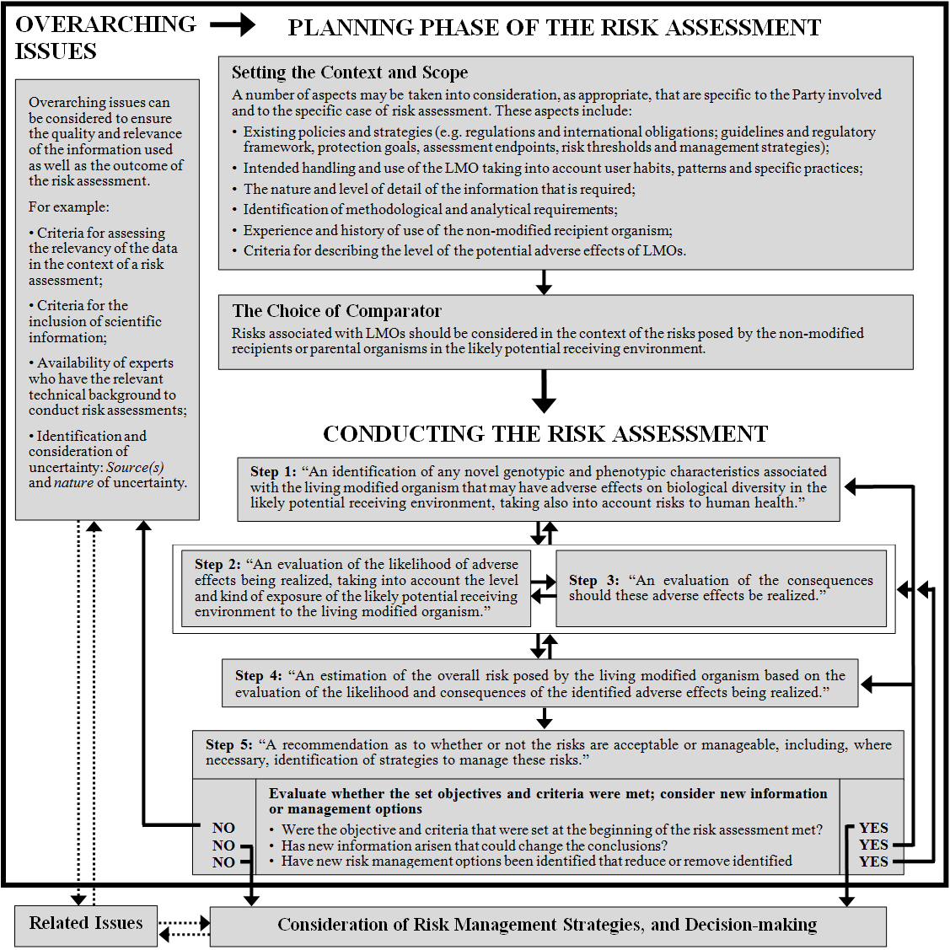

Figure 1. The Roadmap for Risk Assessment. The flowchart represents the risk assessment process as outlined in this guidance. It includes overarching issues, a planning phase of the risk assessment and conducting the risk assessment, to identify and evaluate the potential adverse effects of LMOs on the conservation and sustainable use of biological diversity in the likely potential receiving environment, taking also into account risks to human health. Risk assessments may need to be conducted in an iterative manner, where certain steps may be repeated or re-examined as shown by the solid arrows. The box around steps 2 and 3 shows that these steps may sometimes be considered simultaneously or in reverse order. Dotted arrows indicate the flow to and from issues outside the risk assessment process.
Annex
USE OF TERMS
This section provides a working glossary of key terms used in this document. An attempt was made to adapt definitions that are used in internationally accepted risk assessment guidance to the context of this document.
Assessment endpoint – An explicit expression of the environment that is to be protected, operationally defined as an entity (such as salmon or honeybees, soil quality) and its attributes (such as their abundance, distribution or mortality) (adapted from IPCS, 2001, Integrated Risk Assessment, http://www.who.int/ipcs/publications/new_issues/ira/en/). ^{[back to the text]}
Baseline – A measurement of the existing conditions of an environment or its components without the LMO under consideration and taking into account different practices of use (e.g. agricultural practices). The baseline measurement provides quantitative (e.g. number of organisms, variability of abundance) and/or qualitative information (e.g. as populations) about the receiving environment as a reference for estimating effects of the LMO or its use including, if applicable, information on the assessment endpoints. ^{[back to the text]}
Case-by-case – An assessment approach where each LMO is considered relative to the environment in which the release is to occur and to the intended use of the LMO in question (IUCN, 2003, An Explanatory Guide to the Cartagena Protocol on Biosafety, http://bch.cbd.int/database/record-v4.shtml?documentid=41476). ^{[back to the text]}
Combinatorial effects – Effects that arise from the interactions between two (or more) genes in one organism, including epistatic interactions. The effects may occur at the level of gene expression, or through interactions between RNA, or among gene products. The effects may be analysed as qualitative or quantitative; quantitative effects are often referred to as resulting in antagonistic, additive or synergistic effects (see also “Cumulative effects” for distinction). ^{[back to the text]}
Consequence (of the adverse effect) – The outcome and severity of an adverse effect associated with exposure to an LMO, its use or its products. ^{[back to the text]}
Conventional – Not involving the use of modern biotechnology as defined in Article 3 of the Cartagena Protocol on Biosafety. ^{[back to the text]}
Cumulative effects – Effects that occur due to the presence of multiple LMOs or their products in the receiving environment (see also “Combinatorial effects” for distinction). ^{[back to the text]}
EC50 (median effective concentration) – A concentration that is statistically or graphically estimated to cause a specified effect in 50% of a group of test organisms under specified experimental conditions (IPCS, 2001, Integrated Risk Assessment, www.who.int/ipcs/publications/new_issues/ira/en/).^{[back to the text]}
Ecological function (or “ecological services”) – the role of an organism in ecological processes. What ecological functions or services are relevant to the risk assessment will depend on the protection goals. For example, organisms may be part of the decomposer network playing an important role in nutrient cycling in soils or be important as a pollen source for pollinators and pollen feeders. ^{[back to the text]}
Exposure – The route and level of contact of an LMO or its products to the likely potential receiving environment, including, for instance, the co-occurrence of the LMO or its products and target- or non target-organisms. (adapted from IPCS, 2001, Integrated Risk Assessment, www.who.int/ipcs/publications/new_issues/ira/en/). ^{[back to the text]}
Gene-drive system – Method for introducing and spreading a desired gene into a population, e.g. mosquito (adapted from Hood E, 2008, Selfish DNA versus Vector-Borne Disease, Environmental Health Perspectives 116: A69; www.ncbi.nlm.nih.gov/pmc/articles/PMC2235231/pdf/ehp0116-a00066.pdf). ^{[back to the text]}
Gene flow – For the use of this term in the context of this Guidance, see “Vertical gene transfer” and “Horizontal gene transfer”. ^{[back to the text]}
Gene product – The RNA or protein that results from the expression of a gene. ^{[back to the text]}
Genotypic (characteristics) – Relating to “genotype” as all or part of the genetic constitution of an organism. ^{[back to the text]}
Hazard – The potential of an organism to cause harm to human health and/or the environment (UNEP, 1995, International Technical Guidelines for Safety in Biotechnology, www.unep.org/biosafety/Documents/Techguidelines.pdf). ^{[back to the text]}
Horizontal gene transfer –The transfer of genetic information from one organism to another through means other than from parent to offspring (i.e. vertical) inheritance . Also referred to as “horizontal gene flow” or “lateral gene transfer”. ^{[back to the text]}
Introgression – Introduction of genetic elements from an organism into the genetic pool of organisms of another species, sub-species or population eventually resulting in some fertile offspring. ^{[back to the text]}
LD50 (median lethal dose) – A statistically or graphically estimated dose that is expected to be lethal to 50% of a group of organisms under specified conditions. ^{[back to the text]}
Likelihood (of the adverse effect) – Probability or possibility of the adverse effect to occur. ^{[back to the text]}
Management strategies –See “Risk management”. ^{[back to the text]}
“Omics” technologies – A collection of - usually high-throughput - techniques to study an organism or group of organisms at the level of the genome, gene transcripts, proteins or metabolites, which depending on the level are specifically called “genomics”, “transcriptomics”, “proteomics” and “metabolomics”, respectively. ^{[back to the text]}
Outbreeding – Breeding of individuals or populations that would typically not reproduce without human intervention, for instance, if the individuals are not closely related. ^{[back to the text]}
Outcrossing – The transmission of genetic elements from one group of individuals (e.g. population, crop variety) to another. In plants, outcrossing most commonly results from cross-pollination (adapted from GMO Compass, www.gmo-compass.org/eng/glossary. See also “Vertical gene transfer”). ^{[back to the text]}
Potential receiving environment – The range of environments (ecosystem or habitat, including other organisms), which may come in contact with a released organism due to the conditions of the release or the specific ecological behaviour of the organism (adapted from UNEP, 1995, International Technical Guidelines for Safety in Biotechnology, www.unep.org/biosafety/Documents/Techguidelines.pdf). ^{[back to the text]}
Phenotypic (characteristics) – Relating to “phenotype” as the observable physical or biochemical characteristics of an organism, as determined by both genetic and environmental factors. ^{[back to the text]}
Pleiotropic effects – Effects of a single gene on multiple phenotypic traits. ^{[back to the text]}
Protection goal – A defined goal set out by a country that relates to desired environmental outcomes, and that guides the formulation of strategies for the management of human activities that may affect the environment. ^{[back to the text]}
Risk – The combination of the magnitude of the consequences of a hazard and the likelihood that the consequences will occur (adapted from UNEP, 1995, International Technical Guidelines for Safety in Biotechnology, www.unep.org/biosafety/Documents/Techguidelines.pdf). ^{[back to the text]}
Risk assessment – The process to estimate what risks may be associated with an LMO on the basis of what adverse effects may be caused, how likely the adverse effects are to occur, and what would the consequences be should they occur (adapted from UNEP, 1995, International Technical Guidelines for Safety in Biotechnology, www.unep.org/biosafety/Documents/Techguidelines.pdf). ^{[back to the text]}
Risk management – The measures to ensure that risks identified in the risk assessment are reduced, controlled, or eliminated (adapted from UNEP, 1995, International Technical Guidelines for Safety in Biotechnology, www.unep.org/biosafety/Documents/Techguidelines.pdf). ^{[back to the text]}
Risk threshold – The level of tolerance to a certain risk or the level of change in a particular variable beyond which a risk is considered unacceptable. ^{[back to the text]}
Transformation cassette – A transformation cassette comprises a group of DNA sequences (e.g. parts of a vector and one or more of the following: a promoter, the coding sequence of a gene, a terminator, other regulatory sequences), which are physically linked and often originated from different donor organisms. The transformation cassette is integrated into the genome of a recipient organism through methods of modern biotechnology to produce an LMO. In some cases, a transformation cassette may also be called “expression cassette”, “DNA cassette” or “gene construct”. ^{[back to the text]}
Transformation event – An LMO, typically an LM plant, resulting from the use of modern biotechnology applying in vitro nucleic acid techniques according to Article 3 (i) (a) of the Protocol. ^{[back to the text]}
Transgene – A genetic element or a nucleic acid sequence in an LMO that results from the application of modern biotechnology as described in Article 3 (i) (a) of the Protocol. ^{[back to the text]}
Trans-regulation – Transcriptional regulation of gene expression by regulatory elements that were themselves transcribed in a different region of the genome. For example, a transcriptional factor transcribed in one chromosome may regulate the expression of a gene located in another chromosome. On the other hand, “cis-regulatory elements” are those that are physically linked to the genes that they regulate, e.g. promoters. ^{[back to the text]}
Unintended (effects) – Effects that appear in addition to or, in some cases, instead of the intended effects. Some unintended effects may be foreseen while others are unanticipated. ^{[back to the text]}
Unintended gene product – Gene products that occur, for example, when the inserted gene construct changes during the modification process (such as deletions, duplications, etc.) that give rise to gene products (e.g. proteins or metabolites) which are different from those intended originally, including the fusion of (parts of) the transgenes to endogenous sequences forming chimeric gene products. ^{[back to the text]}
Unmanaged and managed ecosystems – An “unmanaged ecosystem” is an ecosystem that is free from significant human intervention, such as wetlands and nature preserves, as opposed to a “managed ecosystem”, which is an ecosystem affected by varying degrees of human activities, such as farm lands, plantations, aquaculture sites and urban parks. ^{[back to the text]}
Vector – In the context of genetic modification, a vector is an organism (e.g. virus) or a DNA molecule (e.g. plasmid) used to assist the transfer of genetic material from a donor organism to a recipient organism (adapted from UNEP, 1995, International Technical Guidelines for Safety in Biotechnology, www.unep.org/biosafety/Documents/Techguidelines.pdf). In the context of epidemiology, a vector is an organism, often an invertebrate arthropod (e.g. mosquito), that transmits a pathogen (e.g. plasmodium) to a host (e.g. humans). ^{[back to the text]}
Vertical gene transfer – Transfer of genetic information from one organism to direct descendants via asexual division, crossing or sexual recombination. Also referred to as “vertical gene flow”. ^{[back to the text]}

-----
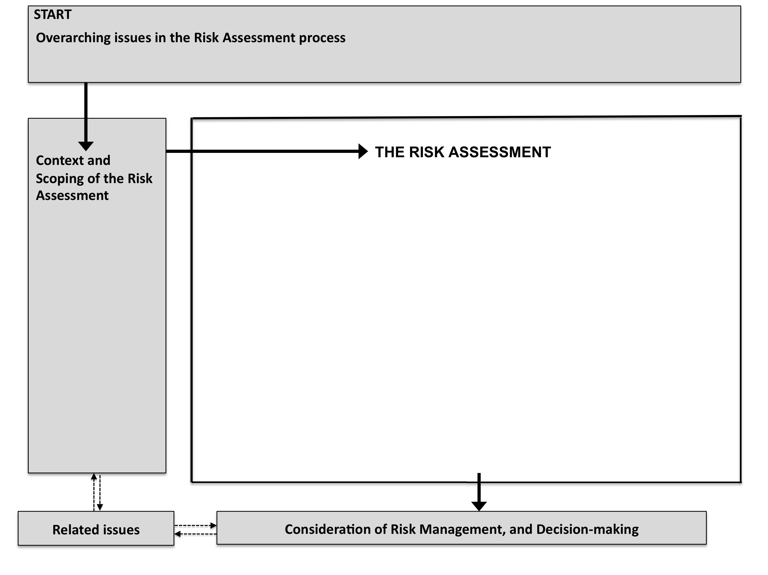

“In order to protect the environment, the precautionary approach shall be widely applied by States according to their capabilities. Where there are threats of serious or irreversible damage, lack of full scientific certainty shall not be used as a reason for postponing cost-effective measures to prevent environmental degradation” (Principle 15 of the Rio Declaration on Environment and Development) at: (http://www.unep.org/Documents.Multilingual/Default.asp?DocumentID=78&ArticleID=1163 ), and in line with Articles 10.6 and 11.8 of the Protocol.
http://bch.cbd.int/protocol/text/article.shtml?a=cpb-01.
Article 15, paragraph 1.
Annex III, paragraphs 3 and 6.
Annex III, paragraphs 4.
The Open-ended Online Expert Forum and the AHTEG on Risk Assessment and Risk Management were established by the COP-MOP in decision BS-IV/11. These groups were extended by the COP-MOP in decision BS-V/12. The terms of reference for these groups may be found in the annexes to decisions BS-IV/11 and BS-V/12 (http://bch.cbd.int/protocol/decisions/decision.shtml?decisionID=11690, http://bch.cbd.int/protocol/decisions/decision.shtml?decisionID=12325).
Including products thereof, as described in paragraph 5 of Annex III to the Protocol.
http://www.cbd.int/biosafety/articles.shtml?a=cpb-43.
Decisions on LMOs may be found, inter alia, in the BCH (http://bch.cbd.int) and links to national and intergovernmental websites relevant for this purpose.
Annex III, paragraph 1.
Risk assessments can be found, inter alia, in the BCH (http://bch.cbd.int) and ICGEB (http://rasm.icgeb.org).
Annex III, paragraph 8 (f).
An Explanatory Guide to the Cartagena Protocol on Biosafety, paragraphs 52-66 (http://data.iucn.org/dbtw-wpd/edocs/EPLP-046.pdf).
Article 10, paragraph 6, of the Protocol: “Lack of scientific certainty due to insufficient relevant scientific information and knowledge regarding the extent of the potential adverse effects of a living modified organism on the conservation and sustainable use of biological diversity in the Party of import, taking also into account risks to human health, shall not prevent that Party from taking a decision, as appropriate, with regard to the import of the living modified organism in question (…), in order to avoid or minimize such potential adverse effects.”
Annex III, paragraph 5.
EFSA (2011) Guidance on selection of comparators for the risk assessment of genetically modified plants and derived food and feed. Available at http://www.efsa.europa.eu/en/efsajournal/doc/2149.pdf.
The bold printed headings of each step are direct quotes from Annex III of the Protocol.
See also article 2, paragraph 2(b) of the Nagoya-Kuala Lumpur Supplementary Protocol on Liability and Redress (http://bch.cbd.int/protocol/NKL_text.shtml).
Examples of relevant attributes of the receiving environment include, among others: (i) ecosystem type (e.g., agroecosystem, horticultural or forest ecosystems, soil or aquatic ecosystems, urban or rural environments); (ii) extension of dimension (small, medium, large or mixed scale); (iii) previous use/history (intensive or extensive use for agronomic purposes, natural ecosystem, or no prior managed use in the ecosystem); (iv) the geographical zone(s) in which the release is intended, including climatic and geographic conditions and the properties of soil, water and/or sediment; (v) specific characteristics of the prevailing faunal, floral and microbial communities including information on sexually compatible wild or cultivated species; and (vi) biodiversity status, including the status as centre of origin and diversity of the recipient organism and the occurrence of rare, endangered, protected species and/or species of cultural value.
See “Use of terms” section.

