Monitoring of LMOs released into the environment
INTRODUCTION
Monitoring may be an appropriate risk management measure in specific circumstances. It is conducted to verify conclusions of risk assessment about the absence or the occurrence of identified beneficial or adverse environmental effect and monitor changes specifically attributable to the LMO.
Provisions in the Protocol that are relevant to monitoring and how it can be utilized are laid out in article 15 on “Risk Assessment”, paragraphs 8(e) and (f) of annex III, which states that the risk assessment methodology may entail “a recommendation as to whether or not the risks are acceptable or manageable, including, where necessary, identification of strategies to manage these risks” and “where there is uncertainty regarding the level of risk, it may be addressed by requesting further information on the specific issues of concern or by implementing appropriate risk management strategies and/or monitoring the living modified organism in the receiving environment”. Further, article 16 on “Risk Management” states “measures based on risk assessment shall be imposed to the extent necessary to prevent adverse effects”, and Parties shall “establish and maintain appropriate mechanisms, measures and strategies to regulate, manage and control risks identified in the risk assessment provisions”, and “endeavour to ensure that any living modified organism, whether imported or locally developed, has undergone an appropriate period of observation that is commensurate with its life-cycle or generation time before it is put to its intended use”.
Additional provisions that may be relevant to the monitoring of LMOs are elaborated in the Protocol’s parent treaty, the Convention of Biological Diversity (CBD). According to article 7 of the CBD on “Identification and Monitoring”, Parties shall identify and monitor components of biological diversity important for its conservation and sustainable use.

Justification: I do not believe monitoring serves “interlinked purposes”. Monitoring should be used for checking the predictions made during the risk assessment as part of risk management.

Justification: This paragraph is redundant.

Justification: This paragraph is reundant.
Monitoring may also be a tool to verify whether risk management strategies that have been enacted are effective towards their stated purpose.
Justification: To avoid redundancy
A country may review and change previous decisions regarding import of LMO if monitoring finds events that may influence the outcome of the risk assessment.
Justification: The cited paragraphs, Articles 10 and 12, relate to the revision of decision made by importing countries (article 11 deals with food/feed).

OBJECTIVE AND SCOPE
The aim of this guidance is to provide a practical, comprehensive, science-based monitoring approach for all types of LMOs intentionally released into the environment that is in line with the provisions and objective of the Protocol. It includes guidance on the design and evaluation of a monitoring strategy. While the focus of this guidance is on the scientific and technical aspects of designing and evaluating a monitoring strategy, considerations on the feasibility, availability of resources and technical challenges for successful implementation of a monitoring strategy are included.
Justification: It is not appropriate to include all type of the environmental release. This guideline should focus on the event after the risk assessment.
Aspects related to monitoring in the context of decision-making, such as when and what types of monitoring should be enacted, and who bears the responsibility for its implementation and associated costs are policy issues that will not be addressed in this document.
The scope of the recommendations for a monitoring strategy in this guidance focuses on the monitoring of environmental effects, at any time such activities are recommended from the outcome of a risk assessment performed in conjunction with an application for any kind of environmental release.
Justification: It is not appropriate to include all type of the environmental release. This guideline should focus on the event after the risk assessment.
Monitoring in the context of human and animal health, especially in the case of products used as food or feed would require different and/or additional approaches and are not covered in this guidance.
Justification: The second sentence makes the scope of monitoring too narrow as human health will be affected positively or negatively through “environmental” changes brought about by introducing or not introducing a certain LMOs. For example, use of drought tolerant LMO crop plants may affect the human health even if LMO itself may not interact directly with humans.
It should be explicitly noted that the description of the monitoring strategy in this guidance relates to step 5 of the risk assessment process (see Roadmap) for intentional releases of an LMO into the environment. Unintentional introductions of LMOs into the environment and unintentional/illegal transboundary movements are outside of the scope of this guidance and dealt with under related articles in the Protocol.
The general provisions outlined here should be broadly relevant, yet not all specific provisions in this guidance will apply in each scenario, but should be determined on a case-by-case basis.
TYPES OF MONITORING
There are two types of monitoring, one for risk assessment and the other for risk management. The former is done as assessment, very often during the experimental small scale release or scale-up process, to determine the effects of LMO in the environment. The latter is done in principle after approval of environmental release of an LMO to check if an OLM is used as expected from conclusions obtained during the risk assessment.
This document deals with the latter type of the monitoring. Monitoring for risk assessment is already dealt with in the guidelines for risk assessment.

A risk assessor may, on a case-by-case basis, and depending on whether the national biosafety legislation or policies have any requirements to this effect, make a recommendation for the implementation of monitoring based on the risk assessment conclusion.

Justification: The provision given is too prescriptive. Need and type of monitoring should be decided based on the risk assessment and also depending on the expected outcome of the introduction of LMOs. Monitoring is not just for detecting adverse effects of LMOs but to check if the expected outcome can be obtained or not. If expected outcome is not obtained, using the LMOs should be discontinued as it may be just unnecessary burden to the economy and possibly to the environment.
DEVELOPMENT OF A MONITORING STRATEGY
If a recommendation is made at the end of the risk assessment for the implementation of monitoring activities in the event that the LMO is introduced into the environment, this recommendation should be substantiated with a description of a scientifically rigorous and effective monitoring strategy.

When developing a strategy for monitoring strategy, the following should be considered appropriately:
- The identification and prioritization of protection goals, potential adverse effects and the choice of indicators and parameters for monitoring (“what to monitor?”);
- Identification and description of appropriate monitoring methods and establishment of baselines (“how to monitor?”);
- Duration and scale of the monitoring activities (“how long to monitor?”);
- Monitoring sites and regions (“where to monitor?”);
- The use of existing monitoring networks;
- Reporting of results from monitoring;
- Analysis of the feasibility and potential challenges associated with the implementation of the recommended monitoring strategy.
These points are further elaborated below.
1. The identification and prioritization of protection goals, potential adverse effects and the choice of indicators and paramaters for monitoring (“what to monitor?”)
Rationale for the identification and prioritization of protection goals and potential adverse effects:
The identification of potential effects adverse or beneficial, indicators and parameters to be monitored will vary from case to case. They should be identified in the risk assessment using the best available science and data.

Justification: The original proposal appears to suggest the identified effects, indicators and parameters are determined by risk hypothesis and scenarios. In my view, potential effects adverse or beneficial, indicators and parameters to be monitored are determined by the scientific data obtained during the risk assessment, not just hypothesis or scenarios.

Justification: Separation of CSM and GS is not appropriate. General environmental surveillance is in place under the law concerning the environment protection and the national Cartagena Protocol enforcing law. The case-specific monitoring described above is too prescriptive.
Points to consider regarding the identification of potential adverse effects or protection goals:
- Likelihood and consequences of a potential adverse effect identified in step 1 of the risk assessment (see Roadmap) to occur;
- Protection goals within the appropriate ecosystem spheres in the relevant environment;
- Uncertainties that were identified during the risk assessment process.

Rationale for the identification and selection of indicators and parameters:
The indicators and parameters chosen are those that can best detect changes that could lead to events related to the expected effects identified during the preceding steps of the risk assessment.

Justification: The last sentence is incomprehensive. There is no need to mention GS. There is no difference between CSM and GS in the scientific principle and also in practice.
Points to consider regarding the identification and selection of relevant indicators and parameters:
- The potential of the indicator or parameter to signal possible LMO-induced changes;
- The breadth of distribution and abundance of an indicator and its level of exposure to the LMO;
- The importance of the indicator or parameter to key ecological processes and functions or to the identified protection goals;
- The potential of the indicator or parameter to reveal changes that could be an indicative of adverse effects;
- The level of difficulty involved in the sampling or identification of the indicator;
- The ability to establish relevant baselines with the indicator.
- The relation of the indicator or parameter to identified protection goals.

2. Identification and description of appropriate monitoring methods and establishment of baselines (“how to monitor?”)
Rationale for the identification and description of appropriate monitoring methods:
The monitoring method is largely dependent on the intended use of LMOs and identification of expected effects or goals of environment protection, as well as indicators and parameters decided upon in the preceding step.
Justification: Monitoring is not just for detecting adverse effects.
The description of the monitoring methodology includes the steps of collecting and analysing data. These may include, for example, methods for (i) sampling of biotic (e.g. of LMOs and/or indicator species) and abiotic (e.g. water, soil) components of the receiving environment, (ii) gathering information (e.g. questionnaires), (iii) generating data (e.g. analytical methods), and (iv) data analysis (e.g. statistical methods, procedures, and statistical significance requirements). The monitoring methodology should be scientifically sound, be described in sufficient detail to allow its use in a similar situation, and be based as much as possible on the use of standardized methods (see also considerations on “Quality and relevance of information” in the Roadmap).
Justification: As environment changes over time, it is almost impossible to replicate exactly what has happened and what was observed.
An important feature of the proposed monitoring strategy and its methodology is the degree to which results from various sites and regions can be compared (see “Monitoring sites and regions” below). Also, a monitoring strategy may be designed in such way that it is in line with existing monitoring programs, e.g. conservation, agricultural and environmental monitoring schemes. Harmonization of methods, data formats, and analytical approaches may facilitate the adaptability of monitoring methods performed by these programmes.
The data should be collected from those most closely associated with the actual use of the LMO (e.g. farmer, land manager) who may be the first to observe relevant changes.
Justification: The original draft is too prescriptive.
Points to consider regarding the monitoring methods:
- The nature of the effect to be monitored (e.g. whether short or long term, delayed or indirect);
- Methods for monitoring baseline changes;

Justification: On account of continuously changing environment, establishing the exact base line is very difficult. In principle, the baseline should be determined during the risk assessment and not in risk management.

- The scientific rigor of the sampling, analytical and statistical methods, where applicable;
Justification: Sampling and analysis may not be involved in some cases.

- The availability of standardized methods;
- The degree to which the methods will meet the objectives of the proposed strategy;
- Descriptive studies or questionnaires as supplementary information to the proposed scientific monitoring strategy;
- The adaptability of any existing already established programmes for the surveillance of broader protection goals.
Rationale for the establishment of baselines:
The establishment of relevant baselines is a key element for detecting changes and inferring whether there is a causal link to the presence of one or more LMOs. The baseline, however, changes seasonally and also progressively over time owing to climate change, land or water use and many other factors. It should also be reminded that some application of LMOs is intended to change the environment itself, such as the bioremediation. What is the baseline should be determined during the risk assessment prior to the decision on monitoring .
Justification: Baselines should be established during the risk assessment, not in the risk management.

3. Duration and scale of the monitoring activities (“how long to monitor?”)
Rationale:
The duration and scale of the monitoring will depend on the type of strategy, effects that are to be monitored (e.g. direct or indirect, immediate of delayed, short- or long-term), and type of LMO (e.g. short or long life cycles). The duration and scale of the monitoring strategy may further vary for each proposed parameter and/or methodology required to achieve relevant scientific information.

4. Monitoring sites and regions (“where to monitor?”)
Rationale:
Monitoring sites and regions should be selected on a case-by-case basis depending on the type of LMO or indicator (e.g. microorganism, plant or animal, its level of domestication, its life-cycle, its novel characteristics, etc.), the intended use of the LMO taking into account the associated management practices, and the receiving environment. The sites and regions to be monitored should be representative of the various biotic and abiotic characteristics of the likely potential receiving environment(s) where the LMO is to be released. In certain cases, pathways of exposure of the environment to the LMO(s) (e.g. seed dispersal or movements of LM animals), as well as areas linked to protection goals (e.g. protected areas and centres of crop origin and genetic diversity or ecologically sensitive regions, may serve as basis for selecting sites to be monitored that extend beyond the intended receiving environment where the LMO(s) may be introduced.
Relevant information regarding the sites and regions to be monitored include, for example, specific locations, their size and relevant characteristics of the sites may be included in the monitoring strategy.
Points to consider:
- Where necessary, availability of reference sites and regions without the LMOs for a comparisons over the monitoring period;
- Dissemination and establishment of the LMO(s) in the likely potential receiving environment;
- Pathways through which the environment is likely to be exposed to the LMO(s);
- The biological and ecological behaviour of the indicators in the receiving environment for consistent detection and observation;
- Where applicable, protected areas and centres of origin and genetic diversity or ecologically sensitive regions with specific protection goals, including the use of buffer areas in order to detect unintended presence or unexpected effects;
- The availability of existing monitoring networks operating within representative regions;
- Availability of monitoring sites and regions sufficient to support statistical analysis of results, and their number.
Justification and Comments:
- In order to avoid confusion, it is important to decide whether monitoring to be dealt with here is whether it is an activity as risk management, as risk assessment or as the both. This draft appears quite ambiguous to this issue, though Annex 1 says it deals with after the decision based on the risk assessment.
- During the risk assessment, we regularly monitor the consequence of introduction of LMOs into the environment. Without such an activity, the risk assessment is impossible. Through such risk assessment, we identify items that need to be monitored during risk management to verify whether the consequence of the use of the LMO is as intended or not. In codex alimentarius, the (post-market) monitoring is included in risk management measures (Principles for the Risk Analysis of Foods Derived from Modern Biotechnology, paragraph 19).
- The monitoring conducted during the risk assessment is done before the completion of the risk assessment. Therefore, it is more comprehensive and exhaustive as described in the present text. However, the monitoring performed during the risk management, i.e., after approval for environmental release, is to be conducted to monitor the items that were identified through the risk assessment, which will be more focused ones. Repeating the same monitoring already done during the risk assessment in the risk management will be real barrier to the post-approval LMO use.

5. The use of existing monitoring networks
Rationale:
The monitoring plan should specify the criteria for the selection of any existing monitoring systems and programs to be used supplying monitoring data. The suitability of such networks should be evaluated beforehand with respect to their potential to achieve the goals of the monitoring plans

Justification: The proposed items are too prescriptive and may not be applicable to every case. In addition, it is not a single regulation that is contributing to the monitoring on most countries. It will be more practical that a country identifies the regulations, on case by case basis, for monitoring required. For example, marine and forest environments are under entirely different jurisdictions.
6. Reporting of results from monitoring
Rationale:
The monitoring strategy may include a plan of how the results of the monitoring activities are to be communicated. Such a reporting plan should identify the items to be reported and time of reporting.

Points to consider:
- Requirements regarding reporting of results from monitoring activities that are set out by the competent authority(ies) or in national biosafety regulations, if available;

- The choice of methods, duration and scale, as well as sites and regions of the proposed monitoring activities;
- Changes (e.g. to indicators) observed during the monitoring, particularly which could affect planned use of the LMOs.

Justification: The intent of this paragraph is obscure, if the monitoring is a part of the risk management, because the risk manager should choose always feasible/doable monitoring strategy.

Paragraphs more pertinent to monitoring for the Risk Assessment
Monitoring required for risk assessment (copied from 3. Duration and scale of monitoring activities)
According to the Protocol, Parties “shall endeavour to ensure that any living modified organism, whether imported or locally developed, has undergone an appropriate period of observation that is commensurate with its life-cycle or generation time before it is put to its intended use”. In this context, monitoring can be used to generate data for risk assessments, for example, during field trials and small-scale releases. The results from a monitoring carried out during a small-scale release may, for instance, increase the scientific rigor of the conclusions of a risk assessment and help avoid the need for later risk management measures at a large-scale release or contribute to much more targeted, cost-effective monitoring strategies. When the risk assessment and monitoring is conducted in such a step-wise manner, monitoring of small-scale releases can also limit the consequences of an adverse effect as compared to the consequences should an adverse effect occur after a large-scale introduction into the environment.
Monitoring activities that require long periods of observation in order for changes to become apparent may pose a number of practical challenges, e.g. in consistency or availability of test sites or subjects over long periods, changing environment of the LMO use, such as, climate, human activity and other factors that may indirectly affect the consequence and empirical limitations (e.g. establishing a causal relation with any change identified in the monitoring program) that should considered in the monitoring strategy (see “Analysis of the feasibility and potential challenges associated with the implementation of the recommended monitoring strategy” below).
Points to consider:
- Different types of adverse effects (i.e. direct or indirect, immediate or delayed);
- Life-cycle and generation time of the LMO as well as its intended use;
- The variability of the monitored parameters through time;
- Unanticipated changes that may be difficult to predict or detect, such as climate and other environmental changes during the use;
- Effects may become detectible only after a longer period of observation, which may be obscured by changes in external factors, such as climate, land use, demography, etc.
Establishment of baselines
The following examples may be used as points of consideration for the establishment of baselines:
- The use of scientifically rigorous methods in constructing the baseline;
- The spatial scale over which to establish the baseline;
- Effects of spatial heterogeneity on the representativeness of the baseline in each of the compared scenarios (LMO vs. non-LMO);
- The breadth of potential spread related to the type of LMO.
Annex 1
Recommendation of monitoring strategies in relation to risk assessment, decision-making and implementation
of risk management under the Protocol
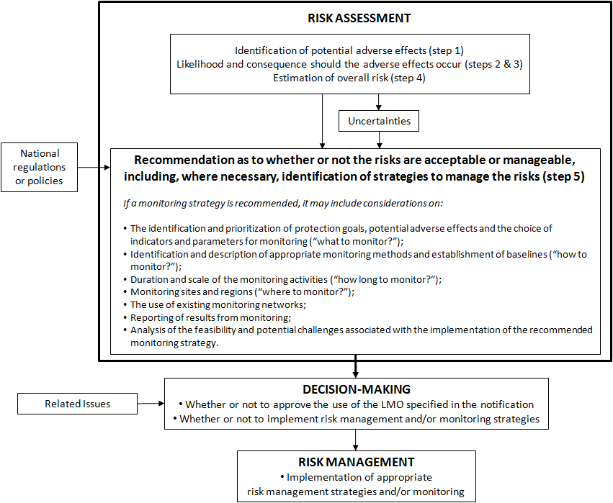

See CBD, Article 7
Article 16, paragraph 4.
Roadmap for Risk assessment, Step 1 Rationale

