Monitoring of LMOs released into the environment
INTRODUCTION
Monitoring, in the context of this guidance, refers to measures, undertaken after an LMO is released into the environment, that aim at detecting the occurrence of changes (e.g. in the receiving environment(s) or in the LMO) that could lead to adverse effects on the conservation and sustainable use of biodiversity, taking into account risks to human health. Adverse effects may be direct or indirect, short or long-term, immediate or delayed, and occur at various ecological levels and biological processes or at various stages in an organism’s life cycle or food chain.
Provisions in the Protocol that are relevant to monitoring and how it can be utilized are laid out in article 15 on “Risk Assessment”, paragraphs 8(e) and (f) of annex III, which states that the risk assessment methodology may entail “a recommendation as to whether or not the risks are acceptable or manageable, including, where necessary, identification of strategies to manage these risks” and “where there is uncertainty regarding the level of risk, it may be addressed by requesting further information on the specific issues of concern or by implementing appropriate risk management strategies and/or monitoring the living modified organism in the receiving environment”. Further, article 16 on “Risk Management” states “measures based on risk assessment shall be imposed to the extent necessary to prevent adverse effects”, and Parties shall “establish and maintain appropriate mechanisms, measures and strategies to regulate, manage and control risks identified in the risk assessment provisions”, and “endeavour to ensure that any living modified organism, whether imported or locally developed, has undergone an appropriate period of observation that is commensurate with its life-cycle or generation time before it is put to its intended use”.
Additional provisions that may be relevant to the monitoring of LMOs are elaborated in the Protocol’s parent treaty, the Convention of Biological Diversity (CBD). According to article 7 of the CBD on “Identification and Monitoring”, Parties shall identify and monitor components of biological diversity important for its conservation and sustainable use.
Monitoring may serve several interlinked purposes within the entire decision process. That is, while monitoring activities are generally directed by the risk assessment, they may also be utilized concurrently within risk management, which informs the decision-making of the LMO (e.g. to decide on the application for transboundary movement, or request more information on the acceptability of risk).
In relation to the risk assessment, as seen in the Roadmap, uncertainties encountered during a risk assessment may affect the evaluation of overall risks and the conclusions of the risk assessment process. In such instances where the relevant uncertainties identified in the risk assessment cannot be reduced by more information, monitoring strategies may be recommended to test risk hypotheses or scenarios. As such, the results of monitoring activities may be used to evaluate the conclusions of the risk assessment process.
In relation to risk management, monitoring can identify the occurrence of events that could lead to adverse effects and in a timely manner for the implementation of appropriate response measures to these events.
Monitoring may also be a tool to verify whether risk management strategies that have been enacted are effective towards their stated purpose, or to identify adverse effects that were not dealt with in the risk assessment, because they could not be detected during the risk assessment process, e.g. long-term or cumulative effects.
In relation to the decision-making procedures, a country may require that monitoring be carried out after introduction into the environment if, for instance, there is uncertainty regarding the level of risk associated with an LMO.
Annex 1 provides a visual diagram to contextualize the use of monitoring within the entire risk assessment process.
OBJECTIVE AND SCOPE
The aim of this guidance is to provide a practical, comprehensive, science-based monitoring approach for all types of LMOs intentionally released into the environment occurring at any scale of release or any intent, that is in line with the provisions and objective of the Protocol. It includes guidance on the design and evaluation of a monitoring strategy. While the focus of this guidance is on the scientific and technical aspects of designing and evaluating a monitoring strategy, considerations on the feasibility, availability of resources and technical challenges for successful implementation of a monitoring strategy are included.
Aspects related to monitoring in the context of decision-making, such as when and what types of monitoring should be enacted, and who bears the responsibility for its implementation and associated costs are policy issues that will not be addressed in this document.
The scope of the recommendations for a monitoring strategy in this guidance focuses on the monitoring of environmental effects, at any time such activities are recommended from the outcome of a risk assessment performed in conjunction with an application for any kind of environmental release (including approvals for experimental or small-scale field releases).
Monitoring in the context of human and animal health, especially in the case of products used as food or feed would requires different approaches that are covered elsewhere (refer to Codex) and are not covered in this guidance. Therefore the guidance here focuses considerations on human health in relation to incidental exposure to LMOs and their products directly by LMO handlers during their transport, use or processing.
This guidance relates to step 5 of the risk assessment process (see Roadmap) for intentional releases of an LMO into the environment. Unintentional introductions of LMOs into the environment and unintentional/illegal transboundary movements are outside of the scope of this guidance and dealt with under related articles in the Protocol.
The general provisions outlined here should be broadly relevant, yet not all specific provisions in this guidance will apply in each scenario, but should be determined on a case-by-case basis.
TYPES OF MONITORING
Monitoring can be grouped into two main types of activities: “case-specific monitoring” and “general surveillance”.
Case-Specific Monitoring (CSM) deals with monitoring for potential adverse effects that were evaluated in the risk assessment of a specific LMO, or to verify the effectiveness of risk management practices that were enacted based on protection goals. For instance, CSM may provide observational data to reduce uncertainties, if that is feasible, once the LMO is released into the environment. Verifying the conclusions of the risk assessment through monitoring may be of particular value where predictive capacity of the information provided is limited (e.g. the scale or duration of release, degree of prior knowledge of the receiving environment, the exposure model considered, the experimental model chosen, etc.).
CSM tracks the occurrence of changes (e.g. in the LMO or the environment) that could lead to adverse effects that were identified in the risk assessment, particularly in step 1. These changes could, for instance, affect the likelihood or consequences (steps 2 & 3) of one or more potential adverse effects identified during the risk assessment and, therefore, impact the estimation of overall risk of the LMO (step 4). As a result, a CSM strategy has close links with the preceding steps of the risk assessment.
CSM is a tool when the level of uncertainty regarding the risks of the LMO is such that it could impact the conclusions and recommendations of the risk assessment process. In such cases, monitoring strategies can be recommended to compensate or reduce uncertainties identified throughout the risk assessment. Therefore, the identification and description of uncertainties arising in the risk assessment (see “Identification and consideration of uncertainty” in the Roadmap) provides important elements to determine whether a monitoring strategy is needed and how it could be designed.
General Surveillance (GS)

The authors recognize that GS is currently prescribed in the EU with the intended purpose to “identify the occurrence of unanticipated adverse effects of the GM plant or its use, on human health or the environment, that were not anticipated in the ERA” (Cite EFSA Guidance). Within the EU, GS applies a “general hypothesis” that a LM Plant “may have unanticipated adverse effects on protected and valued entities of the environment including biodiversity, sustainable production and ecosystem services and functions”. However, the protocol does not prescribe any requirement for monitoring. As such, this document will be restricted to CSM, and refers those interested in the EU’s description and application of GS to EFSA guidance.
In conclusion, a risk assessor may, on a case-by-case basis, and depending on whether the national biosafety legislation or policies have any requirements to this effect, make a recommendation for the implementation of one and/or the other type of monitoring, i.e. CSM and GS, and include a comprehensive plan for a monitoring strategy.
DEVELOPMENT OF A MONITORING STRATEGY
If a recommendation is made at the end of the risk assessment for the implementation of monitoring activities in the event that the LMO is introduced into the environment, this recommendation should be substantiated with a description of a scientifically rigorous and effective monitoring strategy. This monitoring strategy can utilize, as appropriate, either one or the two types of monitoring identified above (i.e. CSM and GS), and may include provisions to ensure the scientific quality and efficacy of the monitoring activities, and for reporting of monitoring data. When both types of monitoring activities are to be undertaken, the monitoring strategy should clearly outline a separate plan for each.
Regardless of the type of monitoring, i.e. CSM and GS, the design of a monitoring strategy should address a number of technical issues that supports the objectives of the Protocol, national protection goals, and contributes to informational needs under risk assessment, risk management, and/or decision-making. Further, the description of a monitoring strategy should be transparent and presented in sufficient detail ensure scientific quality.
A strategy for CSM may encompass:
- The identification and prioritization of protection goals, potential adverse effects and the choice of indicators and parameters for monitoring (“what to monitor?”);
- Identification and description of appropriate monitoring methods and establishment of baselines (“how to monitor?”);
- Duration and scale of the monitoring activities (“how long to monitor?”);
- Monitoring sites and regions (“where to monitor?”);
- The use of existing monitoring networks;
- Reporting of results from monitoring;
- Analysis of the feasibility and potential challenges associated with the implementation of the recommended monitoring strategy.
These points are further elaborated below.
- The identification and prioritization of potentially affected protection goals, potential adverse effects and the choice of indicators and paramaters for monitoring (“what to monitor?”).
The monitoring program must target environmental attributes that should be protected from harm. In addition, evidence from the risk assessment is used to formulate a hypothesis to be tested that is related to the protectiong goal(s).
1. The identification and prioritization of protection goals, potential adverse effects and the choice of indicators and paramaters for monitoring (“what to monitor?”)
Rationale for the identification and prioritization of protection goals and potential adverse effects:

Potential adverse effects should be derived from specific hypotheses or scenarios identified in the risk assessment (see Step 1-5 of the Roadmap) where remaining uncertainties have been identified. in a “bottom-up approach” [to be added to the “Use of terms” section].

There may be additional relevant adverse effects that are identified on the basis of hazard identification research, but not evaluated in the risk assessment (e.g. long-term impacts, food-web interactions, effects on human health from LMO handling).

Points to consider regarding the identification of potential adverse effects or protection goals:
- Likelihood and consequences of a potential adverse effect identified in step 1 of the risk assessment (see Roadmap), in as far as they are subject to uncertainty (step 5 of the Roadfmap);
- Protection goals as recognized in the risk assessment, i.e., the protection goals and assessment endpoints within each National Party’s domestic legislation that have been deemed be relevant.;

Rationale for the identification and selection of indicators :
The indicators (e.g. species, populations, groups of species, environmental processes) chosen are those that can best be used to obtain new data on the identified uncertainties.
Points to consider regarding the identification and selection of relevant indicators and parameters:
- The potential of the indicator or parameter to signal possible LMO-induced changes;
- The breadth of distribution and abundance of an indicator and its level of exposure to the LMO;
- The importance of the indicator or parameter to key ecological processes and functions or to the identified protection goals;
- The potential of the indicator or parameter to reveal changes that could be an indicative of adverse effects;
- The level of difficulty involved in the sampling or identification of the indicator;
- The ability to establish relevant baselines with the indicator.
- The relation of the indicator or parameter to identified protection goals.
Annex 2 provides examples of indicators and protection goals that may be part of a monitoring strategy.
2. Identification and description of appropriate monitoring methods and establishment of baselines (“how to monitor?”)
Rationale for the identification and description of appropriate monitoring methods:
The choice of monitoring methods is largely dependent on the adverse effects and unceratinties described in the previous paragraph.
The description of the monitoring methodology may include methods for (i) gathering data from sampling of relevant components of the receiving environment, (ii) gathering information from informants (e.g. questionnaires), and (iii) data analysis. The monitoring methodology should be described in sufficient detail to allow reproducibility, and be based on standardized methods as far as required by regulations olf the Party.
An important feature of monitoring strategies is the degree to which results from various sites and regions can be compared (see “Monitoring sites and regions” below). Also, a monitoring strategy may be designed in such way that it is in line with existing monitoring programs, e.g. conservation, agricultural and environmental monitoring schemes.
In describing appropriate methods, it should be considered that those most closely associated with the actual use of the LMO (e.g. farmer, land manager) may be the first to observe relevant changes. Therefore, the use of observations, descriptive studies, or questionnaires from those in the user-chain, may be included in the collection data for unanticipated effects as supplementary information, if appropriate.
Points to consider regarding the monitoring methods:
- The nature of the adverse effect to be monitored;

- The availability of standardized methods;

- Descriptive studies or questionnaires as supplementary information to the proposed scientific monitoring strategy;

Rationale for the establishment of baselines:
The establishment of relevant baselines is a key element for detecting and evaluating changes. The baseline should be described in the monitoring methodology in order to provide an accurate representation of the environment prior to its exposure to the LMO(s). In practice, the baseline is a measurement of the relevant indicators in a situation where no introduction of LMOs has occurred.

3. Duration and scale of the monitoring activities (“how long to monitor?”)
Rationale:

According to the Protocol, Parties “shall endeavour to ensure that any living modified organism, whether imported or locally developed, has undergone an appropriate period of observation that is commensurate with its life-cycle or generation time before it is put to its intended use”. In this context, monitoring can be used to generate data for risk assessments, for example, during field trials and small-scale releases. The results from a monitoring carried out during a small-scale release may, for instance, increase the scientific rigor of the conclusions of a risk assessment and help avoid the need for later risk management measures at a large-scale release or contribute to much more targeted, cost-effective monitoring strategies. When the risk assessment and monitoring is conducted in such a step-wise manner, monitoring of small-scale releases can also limit the consequences of an adverse effect as compared to the consequences should an adverse effect occur after a large-scale introduction into the environment.
Monitoring activities that require long periods of observation in order for changes to become apparent may pose a number of practical challenges, e.g. in consistency or availability of test sites or subjects over long periods, and empirical limitations (e.g. establishing a causal relation with any change identified in the monitoring program) that should considered in the monitoring strategy (see “Analysis of the feasibility and potential challenges associated with the implementation of the recommended monitoring strategy” below).
Points to consider:
- Different types of adverse effects (i.e. direct or indirect, immediate or delayed);
- Life-cycle and generation time of the LMO as well as its intended use;
- The variability of the monitored parameters through time;
- Unanticipated changes that may be difficult to predict or detect;
- Effects may become detectible only after a longer period of observation.
4. Monitoring sites and regions (“where to monitor?”)
Rationale:
Monitoring sites and regions should be selected on a case-by-case basis depending on the uncertainties identified in the risk assessment. type of LMO or indicator (e.g. microorganism, plant or animal, its level of domestication, its life-cycle, its novel characteristics, etc.), the intended use of the LMO taking into account the associated management practices, and the likely potential receiving environment. The sites and regions to be monitored should be representative of the various biotic and abiotic characteristics of the likely potential receiving environment(s) where the LMO is to be released. The pathways of exposure of the environment to the LMO(s) (e.g. seed dispersal or movements of LM animals), as well as areas linked to protection goals (e.g. protected areas and centres of crop origin and genetic diversity or ecologically sensitive regions, may serve as basis for selecting sites to be monitored under both CSM and GS strategies that extend beyond the intended receiving environment where the LMO(s) may be introduced.
Relevant information regarding the sites and regions to be monitored include, for example, specific locations, their size and relevant characteristics of the sites may be included in the monitoring strategy.
Points to consider:
- Availability of reference sites and regions without the LMOs for a comparisons over the monitoring period;
- Dissemination and establishment of the LMO(s) in the likely potential receiving environment;
- Pathways through which the environment is likely to be exposed to the LMO(s);
- The biological and ecological behaviour of the indicators in the receiving environment for consistent detection and observation;
- Protected areas and centres of origin and genetic diversity or ecologically sensitive regions with specific protection goals, including the use of buffer areas in order to detect unintended presence or unexpected effects;
- The availability of existing monitoring networks operating within representative regions;
- Number of monitoring sites and regions sufficient to support statistical analysis of results.
5. The use of existing monitoring networks
Rationale:
The monitoring plan should specify any existing monitoring systems and programs to be used supplying monitoring data. The suitability of such networks should be evaluated beforehand with respect to their potential to achieve the goals of the monitoring plans, taking into account the prerequisites that are set for the monitoring, and that should be met by these networks. , taking into account, inter alia:
- Adaptability of existing monitoring to LMO monitoring indicators or parameters;
- The robustness of data generated possible to meet the monitoring objectives;
- The number and relevance of existing indicators for LMO monitoring;
- Representativeness of sites in number or distribution in relation to the intended receiving environment of the LMO release;
- The frequency of observation and methods employed;
- The long-term continuity of the monitoring sites;
- The capacity of the managing institution to collect, report and disseminate data derived from monitoring activities;
- Access to data before or beyond the timeframe of observation;
- Expertise and resources available to carry out the relevant monitoring activities.
6. Reporting of results from monitoring
Rationale:
A monitoring report should provide information on the results of monitoring that are important to reduce the uncertainties of the risk assessment.
The monitoring strategy may include a plan of how the results of the monitoring activities are to be communicated. Such a reporting plan can include, for instance, (i) the periodicity of the reports, (ii) a description of the activities undertaken, (iii) a scientific analysis of the results, and (iv) conclusions and recommendations.
Specific considerations may also be included on what and how to report in the event that changes that could lead to adverse affects are observed during the monitoring activities. Such considerations may include, for example, how to establish a causal link between the LMO(s) and adverse effect(s) and an analysis of the consequences of the adverse effect(s).
A clear description of how the results may be reported can serve various purposes, such as to (i) provide feedback of the efficiency and efficacy of the monitoring activities in relation to the objectives set out in the monitoring strategy; (ii) to inform the need for changes to the monitoring plan and/or other risk management strategies, or for follow-up studies or risk assessments; and (iii) inform authorities of adverse effects or unintentional/illegal transboundary movements of LMOs.
Points to consider:
- Requirements regarding reporting of results from monitoring activities that are set out by the competent authority(ies) or in national biosafety regulations, if available;
- The LMO, including its potential adverse effects and overall risk, the intended use and the likely potential receiving environment as well as any other element that could affect the periodicity of reporting;
- The choice of methods, duration and scale, as well as sites and regions of the proposed monitoring activities;
- How to report changes (e.g. to indicators) observed during the monitoring that could lead to an adverse effect and any possible mitigation measure;
- Any potential challenge associated with the monitoring which could affect its implementation (see below).
7. Analysis of the feasibility and potential challenges associated with the implementation of the recommended monitoring strategy
Rationale:
In the development of a monitoring strategy, it may become apparent that the resources necessary for the implementation of the monitoring strategy may be unavailable or entirely lacking. Further, technical and analytical challenges may be highlighted. In such cases, an analysis of the capacities that may be required for the successful initiation, maintenance and completion of any recommended monitoring strategy should be considered.
Points to consider:
- Possible methodological weaknesses in the monitoring plan to provide statistically meaningful data;
- Whether monitoring sites are representative of all likely potential receiving environments;
- Challenges in observing adverse effects;
- Challenges for establishing cause-effect relationships (causalities) between the LMO(s) and adverse affects;
- Possible difficulties in the interpretation of monitoring results and scientific considerations on what environmental changes should be further investigated;
- Costs and capacities to conduct an effective monitoring;
- Challenges in the utilization of existing monitoring programs or methodologies;
- Unanticipated results that may require adaptation of the monitoring activities (e.g. changes in or inclusion of new parameters or indicators).

Annex 1
Recommendation of monitoring strategies in relation to risk assessment, decision-making and implementation
of risk management under the Protocol
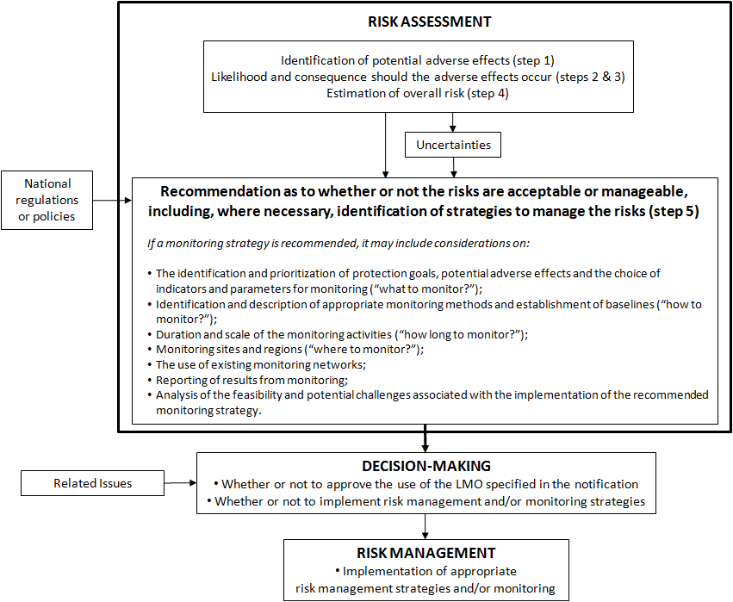
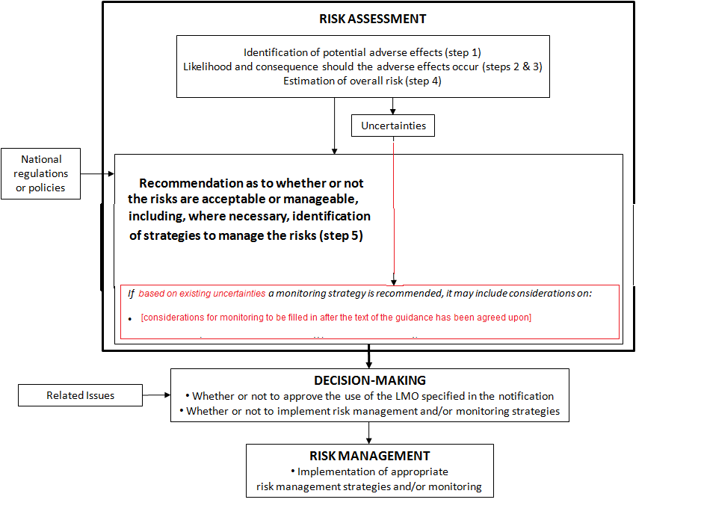
Annex 2
Examples of monitoring subjects indicators and monitoring methods in relation to protection goals

Type of monitoring  (CSM or GS) | Protection goal(s) / Objective | Subjects/Indicator(s) | Example(s) of monitoring methods
CSM | Reduction of level on uncertainty of potential effects identified in the RA | Target organisms, Non-target organisms, environmental parameters, etc. | • Confirming host-range effects of target transgenic proteins, resistance development,  • Confirming exposure routes or levels
CSM | Impact on assessment endpoints or related indicators identified and evaluated in the RA | Target organisms, non-target organisms, environmental parameters, etc. | • Presence and population levels of key selected NTOs  • Food web and predator/prey interactions of key selected NTOs at different trophic levels
CSM | Confirmation of in vivo exposure levels | Non-target organisms, etc. | • Direct or indirect uptake/exposure of NTOs to transgenic pesticidal proteins  • Existence of weed species in herbicide tolerant (HT) fields  • Accumulation of transgenic products in the soil
CSM | Impact on production systems in relation to sustainability | Functional organisms, key environmental services, etc. | • Pollination impacts  • Pest control efficacy
CSM | Monitoring for scale-dependent effects | Wild and weedy relatives, HGT candidates | • Persistence of DNA or transgenic products in the soil  • Frequency of gene transfer potential
CSM | Efficacy of risk management strategies | Case-specific | • Efficacy of refugia strategies to delay resistance development of pesticide-producing crops by testing susceptibility of target pests  • Recording weed populations in HT crop fields or adjacent areas
Sources:
Food and Agriculture Organization of the United Nations. (2011). Biosafety resource book. Rome: FAO, Module B: Ecological Aspects and Module D: Test and Post-Release Monitoring of GMOs.
VDI-Guideline 4330 Part 1: Monitoring the ecological effects of genetically modified organisms, Genetically modified plants, Basic principles and strategies, 2006.
EFSA Panel on GMO; Scientific Opinion on guidance on the Post-Market Environmental Monitoring (PMEM) of genetically modified plants. EFSA Journal 2011;9(8):2316. [40 pp.]

See CBD, Article 7
See Roadmap for Risk Assessment, ”Overarching issues” and Step 5 of ”Conducting the Risk Assessment”.
This may be particularly useful for releases of approved for experimental/field testing purposes where the LMO is evaluated incrementally over successive scales of release, but also applicable for large scale environmental releases.
See Cartagena Protocol, Article 10 p6, Article11 p8, Article 12 p1
See Roadmap and Annex III p8 (x)
See Roadmap, ”Overarching issues”
Article 16, paragraph 4.
Roadmap for Risk assessment, Step 1 Rationale
See articles 17 and 25.

