Module 4

Techniques for detection and identification

**Contents of this module**

**Introduction**

**Protein-based methods**

Introduction

Lateral Flow Assay

ELISA Technique

Limitations of Protein-Based Methods

**DNA-based methods**

Introduction

Nature of DNA

Principles of PCR

Specialised PCR

Analysis of PCR Products

LMO Screening Using PCR

Limitations of DNA-Based Methods

Novel technologies for LMO Detection

**References**

**Introduction**

A number of methodologies and techniques are available to detect, identify and quantify living modified organisms (LMO). These methodologies generally target one of two components, specifically, the proteins that are expressed by the LMO or the DNA insert that was transferred into the organism’s genome.

When planning and setting up a laboratory for the detection and identification of LMOs a choice must be made regarding which methodologies and protocols will be adopted. The techniques that are commonly used to target either of these components, as indicated in table 1, range from those that are fast and more cost-effective, such as lateral flow tests and endpoint PCR, to those that can be more complex, such as quantitative real-time PCR. Furthermore, the methodologies range from qualitative methods to detect the presence of LMOs, to tests that identify individual LMOs, to quantitative tests that measure the percentage of LMOs present in a sample. All of these methodologies have their advantages and drawbacks that need to be taken into account when selecting which of the methodologies should be adopted by the laboratory.

In addition, for service-oriented laboratories, particularly those servicing regulatory authorities, the selection of methods is guided by, amongst other things, the country’s specific regulatory requirements in accordance with national biosafety laws, and should include an assessment of the nature of the goods that would be commonly under investigation as well as the available technical capacity within each individual laboratory to successfully preform the methods of choice.

This module presents an overview of the theoretical and practical aspects of some of the more commonly used methodologies for the detection, identification and quantification of LMOs, including their strengths and limitations.

**Protein-based methods**

**Introduction**

One approach for the identification of LMOs is through the immunological detection of the protein that has been expressed as a result of the insertion of the gene during transformation. The principal behind this technique is the use of antibodies as test reagents. Antibodies are immune system specific proteins that selectively bind to the substance that elicited their production, otherwise known as an antigen.

**Antibody Production**

Antibodies are made by injecting the protein of interest, such as CP4 EPSPS, the protein that confers resistance to the herbicide Roundup, into animals such as rabbits and mice. The animal’s immune system recognises the substance as “foreign” and responds by producing antibodies against it. The antibodies are then purified, conjugated to a detection label, and then used as a reagent to detect the protein of interest.

Therefore, a prerequisite for the use of immunological detection methods is that antibodies that are specific to the transgenic protein of interest are available. While antibodies can be powerful tools in the detection and identification of LMOs there are some considerations that need to be taken into account that may affect the success of immunological testing, such as:

* A genetic modification does not always lead to the production of a new protein, for example LM plants have been developed using RNAi.
* Certain proteins may be under the control of selective promoters and may, therefore, only be expressed in specific parts of the LMO or during specific stages of physiological development.
* The expression levels of transgenic proteins in LMOs might contribute not more than 2% of the total soluble protein, even when strong constitutive promoters are used to drive expression therefore the expression levels may be too low for immunological testing to be successful.
* LMOs might express insoluble proteins that are hard to tackle/target with easy-to-use immunological methods
* All immunoassays are based on the specific binding of antibody to antigen therefore the sample and/or proteins of interest should not be significantly processed or degraded in order for the integrity of the antigen to be maintained. This might demand specific storage conditions of the sample.

There are several testing applications that are based on immunological testing, specifically, lateral flow strip tests and the enzyme-linked immunosorbent assay (ELISA). In the following sections an explanation of each of these testing methods will be provided as well as their applications in GMO detection.

**Lateral Flow Assay**

A lateral flow assay is a simple and easy-to-use detection method that is based on the use of immunochromatography to confirm the presence or absence of a specific analyte. The assay is available in the form of a test strip impregnated with antibodies. These antibodies recognize and bind to a specific antigen that is the target of the testing. The test strips are composed of the following components, as shown in figure 1:

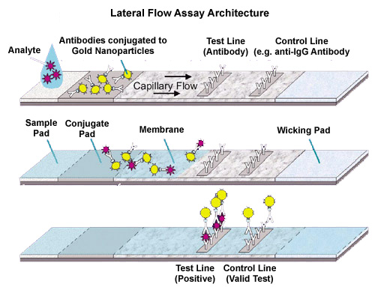

**Figure 1:** Schematic diagram of the structure and components of a lateral flow assay test strip. <http://www.cytodiagnostics.com/store/pc/Lateral-Flow-Immunoassays-d6.htm>

1. Sample Pad: This is the section of the test strip to which the liquid test sample is applied. It is made of a porous material that facilitates the transport of the test sample, via capillary action, upwards through the test strip.
2. Conjugate Pad: This area contains a secondary antibody that is specific to the target analyte which is being tested for in the sample. The secondary antibodies are labelled, or conjugated, with a reporter molecule, such as an enzyme, nanoparticles or fluorescence dyes. As the sample passes through this section of the strip the antibodies recognise and bind to the target analyte and continue flowing through the test strip as a combined sample-antibody complex.
3. Reaction Membrane: This section of the strip contains the test and control lines of the assay and is where the result of the test is displayed.
   1. The test line contains an immobilised primary antibody that is also analyte specific and therefore has the capacity to capture the analyte as the sample-antibody complex passes over the test strip. This forms an analyte “sandwich” that results in the activation of the reporter molecule leading to a visual colour change at the test line in the presence of the target analyte.
   2. The control line is present to confirm that the reaction conditions and components of the test strip are functioning as expected. It contains immobilised antibodies that bind the secondary antibody regardless of whether or not the analyte is bound to it. When the two antibodies bind the reporter molecule is activated leading to a visual colour change that should take place with every test strip.
4. Wicking Pad: This portion of the test strip contains additional absorbent material that acts as a sink to facilitate the movement of the sample through the test strip and maintain capillary flow.

In the context of LMO testing using the lateral flow assay, the test strip is placed in a crude protein extract and a positive result is indicated by the appearance of a test line due to the antibody recognition of the transgenic protein as well as the presence of a control line which indicates that the test is functioning as expected. The absence of a control line renders the test invalid even if the test line displays a colour change, as indicated in figure 2.

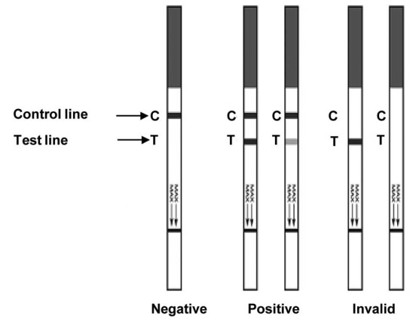

**Figure 2:** Representative results of a lateral flow assay. Adapted from <https://www.spandidos-publications.com/ijmm/30/5/1041>

The advantages of this qualitative method are that it is simple to perform, requires little technical expertise or equipment and can be performed at the site of sampling. Electronic devices have also been developed that allow a semi-quantitative interpretation of the result.

**IN THE LAB:**

To perform a lateral flow test:

1. For seed samples, place the sample into a clean, dry grinding jar and grind with a blender on high speed for about 30 s or until all the grains are ground.

2. Place 5 g of each sample into a clean tube.

3. Add an appropriate amount of extraction buffer [volume buffer (mL) = weight of sample (g) x 3].

4. Mix the ground sample with the extraction buffer by vigorous shaking for at least 15 seconds.

5. Allow the sample to settle for at least 1 minute before testing with the ImmunoStrip®

6. When the sample settles, transfer liquid from the top to a reaction vial until it is filled; avoid suspended particles.

7. Add a test strip to the reaction vial, the protective tape with the arrow indicates the end of the strip to insert into the reaction vial. Test strips must not be submerged more than 0.5cm. If too much of the strip is submerged the antibodies will be released into the sample rather than being wicked up into the strip.

8. After 10 minutes, remove the test strip and analyze the result.

9. To retain the strip, cut off and discard the bottom section covered by the arrow tape.

**ELISA Technique**

The enzyme-linked immunosorbent assay, ELISA, is another type of immunological testing procedure that is based on the use of the specific interaction that takes place between antibodies and their antigens, which in the case of the detection of LMOs, are the proteins synthesised by the newly introduced genes.

There are three different forms of the ELISA assay, as shown in figure 3, each of which is based on the same basic principal of immobilising the antigen, either using an antibody or directly to a solid surface, followed by the use of an enzyme-linked antibody to assess for the presence of the target antigen through the enzyme’s catalysis of a substrate to a detectable signal, typically a colour change. Examples of such enzymes include horseradish peroxidase or alkaline phosphatase.

*Direct ELISA*

In a direct ELISA the antigen, which is contained in a crude protein extract, is bound directly to a solid surface, typically a polystyrene multi-well plate. Detection of the antigen is achieved by a single antibody, which is linked to the reporter enzyme.

*Indirect ELISA*

Like a direct ELISA, the antigen is also bound to a solid surface during an indirect ELISA. However, rather than using a single antibody to detect the antigen, two antibodies are used. The first, primary, antibody is specific to the antigen and it is not labelled with a reporter enzyme. After incubation with the antigen the excess primary antibody is washed away and a secondary antibody is added to the sample well. This antibody is directed against the primary antibody and it is conjugated to the reporter enzyme.

*Sandwich/ Capture Assay*

In this version of the ELISA assay the antigen is not bound to the solid surface, rather an antibody, known as a capture antibody, is immobilised. When the sample is added the capture antibody binds the antigen. Unbound components of the sample are removed by washing. Subsequently, a primary antibody, which is specific to a second epitope of the target antigen, is added to the sample. This antibody may be directly conjugated to the reporter enzyme (direct detection) or a pair of unlabeled primary and conjugated secondary antibodies (indirect detection) may be used to carry out the detection step, as shown in figure 3.

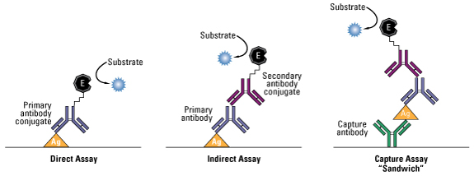

**Figure 3:** Schematic diagram of the three types of commonly used ELISA assays. <https://www.thermofisher.com/ca/en/home/life-science/protein-biology/protein-biology-learning-center/protein-biology-resource-library/pierce-protein-methods/overview-elisa.html>

Given the nature of the ELISA test it is possible to quantify the amount of antigen present in a sample since the intensity of the colour change observed within the sample is directly proportional to the concentration of the antigen, as indicated in figure 4.

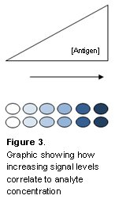

**Figure 4:** Schematic representation of the correlation between signal intensity and antigen concentration. <https://www.bio-rad-antibodies.com/elisa-types-direct-indirect-sandwich-competition-elisa-formats.html>

Therefore, concentration can be estimated by comparing the intensity of the colour changes produced by the sample with those of a series of concentration standards. The intensity of the colour changes in sample and concentration standards can be quantified using a microplate reader.

In the context of LMO detection, ELISA has been widely applied to evaluate the expression level of the protein(s) synthesised by the newly introduced gene(s) at the experimental stage. Information regarding production and use of specific antibodies can be therefore found in many articles describing the developments of transgenic organisms. However, only a few specific antibodies directed against proteins that are the products of transgenes used in approved genetically engineered crops are commercially available[1]. These include antibodies against various forms of the Cry protein, 5-enolpyruvylshikimate-3-phosphate synthase from the *Agrobacterium sp.* strain CP4 and the phosphinothricin acetyltransferase, amongst others. The sensitivity of ELISA tests varies depending on the quality of the antigen/ antibody interaction and the integrity of the protein in the crude extract. ELISA tests can therefore detect the presence of LMOs at concentrations ranging from 0.1% to 5% of the crude extract.

**Limitations of protein-based methods**

Protein based analysis can be a quick and easy tool that can be used to detect and identify the trait of LMOs. However, there are some limitations to its use as indicated below.

*Antibody sensitivity*

The sensitivity of the antibodies used in protein-based methods is dependent on the binding affinity between the antibody and the protein of interest which can be compromised by a number of factors such as degradation due to excessive sample processing.

*Antibody specificity and cross reactivity*

Antibodies can bind an unintended antigen if it is structurally similar to the antigen contained within the protein of interest therefore leading to a false positive signal. The LMO event cannot be identified.

*Commercial availability of antibodies*

Antibodies targeting the protein of interest may not be readily available commercially. This may be due to the lack of demand for such antibodies and since antibodies are costly to make and cannot be stored for extended periods of time.

*Restriction to LMOs with traits/modifications for protein expression*

Only LMOs expressing (detectable amounts of) protein as the result of the genetic modification can be detected with protein-based detection methods.

**DNA-based methods**

**Introduction**

The Polymerase Chain Reaction (PCR) is an *in vitro* molecular biology technique used to enzymatically amplify a specific region of DNA. It was invented by K. Mullis *et.al.* in 1985 and has since revolutionised molecular biology and molecular medicine. It forms the cornerstone for many common experimental procedures such as DNA cloning, detecting and identifying genes for diagnostic and forensic purposes, and for the investigation of gene expression patterns. More recently, PCR has been applied to a number of new and emerging fields such as investigating the authenticity of foodstuff, the presence of genetically modified DNA and the presence of microbiological contamination.

In the following sections the nature of DNA, including its structure and *in vivo* replication, will be described. This will be followed by an explanation of the theoretical and practical principles of PCR and its applications in LMO detection.

**Nature of DNA**

**Components of DNA**

The basic building blocks of DNA are known as nucleotides. A nucleotide is made up of three different chemical components:

1. A phosphate group
2. A pentose sugar molecule, known as deoxyribose
3. One of 4 nitrogenous bases: adenine and guanine, which have double ring structures, known as purines, and, cytosine and thymine which have single ring structures, known as pyrimidines.

When the base binds with the sugar, they form a nucleoside: adenosine, guanosine, cytidine and thymidine. A nucleotide is formed when a purine or pyrimidine base is bound to the pentose ring by an N-glycosylic bond and the phosphate group is bound to the 5’ carbon atom of the sugar by a diesteric bond, as shown in figure 1.

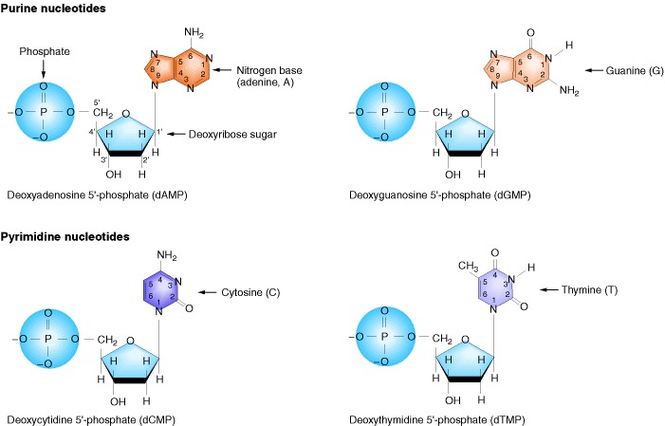

**Figure 1:** Chemical structure of the four nucleotides that form the building blocks of DNA. Griffiths AJF, Gelbart WM, Miller JH, et al. Modern Genetic Analysis. New York: W. H. Freeman; 1999. The Nature of DNA. Available from: <https://www.ncbi.nlm.nih.gov/books/NBK21261/>

**DNA Structure**

A strand of DNA is formed by linking a series of nucleotides together. This is achieved through formation of a phosphodiester bond between the hydroxyl group on the third carbon atom of the deoxyribose sugar molecule and the phosphate group of the subsequent nucleotide. Such a series of linked phosphate and deoxyribose sugar moieties form what is known as a sugar-phosphate backbone. Furthermore, the specific order in which nucleotides are added gives strands of DNA directionality, that is referred to as 5’🡪3’.

Once a single strand of DNA is made it will pair up with another strand through the bases that are attached to the sugar-phosphate backbone. Bases pair up with each other in a very specific manner to form what is known as a “base pair” due to the formation of hydrogen bonds. Adenine will always pair with thymine through two hydrogen bonds while cytosine will always pair with guanine through three hydrogen bonds. This complementarity between the bases results in the formation of two complementary DNA strands that arrange themselves in an antiparallel orientation into a double helix, i.e. one strand runs from 5’🡪3’ while the complementary strand runs in 3´🡪5´. Under physiological conditions, a double-stranded DNA helix is more stable than a single-stranded DNA helix since the bases form a hydrophobic core within the double helix while the sugar-phosphate backbone forms an external hydrophilic layer.

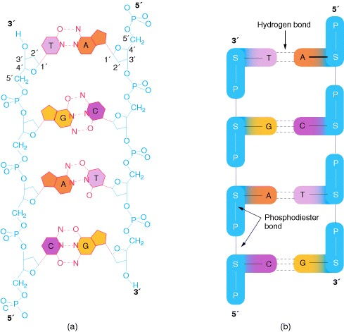

**Figure 2:** A schematic representation of a) the base pairing between the bases of complementary DNA stands and b) the antiparallel orientation of the DNA strands within a double helix. Griffiths AJF, Gelbart WM, Miller JH, et al. Modern Genetic Analysis. New York: W. H. Freeman; 1999. The Nature of DNA. Available from: <https://www.ncbi.nlm.nih.gov/books/NBK21261/>

**DNA Replication**

The aim of DNA replication is to synthesise a second, identical copy, of the existing DNA double helix with the view to preserving and propagating the genetic information. During DNA replication, the double helix unwinds, with each single strand becoming a template for the synthesis of a new, complementary strand. Each of the newly synthesised DNA helices consists of one parent strand and daughter strand. Hence, DNA replication is semi-conservative.

Several enzymes are required in the DNA replication process, as indicated in figure 3.

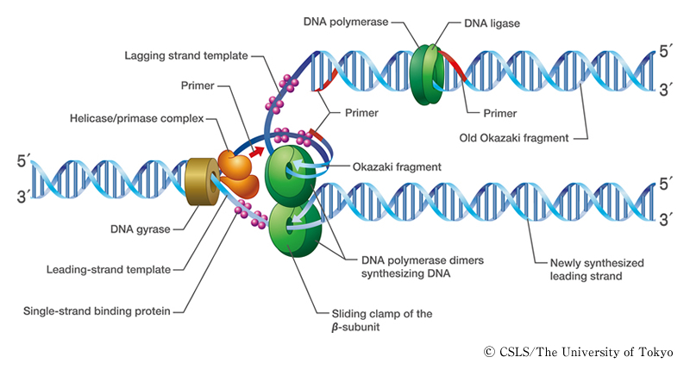

**Figure 3:** Schematic representation of the enzymes involved in DNA replication at the replication fork. <http://csls-text3.c.u-tokyo.ac.jp/active/07_04.html>

The first set of enzymes, topoisomerase/ DNA gyrase and helicase, are responsible for unwinding the DNA double helix in order to make it possible for the other enzymes of the replication machinery to access each of the single strand templates of DNA. Furthermore, the two enzymes help minimise any supercoiling of the DNA by nicking and re-joining single strand of the double helix. Single-stranded binding proteins are also recruited to the replication fork as they play an important role in maintaining the stability of the replication fork. Furthermore, single-stranded DNA is very unstable so single-stranded binding proteins protect it from degradation.

Since the two strands of the DNA helix are arranged in an antiparallel orientation the synthesis of the daughter strand based on the 3’🡪5’ template, also known as the leading strand, is different than that of the 5’🡪3’ template, otherwise known as the lagging strand since DNA can only be synthesised from 5’🡪3’.

Synthesis of the leading strand proceeds directly, from 5'🡪3', as the helix unwinds. However, DNA polymerase cannot start synthesising *ex novo* on a bare single stranded template. It needs a primer with a free 3'OH group onto which it can attach a dNTP. This is achieved by the enzyme primase, which is a part of an aggregate of proteins called the primosome. This enzyme synthesises a small RNA primer on the leading DNA strand from which DNA polymerase can begin its synthesis. Once it is recruited to the template, DNA polymerase continues synthesising the daughter strand using the parent strand as a template. This involves the recruitment of the appropriate free dNTP to its complementary base on the template. The DNA polymerase then catalyses the formation of the 5’🡪3’ phosphodiester bond between the nucleotides. Once DNA synthesis is complete the RNA primers are removed by and the gaps are filled in by a DNA polymerase.

As stated above, DNA can only be synthesized from 5’ 🡪 3’. Accordingly, the synthesis of the lagging strand proceeds in a discontinuous manner and takes place in spurts of short 100 base pair fragments of DNA. These short fragments are known as Okazaki fragments, as shown in figure 4. The Okazaki fragments are then joined together with the enzyme DNA ligase following the removal of the primers.

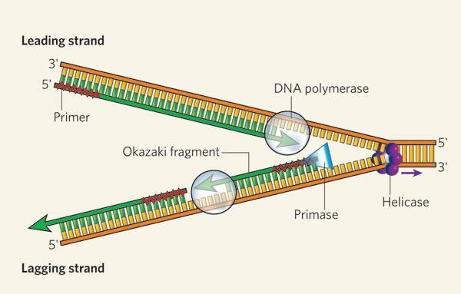

**Figure 4:** Schematic diagram of DNA replication of the leading strand and the lagging strand, including Okazaki fragments. <http://www.nature.com/scitable/content/dna-replication-of-the-leading-and-lagging-14668888>

**Principles of PCR**

PCR is based on the mechanism of DNA replication *in vivo* whereby a double stranded DNA helix is unwound to form two single stranded DNA strands that can act as templates for amplification of a segment of the DNA. To successfully perform a PCR the conditions in the reaction tube need to mirror the conditions that are present *in vivo*. This includes the addition of a set of critical reagents and components for the PCR and exposing these components to a series of very specific temperature conditions that are needed to drive the reaction forward.

**Critical reagents and components of PCR**

* ***Target DNA***

This is the extracted DNA that contains the sequence of DNA that is targeted for amplification. The target sequence can be anywhere from less than 100 to a few thousand bases in length. The mass of DNA template that is typically added to a PCR is typically 200 ng . In principle, amplification of a target sequence by PCR is appearing if at least one intact copy of the target sequence is present in the reaction. However, the higher number of target copies increases the probability of an amplification. Furthermore, increased amounts of DNA compensate for the presence of any damage in the template DNA which may inhibit PCR and allow for the detection of single copies of target sequence.

* ***Primers***

Primers are a pair of short oligonucleotides that are specifically designed to have a high level of complementarity to the regions flanking the segment of DNA that is targeted for amplification. Generally, primers are between 18-24 nucleotides in length with a melting temperature between 55-65oC. Primers are usually added to a PCR at a concentration of 1 μM. The presence of primers at higher concentrations can result in mispriming, primer-dimer formation or amplification of non-target sequences. Conversely, PCR efficiency is reduced if primers are available in limiting concentrations.

**Melting temperature**

The temperature at which half of the double stranded DNA has dissociated into single stranded DNA is known as the melting temperature (Tm).

Tm, and by extension the denaturation process, can be influenced by a number of reaction conditions. For example, at low salt concentrations, high pH and in the presence of organic solvents such as formaldehyde, the melting temperature Tm decreases.

Furthermore, the concentration of G/C, which share 3 hydrogen bonds, and T/A, which share 2 hydrogen bonds, can also affect the Tm. Therefore, the Tm of DNA containing an elevated G/C content is higher compared to that of T/A rich DNA. For example the *Serratia marecescens* genome has a G/C content of approximately 60% and a Tm of approximately 94oC, whereas the *Pneumococcus* genome has a G/C content of approximately 40% and Tm of approximately 85°C.

An estimate of melting temperature can be calculated using the following equation:

Tm = 2(A+T) + 4(G+C)

where A, T, G, C are the number of purinic and pyrimidinic bases in the primer.

One of the more critical parameters for a successful PCR is the use of well-designed primers. The primer sequence determines several things such as the position and length of the product, its melting temperature and ultimately the yield. A poorly designed primer can result in little or no product due to non-specific amplification and/or primer-dimer formation, which can become competitive enough to suppress product formation. Ideally a primer will have a near random mix of nucleotides, 45-55% GC content and be approximately 20 bases long with a Tm in the 55-65°C range. Below is an overview of some of the considerations that contribute to good primer design.

* Primer length

The length of a primer contributes to its specificity, temperature and annealing time. Primers that are between 18-24 bases long are extremely sequence-specific, provided that the annealing temperature is optimal. A general rule-of-thumb is to use an annealing temperature that is 5°C lower than the melting temperature. Optimal annealing temperature should be practically determined using a temperature gradient PCR experiment. Primer length is also proportional to annealing efficiency, with longer primers resulting in less efficient annealing which would lead to fewer templates that are primed at each step and ultimately a decrease in yield.

* Melting temperature (Tm)

It is important to keep in mind that both PCR primers should be designed to have a similar Tm. If there is a mismatch in Tm, a reduction in efficiency or a failure of the amplification will be observed.

* Specificity

Primers must be designed such that they are complementary to a unique region within the template DNA. Primers that contain stretches of polybase sequences, that is a stretch of the same nucleotide only (such as poly dG = GGGGGG), or repeating motifs would have a higher rate of nonspecific priming.

* Inter/ Intra Primer homology

Primers need to be designed with no intra-primer homology, meaning that no regions within the primer should be complementary to each other. This is in order to avoid the formation of secondary structures such as “hair-pins”, which will interfere with the primer annealing to the template. Similarly, inter-primer homology, meaning the presence of complementary regions between the two primers, should also be avoided. This may lead to primer dimer formation and therefore a reduction in yield.

* GC content

Primers should be designed to contain between 45-55% G and C bases. Stretches of G/C bases should be avoided in order to reduce the likelihood of non-specific annealing. Similarly, stretches of A/T bases should also be avoided, as these will “breathe” and open up stretches of the primer-template complex, leading to reduced amplification efficiency.

* 3’-end sequence

The 3’ end of a primer plays an important role in ensuring specific binding. It is therefore often recommended to include G or C residues at the 3' end of primers, which is known as a “GC Clamp”. This helps ensure correct binding at the 3' end, due to the stronger hydrogen bonding between G and C residues as well as minimising any primer “breathing” that might occur.

* ***DNA polymerase***

The DNA polymerase elongates the primers to replicate the targeted DNA sequence. It should have an optimal working temperature of about 70oC and be thermostable.

***History and properties of DNA polymerases***

When the PCR method was first described by Saiki *et al.,* 1985 the polymerase of choice was the Klenow fragment of DNA polymerase I from *Escherichia coli*. This enzyme, however, denatures at temperatures lower than those required to melt the DNA template. Thus, in earlier PCR experiments, fresh polymerase had to be added to the reaction after each cycle. The discovery and use of thermostable DNA polymerases has facilitated the use of PCR because it was no longer necessary to add fresh polymerase to the reaction after every denaturation step.

The first thermostable DNA polymerase used was the Taq polymerase, which was isolated from the bacterium *Thermus aquaticus* that lives in the hot springs of Yellowstone National Park, USA. Even though this enzyme is probably the most widely used in PCR applications, several other DNA polymerases with varying properties are commercially available. Some of these properties include:

* **Processivity:** This is the average number of nucleotides, which a polymerase incorporates into DNA before detaching itself from the template. Taq, for example, synthesises DNA at a rate of 35-100 nucleotides/sec and can amplify stretches of nn bp.
* **5’- 3’ exonuclease activity:** This property of polymerases allows it to remove nucleotides ahead of the growing chain. Both Taq, and AmpliTaq® possess a 5’-3’ exonuclease activity.
* **3’-5’ exonuclease activity:** This allows for proof reading by the DNA polymerase whereby nucleotide mismatches are replaced until the correct base is added. However, the 3’-5’ exonuclease activity can cause primer degradation. Therefore, such enzymes, which include VentTM, DeepVentTM, Pfu and UITmaTM, should only be added after the reaction has started, or alternatively, chemically modified primers should be used.
* **Hotstart Activation:** Polymerases with Hotstart properties, such as AmpliTaqGoldTM, are inactive at room temperature, and can only be activated following an incubation period at 94°C. This provides an increase in specificity, sensitivity and yield.
* ***Deoxyribonucleoside triphosphates***

Free deoxyribonucleoside triphosphates (dNTPs) are required for DNA synthesis, as they are the building blocks for generating the new strands of DNA. The working concentration of each dNTP is between 20-200 μM. Each of the four dNTPs should be used at equal concentrations in order to minimize misincorporation errors. High-purity dNTPs are supplied by several manufacturers either as four individual stocks or as a mixture. The pH of dNTPs stock solutions should be adjusted to 7.0-7.5 to ensure that the pH of the final reaction does not fall below 7.1; however, many dNTP stock solutions are now supplied with pH already adjusted.

* ***Reaction buffers and MgCl2***

Successful PCR requires the use of a suitable buffer in addition to the reagents directly involved in DNA synthesis. The buffer composition depends on the type and characteristics of the polymerase being used and most commonly contain: a) 10 mM Tris, pH 8.3; and, b) 50 mM KCl. Most suppliers provide a 10x buffer for use with the respective polymerase.

In addition to the buffer components, the presence of divalent cations, in the form of magnesium chloride (MgCl2), is critical. The magnesium ions function to:

* form a soluble complex with dNTPs which is essential for their incorporation
* stimulate polymerase activity
* stabilise the interaction of the primer to the template DNA

Low magnesium ion concentrations may lead to low/no yields whereas a high magnesium ion concentrations may lead to the accumulation of non-specific products due to mispriming. MgCl2 concentration in the final reaction mixture is usually between 0.5-5.0 mM, and the optimum concentration is determined empirically. Furthermore, it is important to avoid the presence of contaminants such as chelating agents like EDTA or negatively charged ionic groups such as phosphates since these will alter the concentration of magnesium ions in the reaction.

Multiplex PCR requires specific reaction buffer optimized to amplifiy more than one target sequence in one single reaction.

* ***Other additives and stabilizers***

Current literature includes discussions on various PCR buffers and supplements, such as DMSO, PEG 6000, formamide, glycerol, spermidine, BSA and non-ionic detergents which can be used to increase PCR specificity or efficiency. Certain DNA polymerases will indeed reach their optimum level of activity only in the presence of such supplements.

**IN THE LAB: Preparation of a PCR Mastermix**

The essential components of a PCR are water, reaction buffer, thermostable DNA polymerase, primers, dNTPs, magnesium ions and, finally the template DNA.

When preparing several identical PCRs a single mastermix is assembled rather than preparing several individual reactions. This involves mixing a sufficiently scaled up volume of each of the reagents, except the template DNA, in a single tube. The mastermix is then aliquoted into individual tubes and the template DNA is added. The advantages of using a mastermix include:

* More uniform quantity and quality of reagents present in each individual PCR
* Fewer pipetting transfers reduces risk of contamination of stock solutions
* More accurate volume transfer due to larger volumes being pipetted
* Fewer pipetting transfers reduce the amount of time needed to prepare a PCR

**PCR Procedure**

The PCR technique consists of a series of three steps that are carried out under different temperature conditions, which together comprise a single "cycle”. These three steps, as shown in figure 5, are: a) DNA denaturation, b) Primer annealing / hybridisation; and c) Primer extension.

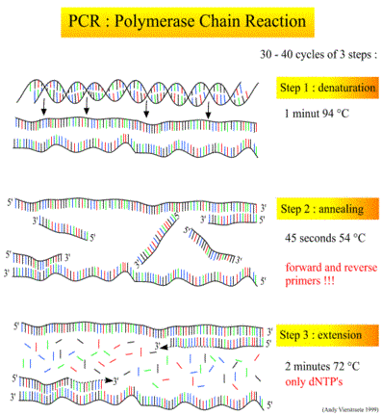

**Figure 5:** The steps of a PCR amplification (Picture: Andy Vierstraete, 1999) <http://users.ugent.be/~avierstr/principles/pcr.html>

* ***DNA denaturation***

The purpose of the denaturation step is to separate any double stranded DNA into two single stranded templates from which DNA synthesis can be based. The two complementary strands are separated as a result of increasing the reaction temperature up to 93-96°C, for a short period of time. This results in the breaking of the hydrogen bonds between the base pairs and the “melting” of any double stranded DNA. The reaction is complete when the entire double stranded DNA becomes single stranded. Furthermore, during this step all enzymatic reactions stop due to the elevated temperature conditions.

* ***Primer annealing***

The primer annealing step allows the primers to bond to its complementary sequence in preparation for the DNA amplification step. It takes place at temperatures around 55-65°C or within 3-5oC of the primer pair’s average Tm. At these reduced temperatures primers are freely flowing in solution and hydrogen bonds are being formed and broken between the bases of the single-stranded primer and the melted template. The primers will form the most stable hydrogen bonds when they are hybridised to a template sequence that is complementary to their own. It is, therefore, important to carry out this step at the right temperature since it needs to be low enough to allow for the hybridisation of the primer to the template DNA but high enough to discourage non-specific priming. Once the primer/template hybrid is formed the DNA polymerase will attach to it and initiate primer extension.

* ***Primer extension***

The primer extension step is when the thermostable DNA polymerase synthesises the new DNA strand by extending the primers across the target sequence using the dNTPs as building blocks. The optimal working temperature for most polymerases is approximately 72°C.

At such temperatures, primers that have successfully annealed to their complementary sequence and have been extended by a few bases possess stronger ionic attraction to the template, which reduces the probability that the nascent strand dehybridizes from the template before extension is complete. However, primers that have misprimed will be released from the templates due to the higher temperatures and therefore the primer will not be extended.

The length of time for the primer extension steps can be increased if the target region of DNA is particularly long, however, for the majority of PCR experiments an extension time of 1 min is sufficient for complete extension.

The final product of the primer extension step is multiple copies of the target DNA fragment whose ends are defined by the 5' termini of the primers and length is defined by the distance between the primers on the DNA template.

**IN THE LAB**

As previously illustrated, PCR is a widely used diagnostic tool. However, due to the highly sensitive nature of this procedure, it is highly prone to contamination by trace amounts of DNA that could serve as templates therefore resulting in amplification of contaminating DNA. Thus, it is critical to perform PCR amplifications under stringent conditions in order to minimise the likelihood of contamination. PCR contamination can originate from several sources such as:

* Laboratory benches, equipment and pipetting devices, which can be contaminated by previous DNA preparations, or by purified restriction fragments
* Cross-contamination between samples
* Products from previous PCR amplifications, also known as carry over contamination.

Below are some standard procedures that should be implemented in diagnostic laboratories in order to establish and maintain a clean environment for any PCR-based assay system. Additional information is provided in the chapter on QA/QC.

**Physical prevention methods**

Providing physically separate working areas with dedicated equipment reduces the risk of contamination. Strict compliance with decontamination requirements is the most important prerequisite to minimise the probability of false-positive results. Laboratory facilities should contain physically separated working areas as follows:

1. *Sample preparation area:* Sample grinding, homogenization and weighing of the required starting material for DNA extraction, are performed in a dedicated sample preparation area.
2. *DNA extraction area:* DNA extraction is performed in a separated area with dedicated pipettes and equipment.
3. *PCR set-up area:* This “clean” room is devoted to the procedures related to the preparation of the PCR reaction.
4. *Post-PCR area:* The amplification of the target DNA sequence is carried out in this area as well as the detection and analysis of PCR products.

**Biochemical prevention methods**

One common biochemical prevention method is through the use of Uracil-DNA Glycosylase (UNG). This method’s mechanism of action involves substituting dUTP for dTTP during PCR amplification, to produce uracil-containing DNA. Subsequent PCR reaction mixtures are then treated with UNG prior to PCR amplification. This leads to the release of free uracil from uracil-containing DNA and degradation of the contaminating uracil-containing DNA during the initial denaturation step of PCR due to the elevated temperatures and alkaline conditions

For this method to function as a method of contamination prevention, it requires that all PCR-reactions in the lab be carried out with dUTP instead of dTTP. However, using uracil-containing DNA may affect downstream applications such as reduced activity of some restriction enzymes and protein-binding or DNA- protein interaction studies.

**PCR Instrumentation**

Two major advances have allowed the PCR process to be automated:

* The use of thermostable DNA polymerases, which resist denaturation and thus inactivation at high temperatures. Therefore, an initial aliquot of polymerase could last throughout numerous PCR cycles.
* The development of thermocyclers, or PCR machines, which could be programmed to alter their temperatures rapidly and in an automated manner. There are several thermocycler designs in use, for example: heating and cooling by fluids, heating by electrical resistance and cooling by fluids and heating by electric resistance and cooling by semiconductors.
* Development of thermocyclers that detect emitted light in real-time PCR-reactions.

A typical thermocycler temperature cycling profile for a three-step PCR is shown in Figure 7.

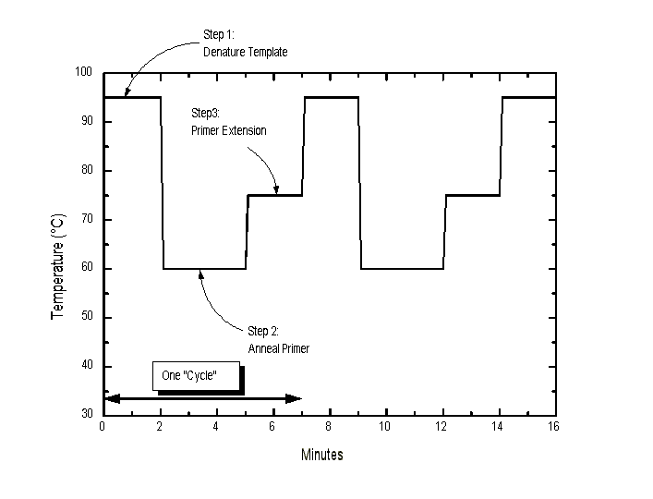

**Figure 7:** PCR temperature cycling profile

**Exponential Amplification**

After each PCR cycle, the newly synthesised segments of DNA can serve as templates during subsequent cycles leading to an exponential increase in the number of copies of the target sequence. The number of copies obtained can be expressed by the following equation:

x: Template copy number

**(2n-2n)x** where: n: Number of cycles

2n: Products of undefined length obtained after the first and second cycles

The equation takes into account the fact that the products of the first successful cycle of amplification are heterogeneously sized DNA molecules, with lengths that may exceed the distance between the binding sites of the two primers. In the second cycle, these molecules generate DNA strands of defined length that will accumulate in an exponential fashion during later rounds of amplification and will form the dominant products of the reaction, as indicated in figure 6.

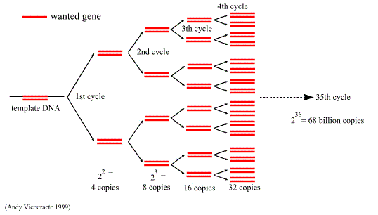

**Figure 6:** The exponential amplification of DNA in PCR (Picture: Andy Vierstraete, 1999) <http://users.ugent.be/~avierstr/principles/pcr.html>

Therefore, after 20 PCR cycles there will potentially be a 220 fold amplification of the target sequence, assuming there is 100% amplification efficiency during each cycle. The efficiency of a PCR will vary from template to template and based on the degree to which the PCR has been optimised.

**Cycle number and plateau effect**

The number of amplification cycles necessary to produce enough target DNA so that it can be visualised using an agarose gel depends largely on the starting concentration of the template DNA. For example, in order to amplify a starting concentration of 50 target molecules 40-45 cycles are recommended, whereas 25-30 cycles are enough to amplify a starting concentration of 3x105 molecules to the same concentration.

This non-proportionality is due to the so-called “plateau effect”, which is the attenuation of the exponential rate of product accumulation during the later cycles of PCR. This may be caused by reagent degradation, reagent depletion, by-product inhibition, competition for reagents by non-specific products and competition for primer binding due to the re-annealing of the product.

If the desired product is not obtained in 30 cycles, a small sample of the amplified product could be used as a template in a new reaction mixture and re-amplified for 20-30 cycles rather than extending the PCR to more cycles. In some cases where the template concentration is limiting, this re-amplification can produce an acceptable concentration of product, whereas extension of cycling to 40 times or more would not and may also increase the likelihood of non-specific amplification.

**IN THE LAB: Template DNA and Cycle Number**

The selection of the ideal number of PCR cycles for the successful amplification of the target region depends on the number of template DNA copies available.

The concentration of DNA that is usually added to PCR should ideally be approximately 10-50 ng/µl. However, the number of copies of the target sequence that is available within this amount of DNA depends on the complexity of the DNA sample. A comparison of the genome size of various plant species that are frequently used in plant transformation and the corresponding number of genome copies in a defined amount of DNA are given in Table 3.

For example, in a 4 kb plasmid containing a 1 kb insert that is targeted for PCR, 25% of the input DNA is the target of interest. Conversely, a 1 kb gene in the maize genome, which is 5x109 bp in size, represents approximately 0.00002% of the input DNA. Therefore, approximately 1,000,000 times more maize genomic DNA is required to maintain the same number of target copies per reaction.

For optimal results, at least 100 copies of the target sequence should be available in the starting template to obtain a signal within 25-30 cycles.

In cases where the template DNA contains less than 100 copies of the target sequence more than 30 PCR cycles would be needed in order to detect a signal by gel electrophoresis. As previously discussed this should be avoided and alternate methods should be employed.

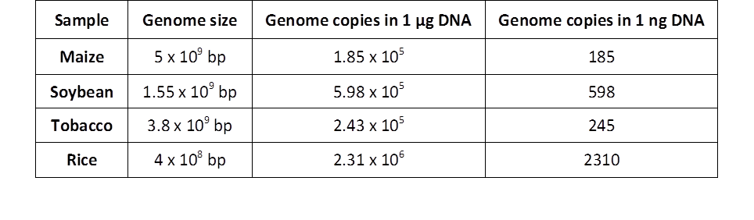

**Table 3:** Comparison of genome size of some plant species and corresponding genome copies in defined amount of DNA

**Example Experimental Procedure – End-point PCR**

GeneralThe specificity of analytical methods using DNA as the target to determine the presence of LMO depends on the specific properties of the targeted DNA-sequence. The different application and

classifications of specificity are as follows.

a) Taxon-specific methods target DNA sequences found in a single taxon, usually a species but possibly of lower or higher taxonomic rank. The taxon-specific methods may be useful to assess the presence,

quality and quantity of DNA derived from the taxon, and are sometimes used as the point of reference for relative quantitation of the LMO content.

b) Screening methods target DNA sequences found in several but not necessarily all transformation events. These sequences may also be found in non-LMO material, for example due to the presence of natural viruses or bacteria. Screening methods may be useful to assess whether or not a product is likely to contain LMO-derived material. An example of a screening method is a qualitative PCR targeting the CaMV 35S promoter and/or the nos terminator from Agrobacterium tumefaciens Ti-plasmid.

c) Construct-specific methods target DNA sequences that are only found in LMO-derived material, i.e.

genetically engineered combinations of DNA sequence elements. Detection of a particular gene construct may be sufficient to identify the transformation event from which the DNA is derived, but the same gene construct may have been used in more than one transformation event, and the inserted number of copies of complete and/or truncated gene constructs per haploid GM-genome may vary between events.

d) Event-specific methods target DNA sequences that are only found in material derived from a single

transformation event, usually a DNA sequence spanning the junction between the inserted DNA and the host genome (the integration border region). The number of copies of the event-specific DNA sequence is always one per haploid GM-genome. The event-specific methods are particularly suitable for identification of a specific event and, when used in a validated real-time PCR method, may also quantify the amount of DNA derived from a particular LMO.

The following protocols are examples for end-point PCR-based methods allowing a screening for a number of LMOs, targeting the 35S promoter and the *nos* terminator, for the detection of specific LMOs (GTS 40-3-2 Roundup Ready® soybean, MON810 maize and Bt-11 maize).

The following methods allow only a qualitative result with indication of detected/not detected of the target sequence in the sample by analysis of electrophoresis results.

***Equipment***

* Micropipettes
* Thermocycler
* Microcentrifuge
* Vortex mixer
* Rack for reaction tubes
* 0.2 ml PCR reaction tubes
* 1.5 ml microcentrifuge tubes
* Separate sterile room with UV hood

REMARK

All equipment should be DNA-free and where possible, sterilised prior to use.

In order to avoid contamination, barrier pipette tips protected against possible aerosol formation should be used.

***Reagents***

* dATP (CAS 1927-31-7)
* dCTP (CAS 2056-98-6)
* dGTP (CAS 2564-35-4)
* dTTP (CAS 365-08-2)
* 10x PCR buffer (usually delivered from the same supplier as the Taq DNA polymerase)
* 25 mM MgCl2
* Taq DNA polymerase 5 U/µL
* Upstream and downstream oligonucleotides (i.e. forward and reverse primers)
* Nuclease-free water

*4 mM dNTP stock solution*

* dNTPs might be supplied in pre-mixed stocks - containing dATP, dCTP, dGTP, dTTP in equal concentration - or separated in individual concentrated stocks. If individual stocks are used, dissolve each dNTP in sterile deionised water, to obtain a final 4 mM dNTP stock solution.
* Divide in aliquots and store at -20°C, dNTPs are stable for several months.

*20 μM primer solutions*

Primer oligonucleotides are generally supplied in lyophilised form and should be diluted to a final concentration of 20 μM.

* Prepare 20 μM primer solution according to the supplier’s instructions.
* 1 μM = 1 pmol/μL so 20 μM = 20 pmol/μL
* X nmol primer + 10X μL sterile water = 100 pmol/μL = 100 μM
* Incubate 5 min at 65°C, shake and incubate for another 3 min at 65°C
* To prepare a 1:5 dilution: Prepare 1 microcentrifuge tube with 400 μL sterile water and add 100 μL of the primer solution (100 μM), final concentration: 20 μM
* Divide into small aliquots and store at -20°C. The aliquots stored at -20°C are stable for at least 6 months; the lyophilised primers are stable at -20°C for up to three years unless otherwise stated by the manufacturer.

*10x PCR buffer*

* Usually the 10x PCR buffer is provided together with the *Taq* DNA polymerase and is ready to use. The buffer should be mixed and briefly centrifuged prior to use.
* Aliquots are stored at -20°C and are stablefor several months.

*25 mM MgCl2 solution*

“PCR grade” MgCl2 solution is generally supplied together with the *Taq* DNA polymerase and is ready to use. The solution should be mixed (vortex) before each use and briefly centrifuged (destruction of the concentration gradient which can be formed in the case of a prolonged conservation). Store at -20°C.

*Nuclease-free water aliquots*

Sterile nuclease-free, deionised water aliquots are prepared for the mastermix and for the dilution of the DNA. For each series of analyses, a new aliquot should be used.

**Taxon-specific PCR: soybean-lectin**

The identification of soybean DNA is performed targeting the *lectin* gene.

The PCR with the primers GMO3/GMO4 determines if amplifiable soybean DNA is present in the sample.

***Characteristics of primers GM03 and GM04***

|  |  |
| --- | --- |
| **GM03** | |
| Sequence | GCCCTCTACTCCACCCCCATCC |
| Length | 22 |
| Mol. Weight (g/mol) | 6471.6 |
| Melting point (G/C) based on a [Na+] of 50 mM | 65.1 |
| **GM04** | |
| Sequence | GCCCATCTGCAAGCCTTTTTGTG |
| Length | 23 |
| Mol. Weight (g/mol) | 6981.1 |
| Melting point (G/C) based on a [Na+] of 50 mM | 59.6 |

***Controls***

It is important to always include controls at every PCR. Negative controls are designed to check if the PCR reagents are contaminated with DNA. Positive controls with characterised samples are also critical in determining the efficiency and specificity of PCR.

The following controls must be introduced in analysis performed with PCR:

* Positive DNA target control: pure DNA, isolated from the conventional soybean
* Negative DNA targetcontrol: pure DNA, isolated from another species, not containing the *lectin* gene
* Amplification reagent control : negative control of the Mastermix, in which water is used instead of DNA

***Mastermix preparation***

The necessary reagents for a series of 10 samples (including positive/negative/no template controls) are mixed together according to the instruction given in Table 1. The following procedure applies to a sample containing 20 μL of GMO3/GMO4 Mastermix and 5 μL of DNA solution. All solutions are stored on ice during the preparation of the Mastermix.

|  |  |  |  |
| --- | --- | --- | --- |
|  | **Final**  **concentration** | **Mastermix**  **for one sample** | **Mastermix**  **for 10 samples** |
|  |  |  |  |
| Sterile, deionised water |  | 10.3 μL | 103 μL |
| 10x PCR Buffer | 1x | 2.5 μL | 25 μL |
| 25 mM MgCl2 | 1.5 mM | 1.5 μL | 25 μL |
| 4 mM dNTPs | 0.8 mM | 5 μL | 50 μL |
| 20 μM oligonucleotide GM03 | 0.2 μM | 0.25 μL | 2.5 μL |
| 20 μM oligonucleotide GM04 | 0.2 μM | 0.25 μL | 2.5 μL |
| *5 U/µL Taq* DNA polymerase | 1 U/rcn | 0.2 μL | 2 μL |
|  |  |  |  |
| **TOTAL** |  | **20 μL** | **200 μL** |

**Table 1.** GM03/GM04 Mastermix

* Prepare a 1.5 ml microcentrifuge tube
* Add the reagents following the order given in Table 1
* Mix gently the GMO3/GMO4 Mastermix by pipetting and centrifuge briefly
* Divide the Mastermix into aliquots of 20 μL in 0.2 ml PCR reaction tubes
* Add 5 μL of the DNA solution to the previous aliquots (note: dilute the DNA at 10-20 ng/μL)
* Shake gently and centrifuge briefly
* Place the PCR reaction tubes in the thermocycler

***PCR program***

|  |  |  |
| --- | --- | --- |
| **Stage** | **Temperature** | **Time** |
| Activation/Initial Denaturation | 95°C | 10 min |
| Denaturation | 95°C | 30 sec |
| Annealing | 60°C | 30sec |
| Extension | 72°C | 1 min |
| Denaturing, Annealing & Extension |  |  |
| Number of cycles | 35 |  |
| Final Extension | 72°C | 3 min |
|  | 4oC | ∞ |

*Following amplification, the samples are centrifuged briefly and put on ice.*

* **Note**: The use of a different thermocycler model or brand leads to the same results provided that PCR programmes are adapted and validated accordingly.

***Analysis of PCR products***

After amplification of the target sequence, the PCR products are analysed by agarose gel electrophoresis in the presence of ethidium bromide. 8 μL of a PCR reaction is mixed with 2 μL of loading buffer; samples are then loaded onto the agarose gel. Migration is performed at 100 V over a period of 1 hour. Size markers (15 μL of 100 bp ladder) are electrophoresed in adjacent wells of the gel to allow accurate size determination of the amplicons. After the run, UV light allows visualisation of the amplified DNA on the gel. The gel may be photographed to provide a permanent record of the result of the experiment.

***Interpretation of the results***

The primer pair GM03/GM04 for the detection of the native *lectin* gene is used as a system's control check; the presence of a *lectin* specific band at **118 bp** confirms that the extracted DNA is of appropriate amplifiable quality.

The positive control will amplify a band at 118 bp. The negative control and the no-template control should not provide any band.

If the positive/negative controls do not give the expected results, the PCR analysis of the selected samples is not valid.

If the controls give the expected results and the sample shows absence of the 118 bp band, in this sample no amplifiable soybean DNA is present. It should be noted that this as well as other protocols in this chapter are qualitative methods, therefore allowing only a qualitative (yes/no) result.

**Taxon-specific PCR: maize-invertase**

The identification of maize DNA is performed targeting the *invertase* gene (ivr1).

The PCR with the primers IVR1-F/IVR1-R determines if maize DNA of suitable amplification quality is present in the sample.

***Characteristics of primers IVR1-F and IVR1-R***

|  |  |
| --- | --- |
| **IVR1-F** | |
| Sequence | CCGCTGTATCACAAGGGCTGGTACC |
| Length | 25 |
| Mol. Weight (g/mol) | 7643 |
| Melting point (G/C) based on a [Na+] of 50 mM | 63.2 |
| **IVR1-R** | |
| Sequence | GGAGCCCGTGTAGAGCATGACGATC |
| Length | 25 |
| Mol. Weight (g/mol) | 7732 |
| Melting point (G/C) based on a [Na+] of 50 mM | 62.8 |

***Controls***

* Positive DNA target control: pure DNA, isolated from the conventional maize
* Negative DNA target control: pure DNA, isolated from a species other than maize not containing the *invertase* gene
* • Amplification reagent control : negative control of the Mastermix, in which water is used instead of DNA

***Mastermix preparation***

The necessary reagents for a series of 10 samples (including positives/negative/no template controls) are mixed together as indicated in Table 2.

The following procedure applies to a sample containing 20 μL of IVR1-F/IVR1-R Mastermix and 5 μL of DNA solution. All solutions are stored on ice during preparation of the Mastermix.

|  |  |  |  |
| --- | --- | --- | --- |
| **Reagents** | **Final**  **concentration** | **Mastermix**  **for one sample** | **Mastermix**  **for 10 samples** |
|  |  |  |  |
| Sterile, deionised water |  | 12.05 μL | 120.5 μL |
| 10x PCR Buffer | 1x | 2.5 μL | 25 μL |
| 25 mM MgCl2 | 1.5 mM | 1.5 μL | 15 μL |
| 4 mM dNTPs | 0.4 mM | 2.5 μL | 25 μL |
| 20 μM oligonucleotide IVR1-F | 0.5 μM | 0.63 μL | 6.3 μL |
| 20 μM oligonucleotide IVR1-R | 0.5 μM | 0.63 μL | 6.3 μL |
| *5 U/µL Taq* DNA polymerase | 1 U/rcn | 0.20 μL | 2 μL |
|  |  |  |  |
| **TOTAL** |  | **20 μL** | **200 μL** |

**Table 2.** IVR1-F/IVR1-R Mastermix

* Prepare a 1.5 ml microcentrifuge tube
* Add the reagents following the order given in Table 2
* Mix gently the IVR1-F/IVR1-R Mastermix by pipetting and centrifuge briefly
* Divide the Mastermix into aliquots of 20 μL in 0.2 ml PCR reaction tubes
* Add 5 μL of the DNA solution to the previous aliquots (note: dilute the DNA at 10-20 ng/μL)
* Shake gently and centrifuge briefly
* Place the PCR reaction tubes in the thermocycler

***PCR program* (IVR1-F/IVR1-R)**

|  |  |  |
| --- | --- | --- |
| **Stage** | **Temperature** | **Time** |
| Initial denaturation | 95˚C | 12 min |
|  |  |  |
| Denaturation | 95 ˚C | 30 sec |
| Annealing | 64 ˚C | 30 sec |
| Extension | 72 °C | 1 min |
| Number of cycles | 35 |  |
| Final extension | 72˚C | 10 min |
|  | 4˚C | ∞ |

*Following amplification, the samples are centrifuged briefly and put on ice.*

***Analysis of PCR products***

After amplification of the DNA, the PCR products are analysed using agarose gel electrophoresis with ethidium bromide. 8 μL of the solution is mixed with 2 μL of loading buffer. The solution mixture is then loaded onto an agarose gel. Migration should take place at 100 V over a period of 1 hour. Size markers (15 μL of 100 bp ladder) are electrophoresed in adjacent wells of the gel to allow accurate size determination of the amplicons. After the run, ultraviolet transillumination (UV) allows visualisation of the DNA in the gel. The gel may be photographed to provide a permanent record of the result of the experiment.

***Interpretation of the results***

The primer pair IVR1-F/IVR1-R is used for the detection of the native maize *invertase* gene as a control check on the amplification quality of the extracted DNA. If the extracted DNA is of sufficient amplification quality an *invertase* specific band at approximately **225 bp** will be observed on the gel.

The positive control should also amplify showing a band size of 225 bp.

The negative control and the no-template should not provide any band.

If the positive/negative controls do not give the expected results, the PCR analysis of the selected samples is not valid.

If the controls give the expected results and the sample shows absence of the 225 bp band, then, provided that the DNA is not inhibited, in this sample, no amplifiable maize DNA is present.

**Please note:** this method is provided as a sample experimental procedure and other options for the detection of taxon-specific targets in maize are available.

**Examples for screening methods for the detection of Genetically Modified Plants**

In general genes are under the regulation of promoters and terminators. The most widely used sequences for the regulation of a transgene are the P-35S-CaMV promoter (derived from the *CaMV*) and the T-nos-RHIRDterminator (derived from *Agrobacterium tumefaciens).* The detection of one of these regulatory sequences in the soybean and/or maize containing sample under examination indicates GMO presence.

In GTS 40-3-2 Roundup Ready® soybean as well as in Bt-11, the identification of both the 35S promoter and the *nos* terminator is possible, whereas only the 35S promoter is present in the MON810 maize line.

Examples for end-point PCR methods for screening are given in the following.

**Detection of the *CaMV* 35S promoter**

***Characteristics of primers* p35S-cf3 *and* p35S-cr4**

|  |  |
| --- | --- |
| **p35S-cf3** | |
| Sequence | CCACGTCTTCAAAGCAAGTGG |
| Length | 21 |
| Mol. weight (g/mol) | 6414.5 |
| Melting point (G/C) based on a [Na+] of 50 mM | 57.4 |
| **p35S-cr4** | |
| Sequence | TCCTCTCCAAATGAAATGAACTTCC |
| Length | 25 |
| Mol. weight (g/mol) | 7544.2 |
| Melting point (G/C) based on a [Na+] of 50 mM | 56.3 |

***Controls***

* Positive control: DNA from reference material (e.g. maize 0.5% GM)
* Negative control: DNA from reference material (e.g. maize 0% GM)
* No-template control (NTC): negative control of the Mastermix, in which water is used instead of DNA

***Mastermix preparation***

The necessary reagents for a series of 10 samples (including positive/negative/no template controls) are mixed together according to the instructions given in Table 3.

The following procedure applies to a sample containing 20 μL of p35S-cf3/p35S-cr4 Mastermix and 5 μL of DNA solution. All solutions are stored on ice during the preparation of the Mastermix.

|  |  |  |  |
| --- | --- | --- | --- |
| **Reagents** | **Final concentration** | **Volume for one** | **Volume for 10 samples** |
| Sterile, deionised water |  | 13.94 μL | 139.4 μL |
| 10x PCR buffer | 1x | 2.5 μL | 25 μL |
| 25 mM MgCl2 | 1.5 mM | 1.5 μL | 1.5 μL |
| 4 mM dNTPs | 0.64 mM | 0.4 μL | 4 μL |
| 20 μM oligonucleotide 35s-cf3 | 0.6 μM | 0.75 μL | 7.5 μL |
| 20 μM oligonucleotide 35S-cr4 | 0.6 μM | 0.75 μL | 7.5 μL |
| 5 U/µL Taq DNA polymerase | 0.8 U/rcn | 0.16 μL | 1.6 μL |
| **TOTAL VOLUME** |  | **20** μL | **200** μL |

**Table 3.** p35S-cf3/p35S-cr4 Mastermix

* Prepare a 1.5 ml microcentrifuge tube
* Add the reagents following the order given in Table 3
* Mix gently the p35S-cf3/p35S-cr4 Mastermix by pipetting and centrifuge briefly
* Divide the Mastermix into aliquots of 20 μL in 0.2 ml PCR reaction tubes
* Add 5 μL of the DNA solution to the previous aliquots
* Shake gently and centrifuge briefly
* Place the PCR reaction tubes in the thermocycler

***PCR program* (p35S-cf3/p35S-cr4)**

|  |  |  |
| --- | --- | --- |
| **Stage** | **Temperature** | **Time** |
| Initial Denaturation | 95°C | 10 min |
| Denaturation | 95°C | 25 sec |
| Annealing | 62°C | 30 sec |
| Extension | 72°C | 45 sec |
| Number of cycles | 50 |  |
| Final Extension | 72°C | 7 min |
|  | 4oC | ∞ |

*Following amplification, the samples are centrifuged briefly and put on ice.*

***Analysis of PCR products***

After amplification of the target sequence, the PCR products are analysed by agarose gel electrophoresis with ethidium bromide. 8 μL of the solution is mixed with 2 μL of loading buffer; the solution is then loaded onto the agarose gel. Migration should take place at 100 V over a period of 1 hour. Size markers (15 μL of 100 bp ladder) are electrophoresed in adjacent wells of the gel to allow accurate size determination of the amplicons. After the run, ultraviolet transillumination allows visualisation of the DNA in the gel. The gel may be photographed to provide a permanent record of the result of the experiment.

It may be desirable in some cases to confirm a ositive or negative PCR result for a particular genetic modification. This may be achieved by employing primers to an alternative target sequence; this is particularly suitable for confirmation of screening test results. A positive identification of the specific target sequence may be confirmed by an appropriate method other than size determination of the PCR product, e.g. hybridization of the PCR product with specific probes, carrying out restriction analyses of the PCR product, sequencing of the PCR product or other equivalent confirmation.

***Interpretation of the results***

The primer pair p35S-cf3/p35S-cr4 is used for detection of the CaMV 35Spromoter, yielding a **123 bp** fragment. This promoter regulates the gene expression of many transgenic plants such as GTS 40-3-2 Roundup Ready® soybean and maize line Bt-11.

The positive control will amplify showing a band at 123 bp. The negative control and the amplification reagent control should not give any band. If the positive/negative controls do not give the expected results, the PCR analysis of the selected samples is not valid.

If the controls give the expected results and the sample gives a band at 123 bp, it can be claimed that in this sample, genetically modified DNA is present.

**Detection of the *nos* terminator**

***Characteristics of primers* HA-*nos* 118-f andHA-*nos* 118-r**

|  |  |
| --- | --- |
| **HA-*nos* 118-f** | |
| Sequence | GCATGACGTTATTTATGAGATGGG |
| Length | 24 |
| Mol. weight (g/mol) | 7462.8 |
| Melting point (G/C) based on a [Na+] of 50 mM | 56.2 |
| **HA-*nos* 118-r** | |
| Sequence | GACACCGCGCGCGATAATTTATCC |
| Length | 24 |
| Mol. weight (g/mol) | 7296.9 |
| Melting point (G/C) based on a [Na+] of 50 mM | 61.2 |

***Controls***

* Positive DNA target control: DNA from reference material (e.g. RRS 0.5% GM)
* Negative DNA target control: DNA from reference material (e.g. soybean 0% GM)
* Amplification reagent control: negative control of the Mastermix, in which water is used instead of DNA

***Mastermix preparation***

The necessary reagents for a series of 10 samples (including positive/negative/no template controls) are mixed together according to the instructions given in Table 4.

The following procedure applies to a sample containing 20 μL of HA-*nos*118-f/HA-*nos*118-r Mastermix and 5 μL of DNA solution. All solutions are stored on ice during the preparation of the Mastermix.

|  |  |  |  |
| --- | --- | --- | --- |
| **Reagents** | **Final concentration** | **Volume for one** | **Volume for 10 samples** |
| Sterile, deionised water |  | 10.34 μL | 103.4 μL |
| 10x PCR buffer | 1x | 2.5 μL | 25 μL |
| 25 mM MgCl2 | 1.5 mM | 1.5 μL | 15 μL |
| 4 mM dNTPs | 0.64 mM | 4 μL | 40 μL |
| 20 μM oligonucleotide HA-nos118f | 0.6 μM | 0.75 μL | 7.5 μL |
| 20 μM oligonucleotide HA-nos118r | 0.6 μM | 0.75 μL | 7.5 μL |
| 5 U/µL Taq DNA polymerase | 0.8 U/rcn | 0.16 μL | 1.6 μL |
| **TOTAL VOLUME** |  | **20** μL | **200** μL |

**Table 4.** HA-*nos*118-f/HA-*nos*118-r Mastermix

* Prepare a 1.5 ml microcentrifuge tube
* Add the reagents following the order given in Table 4
* Mix gently the HA-*nos*118-f/HA-*nos*118-r Mastermix by pipetting and centrifuge briefly
* Divide the Mastermix into aliquots of 20 μL in 0.2 ml PCR reaction tubes
* Add 5 μL of the DNA solution to the previous aliquots
* Shake gently and centrifuge briefly
* Place the PCR reaction tubes in the thermocycler

***PCR Program (HA-nos118-f/HA-nos118-r)***

|  |  |  |
| --- | --- | --- |
| **Stage** | **Temperature** | **Time** |
| Initial Denaturation | 95°C | 10 min |
| Denaturation | 95°C | 25 sec |
| Annealing | 62°C | 30 sec |
| Extension | 72°C | 45 sec |
| Number of cycles | 50 |  |
|  |  |  |
| Final Extension | 72°C | 7 min |
|  | 4oC | ∞ |

*Following amplification, the samples are centrifuged briefly and put on ice.*

***Analysis of PCR products***

Following amplification, the PCR products are analysed using agarose gel electrophoresis with ethidium bromide. 8 μL of the solution is mixed with 2 μL of loading buffer; the solution is then loaded onto an agarose gel. Migration should take place at 100 V over a period of 1 hour. Size markers (15 μL of 100 bp ladder) are electrophoresed in adjacent wells of the gel to allow accurate size determination of the amplicons. After the run, ultraviolet transillumination allows visualisation of the DNA in the gel. The gel may be photographed to provide a permanent record of the result of the experiment.

It may be desirable in some cases to confirm a ositive or negative PCR result for a particular genetic modification. This may be achieved by employing primers to an alternative target sequence; this is particularly suitable for confirmation of screening test results. A positive identification of the specific target sequence may be confirmed by an appropriate method other than size determination of the PCR product, e.g. hybridization of the PCR product with specific probes, carrying out restriction analyses of the PCR product, sequencing of the PCR product or other equivalent confirmation.

***Interpretation of the results***

The primer pair HA-*nos*118-f/HA-*nos*118-r is used for detection of the *nos* terminator, yielding a **118 bp** fragment. This terminator is present in the Roundup Ready® soybean and other lines of transgenic plants (e.g. Maize line Bt-11).

The positive control will amplify showing a band at 118 bp.

The negative control and the no-template should not give any band.

If the positive/negative controls do not give the expected results, the PCR analysis of the selected samples is not valid.

If the controls give the expected results and the sample gives a band at 118 bp, this means that in this sample modified DNA is present.

**Specific detection of GTS 40-3-2 Roundup Ready® soybean by end-point PCR**

This is a construct specific method for the detection of genetically modified glyphosate resistant GTS 40-3-2 (Roundup Ready®) soy beans in raw/processed materials by amplification of a 172 bp single copy sequence representing the junction region between the CaMV 35S promoter and the *Petunia hybrida* chloroplast targeting signal preceding the *Agrobacterium* EPSPS sequence.

***Characteristics of primers***

|  |  |
| --- | --- |
| **P35S-af2** | |
| Sequence | TGATGTGATATCTCCACTGACG |
| Length | 22 |
| Mol. weight (g/mol) | 6725,4 |
| Melting point (G/C) based on a [Na+] of 50 mM | 53 |
| **petu-ar1** | |
| Sequence | TGTATCCCTTGAGCCATGTTGT |
| Length | 22 |
| Mol. weight (g/mol) | 6707,4 |
| Melting point (G/C) based on a [Na+] of 50 mM | 53 |

***Controls***

* Positive DNA target control: DNA from reference material (e.g. RRS 0.1% GM)
* Negative DNA target control: DNA from reference material (e.g. soybean 0% GM)
* Amplification reagent control: negative control of the Mastermix, in which water is used instead of DNA

***Mastermix preparation***

The necessary reagents for one sample (including positive/negative/no template controls) are mixed together according to the instructions given in Table 5.

The following procedure applies to a sample containing 24 μL of P35S-af2/petu-ar1 Mastermix and 1 μL of DNA solution. All solutions are stored in ice during the preparation of the Mastermix.

|  |  |  |  |
| --- | --- | --- | --- |
| **Reagents** | **Final concentration** | **Volume for one** | **Volume for 10 samples** |
| Sterile, deionised water |  | 10.4 μL | 104 μL |
| 10x PCR buffer | 1x | 2.5 μL | 25 μL |
| 25 mM MgCl2 | 1.5 mM | 1.5 μL | 15 μL |
| 4 mM dNTPs | 0.8 mM | 5 μL | 50 μL |
| 20 μM oligonucleotide 35s-f2 | 0.2 μM | 0.25 μL | 2.5 μL |
| 20 μM oligonucleotide petu-r1 | 0.2 μM | 0.25 μL | 2.5 μL |
| 5 U/µL Taq DNA polymerase | 0.5 U/rcn | 0.1 μL | 1 μL |
| **TOTAL VOLUME** |  | **20** μL | **200** μL |

**Table 5**. P35S-af2/petu-ar1 Mastermix

* Prepare a 1.5 ml microcentrifuge tube
* Add the reagents following the order given in Table 5
* Mix gently the P35S-af2/petu-ar1 Mastermix by pipetting and centrifuge briefly
* Divide the Mastermix into aliquots of 20 μL in 0.2 ml PCR reaction tubes
* Add 5 μL of the DNA solution to the previous aliquots
* Shake gently and centrifuge briefly
* Place the PCR reaction tubes in the thermocycler

***PCR program* (P35S-af2/petu-ar1)**

|  |  |  |
| --- | --- | --- |
| **Stage** | **Temperature** | **Time** |
| Initial Denaturation | 95°C | 10 min |
| Denaturation | 95°C | 30 sec |
| Annealing | 60°C | 30 sec |
| Extension | 72°C | 25 sec |
| Number of cycles | 35 |  |
|  |  |  |
| Final Extension | 72°C | 3 min |
|  | 4oC | ∞ |

*Following amplification, the samples are centrifuged briefly and put on ice.*

***Analysis of PCR products***

Following amplification, the PCR products are analysed using agarose gel electrophoresis with ethidium bromide. 8 μL of the solution is mixed with 2 μL of loading buffer; the solution is then loaded onto an agarose gel. Migration should take place at 100 V over a period of 1 hour. Size markers (15 μL of 100 bp ladder) are electrophoresed in adjacent wells of the gel to allow accurate size determination of the amplicons. After the run, ultraviolet transillumination allows visualisation of the DNA in the gel. The gel may be photographed to provide a permanent record of the result of the experiment.

It may be desirable in some cases to confirm a ositive or negative PCR result for a particular genetic modification. This may be achieved by employing primers to an alternative target sequence; this is particularly suitable for confirmation of screening test results. A positive identification of the specific target sequence may be confirmed by an appropriate method other than size determination of the PCR product, e.g. hybridization of the PCR product with specific probes, carrying out restriction analyses of the PCR product, sequencing of the PCR product or other equivalent confirmation.

***Interpretation of the results***

The primer pair P35S-af2/petu-ar1 is used for detection of the construct present in Roundup Ready® soybean, yielding a **172 bp** fragment.

This construct is present in GTS 40-3-2 Roundup Ready® soybean and stacked events of this GM crop.

The positive control will amplify showing a band at 172 bp.

The negative control and the no-template should not give any band.

If the positive/negative controls do not give the expected results, the PCR analysis of the selected samples is not valid.

If the controls give the expected results and the sample gives a band at 172 bp, this means that in this sample GTS 40-3-2 Roundup Ready® soybean DNA is present.

**Specific detection of Bt-11 by end-point PCR**

This is a construct-specific method for the detection of genetically modified *Bacillus thuringiensis* toxin-producing Bt-11 maize (Syngenta, former Novartis) in raw materials by PCR amplification of the junction region of single copy sequence elements originating from the maize *adh* 1S-Intron2 (IVS2) and the *pat* gene from *Streptomyces* *viridochromogenes*.

***Characteristics of primers***

|  |  |
| --- | --- |
| **IVS2-2** | |
| Sequence | CTGGGAGGCCAAGGTATCTAAT |
| Length | 22 |
| Mol. weight (g/mol) | 6799,5 |
| Melting point (G/C) based on a [Na+] of 50 mM | 54,8 |
| **PAT-B** | |
| Sequence | GCTGCTGTAGCTGGCCTAATCT |
| Length | 22 |
| Mol. weight (g/mol) | 6717,4 |
| Melting point (G/C) based on a [Na+] of 50 mM | 56,7 |

***Controls***

* Positive DNA target control: DNA from reference material (Bt-11 1% GM)
* Negative DNA target control: DNA from reference material (maize 0% GM)
* Amplification reagent control: negative control of the Mastermix, in which water is used instead of DNA

***Mastermix preparation***

The necessary reagents for a series of 10 samples (including positive/negative/no template controls) are mixed together according to Table 6.

The following procedure applies to a sample containing 20 μL of IVS2-2/PAT-B Mastermix and 5 μL of DNA solution. All solutions are stored in ice during the preparation of the Mastermix.

|  |  |  |  |
| --- | --- | --- | --- |
| **Reagents** | **Final concentration** | **Volume for one** | **Volume for 10 samples** |
| Sterile, deionised water |  | 11.55 μL | 115.5 μL |
| 10x PCR buffer | 1x | 2.5 μL | 25 μL |
| 25 mM MgCl2 | 2 mM | 2 μL | 20 μL |
| 4 mM dNTPs | 0.4 mM | 2.5 μL | 25 μL |
| 20 μM oligonucleotide IVS2-2 | 0.5 μM | 0.63 μL | 6.25 μL |
| 20 μM oligonucleotide PAT-B | 0.5 μM | 0.63 μL | 6.25 μL |
| 5 U/µL Taq DNA polymerase | 1 U/rcn | 0,2 μL | 2 μL |
| **TOTAL VOLUME** |  | **20** μL | **200** μL |

**Table 6**. IVS2-2/PAT-B Mastermix

* Prepare a 1.5 ml microcentrifuge tube
* Add the reagents following the order given in Table 6
* Mix gently the IVS2-2/PAT-B Mastermix by pipetting and centrifuge briefly
* Divide the Mastermix into aliquots of 20 μL in 0.2 ml PCR reaction tubes
* Add 5 μL of the DNA solution to the previous aliquots
* Shake gently and centrifuge briefly
* Place the PCR reaction tubes in the thermocycler

***PCR program* (IVS2-2/PAT-B)**

|  |  |  |
| --- | --- | --- |
| **Stage** | **Temperature** | **Time** |
| Initial Denaturation | 95°C | 12 min |
| Denaturation | 95°C | 30 sec |
| Annealing | 64°C | 30 sec |
| Extension | 72°C | 30 sec |
| Number of cycles | 40 |  |
| Final Extension | 72°C | 10 min |
|  | 4°C | ∞ |

*Following amplification, the samples are centrifuged briefly and put on ice.*

***Analysis of PCR products***

Following amplification, the PCR products are analysed using agarose gel electrophoresis with ethidium bromide. 8 μL of the solution is mixed with 2 μL of loading buffer; the solution is then loaded onto an agarose gel. Migration should take place at 100 V over a period of 1 hour. Size markers (15 μL of 100 bp ladder) are electrophoresed in adjacent wells of the gel to allow accurate size determination of the amplicons. After the run, ultraviolet transillumination allows visualisation of the DNA in the gel. The gel may be photographed to provide a permanent record of the result of the experiment.

It may be desirable in some cases to confirm a ositive or negative PCR result for a particular genetic modification. This may be achieved by employing primers to an alternative target sequence; this is particularly suitable for confirmation of screening test results. A positive identification of the specific target sequence may be confirmed by an appropriate method other than size determination of the PCR product, e.g. hybridization of the PCR product with specific probes, carrying out restriction analyses of the PCR product, sequencing of the PCR product or other equivalent confirmation.

***Interpretation of the results***

The primer pair IVS2-2/PAT-B is used for detection of the construct present in Bt-11 maize yielding a **189 bp** fragment.

This construct is present in Bt-11 and stacked events of this GM crop.

The positive control should amplify a band of 189 bp.

The negative control and the no-template should not give any band.

If the positive/negative controls do not give the expected results, the PCR analysis of the selected samples is not valid.

If the controls give the expected results and the sample gives a band at 189 bp, this means that in this sample Bt-11 DNA is present.

**Specific detection of MON810 maize by conventional PCR**

This is an event-specific method for the detection of genetically modified insect-protected MON 810 maize (MON-00810-6, Monsanto) in raw materials by amplification of the single copy DNA integration-border region of the genomic sequence and the inserted sequence element originating from the CaMV 35S promoter as a result of *in vitro* recombination.

***Characteristics of primers***

|  |  |
| --- | --- |
| **VW01** | |
| Sequence | TCGAAGGACGAAGGACTCTAACG |
| Length | 23 |
| Mol. weight (g/mol) | 7106,7 |
| Melting point (G/C) based on a [Na+] of 50 mM | 57,1 |
| **VW03** | |
| Sequence | TCCATCTTTGGGACCACTGTCG |
| Length | 22 |
| Mol. weight (g/mol) | 6677,4 |
| Melting point (G/C) based on a [Na+] of 50 mM | 56,7 |

***Controls***

* Positive DNA target control: DNA from reference material with a certain percentage of GM material.
* Negative DNA target control: DNA from reference material (maize 0% GM)
* Amplification reagent control: negative control of the Mastermix, in which water is used instead of DNA

***Mastermix preparation***

The necessary reagents for one sample are mixed together according to Table 7.

The following procedure applies to a sample containing 20 μL of VW01/VW03 Mastermix and 5 μL of DNA solution. All solutions are stored in ice during the preparation of the Mastermix.

|  |  |  |  |
| --- | --- | --- | --- |
| **Reagents** | **Final concentration** | **Volume for one** | **Volume for 10 samples** |
| Sterile, deionised water |  | 11.55 μL | 115.5 μL |
| 10x PCR buffer | 1x | 2.5 μL | 25 μL |
| 25 mM MgCl2 | 2 mM | 2 μL | 20 μL |
| 4 mM dNTPs | 0.4 mM | 2.5 μL | 25 μL |
| 20 μM oligonucleotide VW01 | 0.5 μM | 0.63 μL | 6.25 μL |
| 20 μM oligonucleotide VW03 | 0.5 μM | 0.63 μL | 6.25 μL |
| 5 U/µL Taq DNA polymerase | 1 U/rcn | 0.2 μL | 2 μL |
| **TOTAL VOLUME** |  | **20** μL | **200** μL |

**Table 7**. VW01/VW03 Mastermix

* Prepare a 1.5 ml microcentrifuge tube
* Add the reagents following the order given in Table 7
* Mix gently the VW01/VW03 Mastermix by pipetting and centrifuge briefly
* Divide the Mastermix into aliquots of 20 μL in 0.2 ml PCR reaction tubes
* Add 5 μL of the DNA solution to the previous aliquots
* Shake gently and centrifuge briefly
* Place the PCR reaction tubes in the thermocycler

***PCR program* (VW01/VW03)**

|  |  |  |
| --- | --- | --- |
| **Stage** | **Temperature** | **Time** |
| Initial Denaturation | 95°C | 12 min |
| Denaturation | 95°C | 30 sec |
| Annealing | 64°C | 30 sec |
| Extension | 72°C | 30 sec |
| Number of cycles | 40 |  |
| Final Extension | 72°C | 10 min |
|  | 4°C | ∞ |

*Following amplification, the samples are centrifuged briefly and put on ice.*

***Analysis of PCR products***

Following amplification, the PCR products are analysed using agarose gel electrophoresis with ethidium bromide. 8 μL of the solution is mixed with 2 μL of loading buffer; the solution is then loaded onto an agarose gel. Migration should take place at 100 V over a period of 1 hour. Size markers (15 μL of 100 bp ladder) are electrophoresed in adjacent wells of the gel to allow accurate size determination of the amplicons. After the run, ultraviolet transillumination allows visualisation of the DNA in the gel. The gel may be photographed to provide a permanent record of the result of the experiment.

It may be desirable in some cases to confirm a ositive or negative PCR result for a particular genetic modification. This may be achieved by employing primers to an alternative target sequence; this is particularly suitable for confirmation of screening test results. A positive identification of the specific target sequence may be confirmed by an appropriate method other than size determination of the PCR product, e.g. hybridization of the PCR product with specific probes, carrying out restriction analyses of the PCR product, sequencing of the PCR product or other equivalent confirmation.

***Interpretation of the results***

The primer pair VW01/VW03 is used for detection of the construct present in MON810 maize yielding a **170 bp** fragment.

This construct is present in MON810 and stacked events of this GM crop.

The positive control should amplify a band of 170 bp.

The negative control and the no-template should not give any band.

If the positive/negative controls do not give the expected results, the PCR analysis of the selected samples is not valid.

If the controls give the expected results and the sample gives a band of 170 bp, this means that in this sample MON810 DNA is present.

**5.3.4 Specialised PCR**

In addition to the amplification of a target DNA sequence by the typical PCR procedures already described, several specialised variations of PCR have been developed for specific applications. Below is a non-exhaustive list of some of the more common PCR techniques that may be used within a diagnostic laboratory.

*Real time PCR*

In end-point PCR, as described above, the PCR products are typically analysed at the end of the PCR run/experiment. However, with advances in PCR technology, it is possible to monitor and gather information throughout the process of PCR product formation in real time. This technology was made possible by the development of thermocyclers that combine the function of conventional temperature cycling and the ability to detect fluorescent emissions. Real time PCR, also known as quantitative PCR (qPCR), is carried out in the presence of dyes that emit fluorescence in proportion to the amount of DNA as it increases with each PCR cycle. By recording the amount of fluorescence emitted at the end of each cycle, it is possible to monitor the PCR reaction during its exponential phase and to therefore quantify the ratio/proportion of target sequence in the starting material.

The advantages of using real time PCR include:

1. The ability to collect data during the exponential amplification phase of the reaction as opposed to just at the plateau end-point. This allows for accurate quantification.
2. Minimal to no post-PCR processing is needed when carrying out real time PCR, which minimises the risk of contamination.
3. The real time PCR method is highly sensitive and detection is possible down to 1-10 copies of template DNA.

The specificity of a real-time PCR method depends on (i) the chemistry used to generate and monitor the amplification reaction and (ii) the instrument used to monitor the signal. Various chemistries have been developed for this purpose such as intercalating dyes and hybridisation probes. The details of two of the most commonly used chemistries are described below.

*SYBR® Green*

SYBR® Green is an intercalating dye that binds to the minor groove of double stranded DNA. When bound to DNA the intensity of the fluorescent emissions increases and can therefore be detected by the fluorimeter contained within the thermocycler (figure XX). The more double stranded amplicons are produced following each PCR cycle, the stronger the SYBR® Green dye signal will be. However, it should be noted that the length of the double stranded amplicon also affects signal strength, meaning that a longer product will generate a stronger signal than a shorter one. Therefore, quantification of the presence of a LMO might be hindered if the LMO-specific amplicon varies in length to the chosen taxon-specific amplicon.

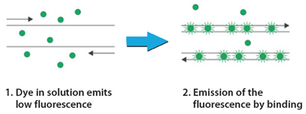

**Figure XX:** Schematic diagram of the mode of action of SYBR® Green an intercalating dye that binds to the minor groove of double stranded DNA (Source <http://www.sigmaaldrich.com/technical-documents/protocols/biology/sybr-green-qpcr.html>)

SYBR® Green can be used to monitor the amplification of PCR products of any double-stranded DNA regardless of its sequence. This, however, can prove disadvantageous since it means that the dye can intercalate with non-specific DNA sequences and primer dimers and thus give false positive signals. However, it is possible to correct for the presence of fluorescence signal that are due to non-specific DNAs and to primer dimers on some devices by performing a melting curve analysis. This is done after the final stage of PCR whereby the products are slowly melted and fluorescence data collected. Since every double-stranded DNA has a specific melting temperature, it is possible to quantify the components having different melting temperatures in one single reaction mix, and therefore to eliminate the non-specific components from the quantification.

*Taqman® Assay*

The Taqman® assay, also known as “fluorogenic 5' nuclease chemistry”, uses a different approach that includes the use of a probe that binds to a specific DNA sequence located between the two PCR primers. The probe is labelled with a fluorescent dye at the 5’ end and a quencher at the 3’ end.

The Taqman® assay makes use of two specific principals:

* The 5’ nuclease activity of Taq polymerase: in addition to being able to elongate the primers for the replication of the targeted DNA sequence, Taq also possesses a 5’🡪3’ nuclease activity, which allows it to remove any double stranded DNA that is downstream and may impede the synthesis of the new strand.
* Fluorescent Resonance Energy Transfer (FRET) is an energy transfer phenomenon that occurs when two fluorophore molecules are in close proximity, typically within 10–100 Å. Specifically, a donor fluorophore in an excited energy state transfers its excitation energy to an acceptor fluorophore that is in close proximity, where the absorption spectrum of the acceptor overlaps with the fluorescence emission spectrum of the donor, as shown in figure XX. The acceptor fluorophore can either quench the light emitted by the donor or emit light of longer wavelength.



Figure XX: Schematic diagram representing the transfer of energy from a donor fluorophore to an acceptor fluorophore.

Based on these two principals, the Taqman® assay therefore involves the design of a probe, which is typically a 20-30 base long oligonucleotide, with a melting temperature that is approximately 10°C higher than that of the primers. The probe contains a reporter fluorescent dye at the 5' end and a quenching dye at the 3' end (Figure XX). The probe cannot be extended like a primer due to the presence of the quencher that blocks extension.

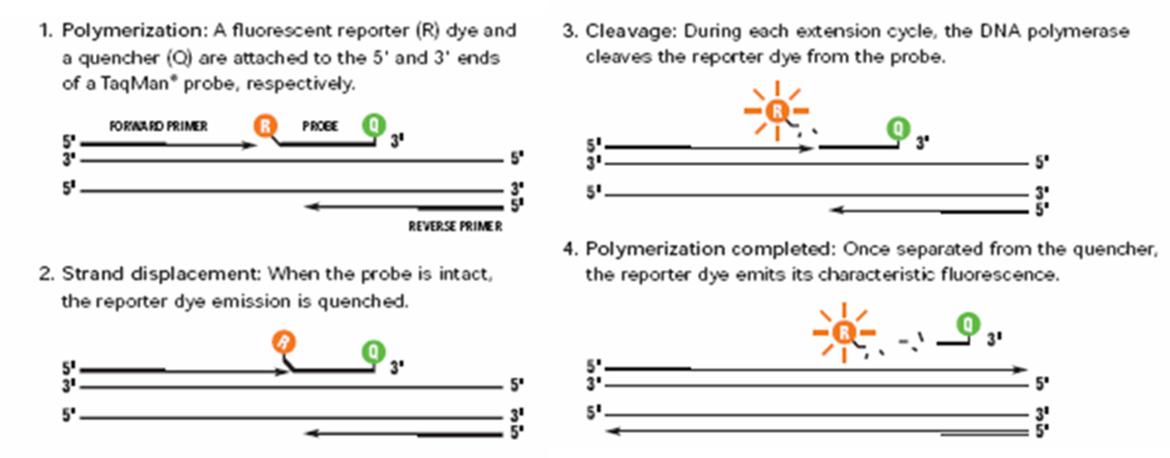

Figure XX: Scheme of TaqMan®Gene Expression Assay Based Real-time PCR. (Source: <https://bmcgenomics.biomedcentral.com/articles/10.1186/1471-2164-7-59>)

During the PCR reaction the probe specifically anneals to the target DNA between the forward and reverse primer sites. When the probe is intact, the proximity of the reporter dye to the quencher dye results in suppression of the reporter fluorescence as a result of the FRET phenomenon. During the amplification phase of PCR, the 5’ nuclease activity of Taq DNA Polymerase degrades the probe as it extends the newly synthesised strand. This results in an increase in fluorescence as amplification proceeds. Accumulation of PCR product is detected by monitoring the increase in fluorescence of the reporter dye. This process occurs during every cycle and does not interfere with the exponential accumulation of product.

The advantages of the Taqman® assay include increased specificity due to the specific hybridisation of the probe to the target DNA. Furthermore, probes can be labelled with different, distinguishable reporter dyes, which allows for the multiplexing of a number of different reactions in one reaction tube. However, a drawback of the Taqman® assay is that the design and synthesis of different probes is required for each target sequence, which can prove to be costly and time consuming.

**Special Classes of Hybridisation Probes**

With advances in real time PCR analysis, several novel designs and different types of hybridisation probes have been developed and are available for real time PCR analysis. Below is a description of other types of hybridisation probes that can be used.

*MGB probes*

A Minor Groove Binder (MGB) is a tripeptide that binds to the minor groove of DNA with high affinity. When attached to a probe the MGB stabilizes annealing by folding into the minor groove of the DNA duplex created between the probe and the target sequence. This increased stability means that MGB probes can be designed to be very short, typically between 13–20 bases. MGB probes have several advantages for quantitative PCR, especially for multiplex assays. Improved spectral performance allows for greater precision and consistency between individual assays and the greater hybridisation specificity enables enhanced target discrimination. Furthermore, the smaller probe can make it easier to design assays by providing more scope for fitting probes within shorter target regions. Amplicon size can be reduced to a minimum by using shorter MGB probes. MGB can be used with the Taqman® assay; the MGB group is attached at the 3' end along with the quencher dye. They can also be used in Eclipse probes where the MGB is conjugated to the 5’ end of the probe with the quencher and the fluorophore is on the 3’ end. The unhybridised probe exists as a random coil that keeps the fluorophore and quencher in close proximity. Once the probe anneals to its target sequence, with added stability from the MGB, the fluorophore and quencher are sufficiently far apart that fluorescence is detected, as shown in figure XX.

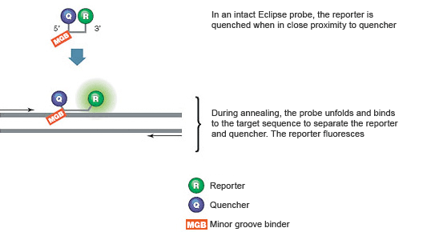

**Figure XX.** Schematic diagram of the mechanism of action of eclipse probes. Source: <http://www.bio-rad.com/en-ca/applications-technologies/introduction-pcr-primer-probe-chemistries>

*FRET Hybridization Probes*

FRET hybridisation probes are designed as a pair of which one probe is labelled with the donor fluorophore and the other with an acceptor fluorophore. FRET hybridisation probes are designed to hybridise to adjacent regions of the template DNA, to within 1-5 nucleotides apart. If both probes hybridise, the two fluorophores are brought closely together resulting in FRET taking place and a signal being released by the acceptor fluorophore, as shown in figure XX.

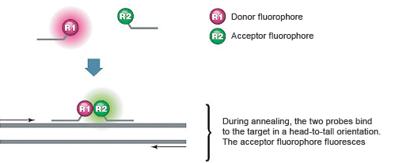

Figure XX: Schematic diagram of the mechanism of action of FRET hybridisation probes. Source: <http://www.bio-rad.com/en-ca/applications-technologies/introduction-pcr-primer-probe-chemistries>

*Molecular Beacons*

Molecular Beacons are DNA probes designed to contain a stem-loop structure. The loop sequence is complementary to the specific target of the probe and the stem sequences are designed to be complementary to each other, as shown in figure XX. The 5’ and 3’ ends of the probe are covalently bound to a fluorophore and a quencher. When the stem-loop structure is closed the fluorophore and the quencher are close together. In this case, all photons emitted by the fluorophore are absorbed by the quencher. In the presence of a complementary sequence, the probe unfolds and hybridises to the target. The fluorophore is displaced from the quencher, and fluorescence is detected.

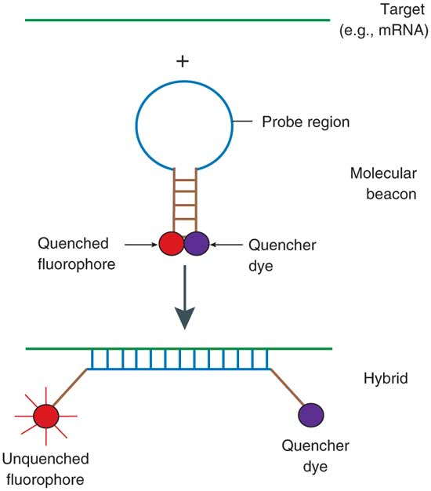

**Figure XX:** Principle of operation of molecular beacons. The probe sequence in the loop binds spontaneously to the target DNA at physiological temperatures, separates a terminally linked pair of fluorophore and quencher, and restores the fluorescence of the quenched fluorophore. Source: <http://www.nature.com/nprot/journal/v1/n3/fig_tab/nprot.2006.242_F1.html>

*Scorpion Probes*

A scorpion probe consists of a specific probe sequence with a stem-loop structure. A fluorophore is attached to the 5' end giving a fluorescent signal that is quenched in the stem-loop configuration by a moiety joined to the 3' end. The stem-loop is linked to the 5' end of a primer, as shown in figure XX. Therefore, unlike molecular beacons, TaqMan, MGB or FRET assays, scorpion assays do not require separate primers and probes. After the extension of the primer moiety within the scorpion probe, a portion of the probe sequence, which was designed to be complementary to a sequence within the target DNA, binds to its complement. This hybridisation event opens the hairpin loop in such a way that fluorescence is no longer quenched and an increase in signal is observed. A PCR blocker is placed between the primer and the stem sequence preventing read-through of the hairpin loop during extension of the opposite strand.

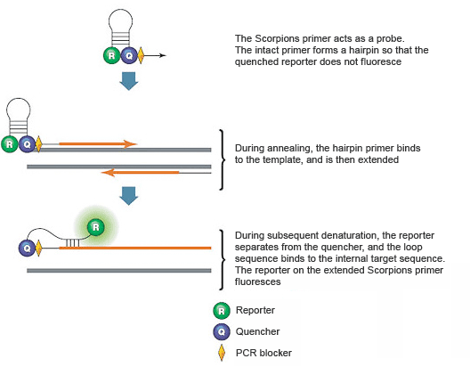

**Figure XX:** Scorpions PCR primers contain a sequence complementary to an internal portion of the target sequence. Source: <http://www.bio-rad.com/en-ca/applications-technologies/introduction-pcr-primer-probe-chemistries>

**Analysis of PCR Products**

**Introduction**

Once PCR amplification has been completed subsequent post-PCR processing steps have to be taken in order to visualise the resulting amplification products. There are 2 main methods that can be used to do so, as described below.

*Intercalating dyes and gel electrophoresis*

Electrophoresis through an agarose gel is a standard method used to separate, identify and purify DNA fragments following PCR.

The term electrophoresis describes the migration of charged macromolecules under the influence of an electric field. This results in the separation of macromolecules, in this case DNA, on the basis of their charge ~~and mass~~. The properties of a macromolecule determine how rapidly an electric field can move it through a gelatinous medium, such as an agarose gel, as outlined in figure XX.

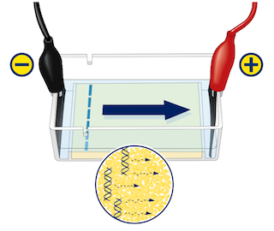

**Figure XX:** Schematic diagram of an electrophoresis set up. Source: <http://www.ncbe.reading.ac.uk/MATERIALS/Electrophoresis%20and%20DNA/electrophoresis.html>

Electrophoresis is performed by mixing the DNA sample with a loading dye and applying it to an agarose gel that is submerged in a buffer. An electrical current is applied across the gel which results in the DNA molecules being repelled from the negative electrode, the cathode, while being simultaneously attracted to the positive electrode, the anode. The frictional force of the agarose gel acts as a "molecular sieve" as the DNA is forced to move through the pores within the gel. The rate of the DNA fragment’s migration through the gel depends on the following factors:

* the strength of the electric field
* the ionic strength and temperature of the buffer in which the molecules are moving
* the relative hydrophobicity of the samples
* the size and shape of the molecules

Since the first three factors care consistent for all the samples that are migrating on the same gel, it is therefore the size of the DNA fragment that determines its rate of migration. Shorter fragments will migrate faster than longer ones. The position of the bands on the gel can be compared to a ladder, which consists of DNA fragments of various known sizes, this allows for the determination of the size of the DNA fragment of interest.

Once the electrophoresis is completed the location of DNA within the gel can be visualised by staining the gel with an intercalating dye. These are molecules that specifically target double stranded DNA and insert themselves within the base pairs. In doing so, the ability of the dye to fluoresce is greatly increased and the location of the DNA can be visualised when the gel is exposed to ultraviolet light. Ethidium bromide is a commonly used intercalating dye that is used to stain agarose gels. It can either be mixed into the molten gel before it is allowed to set or the gel can be soaked in an ethidium bromide solution after the completion of electrophoresis. Another commonly used dye is SYBR® Green which works in a similar fashion as ethidium bromide. It is advantageous over ethidium bromide in that it has a greater sensitivity, however it is more costly.

**IN THE LAB:** Components of agarose gel electrophoresis

*Agarose*

Agarose, a natural colloid extracted from seaweed, is a linear polysaccharide made up of alternating units of galactose and 3,6- anhydrogalactose. Agarose gels have large "pore" sizes and are used primarily to separate large molecules with a molecular mass greater than 200 kDa. They are processed relatively quickly, but with limited resolution since the bands formed in the agarose gels tend to be fuzzy/ diffuse and spread apart. The gels are made by suspending dry powdered agarose in an aqueous buffer, then boiling the mixture until the agarose melts into a clear solution. The solution is then poured onto a gel-tray and allowed to cool to room temperature to form a solid gel. Upon hardening, the agarose forms a matrix whose density is determined by its concentration. The concentration of the agarose gel affects the rate at which DNA migrates through it. In horizontal gels, agarose is usually used at concentrations between 0.7% and 3%, as indicated in table XX.

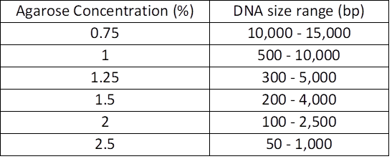

Table XX: Recommended agarose gel concentration for resolving linear DNA molecules

*Electrophoresis buffer*

The electrophoretic mobility of DNA is affected by the composition and ionic strength of the electrophoresis buffer in which the agarose gel is submerged. In the absence of ions, electrical conductance is minimal and DNA migrates slowly, if at all. In a buffer of high ionic strength electrical conductance is very efficient. Several buffers are available for electrophoresis of native double-stranded DNA. These contain EDTA and Tris-acetate; Tris-borate; or Trisphosphate at a concentration of approximately 50 mM. Electrophoresis buffers are usually prepared as concentrated solutions and stored at room temperature.

*DNA Molecular Weight Ladder*

Since migration distance depends on the size of the DNA fragment, a molecular weight ladder, which consists of mixtures of DNA fragments of varying known sizes, should be loaded into wells on both the right and left sides of the gel to facilitate the estimation of the size of the unknown DNA fragments on gels.

*Loading buffer*

Before loading DNA samples into the wells of an agarose gel, they must first be mixed with a loading buffer, which usually comprises water, sucrose, and a dye, such as xylene cyanole, bromophenol blue, or bromocresol green. The loading buffer serves three purposes: 1) increases the density of the sample ensuring that the DNA drops evenly into the well; 2) adds colour to the sample, thereby simplifying the loading process; and 3) imparts a dye to the sample that, in an electric field, moves toward the anode at a predictable rate therefore providing a visual indication of how far along the gel migration has progressed.

**Example Experimental Procedure – Agarose Gel Electrophoresis**

**Caution: Ethidium bromide is a powerful mutagen/carcinogen and is moderately toxic. Gloves should always be worn when handling solutions and gels containing ethidium bromide**.

***Equipment***

* Horizontal electrophoresis unit with power supply
* Microwave oven or heating stirrer
* Micropipettes
* 1.5 ml reaction tubes
* Balance capable of 0.1 g measurements
* Spatulas
* Rack for reaction tubes
* Glassware grade A
* Transilluminator (UV wavelength: ~312 nm)
* Instruments for documentation like a digital camera based image acquisition system.

***Reagents***

* TBE Tris/Boric acid/EDTA buffer (10x)
* Deionised water
* Agarose, suitable for DNA electrophoresis
* Tris[hydroxymethyl] aminomethane (Tris) (CAS 77-86-1)
* Boric acid (CAS 10043-35-3)
* Na2EDTA (CAS 139-33-3)
* Ethidium bromide (CAS 1239-45-8)
* Sucrose (CAS 57-50-1)
* Xylene cyanole FF (CAS 2650-17-1)
* DNA markers: Lambda DNA EcoRI/HindIII digested (or other similar suitable marker) or 100bp DNA ladder

*10x TBE buffer (1 litre)*

Prepare 10x TBE buffer according to the instructions below or buy a ready-to-use solution.

Tris [hydroxymethyl] aminomethane (Tris) 54.0 g

Boric acid 27.5 g

Na2EDTA 7.44 g

* Mix reagent to deionised water to obtain a 1 litre solution at pH 8.3
* Store at room temperature

*6x loading buffer (10 ml)*

Prepare 6x loading buffer according to the instructions below or buy a ready-to-use solution.

Xylene cyanole FF 0.025 g

Sucrose 4 g

* Add sucrose and Xylene cyanole FF to deionised water to obtain 10 ml of solution.
* Mix the solution, autoclave and store at 4°C.

**Procedure**

* Seal the edges of a clean, dry plastic gel-tray either with tape or other means. Position the appropriate comb so that complete wells are formed when the agarose solution is added.
* Dilute 10x TBE buffer to prepare the appropriate amount of 0.5x TBE buffer to fill the electrophoresis tank and to prepare the gel.
* Weigh powdered agarose depending on the dimensions of the amplicon (according to table 1) and add it to an appropriate amount of 0.5x TBE buffer in an Erlenmeyer flask with a loose-fitting cap (usually 150 ml gel solution for a 15 x 15 cm gel-tray and 100 ml gel for a 15 x 10 cm gel-tray).
* Heat the slurry in a microwave oven or in a boiling water bath until the agarose dissolves (check the volume of the solution after heating).
* Cool the mixture to 50 - 60°C and add ethidium bromide (from a stock solution of 10 mg/ml) to a final concentration of 0.2 µg/ml and mix thoroughly.
* Pour the solution into the gel-tray and allow the gel to set. The amount of gel used should correspond to a depth of approximately 3 - 5 mm.
* After the gel is completely set, carefully remove the comb and the tape and place the gel in the electrophoresis tank.
* Add enough 0.5 x TBE buffer to the electrophoresis unit to cover the gel to a depth of about 2 - 5 mm.

**Prepare samples and marker for genomic DNA as follows:**

***sample marker***

water 3 µl water 6 µl

loading buffer 2 µl loading buffer 2 µl

sample 5 µl  DNA *Eco*RI / *Hind*III 2 µl

10 µl 10 µl

**Prepare samples and marker for PCR products as follows:**

***sample marker***

loading buffer 2 µl 100 bp DNA ladder 15 µl

sample 8 µl

10 µl

* Load 10 µl of each sample into consecutive wells and the appropriate DNA marker into the first and last lane.
* Close the lid of the gel tank and attach the electrical leads so that the DNA will migrate toward the anode and apply a voltage of 90-100 V/15 cm.
* Run the gel until the xylene cyanole has migrated the appropriate distance through the gel (~ 40 - 60 minutes).
* Turn off the current; remove the leads and the lid from the gel tank. Place the gel on a UV lightbox and photograph the gel.
* Discard the gel into the provided ethidium bromide solid waste bin.

*Fluorescent labelling*

Fluorescent labelling can be used in a number of ways to analyse the products of PCR amplification. One method of fluorescent labelling involves the use of primers that have been labelled with a fluorescent dye. This leads to the amplification product having a label directly attached to it during PCR amplification. Visualisation of such PCR products requires the use of specialised equipment, such as capillary electrophoresis in order to complete the visualisation process and the gathering of data.

In addition, as previously described, fluorescent labelling is the cornerstone of real time PCR based techniques whereby PCR is carried out in the presence of dyes that emit fluorescence in proportion to the amount of DNA as it increases with each PCR cycle. By recording the amount of fluorescence emitted at the end of each cycle, it is possible to monitor the PCR reaction during its exponential phase. This can be performed by using intercalating dyes such as SYBR® Green or using fluorescently labelled probes, as described in the previous section. This type of visualisation technique is advantageous in comparison to gel electrophoresis since there is minimal post-PCR processing involved in order to obtain data. This reduces labour and material costs as well as minimises the risk of contamination within the laboratory because there is no manipulation of the amplified PCR product in preparation for the visualisation technique, such as mixing with loading buffer or placement onto a gel.

**LMO Detection Using PCR**

**Introduction**

The various tools and methodologies that are available for the detection and identification of LMOs can be used to test samples for the presence of LMOs. There are a number of ways that these tools can be used in the context of each country’s national framework. Specifically, there are two main types of LMO detection categories. The first is qualitative detection which is used to indicate whether or not LMOs are present in the sample. Following this type of screening further qualitative testing may need to be undertaken if a sample is found to be positive for the presence of LMO in order to fulfil legislative requirements that may be in force. These requirements vary from country to country and may include further testing to determine the specific identity of the LMO events that may be present in the sample and/or measuring the quantity of each LMO event present in the sample. Existing ISO standards provide valuable general guidance and recommendations for reliable detection and identification of LMOs using PCR (ISO 24276, ISO 21569, ISO 21570, ISO 21571). General requirements and guidance concerning effective PCR-based LMO screening strategies are provided by an European Technical Specification (CEN/TS 16577).

**Qualitative Detection**

Qualitative detection methods can be used as an initial screening and identification step to investigate whether or not a sample contains LMO-specific DNA. Qualitative analysis could therefore be performed on products sampled from any point along the supply chain. If the qualitative screening indicates the presence of LMOs, subsequent testing can be carried out to determine the specific identity of LMOs that may be present in the sample, or further quantitative testing may be performed, as further in this chapter.

Qualitative testing is carried out in a methodical manner in order to maximise the amount of information obtained from the smallest number of reactions, in an attempt to minimise cost and time dedicated to this step. There are four main categories of target amplicons that are used during the screening and identification process (Figure XX):

1. **Element-specific** – This type of testing can be used to target any of the commonly used genetic elements that are known to be present in the various commercialised LMOs such as promoters, terminators or transgenes.
2. **Construct-specific** – This amplifies regions within the transgene construct, spanning the junctions between different genetic elements. Depending on the primer pair being used, this type of testing can be used to narrow down the pool of potential LMOs that may be present in a sample.
3. **Event-specific** – This testing method is made up of primer pairs that overlap the junction between the inserted construct and the genomic DNA and is used to identify individual LMOs.
4. **Taxon-specific** – This targets endogenous genes within the genome of the recipient organism of LMOs and is used to confirm whether or not DNA sufficient for amplification in PCR-reactions (amount and quality) is present and its species of origin.

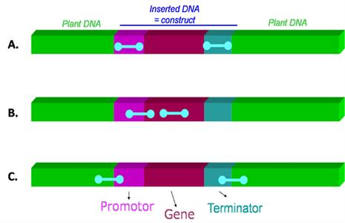

**Figure XX:** Schematic representation of the different types of PCR target regions for the detection of the LM sequence A) element specific; B) construct-specific and C) event-specific

**Screening Methods**

When analysing a sample for the presence of LMOs, laboratories generally perform an initial ‘screening’ step. Once a sample is received and DNA has been extracted the initial screening step involves amplifying the DNA with a taxon-specific target region and a set of element- or construct-specific amplicons in order to detect target sequences that are commonly present in known LM events.

As previously described the taxon-specific amplification is used to confirm that DNA from a specific species is present and whether or not it is of sufficient quality to be amplified using PCR. This is important since it ensures that any negative result from subsequent element-specific tests can be attributed to the absence of the target LM sequence.

Amplification with a set of element- or construct-specific primers allows for the detection of sequences that are commonly present in known LM events. Some of the most commonly targeted elements for the initial screening step include P-35S-CaMV, T-NOS-RHIRD, CS-CP4epsps-RHIRD, CS-Barnase-BACAS and CS-pat-STRVR. Additional screening targets can be added if it is appropriate in the context of a specific country’s national legislation.

If amplification is detected using an element- or construct-specific method, this indicates that DNA from a LMO is present in the sample.

**Identification Methods**

The further narrowing down of the possible identity of the LMOs present in a sample can be carried out depending on the combination of elements that gave a positive signal during the screening test. The pattern of positive elements can be compared to the patterns that would be expected from LMOs of a known identity and, therefore, the identity of the LMOs that may be present in a sample can be narrowed down to a few possible choices. This is known as the matrix approach. Several such reference matrices exist, such as the Waiblinger Table and the GMOseek matrix, amongst others[2]. There are two different types of commonly used matrices for the application of PCR-based screening strategies using the matrix approach.

1. LMO method matrix – which is defined as a relational presentation, for example a table, of symbols or numbers, where the genetic elements and genetic constructs that are detected by a defined PCR method and the corresponding LMOs are tabulated. The symbols (“+” or “-”, or numbers) indicate whether or not the target sequence is detectable by the specified method in a given LMO.
2. LMO target matrix – tabulates only information about the presence of genetic elements or genetic constructs in LMOs. The entered symbols or numbers indicate the presence or absence of the target sequence and copy number, if available, in a given LMO event. In contrast to LMO method matrices, LMO target matrices are independent from a particular detection method.

Once the identity of the LMO is determined, or narrowed down to a few possible choices, further identification methods can be carried out, using event-specific methods, to conclusively establish identity, as shown in the example XX, below.

|  |  |  |  |  |  |  |  |
| --- | --- | --- | --- | --- | --- | --- | --- |
| **Sample** | **Result (+/ -)** | | | | | | **Possible LMO(s) present** |
| Plant specific | p35S | tNOS | EPSPS | bar | pat |
| 1 | Soybean | + |  |  |  | + | ACS-GMØØ5-3 or ACS-GMØØ6-4 |
| 2 | Soybean | + | + |  |  | + | SYN-ØØØH2-5 |
| 3 | Maize | + | + | + |  |  | MON-ØØ6Ø3-6 or MON-88Ø17-3 or MON-87427-7 |
| 4 | Maize | + | + |  | + |  | ACS-ZMØØ4-3 |

**Example XX:** Application of the matrix approach to establish possible identities of LMOs present in a sample. In the examples given in this table, assuming that the samples are not mixed, Samples 1 and 3 would need further testing using event specific targets to specifically identify which of the possible LMOs listed is actually present in the sample.

As powerful as the matrix approach is, it does have some limitations:

1. Mixed Samples: samples obtained for testing may contain more than one LMO either from the same or different species. While the screening method could give some indication as to the possible LMOs that may be present, the pool of potential LMOs can still be quite vast and several event-specific tests would still need to be carried out, which poses a burden on testing laboratories.
2. Stacked events: this screening method cannot distinguish between a mixed sample and a stacked event.
3. Complex LMOs: As LMOs develop, novel genetic elements, that are not part of the screening method being employed, may be used to build the construct. Such an LMO may therefore not be detected using these methods.

**Quantitative Analysis**

Quantitative analysis involves the analytical determination of the relative percentage of LMO content in a sample by normalising the amount of the LMO specific sequences against the amount of a taxon-specific gene, such as lectin for soybean and invertase, or zein for maize. The resulting percentage of LMO content is therefore expressed as:

Percentage LMO content = LM-DNA X 100%

Reference-DNA

Such a determination can be carried out using conventional PCR based analysis. However, a major drawback of conventional PCR is the lack of accurate quantitative information due to amplification efficiency. If the reaction efficiency for each amplification cycle remained constant, the concentration of DNA following PCR would be directly proportional to the amount of initial DNA target. However, the amplification efficiency of PCR varies among different reactions, as well as in subsequent cycles in a single reaction, in particular, in the later cycles of the PCR, where the amplification products are formed in a non-exponential fashion at an unknown reaction rate.

DNA quantification based on conventional PCR would rely on end-point measurements, in order to achieve maximum sensitivity, when the amplification reaches the maximum product yield (i.e. the "plateau phase"). At this stage the reaction has gone beyond the exponential phase primarily due to depletion of reagents and the gradual thermal inactivation of the polymerase used. The resulting correlation between the final product concentration and number of initial target molecules is therefore limited. To overcome these limitations, real-time PCR can be used to address the problems of establishing a relationship between the initial concentration of target DNA and the amount of PCR product generated by amplification.

*Principles of quantification with real-time PCR*

The relative LMO content of a sample can be quantified and expressed as the number of target DNA sequences per target taxon-specific sequences, as outlined above. The amount of taxon-specific sequences involves measuring the amount of DNA sequences of an endogenous reference gene, which is used as a “normaliser”. When choosing such reference gene the following considerations should be kept in mind:

1. species specificity
2. a single copy of the gene per haploid genome,
3. be stably represented in different lines of the same species
4. has an amplification efficiency that is equivalent to the LMO traits being analysed by ensuring good primer and probe design.

Similarly, with regards to measuring the amount of LM-DNA in a sample certain considerations have to be taken into account when selecting a target site in order to facilitate the interpretation of the results and avoid misestimating the amount of DNA present:

1. *Event ploidy:* It is possible that the LM event has a different ploidy as compared to the wild type genome, for example tetraploid instead of diploid. This can be empirically evaded by using reference materials that are consistent with the sample, for example using a maize flour reference material to quantify maize flour. Furthermore, quantification standards that do not originate from certified reference materials, such as cloned DNA sequences or genomic DNA mixtures, can be calibrated against certified reference materials in order to correct for molecular discrepancies in quantification.
2. *Event zygosity:* The LM trait could be either homozygous or heterozygous. Event zygosity can also be corrected by following the precautions as those listed under event ploidy.
3. *Event copy number:* The number of insertions per haploid genome of a construct which could have been inserted as a single copy per haploid genome or more. This can be taken into account by designing the primer-probe system that overlaps the junction between the inserted construct and the plant genome. Since border sequences are unique this event-specific detection system will not amplify multiple insertions of the same construct during quantification.

As a result of these possible sources of error it is widely accepted to report such results by expressing the percentage LMO in terms of haploid genomes. Furthermore, such sources of discrepancy should be taken into account when a method is developed and validated, since the limit of detection (LOD) and the limit of quantification (LOQ) are influenced by the real number of copies being quantified.

*Designing a real-time LMO quantification experiment*

When designing a real-time PCR amplification the following components must be included:

* A first set of primers/probes that were designed to amplify an LMO-specific target DNA sequence.
* A second set of primers/probes that were designed amplify an endogenous, species specific reference sequence, for use as a “normaliser” when calculating the relative percentage of LMO content in a sample.
* A set of serial dilutions of DNA from an appropriate positive control amplified by the primers/probes that were designed to amplify both the LMO-specific target DNA sequence and the endogenous, species specific reference sequence in order to create a standard curve. Standard curves should include at least four different concentration points. Each point of the standard curve, and the sample, should be loaded at least in triplicate. These standard curves are used to determine the amount of LMO-specific target DNA sequence and the endogenous, species specific reference sequence in unknown samples.
* A no template control that is amplified by the primers/probes that were designed to amplify both the LMO-specific target DNA sequence and the endogenous, species specific reference sequence.

Depending on the chemistry and the equipment available for carrying out the experiment, it may be possible to amplify both the LMO-specific target DNA sequence and the endogenous, species specific reference sequence as a multiplexed reaction. This is made possible due to the availability of several reporter dyes that have different maximal emission wavelengths, which are used to synthesise TaqMan® probes, as shown in figure XX. This allows the detection of amplification products from multiple targets in the same tube at the same time.

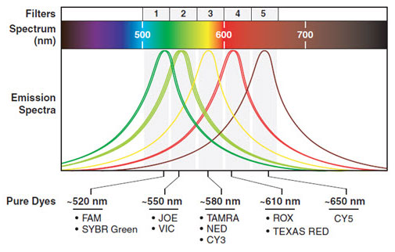

**Figure XX:** The emission spectra of various dyes that are commonly used in real time PCR. Source <https://www.thermofisher.com/ca/en/home/technical-resources/technical-reference-library/real-time-digital-PCR-instruments-support-center/7500-real-time-pcr-systems-support/7500-real-time-pcr-systems-support-getting-started.html>

Multiplexed reactions are advantageous in that they save time since fewer reactions would have to be set up per sample. This in turn also leads to a reduction in the likelihood that pipetting errors occur during the PCR set-up. In addition there would also be a reduction in costs due to the use of less reagents and the possibility of being able to place more samples on a single PCR run. Multiplexing also reduces the amount variability between measurements of the amplification results of the LMO-specific target DNA sequence and the endogenous, species specific reference sequence since both amplifications occur in the same tube under identical conditions. However, it should be noted that multiplexed reactions may result in decreased detection sensitivity with respect to the reaction’s limit of quantification due to interference between the two reactions and their variable consumption of reagents.

*Interpretation and analysis data produced by real-time PCR*

As a real-time PCR experiment proceeds, the instrument measures fluorescence at the end of each cycle. The data is compiled into an amplification plot which displays cycle number on the x-axis against fluorescence on the y-axis. The plot is usually graphed on a semi-logarithmic scale.

The amplification plot makes it possible to distinguish between the three different phases that occur during PCR.

1. An initial “lag” phase, which takes place between cycles 1-18, shows minor fluctuations in fluorescence. This corresponds to background signal.
2. This is followed by an exponential phase, which takes place between cycles 18-28, when the accumulation of amplified product is significantly higher than the background signal. The cycle number at which this occurs is known as the “cycle quantification” (Cq value) or “threshold cycle” (Ct value). When using real time PCR for quantification data is collected during this point. This significantly enhances the accuracy of quantification since there is a direct correlation between the starting amount of template and the cycle number at which amplification starts to become exponential. The higher the initial amount of template DNA, the sooner accumulated product is detected in the PCR process, and the lower the CT value is.
3. The final stage in when the plots tend to reach a “plateau”. This corresponds to the end-point of the PCR amplification.

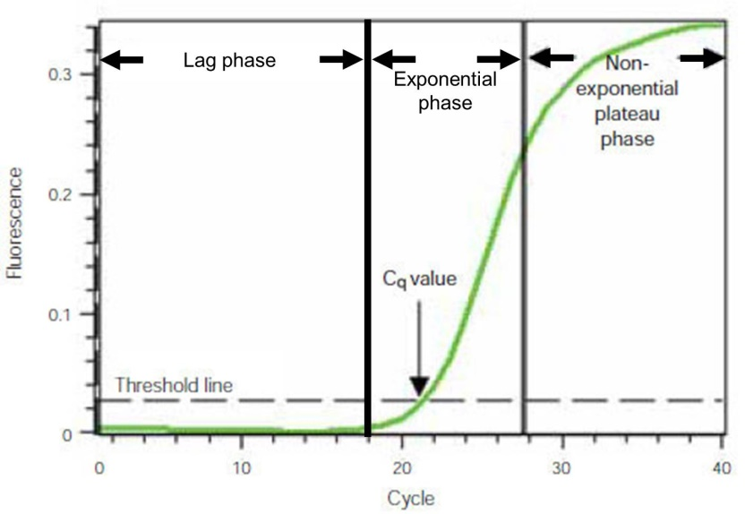

**Figure XX:** A real time PCR amplification plot displaying baseline-subtracted fluorescence against the number of PCR cycles. Source: Adapted from <http://www.bio-rad.com/en-ca/applications-technologies/what-real-time-pcr-qpcr>

In practice, the choice of positioning the threshold line, which is used to determine Ct values, is often up to the operator, therefore representing one of the subjective elements in real-time PCR. Data produced by real-time indetermination displays the amplification plots produced in each well on a single overlapping graph, as indicated in figure XX. In such a plot the threshold line should be placed above any baseline activity and within the exponential increase phase, which appears linear in the log transformation representation of the data.

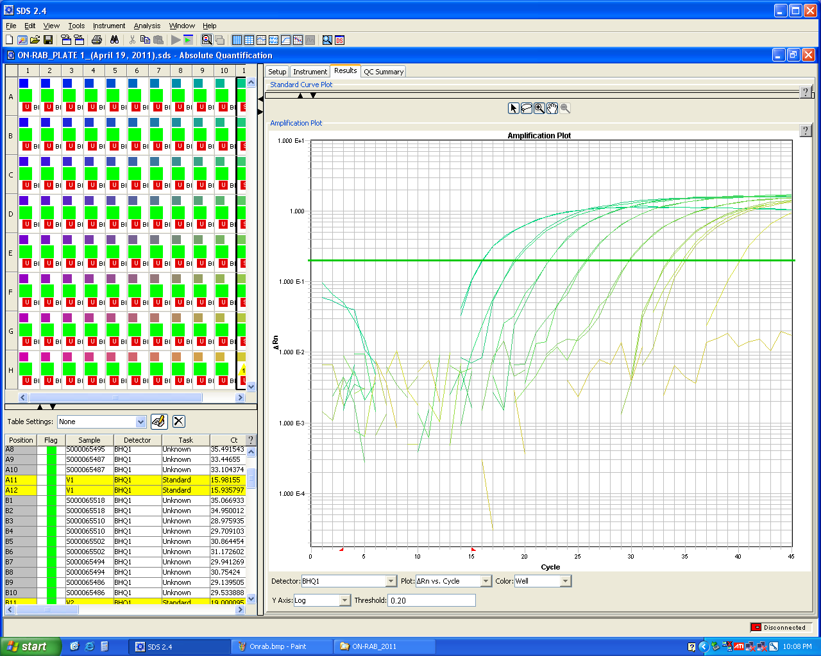

**Figure XX:** Amplification plot from a real-time PCR experiment.

*Calculating LMO content*

The LMO content of a sample can be determined in two different ways:

Standard Curve Method

Standard curves for each of the certified reference material that was amplified by the primers/probes that were designed to amplify both the LMO-specific target DNA sequence and the endogenous, species specific reference sequence are plotted as shown in figure XX.

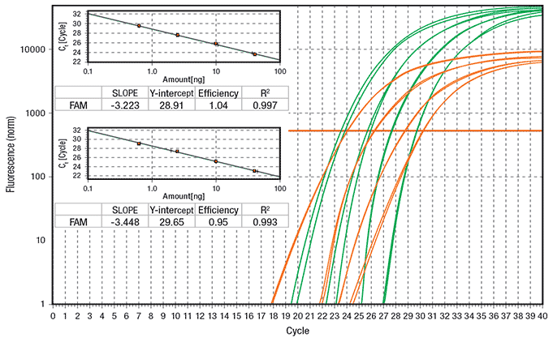

**Figure XX:** Schematic representation of the amplification plots of a set of four 4-fold serial dilutions of a reference material to produce a standard curve of the endogenous reference gene and the event specific amplification. Data represents four replicates for each DNA dilution. Source: <http://www.sigmaaldrich.com/technical-documents/articles/biology/roche/kapa-multiplex-rtpcr.html>

Using these standard curves, the amount of LMO-specific target DNA and the endogenous genomic DNA can be calculated by obtaining the Ct values from the unknown samples and using the appropriate standard curve to determine the amount of DNA.

The resulting percentage of LMO content is therefore calculated as the ratio between the GM target sequence amount and the reference gene sequence amount, using the formula:

Percentage LMO content = LM-DNA X 100%

Reference-DNA

It is necessary that the Ct values of the samples fall within the upper and lower limits of both standard curves. Outliers must be excluded since they are prone to quantification errors.

Comparative Ct Method

This method, also known as ΔΔCt, compares the differences in Ct values of the unknown samples and those of the certified reference materials, which have been normalized against the Ct values of the endogenous genomic DNA.

The first step in this procedure is to calculate the first ΔCt for each of the unknown samples and the endogenous genomic DNA, as shown in the table below:

|  |  |  |  |  |  |
| --- | --- | --- | --- | --- | --- |
| Unknown Sample | | Certified Reference Material | | ΔCt | |
| Average Ct value LMO-specific target | Average Ct value endogenous genomic DNA | Average Ct value LMO-specific target | Average Ct value endogenous genomic DNA | Unknown Sample | Certified Reference Material |
|  | 20 |  | 18 | 25-20 = 5 | 22-18 = 2 |
| 25 |  | 22 |  |

The ΔΔCt values are then calculated as follows:

ΔΔCt = (ΔCt Unknown Sample) - (ΔCt Certified Reference Material)

ΔΔCt = 5-2 = 3

The final result of this method is presented as the fold change of LMO-specific target DNA in the unknown sample relative to the certified reference material, normalized to the endogenous genomic DNA. Therefore, in order to determine the fold change between the unknown sample and the certified reference material the following calculation is used:

2 –ΔΔCt

2 -3 = 0.125 fold difference between the unknown sample and the certified reference material

For this method to be successful, the amplification efficiencies of both the LMO-specific target DNA and the endogenous genomic DNA reactions should be similar. A method for determining this is to establish how the ∆Ct varies with template dilution. If the efficiencies of the two amplicons are approximately equal, a plot of template DNA dilution versus ∆Ct would display a line that is almost horizontal. If amplification efficiencies are unequal then the standard curve method should be used for quantification.

**Sample Experimental Procedures – Real-time PCR**

The following protocols are real-time PCR-based methods for the quantification of the specific LM event MON810 by single Real Time PCR and for the detection of 35S promoter and *nos* terminator by multiplex Real Time PCR (qualitative analysis). It should be noted that both experiments should be preceded by an inhibition run to test the amplifiability of the extracted DNA.

*Real Time for quantitative analysis*

Real-time PCR will be used to amplify an endogenous reference target DNA sequence that is unique to maize (taxon specific), plus a DNA target sequence that indicates the presence of the genetically modified crop.

The assays can encompass two independent PCR systems, or happen in the same well as a multiplex reaction. Each target DNA has specific DNA primers and dye-labelled probes. One PCR system detects a GMO-specific target DNA sequence, the other is an endogenous reference system designed to serve as a quantitative reference that detects GM and non-GM maize.

*Real Time for qualitative analysis*

As previously stated, being widespread in many LMO laboratories, Real-time is used also for qualitative purposes. The following duplex Real-time PCR is an example of screening method putting together the detection of 35S promoter and nos-terminator. The two reactions will take place in the same well, this being possible because the specific probes are labelled with different dyes, allowing the two amplifications to be monitored separately.

**Note:** This sample experimental procedure should be considered basic examples of LMO analysis using the real-time PCR approach. It is recommend that pertinent sources and literature are periodically reviewed in order to acquire information on more recently developed and validated protocols (<http://gmo-crl.jrc.ec.europa.eu/StatusOfDossiers.aspx>).

**Multiplex element specific method for the detection of *P35S* and  
 T-nos by Real-Time PCR**

This section describes the protocol for a duplex real-time PCR screening method for the detection of modified plants.

Target DNA sequences from *Cauliflower Mosaic* Virus 35S promoter (P35S) and nos-terminator from *Agrobacterium* *tumefaciens* (T-nos) are amplified. The duplex real-time PCR method uses primer and probe sequences that have already been published for the individual (“single”) detection of both target sequences. Combined with a reference gene and using reference standard material, the method can be used to semi-quantitatively estimate the amount of LM plants in an unknown sample.

**Materials and equipment**

1. ABI PRISM® 7500 Sequence Detector System (Applied Biosystems)
2. 96-Well Reaction Plates
3. Optical caps/adhesion covers
4. Micropipettes
5. Racks for reaction tubes
6. 0.5 mL and 2 mL DNase free reaction tubes
7. Standard bench top centrifuge with rotor or standard microfuge fit for 0.5 mL reaction tubes, centrifuge for 96-Well reaction plates
8. Vortex mixer
9. 1.5 ml microcentrifuge tubes

**Characteristics of primers for T-Nos**

|  |  |
| --- | --- |
| **Primer forward: 180-F** | |
| Sequence | CATGTAATGCATGACGTTATTTATG |
| Length | 25 |
| Mol. weight (g/mol) | 7686.1 |
| Melting point (G/C) based on a [Na+] of 50 mM | 51.1 |
| **Probe: TM-180YY** | |
| Sequence | YY-ATGGGTTTTTATGATTAGAGTCCCGCAA-BHQ1 |
| Length | 28 |
| **Primer reverse: 180-R** | |
| Sequence | TTGTTTTCTATCGCGTATTAAATGT |
| Length | 25 |
| Mol. weight (g/mol) | 7643.1 |
| Melting point (G/C) based on a [Na+] of 50 mM | 49.5 |

**Characteristics of primers for P 35S**

|  |  |
| --- | --- |
| **Primer forward: 35S-FTM** | |
| Sequence | GCCTCTGCCGACAGTGGT |
| Length | 18 |
| Mol. weight (g/mol) | 5491.6 |
| Melting point (G/C) based on a [Na+] of 50 mM | 54.9 |
| **Probe: 35S-TMP-FAM** | | |
| Sequence | FAM-CAAAGATGGACCCCCACCCACG-BHQ1 | |
| Length | 22 | |
| **Primer reverse: 35S-RTM** | | |
| Sequence | AAGACGTGGTTGGAACGTCTTC | |
| Length | 22 | |
| Mol. weight (g/mol) | 6790.5 | |
| Melting point (G/C) based on a [Na+] of 50 mM | 54.8 | |

**Controls**

Each test series shall include the controls as stated in **Table XX**; **of section 5** of this manual. If the controls do not yield the expected results, the test results shall be rejected and the analysis shall be repeated.

**Experimental procedure**

1. Thaw, mix and centrifuge the components needed for the run. Keep thawed reagents on ice.
2. In a 2 mL tube on ice, add the components in the order mentioned in Table 1 (except DNA) to prepare the reaction mix.

|  |  |  |
| --- | --- | --- |
| **Reagents\*** | **Final concentration** | **Volume per reaction (µL)** |
| TaqMan® universal PCR Master Mix (2x) | 1X | 12.5 |
| Primer 35S-F (2µM) | 0.1 µmol/L | 1.25 |
| Primer 35S-R (2µM) | 0.1 µmol/L | 1.25 |
| Probe 35S-TMP FAM (2µM) | 0.1 µmol/L | 1.25 |
| Primer 180-F (20 µM) | 1.0 µmol/L | 1.25 |
| Primer 180-R (20 µM) | 1.0 µmol/L | 1.25 |
| Probe TM-180 YY (4 µM) | 0.2 µmol/L | 1.25 |
| DNA-extract | Samples: about 50 000 cp maize DNA per reaction | 5 |
| **TOTAL REACTION VOLUME** |  | **25** |

* Waiblinger et al. 2008(DOI 10.1007/s00217-007-0748-z)

**Table 1**. Reaction mix for Real-Time PCR (ABI 7500)

1. Mix well and centrifuge briefly.
2. Label one 0.5 mL reaction tube for each DNA sample to be tested.
3. Add into each reaction tube the amount of reaction mix needed for 3.3 repetitions (66 µL). Add into each tube the proper amount of DNA for 3.3 repetitions (16.5 µL DNA). The additional 0.3 repetition included will ensure adequate volume when loading the samples. Vortex for approximately 10 sec. each tube. This step is of mandatory importance to reduce to a minimum the variability between the replicates of each sample.
4. Spin down in a micro-centrifuge. Aliquot 25 µL in each well according to the chosen plate setup loading order.
5. Place an optical cover on the reaction plate and briefly centrifuge the plate.
6. Place the reaction plate into the ABI Real-time PCR equipment.
7. Programme the Real-Time equipment.
8. Set up the plate layout. A sample layout is indicated in figure 1.

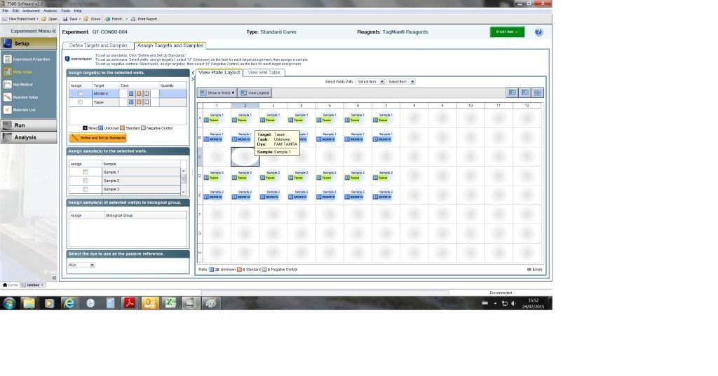

**Figure 1**. Software layout

1. Choose the number of cycles, the reaction volume and the details of each reaction step (Table 2).
2. Start the run.

|  |  |  |  |
| --- | --- | --- | --- |
| **Stage** | **Temperature** | **Time** | **No Cycle** |
| Decontamination (UNG) | 50°C | 2 min | 1 |
| Activation/Initial Denaturation | 95°C | 10 min | 1 |
| Denaturation | 95°C | 15 sec |  |
| Annealing & Extension | 60°C | 60 sec |  |
| Denaturing, Annealing & Extension |  |  | 45 |

**Table 2**. Amplification conditions

**Data analysis and interpretation of results**

Subsequent to the Real-time PCR run, the data are evaluated using the following procedure:

* + Set the threshold: display the amplification curves in logarithmic mode, place the threshold line in the area where the amplification profiles are parallel (exponential phase of PCR)**.**
  + Set the baseline: determine the cycle number at which the threshold line crosses the first amplification curve and set the baseline three cycles before that value (e.g. earliest Ct = 25 🡪 baseline Ct = 25 – 3 = 22).
  + Save the settings and export the data.

This being a qualitative method, we only need to verify that the amplification took place. Adding reference amplification to the plate we could get some semi-quantitative information.

**Protocol for a construct specific method for the quantitation of MON810 by Real-Time PCR**

This paragraph describes a method for the detection and quantitation of a taxon-specific maize gene (maize starch synthase IIb: *zSSIIb*) and of the specific DNA construct junction region between the intron sequence of maize heat shock protein 70 gene and synthetic *cryIA(b)* gene derived from *Bacillus thuringiensis* present in the genetically modified (GM) maize MON810. The method is based on real-time PCR using plasmid as a reference material in order to quantify the relative amount of MON810 using a conversion factor (Cf) that is the ratio of copy numbers between construct-specific and taxon-specific DNA sequences in the representative genuine MON810 seeds.

**Equipment and Reagents**

1. ABI PRISM® 7500 Sequence Detector System (Applied Biosystems)
2. 96-Well Reaction Plates
3. Optical caps/adhesion covers
4. Micropipettes
5. Racks for reaction tubes
6. 0.5 mL and 2 mL DNase free reaction tubes
7. Real-time PCR detection system and appropriate analysis software
8. Standard bench top centrifuge with rotor or standard microfuge fit for 0.5 mL reaction tubes, centrifuge for 96-Well reaction plates
9. Vortex mixer
10. 1.5 ml microcentrifuge tubes.

**Characteristics of primers for the MON810 specific system (QT-CON-00-004)**

|  |  |  |  |
| --- | --- | --- | --- |
| **Primer forward: M810 2-5'** | | | |
| Sequence | | TCGAAGGACGAAGGACTCTAACG | |
| Length | | 22 | |
| Mol. weight (g/mol) | | 6692.4 | |
| Melting point (G/C) based on a [Na+] of 50 mM | | 54.8 | |
| **GMO target probe: M810-Taq** | | | |
| Sequence | | FAM-AGATACCAAGCGGCCATGGACAACAA-TAMRA | |
| Length | | 26 | |
| **Primer reverse: M810 2-3'** | | |
| Sequence | GGATGCACTCGTTGATGTTTG | |
| Length | 21 | |
| Mol. weight (g/mol) | 7106.3 | |
| Melting point (G/C) based on a [Na+] of 50 mM | 52.4 | |

**Characteristics of primers for the taxon specific system (QT-CON-00-004)**

|  |  |  |  |
| --- | --- | --- | --- |
| SSIIb1-5' | | | |
| Sequence | CTCCCAATCCTTTGACATCTGC | | |
| Length | 22 | | |
| Mol. weight (g/mol) | 7204.3 | | |
| Melting point (G/C) based on a [Na+] of 50 mM | 54.8 | | |
| Taxon probe: SSIIb1-Taq | | | |
| Sequence | | | FAM-AGCAAAGTCAGAGCGCTGCAATGCA-TAMRA |
| Length | | | 25 |
| SSIIb1-3' | | | |
| Sequence | | TCGATTTCTCTCTTGGTGACAGG | |
| Length | | 23 | |
| Mol. weight (g/mol) | | 7659.6 | |
| Melting point (G/C) based on a [Na+] of 50 mM | | 55.3 | |

**Standard curve**

The calibration curve method has been used for quantitation of copy numbers in extracted DNA from unknown test sample DNA extracts. Separate calibration curves with each primer/probe system are generated in the same analytical amplification run. The calibration curves are composed of five concentrations including 20, 125, 1500, 20000, 250000 copies of DNA of plasmid pMul5. At each of the five calibration points, triplicate measurements are performed. Triplicate reactions using an appropriate dilution of the DNA extracted from the unknown sample were also measured in the ABI PRISM® 7500 SDS (Applied Biosystems) in the same analytical run.

The *C*q values determined for the calibration points in the *zSSIIb* or MON810 construct-specific target, respectively, are plotted against the logarithm of the copy number of plasmid DNA of pMul5 to establish a calibration curve. The copy numbers measured for the test sample DNA are obtained by interpolation from the standard curves. For the determination of the amount of MON810 in the test sample, the copy number of the MON810 construct is divided by the copy number of the *zSSIIb* gene and the construct-specific Cf of MON810, multiplied by 100 to obtain the percentage.

**Controls**

Each test series shall include the controls as stated in Table 4; Session 6 of this manual. If the controls do not yield the expected results, the test results shall be rejected and the analysis shall be repeated.

As a positive control/calibration reference material, at least two alternatives are available, as follows.

1. High quality, pure genomic DNA extracted from maize kernel may be used if the quantity of DNA is known, on the basis of calculating copy numbers of the target sequence from the genome size of MON810 maize.
2. A plasmid containing the target sequence(s) may be added in different concentrations with known copy numbers.

**Mastermix preparation**

1. Thaw, mix and centrifuge the components needed for the run. Keep thawed reagents on ice.
2. In a 2 mL tube on ice, add the components in the order mentioned in Table 3 (except DNA) to prepare the reaction mix. Please prepare only the reaction mix needed for the run. Mix well and centrifuge briefly.
3. Label one 0.5 mL reaction tube for each DNA sample to be tested.
4. Add into each reaction tube the amount of reaction mix needed for 3.3 repetitions (66 µL).
5. Add into each tube the proper amount of DNA for 3.3 repetitions (16.5 µL DNA). The additional 0.3 repetition included will ensure adequate volume when loading the samples. Vortex for approximately 10 sec. each tube. This step is of mandatory importance to reduce to a minimum the variability between the replicates of each sample.
6. Spin down in a micro-centrifuge. Aliquot 25 µL in each well according to the chosen plate setup loading order.
7. Place an optical cover on the reaction plate and briefly centrifuge the plate.
8. Place the reaction plate into the ABI Real-time PCR equipment.
9. Programme the Real-Time equipment
10. Set up the plate layout.

The length of the SSIIb PCR product is 151 bp; the length of the MON 810 PCR product is 113 bp.

|  |  |  |  |
| --- | --- | --- | --- |
| **GM target** | | **Taxon target** | |
| Reagent | Final  Concentration | Reagent | Final  Concentration |
| TaqMan® Universal  PCR Master | 1x | TaqMan® Universal  PCR Master | 1x |
| Primer Fw | 0.50 μmol/L | Primer Fw | 0.50 μmol/L |
| Primer Rev | 0.50 μmol/L | Primer Rev | 0.50 μmol/L |
| Probe | 0.20 μmol/L | Probe | 0.20 μmol/L |
| Template DNA | 50 ng | Template DNA | 50 ng |
| **TOTAL VOLUME** | **25 µL** | **TOTAL VOLUME** | **25 µL** |

**Table 3**. PCR reaction setup

|  |  |  |  |  |
| --- | --- | --- | --- | --- |
| **Stage** | | **Time** | **Temperature °C** | **No Cycles** |
| Pre-PCR: decontamination | | 2 min | 50°C | 1 |
| Pre-PCR: activation of DNA polymerase and denaturation of template DNA | | 10 min | 95°C | 1 |
|  |  |  |  |  |
| Step 1 | Denaturation | 30 sec | 95°C |  |
| Step 2 | Annealing and elongation | 60 sec | 59°C |  |
| Denaturing, annealing & elongation | |  |  | 40 |

**Table 4.** Reaction conditions

***Plate setup***

|  |  |  |  |  |  |  |  |  |  |  |  |  |
| --- | --- | --- | --- | --- | --- | --- | --- | --- | --- | --- | --- | --- |
|  | **1** | **2** | **3** | **4** | **5** | **6** | **7** | **8** | **9** | **10** | **11** | **12** |
| **a** | ***S1*** | ***S1*** | ***S1*** | ***S2*** | ***S2*** | ***S2*** | ***S3*** | ***S3*** | ***S3*** | ***S4*** | ***S4*** | ***S4*** |
| **b** | ***S5*** | ***S5*** | ***S5*** | ***U1*** | ***U1*** | ***U1*** | ***U2*** | ***U2*** | ***U2*** | ***U3*** | ***U3*** | ***U3*** |
| **c** | ***U4*** | ***U4*** | ***U4*** | ***U5*** | ***U5*** | ***U5*** | ***U6*** | ***U6*** | ***U6*** | ***U7*** | ***U7*** | ***U7*** |
| **d** | ***U8*** | ***U8*** | ***U8*** | ***U9*** | ***U9*** | ***U9*** | ***U10*** | ***U10*** | ***U10*** | ***C0*** | ***C0*** | ***C0*** |
| ***Upper half: MON810 maize specific system*** | | | | | | | | | | | | |
| ***Lower half: Reference specific system*** | | | | | | | | | | | | |
| **e** | ***S1*** | ***S1*** | ***S1*** | ***S2*** | ***S2*** | ***S2*** | ***S3*** | ***S3*** | ***S3*** | ***S4*** | ***S4*** | ***S4*** |
| **f** | ***S5*** | ***S5*** | ***S5*** | ***U1*** | ***U1*** | ***U1*** | ***U2*** | ***U2*** | ***U2*** | ***U3*** | ***U3*** | ***U3*** |
| **g** | ***U4*** | ***U4*** | ***U4*** | ***U5*** | ***U5*** | ***U5*** | ***U6*** | ***U6*** | ***U6*** | ***U7*** | ***U7*** | ***U7*** |
| **h** | ***U8*** | ***U8*** | ***U8*** | ***U9*** | ***U9*** | ***U9*** | ***U10*** | ***U10*** | ***U10*** | ***C0*** | ***C0*** | ***C0*** |

**Table 5**. Plate setup.

**Data analysis and interpretation of results**

Subsequent to the Real-time PCR run, the data are evaluated using the following procedure:

* + Set the threshold: display the amplification curves in logarithmic mode, place the threshold line in the area where the amplification profiles are parallel (exponential phase of PCR)**.**
  + Set the baseline: determine the cycle number at which the threshold line crosses the first amplification curve and set the baseline three cycles before that value (e.g. earliest Cq = 25 🡪 baseline Cq = 25 – 3 = 22).
  + Save the settings and export the data on an excel file Opening the exported results file in Microsoft®Excel.
  + Calculate the Cq average of each group of replicate to calculate the ΔCq values.

For each sample, %GMO is calculated by analysing the sample’s ΔCq, comparing it to the set of log (% GMO) and ΔCq values obtained from the concentration standards set.

**Inhibition run**

Preparation of DNA dilution series

The inhibition run preparation starts by bringing the extracted DNA to a level corresponding to the highest DNA concentration intended to be used in the subsequent PCR method, the so called "undiluted" sample. From this first sample, a fourfold dilution series of each DNA extract is prepared (1:4, 1:16, 1:64, and 1:256).

40 μl of each dilution should be prepared as follows:

* Label tubes with the number of the corresponding DNA extract plus the dilution rate from the working dilution. In the table below, DNA extract number 1 is taken as example.
* Distribute appropriate volumes of dilution buffer, i.e. TlowE buffer, in labelled tubes (see table below, column named “TlowE Buffer”
* In the tube labelled 1 (1:4) add 10 μl of the working dilution 1 and mix by pipetting at least 20 times or vortex for at least 3 seconds.
* In the tube labelled 1 (1:16) add 10 μl of the 1 (1:4) diluted sample and mix by pipetting at least 20 times or vortex for at least 3 seconds.
* Proceed in this way to prepare the dilution series described in the table below.

|  |  |  |  |  |  |
| --- | --- | --- | --- | --- | --- |
| **DNA dilutions** | **Starting DNA** | **Dilution factor** | **Vol. DNA (µl)** | **TlowE buffer (µl)** | **Total (µl)** |
| 1 (1:4) | Working Dilution | 4 | 10 | 30 | 40 |
| 1 (1:16) | 1 (1:4) | 4 | 10 | 30 | 40 |
| 1 (1:64) | 1 (1:16) | 4 | 10 | 30 | 40 |
| 1 (1:256) | 1 (1:64) | 4 | 10 | 30 | 40 |

The test is conducted at least with the taxon specific reference system. To assess the presence of inhibitors, the Cq values of the diluted samples are plotted against the logarithm of the dilution factor and an equation is calculated by linear regression. Three criteria have to be met: the slope of the regression line should be within -3.6 and -3.1, the linearity should be above 0.98, and the Cq value for the "undiluted" sample extrapolated from the linear regression is compared with the measured Cq for the same sample. The difference (ΔCq), average between the measured Cq and the extrapolated Cq value, should be within 0.5. Therefore, one of the criteria, as defined in the Minimum Performance Requirements for Analytical Methods of GMO Methods, is dedicated to the evaluation of the expected vs measured DNA content in the most concentrated sample which can, in case of inhibition, result in underestimation ( http://gmo-crl.jrc.ec.europa.eu/guidancedocs.htm).

**Limitations of DNA-Based Methods**

While DNA analysis is a very powerful tool in the field of LMO detection and identification, there continue to be some limitations posed on this diagnostic tool. Below is a brief discussion of some of the most common limitations faced by laboratories when using DNA based methods.

*DNA Sequence Information*

Sequence information is necessary to facilitate the development of detection protocols in order to be able to design primers that target the genetic elements that have been inserted in the LMO. However, such information is considered confidential business information and is not always readily available to regulatory laboratories. While the regulatory frameworks of some countries require notifiers to include a detection method in their notification, it is still necessary to validate such methods and the availability of sequence information would facilitate this process.

*Certified Reference Materials*

Certified reference materials (CRMs) are necessary for the validation of testing procedures in laboratories as well as in their day to day operations for ensuring that quality control measures meet the necessary standards (see section XX). While some CRMs that correspond to commercially available LMOs may be available for purchase, they are not always available for locally developed LMOs or LMOs that are unauthorized. Some laboratories have also turned to using reference materials in the form of plasmid DNA fragments or by assembling DNA fragments that serve to mimic the junctions of transgenic elements in a given LMO. However this can result in an overestimation of the LMO concentration present in a case sample due to the increased PCR efficiency of amplifying purified plasmid DNA. While it is possible for individual laboratories to generate the necessary CRMs for them to perform their testing, this can prove to be laborious and costly. It may be worthwhile for regulatory systems to consider requiring LMO developers to provide reference material to the regulatory laboratory performing LMO detection for each LMO being notified to the regulatory authorities in order to overcome this limitation.

*Degraded Samples*

DNA degradation can occur if samples are exposed to an unfavorable environment prior to its extraction, such as high heat or humidity. Care must therefore be taken during sample collection and sample storage to ensure that the integrity of the DNA within the sample is maintained. The risk of DNA degradation is also higher in samples that may have been processed which may lead to fragmentation of the DNA.

*Sample inhibition*

Inhibition can occur if inhibitors that have been co-extracted with the DNA from the sample. Looking for inhibition is important because it provides information on the efficiency of the reaction. If an LMO is present in very low concentration and the extracted DNA contains inhibitors, the analysis could give a negative result even if the target DNA is present, meaning a false negative result. Inhibition tests can therefore be carried out by preparing a set of serial dilutions of the extracted DNA.

*Stacked Events*

A stacked LMO event is when a single LMO contains two or more transgenic traits. This can be obtained through the cross breeding of two or more LM plants with individual traits, the transformation of a novel LMO with a multi-gene transformation cassette or with multiple transformation cassettes with individual genes, or the retransformation of an LMO. Such LMOs pose a challenge in their detection and identification because it is virtually impossible to differentiate between samples that contain a mixture of single events and samples that contain DNA from a stacked event. This may prove problematic since in some countries the appropriate approvals may have been obtained for a given single event but not for a stacked event containing that same single event.

**5.3.8 Novel technologies for LMO Detection**

**Introduction**

While real time PCR represents the most commonly used method for the detection and identification of LMOs, with advances in DNA detection technologies, new methods have been adapted for use in the field of LMO detection. These methods are being applied to address some of the limitations that traditional methodologies have not been able to address, particularly with the advances in LMO development. Below is a discussion of some of the more popular methods that are being implemented in LMO detection laboratories.

*Digital PCR*

Digital PCR (dPCR) is based on the same principals of Taqman® chemistry, however, prior to PCR amplification the reaction components are partitioned in such a way that they are broken up into several thousand droplets. During the partitioning process the sample DNA, that has been diluted down to a limiting quantity, is randomly distributed into individual partitions, such that each partition which would contain anywhere from zero to a few copies of sample DNA, as shown in figure XX.

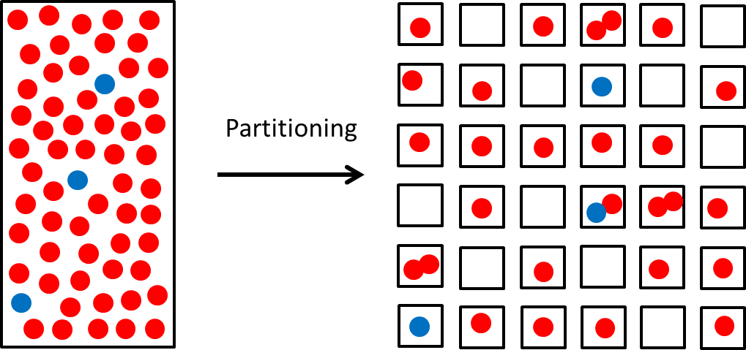

**Figure XX**: Schematic representation of the partitioning process that is carried out for dPCR.

The partitioning process varies depending on the choice of instrumentation used. There are two main methods:

1. Droplet based dPCR: This method involves separating a sample into thousands of nanolitre sized droplets using a droplet generator instrument.
2. Array based dPCR: This involves partitioning the sample on a reaction plate that contains several thousand reactions “through-holes” each of which can accommodate nanolitre sized reaction volumes

Each partition also contains all the necessary PCR reaction components therefore once they are exposed to traditional PCR reaction conditions any DNA that may be present in a partition will be amplified. Results of the amplification are measured either at the end point of the PCR or in real time, depending on the instrument being used, by detecting the presence of a fluorescence signal that would have been released by the Taqman® probe.

This method of PCR is advantageous in that it allows for easier detection of low concentrations of target DNA that may be present in a sample. This is because traditional real time PCR provides a single data point from each DNA sample. Any signal produced from low concentrations of target DNA that may be present in the sample will be drowned out by the signal produced from the more abundant DNA that is present or will not produce a sufficient signal that meets threshold requirements. However, with dPCR each partition serves as an individual amplification that provides a unique data point for the DNA that is present in the partition. Therefore, a strong signal is obtained from target DNA that is present in low concentrations and occupies a single partition. This results in a more accurate representation of the nature of the whole DNA sample.

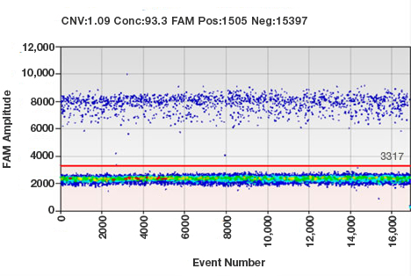

**Figure XX:** Sample results from a ddPCR experiment. Each droplet in a sample is plotted on a graph of fluorescence intensity versus droplet number. All positive droplets (those above the threshold intensity indicated by the red line) are scored as positive, and each is assigned a value of 1. All negative droplets (those below the threshold) are scored as negative, and each is assigned a value of 0 (zero). This counting technique provides a digital signal from which to calculate the starting target DNA concentration by a statistical analysis of the numbers of positive and negative droplets in a given sample. Source: <http://www.bio-rad.com/en-ca/applications-technologies/droplet-digital-pcr-ddpcr-technology>

Furthermore, once all the data from each partition is collected computer software performs the necessary statistical calculations, using Poisson’s law of small numbers, to determine the number of copies per microlitre of the target sample in the original DNA solution. This is based on the fact that the proportion of positive droplets detected following PCR is proportional to the concentration of target DNA in the sample. As a result, absolute quantification of the DNA sample can be carried out. This is done without the need for standard curves, or the amplification of an endogenous reference gene, as is the case with relative quantification when preforming traditional real time Taqman® PCR.

*Loop-Mediated Isothermal Amplification*

Loop-Mediated Isothermal Amplification (LAMP) is a DNA amplification procedure that is carried out at a single, isothermal, temperature, unlike traditional PCR where temperature cycling is required. It is preformed using a DNA polymerase that has high strand displacement capabilities and is functional at optimal temperatures around 60-65oC. The method requires the use of 4-6 primers that target 6-8 distinct regions, as indicated in figure XXa, which work in concert to amplify the DNA in two distinct phases.

1. *Non-cyclical Phase*: this step results in the generation of the stem loop or “dumbbell” DNA structure that serves as the key intermediate from which amplification can continue, as shown in figure XXb.
2. *Cycling Phase:* using the dumbbell structure as a starting point, the DNA polymerase continues the amplification process to generate concatemers of inverted repeats of the target amplicon, as outlined in figure XXc.

In addition to being performed at a constant temperature, the LAMP reaction can be completed within 30 minutes, yielding between 10-20µg of amplified DNA. The results can be visualised with the naked eye using simple colorimetric techniques, such as the formation of a precipitate or a colour change resulting from a change in pH as amplified DNA accumulates. These qualities make the LAMP technique suitable for use in the field with results being provided with minimal delay. However, the development and validation of an optimised LAMP assay can be laborious and the nature of the assay does not allow for the possibility of multiplexing.

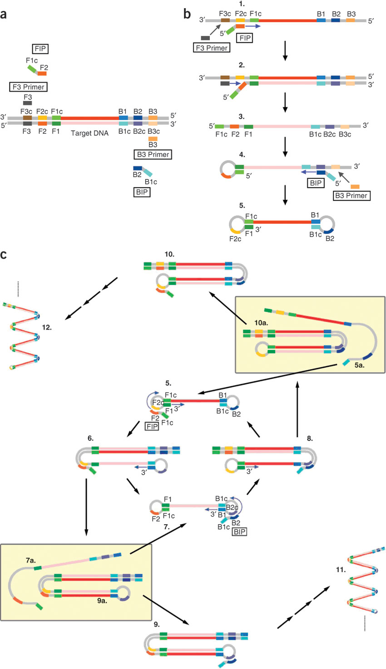

**Figure XX:**(**a**) Primer design of the LAMP reaction. For ease of explanation, six distinct regions are designated on the target DNA, labeled F3, F2, F1, B1c, B2c and B3 from the 5′ end. As c represents a complementary sequence, the F1c sequence is complementary to the F1 sequence. Two inner primers (FIP and BIP) and outer primers (F3 and B3) are used in the LAMP method. FIP (BIP) is a hybrid primer consisting of the F1c (B1c) sequence and the F2 (B2) sequence. (**b**) Starting structure producing step. DNA synthesis initiated from FIP proceeds as follows. The F2 region anneals to the F2c region on the target DNA and initiates the elongation. DNA amplification proceeds with BIP in a similar manner. The F3 primer anneals to the F3c region on the target DNA, and strand displacement DNA synthesis takes place. The DNA strand elongated from FIP is replaced and released. The released single strand forms a loop structure at its 5′ end (structure 4). DNA synthesis proceeds with the single-strand DNA as the template, and BIP and B3 primer, in the same manner as described earlier, to generate structure 5, which possesses the loop structure at both ends (dumbbell-like structure). (**c**) Cycling amplification step. Using structure 5 as the template, self-primed DNA synthesis is initiated from the 3′ end F1 region, and the elongation starts from FIP annealing to the single strand of the F2c region in the loop structure. Passing through several steps, structure 7 is generated, which is complementary to structure 5, and structure 5 is produced from structure 8 in a reaction similar to that which led from structures 5–7. Specifically, intermediate structures 7a and 9a and structures 5a and 10a (in the yellow boxes) are produced from structures 6 and 8, respectively. Structures 9a and 10a then form structures 9 and 10, respectively, whereas the displaced strands 7a and 5a form the dumbbell-like structures 7 and 5, respectively. More elongated structures (11, 12) are also produced. Source: <http://www.nature.com/nprot/journal/v3/n5/fig_tab/nprot.2008.57_F1.html>

**5.4 References**

**DNA**

Alberts, B., Bray, D., Lewis, J., Raff, M., Roberts, K. and Watson, J.D. (1983). Molecular biology of the cell. Garland Publishing, Inc., New York.

Atlas, R.M. and Bej, A.K. (1994). Polymerase Chain Reaction. In: Gerhardt, P., Murrey, R.G.E., Wood, W.A. and Krieg, N.R., (Eds.) Methods for general and molecular bacteriology. Washington, D.C.: American Society for Microbiology, pp. 418–435.

Dieffenbach, C.W., Lowe, T.M.J. and Dveksler, G.S. (1995). General Concepts for PCR Primer Design. In: Dieffenbach, C.W, and Dveksler, G.S. (Eds.) PCR Primer: a Laboratory Manual. New York: Cold Spring Harbor Laboratory Press, Cold Spring Harbor, NY, USA, pp. 133–155.

Innis, M.A. and Gelfand, D.H. (1990). Optimization of PCRs. In: Innis, M.A., Gelfand, D.H., Sninsky, J.J., and White, T.J. (Eds.) PCR Protocols: a Guide to Methods and Applications. New York: Academic Press, pp. 3–12.

Innis, M.A., and Gelfand, D.H. (1994). Optimization of PCRs. In: Innis, M.A., Gelfand, D.H., Sninsky, J.J., and White, T.J. (Eds.) PCR Protocols: a Guide to Methods and Applications. London: CRC Press, pp. 5–11.

Innis, M.A., Myambo, K.B., Gelfand, D.H. and Brow, M.A. (1988). DNA sequencing with Thermus aquaticus DNA polymerase and direct sequencing of polymerase chain reaction-amplified DNA. Proceedings of the National Academy of Science USA 85, 9436-9440.

Longo, M.C., Berninger, M.S. and Hartley, J.L. (1990). Use of uracil DNA glycosylase to control carry-over contamination in polymerase chain reaction. Gene 93, 125– 128.

N. Mallah, M. Obeid, G. Abou Sleymane (2017). Comprehensive matrices for regulatory approvals and genetic characterization of genetically modified organisms. Food Control, 80:52-58.Newton, C.R. and Graham, A. (1994). PCR. BIOS Scientific Publishers, Limited, Oxford.

Niederhauser, C., Höfelein, C., Wegmüller, B., Lüthy, J. and Candrian, U. (1994). Reliability of PCR Decontamination Systems. PCR Methods and Applications 4, 117–123.

Ogawa, T. and Okazaki, T. (1980). Discontinuous DNA replication. Annual Review of Biochemistry 49, 421–457.

Roux, K.H. (1995). Optimization and troubleshooting in PCR. PCR Methods and Applications 4, 185-194.

Rolfs, A., Schuller, I., Finckh, U. and Weber-Rolfs, I. (1992). Substances affecting PCR: Inhibition and enhancement, 51-58. In: PCR: Clinical diagnostics and research, Springer.

Roth, A., Mauch, H. and Göbel, U. (1997). Nucleic Acid Amplification Techniques – Recommendations for Employing Molecular Methods in Diagnostic Routine Microbiology Laboratories and Measures for Internal Quality Assurance. Gustav Fischer Verlag, Stuttgart.

Saiki, R.K., Scharf, S.J., Faloona, F., Mullis, K.B., Horn, G.T., Erlich, H.A. and Arnheim, N. (1985). Enzymatic amplification of ß-globin genomic sequences and restriction site analysis for diagnosis of sickle cell anemia. Science 230, 1350.

Saiki, R.K. et al. (1988). Primer-directed enzymatic amplification of DNA with a thermostable DNA polymerase. Science 239, 487.

Sambrook, J., Fritsch, E.F. and Maniatis, T. (1989). In vitro Amplification of DNA by the Polymerase Chain Reaction. In: Sambrook, J., Fritsch, E.F. and Maniatis, T. (Eds.) Molecular Cloning: a Laboratory Manual. New York: Cold Spring Harbor Laboratory Press, Cold Spring Harbor, NY, USA, chapter 14.

Sharrocks, A.D. (1994). The design of primers for PCR. In: Griffin, H.G. and Griffin, A.M (Eds.) PCR Technology: Current Innovations. London: CRC Press, pp. 5–11.

Suggs, S.V., Hirose, T., Miyake, E.H., Kawashima, M.J., Johnson, K.I., and Wallace, R.B. (1981). Using Purified Genes. In ICN-UCLA Symp. Developmental Biology, Vol. 23, Brown, D.D. Ed., Academic Press, New York, 1981, 683.

ISO 21569 Foodstuffs -- Methods of analysis for the detection of genetically modified organisms and derived products -- Qualitative nucleic acid based methods

ISO 21570 Foodstuffs -- Methods of analysis for the detection of genetically modified organisms and derived products -- Quantitative nucleic acid based methods

ISO 21571 Foodstuffs -- Methods of analysis for the detection of genetically modified organisms and derived products -- Nucleic acid extraction

ISO 21572 Foodstuffs -- Molecular biomarker analysis -- Protein-based methods

ISO 24276 Foodstuffs -- Methods of analysis for the detection of genetically modified organisms and derived products -- General requirements and definitions

CEN/TS 16707 Foodstuffs - Methods of analysis for the detection of genetically modified organisms and derived products - Polymerase chain reaction (PCR) based screening strategies.

Additional Reading

Gayer-Herkert, G., (1992). Molekularbiologische Methoden für den Nachweis von Mikroorganismen in Mischpopulationen – eine Literaturstudie. Bioengineering 5 + 6, 55–64.

Horton, H., Moran, L., Ochs, R., Rawn, J. and Scrimgeour, K., (1994). Principes de Biochimie. De Boeck – Wesmael, S.A., Bruxelles.

Knippers, R. (1995). Molekulare Genetik. Georg Thieme Verlag, Stuttgart.

Kwok, S., Kellog, D.E., McKinney, N., Spasic, D., Goda, L., Levenson, C. and Sninsky, J.J. (1990). Effects of primer-template mismatches on the polymerase chain reaction: Human Immunodeficiency Virus 1 model studies. Nucleic Acids Research 18, 999–1005.

Larzul, D. (1993). Le PCR: un procédé de réplication in vitro. Tec & Doc-Lavoisier, Paris.

Stryer, L. (1991). Biochemie. Spektrum Akademischer Verlag, GmbH, Heidelberg.

Watson, D.J., Hopkins, N., Roberts, J., Steitz, J. and Weiner, A. (1988). Molecular Biology of the Gene. The Benjamin/Cummings Publishing Company, Inc., New York.

**Protein**

Clark, M.F. and Adams, A.N. (1977). Characteristics of the microplate method of enzyme-linked immunosorbent assay for the detection of plant viruses. Journal of General Virology 34, 475–483.

Hemmer, W. (1997). Foods Derived from Genetically Modified Organisms and Detection Methods. Biosafety Research and Assessment of Technology Impacts of the Swiss Priority Program Biotechnology – Report 2/97, 61 pages. http://www.bats.ch/bats/publikationen/1997-2_gmo/index.php (accessed January 2010)

Lipp, M., Anklam, E. and Stave, J.W. (2000). Validation of an immunoassay for detection and quantification of a genetically modified soybean in food and food fractions using reference materials. Journal of AOAC International 83, 919–927.

Longstaff, M., Edmonds, H.S. and Newell, C.A. (1995). An improved method for the detection and quantification of recombinant protein in transgenic plants. Plant Molecular Biology Reporter 13, 363–368.

Mohapatra, U., Mccabe, M.S., Power, J.B., Schepers, F., Vanderarend, A. and Davey, M.R. (1999). Expression of the bar gene confers herbicide resistance in transgenic lettuce. Transgenic Research 8, 33–44. Padgette, S.R., Kolacz, K.H., Delannay, X., Re, D.B., LaVallee, B.J., Tinius, C.N., Rhodes, W.K., Otero, Y.I., Barry, G.F., Eichholtz, D.A., Peschke, V.M., Nida, D.L., Taylor, N.B. and Kishore, G.M. (1995). Development, identification, and characterization of a glyphosate-tolerant soybean line. Crop Science 35, 1451– 1461.

Additional Reading

Brett, G.M., Chambers, S.J., Huang, L. and Morgan, M.R.A. (1999). Design and development of immunoassays for detection of proteins. Food Control 10, 401– 406.

Commission Directive 79/700/EEC of 24 July 1979 establishing Community methods of sampling for the official control of pesticide residues in and on fruit and vegetables. OJ L 239, 22.9.1979, p. 24.

Rogan, G.J. Dudin, Y.A., Lee, T.C., Magin, K.M., Astwood, J.D., Bhakta, N.S., Leach, J.N., Sanders, P.R. and Fuchs, R.L. (1999). Immunodiagnostic methods for detection of 5-enolpyruvylshikimate-3-phosphate synthase in Roundup Ready® soybeans. Food Control 10, 407–414.

Stave, J.W. (1999). Detection of new or modified proteins in novel foods derived from GMO - future needs. Food Control 10, 367–374.

Van der Hoeven, C., Dietz, A. and Landsmann, J. (1994). Variability of organspecific gene expression in transgenic tobacco plants. Transgenic Research 3, 159–165.

<http://www.sciencedirect.com/science/article/pii/S0956713513005367>

<http://www.sciencedirect.com/science/article/pii/S0924224414000661>

<https://www.ncbi.nlm.nih.gov/pmc/articles/PMC4589694/>

[http://download.springer.com/static/pdf/705/art%253A10.1186%252Fs12859-014-0417-8.pdf?originUrl=http%3A%2F%2Fbmcbioinformatics.biomedcentral.com%2Farticle%2F10.1186%2Fs12859-014-0417-8&token2=exp=1496690125~acl=%2Fstatic%2Fpdf%2F705%2Fart%25253A10.1186%25252Fs12859-014-0417-8.pdf*~hmac=41365c321a087a127130781d5482e33869a7b29aa5fcd2eadc7c86722a6221f0](http://download.springer.com/static/pdf/705/art%253A10.1186%252Fs12859-014-0417-8.pdf?originUrl=http%3A%2F%2Fbmcbioinformatics.biomedcentral.com%2Farticle%2F10.1186%2Fs12859-014-0417-8&token2=exp=1496690125~acl=%2Fstatic%2Fpdf%2F705%2Fart%25253A10.1186%25252Fs12859-014-0417-8.pdf*~hmac=41365c321a087a127130781d5482e33869a7b29aa5fcd2eadc7c86722a6221f0)

[http://download.springer.com/static/pdf/705/art%253A10.1186%252Fs12859-014-0417-8.pdf?originUrl=http%3A%2F%2Fbmcbioinformatics.biomedcentral.com%2Farticle%2F10.1186%2Fs12859-014-0417-8&token2=exp=1496690125~acl=%2Fstatic%2Fpdf%2F705%2Fart%25253A10.1186%25252Fs12859-014-0417-8.pdf*~hmac=41365c321a087a127130781d5482e33869a7b29aa5fcd2eadc7c86722a6221f0](http://download.springer.com/static/pdf/705/art%253A10.1186%252Fs12859-014-0417-8.pdf?originUrl=http%3A%2F%2Fbmcbioinformatics.biomedcentral.com%2Farticle%2F10.1186%2Fs12859-014-0417-8&token2=exp=1496690125~acl=%2Fstatic%2Fpdf%2F705%2Fart%25253A10.1186%25252Fs12859-014-0417-8.pdf*~hmac=41365c321a087a127130781d5482e33869a7b29aa5fcd2eadc7c86722a6221f0)

(<https://www.ncbi.nlm.nih.gov/pmc/articles/PMC4280562>)

<http://www.biotechniques.com/multimedia/archive/00010/02324pf01_10910a.pdf>

<https://www.ncbi.nlm.nih.gov/pmc/articles/PMC102528/>

<http://www.sciencedirect.com/science/article/pii/S131961031400129X>

<http://www.elisa-antibody.com/ELISA-Introduction>

<https://www.thermofisher.com/ca/en/home/life-science/protein-biology/protein-biology-learning-center/protein-biology-resource-library/pierce-protein-methods/overview-elisa.html>

[DNA-based Detection of GM Ingredients](http://scholar.google.com/scholar_url?url=http://books.google.com/books%3Fhl%3Den%26lr%3Dlang_en%26id%3DExgnDwAAQBAJ%26oi%3Dfnd%26pg%3DPA205%26dq%3D%2522genetically%2Bmodified%2Borganism%2522%26ots%3DFAU8IS-7RE%26sig%3D3HOSmIWq73MXC0QJQz6vlYeBTp4&hl=en&sa=X&scisig=AAGBfm3puZqPjjkJAOW9GOLz6kY599zGVA&nossl=1&oi=scholaralrt) P Guertler, A Hahn, U Busch, KH Engel - Advances in Food Diagnostics, 2017 Page 229. 205 8 DNA-based Detection of GM Ingredients Patrick Guertler1, Alexandra Hahn2, Ulrich Busch1 and Karl-Heinz Engel3 1Bavarian Health and Food Safety  
Authority (LGL), Molecular Biology Unit, Oberschleißheim **...**

<https://www.ncbi.nlm.nih.gov/pmc/articles/PMC4548226/>

<https://tools.thermofisher.com/content/sfs/manuals/cms_088717.pdf>

<http://lib3.dss.go.th/fulltext/Journal/J.AOAC%201999-2003/J.AOAC2002/v85n3(may-jun)/v85n3p775.pdf>

<http://bch.cbd.int/cms/ui/collaboration/download/download.aspx?id=838>

<https://www.thermofisher.com/ca/en/home/life-science/pcr/digital-pcr.html>

<https://academic.oup.com/nar/article/28/12/e63/2359194/Loop-mediated-isothermal-amplification-of-DNA>

<http://www.isaaa.org/resources/publications/pocketk/42/>

<https://www.hindawi.com/journals/bmri/2015/392872/>

<https://www.researchgate.net/profile/Filipe_Pereira3/publication/317970013_A_method_to_assemble_DNA_fragments_mimicking_junctions_of_transgenic_elements_Application_to_the_AquAdvantage_salmon/links/59569093aca2720010847eb8/A-method-to-assemble-DNA-fragments-mimicking-junctions-of-transgenic-elements-Application-to-the-AquAdvantage-salmon.pdf>

1. <http://www.envirologix.com/solutions/catalog/?filtering=1&filter_target=gmo&filter_technology=protein>
2. Links to publicly available matrices can be found in chapter XX.