Module 2

Overview of the detection and identification of Living Modified Organisms

**Contents of this module**

Overview of techniques used in modern biotechnology

Introduction

Overview of commonly used methods for genetic modification of plants

Overview of available detection and identification methods

Protein-based methods for LMO detection

DNA-based methods for LMO detection

Comparison between protein- and DNA-based methods for LMO detection

Challenges in LMO detection and new technology developments

Pipeline for the development of LM Crops

Considerations for National Strategies towards the detection and identification of LMOs

**Overview of techniques used in modern biotechnology**

***Introduction*** Cultivars produced through the domestication of wild crop relatives by selection and controlled breeding predate human culture.[1] The development of highly productive, better adapted, or pest resistant crops as well as crops producing improved or alternative products by cross breeding sexually compatible plants of the same or closely related species have been the mainstay of modern agriculture. Advances in these breeding technologies have made it possible to produce, not only crosses between plants that are sexually compatible, but also between plants that are considered as naturally cross sterile. Examples of techniques used in such cases are embryo-rescue techniques, *in vitro*/*in vivo* embryo cultivation, ovary and ovule cultures, *in vitro* pollination and *in vitro* fertilization. In addition, mutational changes could be induced, for instance, through seed irradiation or chemical treatment. Simultaneously, improving knowledge of the molecular genetics of the wild crop relatives has identified important markers in plant breeding, with an understanding that the wild crop relatives provide an historic reference.

Over the past four or five decades, many of the limitations of conventional breeding, e.g. hybridization and selection methods including the ability to target and introduce single selected traits rather than evaluating randomly recombining genomes have been overcome with modern biotechnology.

Under the Cartagena Protocol, modern biotechnology means the application of:

1. *In vitro* nucleic acid techniques, including recombinant deoxyribonucleic acid (DNA) and direct injection of nucleic acid into cells or organelles, or
2. Fusion of cells beyond the taxonomic family,

that overcome natural physiological reproductive or recombination barriers, techniques that are not used in traditional breeding and selection.

When an agricultural crop cultivar is produced using modern biotechnology it is called a living modified organism (LMO). Other terms used for this process are genetic modification, genetic engineering, recombinant DNA and DNA manipulation. Consequently, the terms genetically modified organism (GMO) as well as genetically engineered organism are often used interchangeably with LMO. However; the Cartagena Protocol emphasizes the “living” nature of the organism, and some of its provisions also apply to LMOs intended for direct use as food or feed, or for processing. The Cartagena Protocol specifically focuses on LMOs i.e. any “living” organism that possesses a novel combination of genetic material obtained through the use of modern biotechnology.

In the context of agricultural crops, the terms LMO and GMO refer to plants in which foreign genetic material has been stably introduced into a host genome using modern biotechnology. These plants are products of modern biotechnology. In modern biotechnology, introduced genetic material can originate from a different species, giving rise to a “transgenic” plant or from the same or other sexually compatible species giving rise to a “cisgenic” plant. The genetic introduction may result in a mutation, the correction of a mutation, in the formation of a gene product, i.e. a protein or silencing of the expression of an endogenously produced protein, i.e. gene silencing mediated by RNA. The introduction may also result in a new plant trait or characteristic or the modification of an existing characteristic. Some of the most common traits produced using modern biotechnology include: cold tolerance, herbicide tolerance, male sterility/fertility restoration, insect resistance, virus resistance, fungal resistance and modification of nutrient biosynthesis.

***Overview of commonly used methods for genetic modification***

LMOs are developed using *in vitro* nucleic acid techniques that consist of inserting, deleting or modifying a gene or DNA/RNA sequence in a recipient or parental organism.

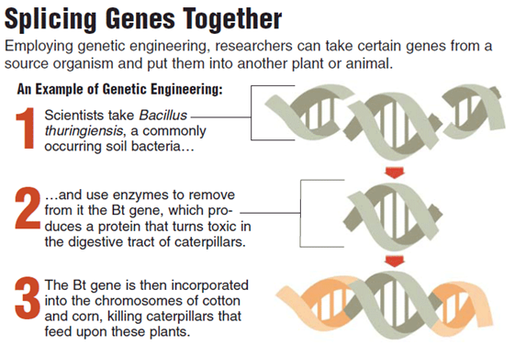

**Figure 1 –** In vitro nucleic acid techniques Source:North Carolina State University, College of Agriculture and Life Sciences (website).

Production of LMOs through genetic modification is a multistage process that can be achieved through a variety of molecular methodologies. A description of principal steps involved in the development of LM plants is:[2]

* Once a gene of interest has been identified through DNA sequencing and isolated from a donor organism, it is manipulated in the laboratory to be safely and productively introduced into the intended recipient organism. The manipulation may, for example, include changes to the nucleotide sequence to enhance or modulate gene expression.
* Using modern biotechnology methods genetic sequences that affect gene expression known as the promoter and terminator are enzymatically added to the gene(s) of interest. This combination of promoter, gene of interest and terminator is known as a “transformation cassette”,[3] as shown in figure 2. Promoters and terminators are examples of genetic elements that control gene expression in different ways depending on their structure and/or cellular signals. For example, some promoters allow for the continuous expression of the gene (these are known as “constitutive promoters”), while others switch the expression of the gene on or off in different organs and/or developmental stages of the organism or in response to stimuli or other external influences. Some promoters may be "tissue specific", meaning that they are able to switch on and regulate gene expression only in a few cells or in specific tissues of the organism.
* A “marker gene” is sometimes incorporated into the transformation cassette to help identify and/or select cells or individuals in which the transformation cassette(s) was successfully introduced. Marker genes may, in some cases, be removed from the LMOs at a later stage.
* Finally, the transformation cassette is normally incorporated into a larger DNA molecule known as a vector.[4] The purpose of the vector is to assist the transfer of the transformation cassette into the recipient organism.

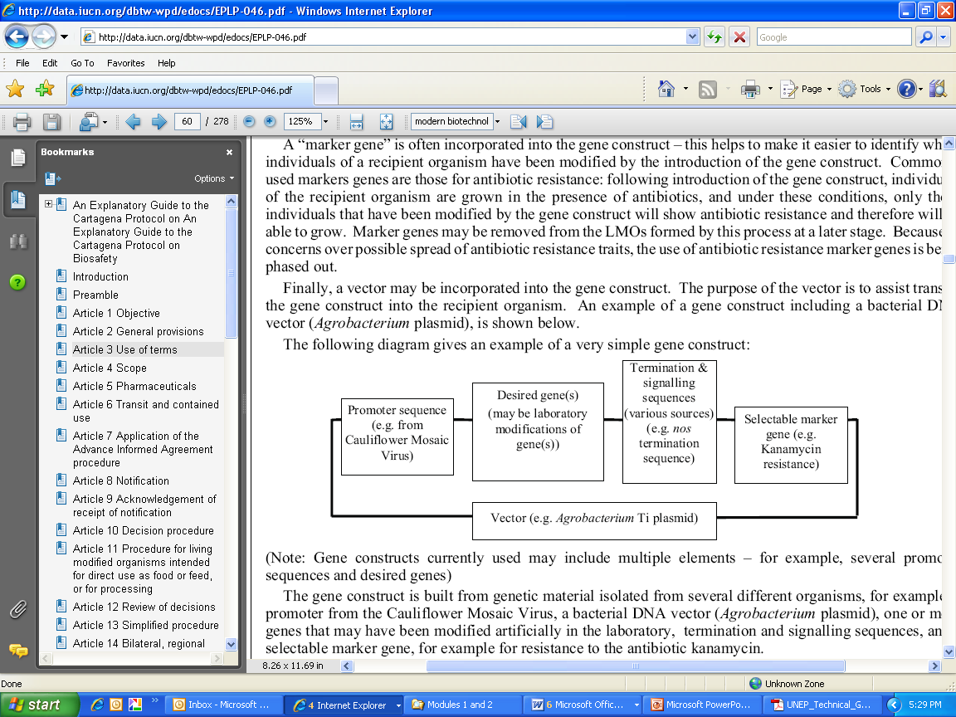

Note: Transformation cassettes currently used may include multiple elements – for example, several promoter sequences and desired genes.

**Figure 2 –** Scheme of a transformation cassette and vector. Source: IUCN (2003).

The transformation cassettes are integrated into the genome of the recipient organism through a process known as transformation, as outlined in figure 3. This can be carried out through different methods such as infection using, for example, *Agrobacterium tumefaciens*, particle bombardment, protoplast transformation or microinjection.

Transformed cells are then selected, for example, with the help of a marker gene, and regenerated into a complete organism through further manipulations such as cell culture and breeding techniques. The resulting organisms are further characterized to identify those that continue to express the desired phenotype of the recipient organism while also containing the desired transgene(s)[5] or modification. Through selection, many experimental LMOs are discarded and only a few events may reach the commercialization stage..

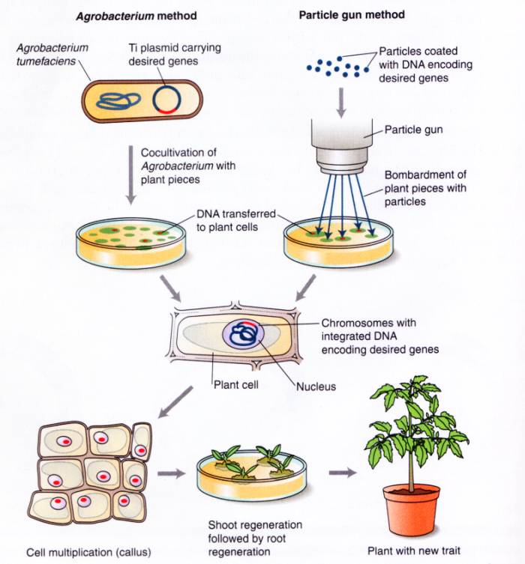

**Figure 3 –** Genetic modification of plants. Source: Mirkov (2003).

Although, LMOs may be produced by cell fusion of cells from two different organisms not belonging to the same taxonomic family that contains no LMOs have ever been produced using this technique.

***Overview of available detection and identification methods[6]***

Many methods and techniques have been published to detect, identify and quantify living modified organisms. They range from fast and cost-effective, such as lateral flow strips and endpoint polymerase chain reaction (PCR), to more complex methods, such as quantitative real-time PCR and whole genome sequencing.

A molecular biology laboratory is essential for LMO test method development and testing. Only a few methods can be executed in the field without laboratory support. Laboratory design and construction for LMO detection depends on the methods of identification that will be adopted. For service-oriented laboratories, particularly those serving regulatory authorities, the selection of methods is guided by, among other considerations, by the country’s specific regulatory requirements in accordance with its national biosafety laws.

DNA and protein molecules are both targets for molecular detection, identification and quantification of LMOs. There are advantages and disadvantages to targeting DNA or protein, or both which depend largely on the available expertise, infrastructure, capacity to handle samples, laboratory equipment, required assay sensitivity and regulatory requirements.

The Table below provides a brief overview of some of the most commonly used methodologies for the detection, identification and quantification of LMOs, their strengths and limitations.



|  |  |  |  |  |
| --- | --- | --- | --- | --- |
| (<http://www.gmotesting.com/Testing-Options>) | | | | |
| Analysis Molecular Basis | Target | Test | Advantages | Disadvantages |
| Immunologic | Protein | Laminar Flow Strip ELISA | Because the test is rapid and can be performed onsite, this method is very useful as an initial screen for seed and grain | Often low sensitivity (Limit of detection 0.1-1%) |
| Because the test is not performed with laboratory controls, operator error resulting in inaccurate test results can sometimes be an issue. |
| Not appropriate for processed products |
| GM protein levels may vary between different commercial GM cultivars and different parts of the same GM plant |
| Plate ELISA | High sensitivity (Limit of detection 0.01-0.1%) | Not appropriate for processed products |
| GM protein levels may vary between different commercial GM cultivars and different parts of the same GM plant |
| Must be performed in a laboratory |
| Genetic | Nucleic Acid | PCR | High sensitivity (limit of detection 0.01%) and specificity | Must be performed in a laboratory |
| Capable of detecting all GMOs |
| Allows definitive quantification |
| Effective with broad range of sample types |
| Industry standard used worldwide in surveillance and testing labs |



**Protein-based methods for LMO detection**

are based onbind LMO specific proteins (i.e. those encoded by the inserted genes) are detected with antibodies that bind to LMO specific protein epitopes. Protein test methods include the lateral flow strip test, the micro-titre plate format enzyme-linked immunosorbent assay (ELISA) or gel electrophoresis based protein immunoblots, also known as western blots. Since the process of antibody production is extremely complex and costly, detection using these methods typically relies on the availability of commercial antibodies.

Protein detection using lateral flow strip tests, ELISA or western blot starts with sample homogenization and a simple extraction procedure of total crude proteins from a sample with water or buffer. An explanation of the structure and use of these strips is given by Shillito and Currier (2011). lateral flow strip method is qualitative. IThe user only needs to expose the strip to the sample extract to visually determine the result, negative or positive, by the appearance of one or two test lines due to antibody recognition of a control protein or both the control protein and the transgenic protein. These strips can also be used with a subsampling approach to give a semi-quantitative result.

The plate ELISA is a laboratory method allowing the user to look at different antibody and target protein concentrations. Anti-target antibody is used to pre-coat the wells of a micro-titre plate. After the sample extract is added allowing the target protein to bind to the antibody fixed to the microtiter well, and cellular debris, including other proteins, are removed from the plate through a series of wash steps bound protein is detected using a colorimetric assay. Color intensity is evaluated visually or with optical plate reader. The advantages of LMO testing using ELISA is that a qualitative or quantitative test can be developed in the lab for a specific target and this method is more sensitive than the lateral flow strip .

Western blotting allows target proteins to be identified by their size. After they are separated by gel electrophoresis, proteins arranged by molecular size and charge are transferred from the gel to a membrane for the detection of the target protein. This step usually involves two antibodies: a primary antibody that is specific to the target protein followed by a secondary antibody, which is linked to a reporter molecule that binds to the primary antibody. After the excess antibody is removed from the membrane, the secondary antibody is typically visualized by radiometric, colorimetric, chemiluminescent or fluorescent methods performed by either colouring the membrane itself or exposing it to a light sensitive film, such as X-ray film. Once the membrane or film is developed, the presence of the transgenic protein is indicated as a distinct band on the membrane or film. The advantage of this method is that it is sensitive and may detect different isoforms of the target protein. A Western blot is not suitable for detection of LMOs in mixtures as it does not have appropriate sensitivity

A general disadvantage of all immunological methods is that its sensitivity is dependent on the binding affinity between the antibody and the target protein, and the level of expression of the protein in the LMO. It may also be affected by cross-reactivity between the antibody and native forms of the same protein that may be present in the organism, or by similar proteins expressed by other LMOs.

**PCR-based methods for LMO detection**

DNA-based methods for LMO detection, identification and quantification rely primarily on the use of the polymerase chain reaction (PCR) and related molecular techniques. DNA is extracted from plant cells prior to PCR. Extraction methods have been published and are available as kits for different tissue types and applications (e.g. leaves or seeds). PCR uses synthetic DNA oligonucleotides, called “primers”, and DNA polymerase to replicate and amplify targeted regions of an inserted DNA sequence found in the extracted DNA. Because a single DNA copy can be precisely amplified tens of millions of times, the target sequence can be detected in a very small amount of plant sample DNA. In PCR, denatured DNA primersanneal to specific DNA sequences flanking the target DNA sequence. DNA polymerase extends the primer through the target DNA producing a single stranded transcript that subsequently anneals to the reverse primer which is extended. The process continues until the amplified product can be visualized.

The amplified target DNA can be detected and measured by gel electrophoresis or real time PCR. Gel electrophoresis separates DNA according to its size and charge in an electric field. Intercalating fluorescent dyes are available that specifically bind DNA for detection and quantification.

Real-time PCR technology permits the detection of target sequence during the PCR amplification process, with either an intercalating fluorescent DNA binding dye or a fluorescence tagged probe. Published PCR methods are available for many LMOs. These vary in technology, size of transcript, validation status and international acceptance. Depending on the combination of primers used, PCR detection can be gene-specific, construct-specific or event-specific. The differences between each type of PCR target region is represented in Figure 1.

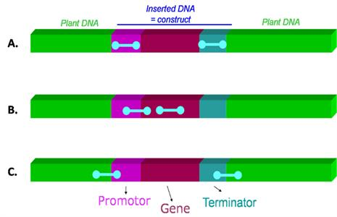

**Figure 4:** Different types of PCR target regions A) common regulatory elements (such as promoters, terminators) B) gene-specific or construct-specific (junction between two genetic elements within the construct) C) event-specific (junction between the inserted construct and the plant genome) Source: National Institute of Biology

PCR is sensitive, specific and versatile, and can be used to simultaneously screen a sample for LMO content, identify the specific LMO gene or event present and, when used in a real-time PCR platform, quantify the amount of LMO present in the sample. Multiplex and matrix[7] approaches can also be used for multi-target detection. A disadvantage of a PCR based approach, however, is that it requires specialized expertise and equipment.

**Comparison between protein- and PCR-based methods for LMO detection**

Protein- and DNA-based are routinely used approaches for LMO detection.

Protein-based methods, such as lateral flow strip tests and ELISA, are simple, time efficient (several minutes to a few hours), and convenient for a small number of samples. The lateral flow strip test is useful for LMO testing at the point of sampling. However, protein-based detection of LMOs requires a different test for the detection of individual LMO traits and cannot be used to simultaneously distinguish between different LMO events that may be present in a single sample. Immunoassays are routinely used to test samples for multiple LMO traits, either as strips detecting multiple proteins, or as combs containing multiple strips. In contrast, western blots and PCR approaches, while more specific and sensitive, may require more steps and time (several hours to days) and rely on specialized laboratory equipment and expertise.

Protein-based methods are only suitable for detecting LMOs that contain a detectable protein unique to or absent from the LMO. However, they are not suitable for detecting specific genetic elements involved in gene expression, such as regulatory sequences that silence the expression of target genes through RNAi.

Protein-based methods rely on the specificity of the antigen-antibody interaction therefore, any changes in the tertiary structure of the target protein can potentially render the method ineffective. Such conformational changes are sometimes introduced during sample processing if the samples are subjected to heat and/or chemical treatment. The detection capability in protein-based methods is affected by the expression level of the target protein which can vary between tissues or different stages of in life cycle and can be influenced by external factors such as climate and soil conditions. Tissue specificity of expression also plays a role in detection since target protein expressed in roots may not be detected in leaves.

DNA can be more stable than proteins. In practice, proteins degraded by solvents or heat may not be detectable by immunological methods, but PCR can detect the DNA., DNA is present in the nuclei of every cell and PCR can be used to screen a sample for the presence of several potential LMO targets simultaneously.

**Challenges in LMO detection and new technology developments**

Challenges to applying available technologies to LMO detection are present for many nations, but these can be worked out. A brief overview of some of the key considerations follows.

*Availability of validated methods*

The criteria for validation and verification of many LMO methods has been elucidated. Much of this information has been published, harmonized and standardized internationally (e.g. ISO TC 34/SC 16). These standards and publications provide information for method development and use ranging from the most basic type of PCR amplification or ELISA to laminar flow strip tests, real time PCR and DNA sequencing. These criteria have been published in Codex CAC/GL 74-2010. Evaluating biological diversity and safety for additional ecological and environmental consideration outside of international LMO trade markets is also ongoing with trait and characteristic developers.

*Implementation of a Quality System*

At the international level a laboratory must be competent to perform their tests. Competence is evaluated against a management system for laboratories or businesses that test for LMOs. Standards for laboratory competence are available internationally from the International Organization for Standardization and the International Seed Testing Organization (e.g. ISO 17025 and ISTA Rules). These standards provide guidance for developing a laboratory quality system and a framework for international accreditation. In addition, both organizations have developed standards for methods, methods development and sampling.

*Access to detection methods and reference material*

Many methods for LMO testing have been collaboratively validated and published. They are available to the public and widely used for the evaluation of drift and the development of crop buffers. Certified reference material is also available from many sources. Genome sequencing has become a useful tool and may in some cases be used to determine LMOs. Methods for most commercial plant LMOs are accessible through the BCH database, and the CropLife detection methods database (detection-methods.com). Use of these sources of methods can reduce the possible difference in results found by countries using different detection methods for the same LMO. Reference materials for most commercial plant LMOs are available from AOCS or IRMM However certain reference materials may not be available for some LMOs.

*Gaps in National Biosafety Frameworks*

Considering the challenges faced with access to detection methods and reference material, many regulatory systems consider the inclusion in the requirements for LMO developers to provide sufficient reference material of each notified LMO to the national competent authority laboratory or the designated test laboratory. Furthermore, since it is costly to develop and validate a new method for LMO analysis, developers in most cases provide a method for the detection of the LMO event in publicly available databases.

*Novel approaches for simultaneous detection of multiple LMOs*

The increase in LMO research and commercialization is resulting in a continuous increase in the number of LMO events that laboratories may wish to detect. In addition, the potential for presence of unapproved LMO events may be increasing, and detection laboratories are faced with the challenge of having to potentially detect multiple LMOs present in a single sample, some of which may be approved, while others may have not yet been authorised or are illegal, according to the Party’s regulatory context. One approach to address this challenge is to use a suitable screening strategy such as following a matrix approach to simultaneously detect multiple genetic elements that are commonly used in an attempt to widen the screening capabilities. When used in conjunction with bioinformatics software, the matrix results can be used to identify the potential LMOs that are present in the sample. This approach can be customized to include as many LMOs as the laboratory is required to detect, and it is primarily applicable to PCR-based methods.

*Emerging technologies for LMO development and detection methods*

New and emerging technologies for developing LMOs are proving to be a challenge for the detection and identification of the LMOs. For example, new gene silencing technologies include the use of double stranded RNA (dsRNA) molecules to confer desirable traits to LMOs. In such cases, a transgenic protein is not produced, and therefore only DNA-based detection methods can be used. Furthermore, other LMOs are being developed through emerging techniques.

On the other hand, the continuous development of new technologies makes LMO detection more readily accessible, especially in countries with fewer resources. For example, digital PCR and other chip-based technologies will soon enable the routine detection of LMOs in the field with portable devices. In addition, another technology that is fast becoming available is isothermal nucleic acid amplification. This approach has several means by which it can be performed and is already being offered as commercial kits. Isothermal reactions have the advantage of being fast and having low cross contamination rates, as well as having the specificity and sensitivity of PCR-based methods.

While many countries may consider the development of a framework for LMO detection to be a burden, the technology may also be applied to other purposes such as human, plant and animal pathology, amongst other uses.

***Pipeline for the development of LMOs***

The pipeline for the development of an LMO and its subsequent commercialisation and release into the environment is a long, multi-step process that is follows the research and development process, to obtain an LMO with the desired traits, as represented in figure 5.

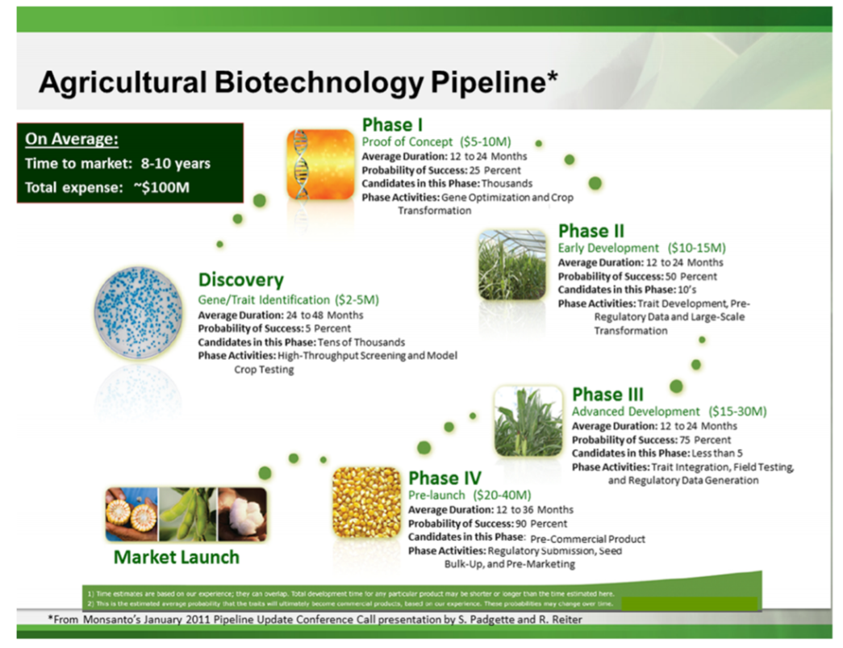

**Figure 5 -** Example of a commercial pipeline process to develop transgenic events, which includes several phases to market launch. Source: <http://pubs.acs.org/doi/pdf/10.1021/jf400685y>

The first of these steps is the identification of a desired trait and the isolation of the genetic information that is responsible for imparting this trait in the organism.

This is followed by further research and development to optimise the genetic construct that will be used to transform the recipient organism. This first phase includes the testing of the optimal promoter and terminator sequences as well as the stability of the construct.

Once the recipient organism is transformed, the selection of the biologically relevant and higher performing events takes place. In the case of developing LM plants this includes testing the events under greenhouses and field testing conditions. Introgression breeding can be used to develop the best performing plant varieties that will eventually be commercialised. Once the optimal plant variety is selected, the production of seed for distribution can take place.

The final stages of the LMO development pipeline consist of conducting regulatory studies or analyses to provide scientific evidence on the biosafety measures that may be required for adequate handling and responsible use of the LMO. This involves generating the data required to obtain regulatory approval of the LMO. The type of data that is required varies from country to country, but normally includes information on the stability of the genetic construct, nutritional equivalence as compared to the parental organism, allergenicity testing and risk assessment studies[8]. Once completed the necessary data is submitted to the relevant competent national authorities that are responsible for regulating the import and/or cultivation of LMOs, to obtain approval.

The first engineered organism that was considered an LMO, produced in 1978, was a strain of *Escherichia coli* that produced biologically active human somatostatin. it was produced using recombinant DNA techniques. Subsequently, other proteins such as insulin were produced at a commercial scale using similar methods.

In 1996, the first genetically modified seeds of the FLAVR SAVR™ Tomato were authorized in the United States for use as in commercial agricultural applications, as were E176 maize and Roundup ReadyTM soy. According to the International Service for the Acquisition of Agri-biotech Applications (ISAAA), the worldwide area cultivated with LM crops has been growing steadily since 1996, and in 2016, the cultivation of LM crops accounted for 185.1 million hectares.

The most common LMOs currently being cultivated are LM canola, maize, cotton and soybean. These varieties have been modified to exhibit herbicide tolerance and/or insect resistance. Research has shown that the amount of time it takes to develop and commercialise new traits in each of these crops is on average 11.7, 12.0, 12.7 and 16.3 years, respectively. The introduction of new traits, including agronomic and quality traits, into other crops, such as potato and rice, amongst others, is also taking place at faster rates, as shown in figure 6.

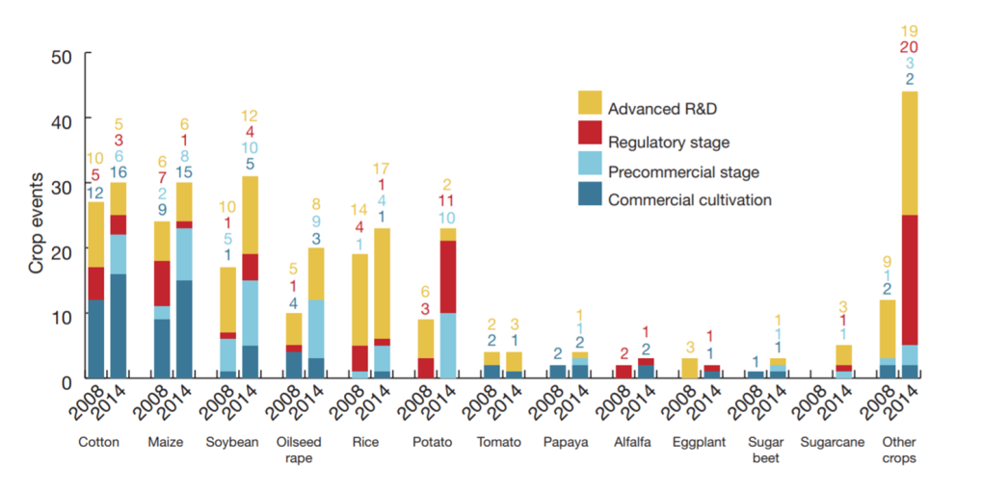

**Figure 6:** GM crop events in the market and at the precommercial, regulatory and advanced R&D stages in 2008 and 2014, illustrated by crop. Source: <https://sites.biochem.umass.edu/vierlinglab/files/2015/04/2016nbt.3449Status-of-GMO-crops.pdf>

Amongst the agronomic traits which have recently been introduced are tolerance to the herbicide dicamba, as found in MON-877Ø8-9 soybean as well as tolerance to abiotic stress and increased yield, as observed in Droughtgard™ Maize, MON-8746Ø-4 and MON-87403-1 which is maize modified to obtain increased ear biomass. Furthermore, the introduction of quality traits has also seen a rise in the rate of development. Examples of such crops include the ArcticTM Apple OKA-NBØØ1-8 and OKA-NBØØ2-9 which were modified to resist to enzymatic browning, as well as pineapple which was modified for altered color and reduced ripeningFDP-ØØ114-5.

Beyond the LMOs that have been developed for agricultural applications, there are also several LMOs that have been developed for industrial and pharmaceutical purposes. For example, in 2009, a goat that produces a recombinant human antithrombin was the first LM animal to be approved for commercial production. In addition the AquAdvantage® Salmon, is an organism modified to grow to market size in half the normal amount of time. This application has been recently approved in the USA in 2015 and Canada in 2016.

***Considerations for National Strategies towards the detection and identification of LMOs***

A description of how detection methods affect inter-nation trade in grains is given by Shillito (2016). A Party that is considering establishing provisions for the detection and identification of LMOs in their system may need to take into account several considerations. First, the Party must decide the type of and acceptable level of LMOs resulting from modern biotechnology that may have adverse effects on biological diversity, taking also into account risks to human health. It is important to recognise that a Party is not required to set up a detection laboratory as a condition of being a signatory to the protocol. Then they should anyEstablishing the effective communication channels amongst the relevant authorities also facilitates the efficient implantation of relevant provisions. A possible strategy for the efficient sampling, detection and identification of LMOs may be initiated by the country by defining each of the following parameters should they wish to establish the scope and procedure of LMO testing within the country:

1. The national objectives and sampling targets;

Possible targets may include the environmental monitoring and sampling at points of entry for the monitoring of transboundary movements of authorised LMOs and/or the detection and control of unauthorised LMOs.

1. The parameters that may be monitored and controlled;

Possible parameters include maintaining a suitable documentation system that traces the transboundary movement of material that may contain LMOs, and if established in the regulation, and relevant for the decision-making process, quantify the amounts present. Depending on the intended control level, the required analytical capability may be established, such as qualitative (presence/absence) or quantitative (e.g. if certain thresholds require different measures.). The resources (financial, human) that can be made available in the foreseeable future are a major consideration.

Besides the resources required for laboratory testing capacities, eventually, countries may also wish to develop adequate capacities to sample LMOs, including training of their lab technicians, and border control officers and field inspectors. Representative sampling is critical for the detection pipeline, in that it determines the quality of the results and the overall outcomes of the system to monitor, detect and/or identify LMOs. Taking the importance of sampling into account, where resources are limited, efforts may be more efficiently allocated if they are focused on sound field sampling combined with basic yet reliable, qualitative laboratory capacities.

**References**

Codex CAC/GL 74-2010. “Guidelines on Performance Criteria and Validation of Methods for Detection, Identification and Quantification of Specific DNA Sequences and Specific Proteins in Foods” (also available for download from http://files.foodmate.com/2013/files_1810.html)

IUCN (2003) An Explanatory Guide to the Cartagena Protocol on Biosafety. Available at <http://bch.cbd.int/database/record-v4.shtml?documentid=41476> (access August 2017).

Mirkov TE (2003) The molecular basis of genetic modification and improvement of crops. In: Chrispeels MJ, Sadava DE (eds.) Plants, Genes and Crop Biotechnology. Jones and Bartlett Publishers, 2nd edition.

North Carolina State University (website) Available at http://www.ces.ncsu.edu/ (access August 2017).

National institute of biology, Slovenia (Website) Available at <http://www.nib.si/eng/index.php/aktualno/project/272-gmoseek-better-control-of-genetically-modified-organisms-gmos-for-an-improved-european-food-safety.html> (Access August 2017)

Technical Tools and Guidance for the Detection and Identification of LMOs (Website) Available at <http://bch.cbd.int/protocol/cpb_detection/toolsandguidance.shtml> (Access August 2017)

Parisi C., Tillie P., Rodriguez-Cerezo E. (2016) The global pipeline of GM crops out to 2020 *Nature Biotechnology*, 34 (1) ,pp.31-36.

McDougall, P. (2011). The cost and time involved in the discovery, development and authorisation of a new plant biotechnology derived trait. Crop Life International. Available at: <https://croplife.org/wp-content/uploads/pdf_files/Getting-a-Biotech-Crop-to-Market-Phillips-McDougall-Study.pdf> (Access August 2017)

Felix-Urquídez Dalmira, Perez-Urquiza Melina,Valdez Torres Jose-Benigno, Leon-Felix Josefina, García-Estrada Raymundo, and Acatzi-Silva Abraham Development, Optimization, and Evaluation of a Duplex Droplet Digital PCR Assay To Quantify the T‑nos/hmg Copy Number Ratio in Genetically Modified Maize. Anal. Chem. 2016, 88, 812−819. DOI: 10.1021/acs.analchem.5b03238

ISAAA. 2016. Pocket K No. 1 Questions and Answers About Genetically Modified Crops: A Pocketful of Information. ISAAA: Ithaca, NY. Available at <http://www.isaaa.org/resources/publications/pocketk/1/> (Access August 2017)

<http://pubs.acs.org/doi/pdf/10.1021/jf400685y>

ISAAA. 2017. Pocket K No. 16: Biotech Crop Highlights in 2016. ISAAA: Ithaca, NY. Available at <http://www.isaaa.org/resources/publications/pocketk/16/> (Access August 2017)

James C (2016) Global Status of Commercialized Biotech/GM Crops: 2016. ISAAA Brief No. 52. ISAAA: Ithaca, NY. Available at <http://www.isaaa.org/resources/publications/briefs/52/download/isaaa-brief-52-2016.pdf> (Access August 2017)

Mirkov TE (2003) The molecular basis of genetic modification and improvement of crops. In: Chrispeels MJ, Sadava DE (eds.) Plants, Genes and Crop Biotechnology. Jones and Bartlett Publishers, 2nd edition.

OECD (1986) Recombinant DNA Safety Considerations. Available at <http://www.oecd.org/dataoecd/43/34/40986855.pdf> (Access August 2017)

Shillito RD and Currier T: Immunoassays and Detection method in International Trade. Immunoassays in Agricultural Biotechnology, edited by Guomin Shan, John Wiley & Sons, 2011

Shillito, R.D. Detection of Genetically Modified Grains., in: : <http://scitechconnect.elsevier.com/wp-content/uploads/2015/07/Detection-of-Genetically-Modified-Grains.pdf> published in Encyclopedia of grains, Elselvier 2016 (accessed April 3 2018).

Stein A.J., Rodríguez-Cerezo E. (2009). The global pipeline of new GM crops: implications of asynchronous approval for international trade. Technical Report EUR 23486 EN. Luxemburg: European Communities. Available at <http://ftp.jrc.es/EURdoc/JRC51799.pdf> (access August 2017).

Arne Holst-Jensen, Yves Bertheau, Marc de Loose, Lutz Grohmann, Sandrine Hamels, Lotte Hougs, Dany Morisset, Sven Pecoraro, Maria Pla, Marc Van den Bulcke, Doerte Wulff, Detecting un-authorized genetically modified organisms (GMOs) and derived materials, Biotechnology Advances, Volume 30, Issue 6, 2012, Pages 1318-1335, ISSN 0734-9750, <http://www.sciencedirect.com/science/article/pii/S0734975012000377> (access August 2017).

Willems, et. al. (2016) Statistical framework for detection of genetically modified organisms based on Next Generation Sequencing, Food Chemistry https://www.sciencedirect.com/science/article/pii/S0308814615011073

Zel J, Milavec M, Morriset D, Plan D, Van den Eede G, Gruden K (2012) How to reliably test for GMOs, Springer briefs in food health and nutrition. <http://www.springer.com/us/book/9781461413899>

Zel et. al. (2012) Op cit.

1. Primates. (J.J. Petter, Ed.). Des relations d’attachement essentielles à la vie d’un groupe de chimpanzés, Nathan, Paris, pp. 244-247
2. Adapted from IUCN (2003).
3. A transformation cassette comprises a group of DNA sequences (e.g., parts of a vector and one or more of the following: a promoter, the coding sequence of a gene, a terminator, other regulatory sequences), which are physically linked and often originated from different donor organisms. The transformation cassette is integrated into the genome of a recipient organism through methods of modern biotechnology to produce an LMO. A transformation cassette may also be called “expression cassette” (mainly when a specific expression pattern is aimed at), “DNA cassette” or “gene construct”.
4. In the context of genetic modification, a vector is an organism (e.g., virus) or a DNA molecule (e.g., plasmid, nucleic acid cassettes) used to assist the transfer of genetic material from a donor organism to a recipient organism.
5. A nucleic acid sequence in an LMO that results from the application of modern biotechnology as described in Article 3 (i) (a) of the Protocol.
6. *Text adapted from Technical tools and guidance written by Chris Viljoen, Sarah Agapito-Tenfen, and Gretta Abou-Sleymane*
7. JRC GMO-Matrix application. http://gmo-crl.jrc.ec.europa.eu/jrcgmomatrix/
8. Please refer to information depicted in Annexes I, II and III of the Cartagena Protocol.