**Procedure for Sample Management**

When samples are received by the laboratory there needs to be procedures in place for the submission, receipt, preservation, labelling and destruction of samples received from clients.

The procedures set out for receiving, handling, storing and destruction of samples, including procedures for documenting each step provide for traceable records to ensure the preservation of the samples’ integrity and minimising contamination. Below is a description of several steps to consider during sample receipt.

*Sample Submission*

All samples accepted by the Laboratory should be accompanied by the official laboratory form requesting an examination in either hardcopy or electronic format as specified by the laboratory. These forms, as a minimum, should include the following information:

**MASS REDUCTION**

Mass reduction is the part of the sample preparation procedure to reduce the mass of a laboratory sample through subsampling (ISO/FDIS 6498:2011). This would need to be carried out if the laboratory sample that was submitted for analysis is bigger than the sample size required by the laboratory.

There are several techniques that can be used to reduce the mass of the sample in such a way that the resulting subsample that will be carried forward during processing continues to be representative of the whole laboratory sample. These include:

1. Pre-grinding: The whole laboratory sample is Grind whole sample, document if only part of the sample is used

2. Subsampling: Several methods can be used to reduce the size of the laboratory to

a. Fractional shovelling

b. Spoon method

c. Long pile method

d. Coning and quartering

e. Splitters and dividers

f. Paper rifle cone splitter

Adapted from JRC’s “Guidelines for sample preparation procedures in GMO analysis”

1. Data about the client submitting the information. This information is used by the laboratory direct them to the correct contact person in the event laboratory has any questions that may come up during sample processing. It also provides information regarding who to send the final report to and payment procedures. This section must also include the client’s signature.
2. A description, provided by the client, of each sample submitted to the laboratory, including information on the type of sample, for example if it is food, feed or seed.
3. An indication of what the target organism may be and what type of analysis is requested.
4. Information on whom or how the samples were delivered to the laboratory, including as appropriate, the name of the person who delivered the sample and/ or shipping labels if the sample arrived by mail.

Once the documentation is checked and verified for completeness the laboratory personnel should inventory the sealed sample packages and compare the number and descriptions of the samples received with the information in the official laboratory form to ensure that all samples are present. If there is a discrepancy in the number or description of the samples, the client should be contacted to clarify and reconcile the discrepancy. Any changes to the submission information should be documented in laboratory case file.

Furthermore, the condition of the sample packaging should be evaluated. If the sample packaging has been compromised or damaged during shipping, for example a tear in the packaging that resulted in the cross-contamination of samples, then this must be recorded in the case file. If the compromised packaging affects the suitability of a sample to be tested then laboratory personnel should contact the client to inform them. This information should also be recorded in the case file.

Following the verification of documentation, a verification of the sample size (see the following section) has to be made. The sample is weighted and a note if made if the weight of the sample size is in accordance with the specifications set out by the laboratory. If the sample size is too small this will be documented in the laboratory case file and the client will be informed, according to laboratory policy, whether or not this sample will be processed. If the sample size is larger than the specifications set out by the laboratory then a representative mass reduction (see sidebar) may need to be carried out in accordance with laboratory policy. In either case a note would have to be issued in the laboratory report

Once these checks have been carried out the samples have to be registered within the laboratory’s information management system.

A sequentially generated lab number shall be assigned to the case upon receipt of the first official laboratory form requesting an examination. Any supplemental sample submission(s) shall be assigned the same Laboratory number as the original submission. These laboratory file numbers are unique identifiers and shall be placed on all documents relating to a particular case. Furthermore, each individual sample that is submitted for a particular case shall be assigned a consecutive item number and/or barcode label. If a subsample and/ or multiple test portions of a sample are created during processing, a sub-item number shall be generated using sample’s unique numeric sequence separated by a hyphen (e.g., 1-1, 1-2, etc.).

Once review is completed the laboratory personnel that received the samples and carries out the check should sign or initial the documentation in the designated area and mark the date the samples were received in the case file. The samples can now be placed in storage until further processing.

**Sequentially generated Numbering**

When selecting a numbering system for samples it would be useful to follow a system that is intuitive and meaningful, for example: “*LYYYY###*”, where

•L - is the laboratory acronym. This would be particularly useful if the lab storage space is shared and the samples need to be identified as belonging to the LMO/ GMO testing laboratory.

• YYYY - are the four digits of the calendar year.

• ### - is a sequentially assigned three-five digit number, beginning with the number one (001) assigned to the first case submitted in the calendar year

*Considerations for Sample size:*

The minimum sample size of any given sample depends on the sample type and matrix which is usually defined in mass. Below is a table recommending appropriate laboratory sample sizes based on the type of matrix

|  |  |
| --- | --- |
| **Products** | **Recommended laboratory sample size** |
| Seeds | Mass equivalent of 3 000 kernels |
| Commodity grains | Mass equivalent of 10 000 grains |
| First transformation products (semolina, flour, grits, oilcake etc.) | From 100 g to 1 kg |
| Liquids | 500 ml |
| Doughy and viscous products | 500 g |
| End products (e.g. packed rice noodles) | From 100 g to 1 kg |

**Table 1:** Recommended laboratory sample sizes according to the type of matrix (Adapted from the JRC’s “Guidelines for sample preparation procedures in GMO analysis”)

For seeds and commodity grains where the recommended laboratory sample size corresponds to the mass equivalent of a certain number of kernels or grains it is important to conduct a validation study in the laboratory to confirm the mass equivalent for each type of seed that is commonly encountered in the laboratory. Below is a table that provides guidelines for the mean mass of 1000 kernels of various plant species from which the appropriate laboratory sample size can be extrapolated.

|  |  |
| --- | --- |
| **Plant species** | **Mean mass of 1000 kernels (in g)** |
| Barley | 37 |
| Linseed | 6 |
| Maize | 285 |
| Millet | 23 |
| Oat | 32 |
| Rapeseed | 4 |
| Rice | 27 |
| Rye | 30 |
| Soybean | 200 |
| Sugar beet | 11 |
| Sunflower | 100 |
| Tomato | 4 |
| Wheat | 37 |

**Table 2:** Data concerning the mean mass of 1000 kernels for different plant species ((Adapted from the JRC’s “Guidelines for sample preparation procedures in GMO analysis”)

It should be noted that for the each plant species there may be a large number of varieties that are encountered in the laboratory. Each of these varieties may have different sized kernels therefore a variety with bigger kernels (compared to the average values of maize kernels), may contain less than 1000 kernels in in a mean sample mass.

In certain cases where samples that have been submitted to the laboratory with a mass equivalent that is lower than the recommended laboratory sample size or sample with bigger kernels it would be good practice to, on a case-by-case basis as appropriate, check the number of kernels that are present in those samples. This can be done by measuring the mass of 100 kernels and extrapolating an estimate of the number of seeds present based on the mass of whole sample.

*Sample Storage*

Storage of the samples prior to and during sample preparation, as well as after its analysis should be performed under appropriate conditions (e.g. at room temperature, refrigerated, frozen). It is the responsibility of laboratory personnel to ensure, insofar as possible and reasonable, that samples do not experience loss, cross-contamination, or deleterious change while in the laboratory.

While most samples may be stored at room temperature without any negative effect on the sample’s quality, it is important to ensure that the environmental conditions are appropriate to do so. For example if the room environment is warm and humid this may lead to the growth of mould in the sample, therefore leading to a deleterious change in the quality if the sample. Therefore, samples that may experience a deleterious change without refrigeration should be placed in a refrigerator or freezer as soon as possible until such time that they will be prepared for analysis. Furthermore, in the case of seed samples, care must be taken that there is no accidental release of the seeds into the environment. In this case is advisable to homogenise the sample as soon as possible to eliminate the risk of an accidental release.

**Sample Homogenisation**

In general the whole laboratory sample is homogenized to obtain a test sample for the analysis, if the size of the sample conforms to the laboratory’s requirements. Homogenization is required for two reasons:

1. to achieve sufficient efficiency of analyte extraction; and,
2. to ensure homogeneity and an equal representation of LMO-derived particles in the test samples.

The aim of homogenisation is particle size reduction. The smaller the particle size of a sample the more DNA or protein can be extracted from the test portion. Homogenization is the step with the highest risk of error and contamination.

The risk of error arises due to the fact that, as indicated in Box XX, a laboratory sample can range from 100g- 3kg in mass, depending on the plant species. Whereas the resulting test potion that will be used to carry out the analysis can range from 20mg -1g in mass. This represents a 200- 10,000 fold difference in mass and, as such represents the biggest possible source of error. Therefore a specific procedure should be followed during the sample homogenisation to manage and reduce the likelihood of error.

The contamination risk that occurs during the homogenisation procedure is largely due to the formation of a fine dust that often appears during the grinding step. This dust could contaminate subsequent laboratory samples, if appropriate laboratory practices are not in place. Therefore all the sample preparation steps should be done under stringent conditions to avoid cross-contamination while minimising the degradation of the target analyte, be it DNA or proteins, in the test sample.

The homogenisation of samples must be carried out in a room or area dedicated primarily to that purpose following strict procedures for sample processing and the subsequent cleaning of surfaces and equipment. This procedure is outlined in further detail in the next section.

*Procedure for Sample preparation*

The choice of method used to carry out the particle size reduction also depends on physical and chemical composition of the material being homogenised, its quality and the laboratory’s capacity. The homogenization of samples may be achieved with mills, homogenizers, immersion blenders, coffee grinders, or other suitable equivalent device, depending on the size and the structure of the laboratory sample. However, grinding using a mill with an integrated sieve gives you control and uniformity over particle size. In the case of difficult samples that may be prone to degradation during the homogenisation step, the use of sequentially smaller sieve sizes that are to reach an optimal particle size may be appropriate. Furthermore, difficult samples can also be homogenised in liquid nitrogen. This serves to reduce the generation of heat that is produced during the homogenisation process, thus reducing the chances of analyte degradation and maintaining sample integrity.

After grinding, the laboratory sample should be thoroughly mixed, or blended, to obtain a very homogeneous analytical sample. In cases where the laboratory sample is flour or liquid, homogenization is not needed but thoroughly mixing or shaking the sample is necessary. This is carried out by placing the homogenised sample in a disposable plastic bag or other suitable container, that is, at a maximum, half full and inverting the contents of the container 20 times.

Once the sample has been homogenised and mixed the test portion is obtained through “grab sampling”. The grab sampling must be carried out immediately after the mixing procedure in order to minimise gravitational segregation of the homogenised particles, which may affect the homogeneity of the sample. For each sample two 200mg test portions are taken from the prepared sample. A back up aliquot of the prepared sample is also preserved in the event that a reanalysis of the sample is needed in the future. If the backup aliquot is ever used, the homogeneity of the sample would have to be re-established using the bag mixing technique.

All samples taken during the grab sampling procedure must then be stored in an environment that is conducive to the maintenance of the sample’s integrity. The most appropriate storage depends highly on the sample type and the length of time that the sample will be stored for. For example the two test portions can be stored at 4 degrees for a few days until they are further processed. On the other hand the backup aliquot, which is normally kept for longer periods of time (e.g. 3 months), would need to be stored at -20 degrees for the period time specified before it is either used or destroyed.

Once the test portions are successfully processed and analysed the resulting DNA and back up aliquot will have to be appropriately labelled and stored for the length of time specified by the laboratory. Once the time has elapsed it would be authorized to destroy the samples. Any sample destruction would have to be appropriately documented in the sample case file. This includes documenting the date of destruction and the identity of the person who destroyed the sample.

Below is a flow chart outlining a step by step guide on practical, hands on procedures that can be followed in order to successfully homogenise a sample.

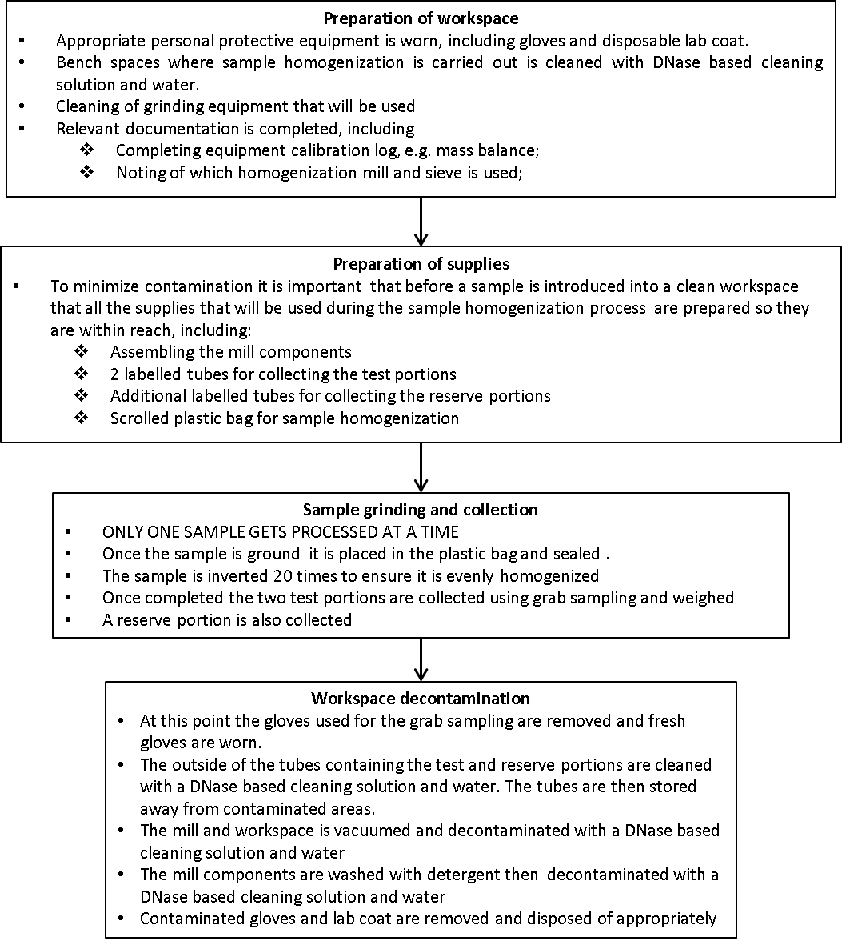

**Considerations for QA/ QC during Sample Homogenisation**

The application of stringent QA/QC procedures during the sample homogenisation step is vital since, as previously indicated, it is the step with the highest contamination risk and the quality of the homogenisation will affect the efficiency of downstream processes. In addition to the measures described above that can be put in place during sample preparation, the following considerations should also be kept in mind:

*Maintaining homogenised particle size:* Ensuring that the particles produced during the homogenisation step are of a consistent and specific size can be done by using a grinder with an integrated sieve. However, with time, the size of the openings within the sieve can increase. Routinely calibrating and inspecting the sieve should be done to ensure that at least 95% of particles produced during the homogenisation procedure are at the correct size.

*Carry over*: To validate whether or not the decontamination procedure that has been adopted by your laboratory is adequate in ensuring that the surfaces and equipment are analytically clean and free of material that can be carried over into the next sample, a test can be performed to validate the procedures. This involves either:

1. Processing an LMO/ GMO sample followed by a non-LMO/ non-GMO sample then analytically testing for the presence of any traces of LMO/ GMO material in the sample; or
2. Processing a sample of species A (for example corn) followed by a sample of species B (for example flax) then analytically testing for the presence of traces of species A, in this case corn, in the test portion of species B, the flax.

*Representativeness of test portion*: As previously indicated a laboratory sample can range from 100g- 3kg in mass, depending on the species, whereas the resulting test potion that will be used to carry out the analysis can range from 20mg -1g in mass. Due to this large difference in size between the lab sample and the test portion, validation test have to be carried to ensure the representativeness of lab sample. Similarly to the approach provided above, this involves either:

1. Processing a sample that has been spiked with 1 LMO/ GMO grain in 10,000 non-LMO/ non-GMO grains of the same species; or
2. Processing a sample that has been spike with one grain from species A (for example corn) in 10,000 grains of species B (for example flax).

In both cases six test portions are tested for the presence of the spiked grain. The testing procedure is considered representative if all six test portions test positive for the presence of the spiked grain. If not, then possible ways forward may include either increasing the test portion size or decreasing the particle size of the homogenised samples.

-----