Module 2
Overview of the detection and identification of Living Modified Organisms
Contents of this module
Overview of techniques used in modern biotechnology
Introduction
Overview of commonly used methods for genetic modification of plants
Overview of available detection and identification methods
Protein-based methods for LMO detection
DNA-based methods for LMO detection
Comparison between protein- and DNA-based methods for LMO detection
Challenges in LMO detection and new technology developments
Pipeline for the development of LM Crops
Considerations for National Strategies towards the detection and identification of LMOs
Overview of techniques used in modern biotechnology

Introduction
Historically, agricultural crop cultivars have been produced through the domestication of wild crop relatives through a continuous process of selection and controlled breeding by humans, for the development of more productive, better adapted, or pest resistant crops as well as crops that produce better or different quality of products than previous ancestral lines. Such changes involve, for example, the cross breeding of sexually compatible plants of the same species or closely related species resulting in the introduction and/ or culling of traits, and their associated genes. In recent decades, advances in breeding technologies have made it possible to produce, not only crosses between plants that are sexually compatible, but also between plants that are considered as naturally cross sterile. Examples of techniques used in such cases are embryo-rescue techniques, in vitro/in vivo embryo cultivation, ovary and ovule cultures, in vitro pollination and in vitro fertilization. In addition, mutational changes could be induced, for instance, through seed irradiation.
There are a number of limitations to traditional hybridization and selection methods. One major disadvantage is that breeders often wish to introduce single selected traits rather than transferring and recombining entire genomes. In addition, the selection and sorting of genetically stable varieties is a slow process.
These drawbacks may be alleviated through the use of modern biotechnology techniques. Under the Cartagena Protocol, modern biotechnology means the application of:
- In vitro nucleic acid techniques, including recombinant deoxyribonucleic acid (DNA) and direct injection of nucleic acid into cells or organelles, or
- Fusion of cells beyond the taxonomic family,
that overcome natural physiological reproductive or recombination barriers and that are not techniques used in traditional breeding and selection.
The use of modern biotechnology techniques results in the production of living modified organisms (LMOs), which are also referred to as genetically modified organisms (GMOs) by some other bodies and legislations. The Cartagena Protocol specifically focuses on LMOs i.e. any “living” organism that possesses a novel combination of genetic material obtained through the use of modern biotechnology.
In the context of agricultural crops, these terms refer to plants in which genetic material has been stably introduced into a host genome using modern biotechnology techniques. This genetic material may have originated from a different species, giving rise to a “transgenic” plant. Alternatively, if the genetic material originated from a plant of the same or other sexually compatible species, then this gives rise to a “cisgenic” plant. In either case, the introduction a modification results in the formation of a gene product, i.e. a protein. In some modified plants the desired effect is the silencing of the expression of an endogenously produced protein, i.e. gene silencing mediated by RNA. Some of the most common traits that are introduced into crops using modern biotechnology include: herbicide tolerance, male sterility/fertility restoration, Bt-derived insect resistance, virus resistance, fungal resistance and modification of nutrient biosynthesis.
Overview of commonly used methods for genetic modification
LMOs are most commonly developed through the use of in vitro nucleic acid techniques by inserting, deleting or modifying a gene or DNA/RNA sequence in a recipient or parental organism.
The terms genetic modification, genetic engineering, recombinant DNA and DNA manipulation are terms that apply to the direct modification of an organism’s genes. Consequently, the terms genetically modified organism (GMO) as well as genetically engineered organism are often used interchangeably with LMO. As indicated above, the Cartagena Protocol emphasizes the “living” nature of the organism, and some of its provisions also apply to LMOs intended for direct use as food or feed, or for processing.
Figure 1 – In vitro nucleic acid techniques Source: North Carolina State University, College of Agriculture and Life Sciences (website).

Production of LMOs through genetic modification is a multistage process that can be achieved through a variety of methodologies. Below is a description of the principal steps that are commonly used in the development of LM plants can be summarized as follows:
- Once a gene of interest has been identified and isolated from a donor organism, it is manipulated in the laboratory in order for it to be inserted effectively into the intended recipient organism. The manipulation may, for example, include changes to the nucleotide sequence so as to enhance or modulate the expression of the gene once it has been inserted into the intended recipient organism.
- The gene(s) of interest, is placed in between a “promoter sequence” and a “terminator sequence” which are needed for the proper expression and functioning of the gene(s) of interest in an orderly manner. This combination of genetic elements is known as a “transformation cassette”, as shown in figure 2. Different promoter sequences control gene expression in different ways depending on their structure and/or cellular signals, for example, some allow for the continuous expression of the gene (these are known as “constitutive promoters”), while others switch the expression of the gene on or off in different organs and/or developmental stages of the organism or in response to stimuli or other external influences. Some promoters may be "tissue specific", meaning that they are able to switch on and regulate gene expression only in a few cells or in specific tissues of the organism.
- A “marker gene” is sometimes incorporated into the transformation cassette to help identify and/or select cells or individuals in which the transformation cassette(s) was successfully introduced. Marker genes may, in some cases, be removed from the LMOs at a later stage.
- Finally, the transformation cassette is normally incorporated into a larger DNA molecule known as a vector. The purpose of the vector is to assist the transfer of the transformation cassette into the recipient organism.
Note: Transformation cassettes currently used may include multiple elements – for example, several promoter sequences and desired genes.
Figure 2 – Scheme of a transformation cassette and vector Source: IUCN (2003).
The transformation cassettes are integrated into the genome of the recipient organism through a process known as transformation, as outlined in figure 3. This can be carried out through different methods such as infection using, for example, Agrobacterium tumefaciens, particle bombardment or microinjection.
Transformed cells are then selected, for example, with the help of a marker gene, and regenerated into a complete organisms through further manipulations such as cell culture and breeding techniques. The resulting organisms are further characterized in order to identify those that continue to express the desired phenotype of the recipient organism while also containing the desired transgene(s) or modification. Through selection, many experimental LMOs are discarded and only a few events may reach the stage of commercialization.
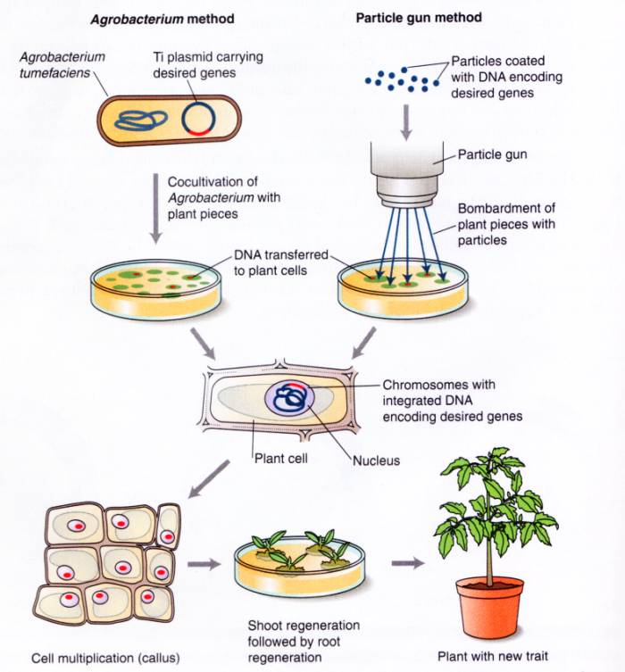
Figure 3 – Genetic modification of plants. Source: Mirkov (2003).
LMOs can also be produced through cell fusion where cells from two different organisms that do not belong to the same taxonomic family are fused resulting in an organism containing the genetic information from both parental cells. The resulting LMO may contain the complete genomes of the parental organisms or parts of their genomes. Cell fusion can be applied to bacterial, fungal, plant or animal cells, using a variety of techniques to promote fusion. To date no LMOs have been produced using this technique.
Overview of available detection and identification methods
A number of methodologies and techniques are available to detect, identify and quantify living modified organisms. These methodologies range from fast and cost-effective, such as lateral flow strip and endpoint polymerase chain reaction (PCR), to those that can be more complex, such as quantitative real-time PCR and whole genome sequencing.
When planning and setting up a laboratory for the detection and identification of LMOs choices can be made regarding which methods and protocols will be adopted. For service-oriented laboratories, particularly those serving regulatory authorities, the selection of methods is guided by, among other considerations, the country’s specific regulatory requirements in accordance with national biosafety laws. The methodologies may range from qualitative methods that are used to detect for the presence of LMOs in general. Other tests allow for the identification of individual LMOs while others are quantitative tests that provide information on the quantity of LMOs present in a sample.
Either the DNA or the protein molecules can be targeted for the detection or identification of such LMOs. Both approaches have advantages and disadvantages and the adoption of one over the other, or both, depends largely on the available expertise, infrastructure, capacity to handle samples, laboratory equipment, required assay sensitivity and regulatory requirements.
Below is a brief overview of some of the most commonly used methodologies for the detection, identification and quantification of LMOs, their strengths and limitations.
Analysis | Test | Advantages | Disadvantages
Protein Based Method | Strip test | Because the test is rapid and can be performed onsite, this method is very useful as an initial screen for seed and grain | Often low sensitivity (Limit of detection 0.1-1%)
 |  |  | Because the test is not performed with laboratory controls, operator error resulting in inaccurate test results can sometimes be an issue.
 |  |  | Not appropriate for processed products
 |  |  | GM protein levels may vary between different commercial GM cultivars and different parts of the same GM plant
 | ELISA | High sensitivity (Limit of detection 0.01-0.1%) | Not appropriate for processed products
 |  |  | GM protein levels may vary between different commercial GM cultivars and different parts of the same GM plant
 |  |  | Must be performed in a laboratory
DNA Based Method | PCR | High sensitivity (limit of detection 0.01%) and specificity | Must be performed in a laboratory
 |  | Capable of detecting all GMOs
 |  | Allows definitive quantification
 |  | Effective with broad range of sample types
 |  | Industry standard used worldwide in surveillance and testing labs

Table 1: Summary of available testing options for the detection and identification of LMOs, including the advantages and drawbacks of each method. http://www.gmotesting.com/Testing-Options
Analysis | Test | Measures | Advantages | Disadvantages
Immunologic | Strip test | Protein | Because the test is rapid and can be performed onsite, this method is very useful as an initial screen for seed and grain | Often low sensitivity (Limit of detection 0.1-1%)
 |  |  |  | Because the test is not performed with laboratory controls, operator error resulting in inaccurate test results can sometimes be an issue.
 |  |  |  | Not appropriate for processed products
 |  |  |  | GM protein levels may vary between different commercial GM cultivars and different parts of the same GM plant
 | ELISA | Protein | High sensitivity (Limit of detection 0.01-0.1%) | Not appropriate for processed products
 |  |  |  | GM protein levels may vary between different commercial GM cultivars and different parts of the same GM plant
 |  |  |  | Must be performed in a laboratory
Genetic | PCR | DNA | High sensitivity (limit of detection 0.01%) and specificity | Must be performed in a laboratory
 |  |  | Capable of detecting all GMOs
 |  |  | Allows definitive quantification
 |  |  | Effective with broad range of sample types
 |  |  | Industry standard used worldwide in surveillance and testing labs
Protein-based methods for LMO detection
LMO specific proteins (i.e. those encoded by the inserted genes) can be detected using immunoassays which are based on antibody recognition of an epitope specific to the transgenic protein. The method of protein testing is either in the form of a lateral flow strip test, a micro-titre plate format such as the enzyme-linked immunosorbent assay (ELISA) or a gel electrophoresis protein immunoblot, also known as western blot. Protein-based detection methods require the use of antibodies that specifically bind to the transgenic protein. Since the process of antibody production is extremely complex and costly, detection using these methods typically relies on the availability of commercial antibodies.
Protein detection using lateral flow strip tests, ELISA or western blot is performed through a simple procedure of extracting total crude proteins from a sample by adding water or buffer followed by sample homogenization.
For lateral flow strip testing, a strip is placed in the crude protein extract and a positive result is indicated by the appearance of a test line due to the antibody recognition of the transgenic protein. The advantages of this qualitative method are that it is very simple to perform, requires little technical expertise or equipment and can be performed at the point of sampling. Electronic devices have also been developed for a semi-quantitative interpretation of the result.
The ELISA based approach to LMO detection follows the same principle as lateral flow strips, and as such it also involves a crude protein extraction step. However, the antibody is used to pre-coat the internal surface of a micro-titre plate. Following a series of steps which allow the target protein to bind to the antibody, the cellular debris, including other proteins, are removed from the plate through a series of wash steps. The bound protein is detected using a colorimetric assay that can be evaluated through visual inspection or using an optical plate reader. This method produces a qualitative result if read through visual inspection. However, a quantitative result can be obtained if the necessary protein standards and calibration curves are included on the plate and an optical plate reader is used to evaluate the intensity of the colorimetric reaction resulting from antibody recognition of the target protein in the sample. The advantages of LMO testing using ELISA are that a qualitative or quantitative result can be produced relatively easily and that it is more sensitive than the lateral flow strip method.
For western blotting, the extracted proteins are separated according to their size by gel electrophoresis. The proteins are then transferred from the gel to a membrane for the detection of the target protein. This step usually involves two antibodies: first a primary antibody that is specific to the target protein followed by a secondary antibody, which is linked to a reporter molecule that binds to the primary antibody. After the excess antibody is removed from the membrane, the secondary antibody is typically visualized by colorimetric, chemiluminescent or fluorescent methods performed by either colouring the membrane itself or exposing it to a light sensitive film, such as X-ray film. Once the membrane or film is developed, the presence of the transgenic protein is indicated as a distinct band on the membrane or film. The advantage of this method is that it is sensitive and may detect different isoforms of the target protein.
A general disadvantage of all protein based methods is that its sensitivity is dependent on the binding affinity between the antibody and the target protein, and may be affected by of cross-reactivity between the antibody and native forms of the same protein that may be present in the organism.
DNA-based methods for LMO detection
DNA-based methods for LMO detection and identification rely primarily on the use of the polymerase chain reaction (PCR) and related molecular techniques. PCR is a method that utilizes synthetic DNA oligonucleotides, so called “primers”, to replicate or “amplify” targeted regions of an inserted DNA sequence that is present in the LMO. The amplified product can then be detected to determine whether or not DNA originating from an LMO is present in a sample.
DNA extraction is required prior to PCR. The choice of extraction method depends on the type of LMO being analysed, since some methods are more suitable than others for particular types of LMOs, for example leaves versus oil seeds. Following DNA extraction, target sequences are amplified using primers that are designed to specifically bind to the target sequence during the PCR reaction. The resulting PCR product can either be detected during the amplification process (real-time PCR) or after the PCR is completed (end-point PCR).
Visualising the presence of the target sequence following end-point PCR, is done through gel electrophoresis. This process separates the amplified DNA according to its size by allowing it to migrate through a gel matrix under the influence of an electric current. The amplified DNA fragment that corresponds to the inserted DNA in the LMO can be visualised using a dye that binds to double stranded DNA and fluoresces under ultraviolet light. Real-time PCR technology allows for the detection of the amplified target sequence during the PCR amplification process, by using either a fluorescent DNA binding dye or a fluorescence tagged probe.
The DNA binding dye fluoresces when it intercalates within double stranded DNA molecules. As PCR progresses the level of fluorescence increases proportionately with the amount of newly synthesised DNA. Therefore, such dyes simply detect the amount of PCR product generated during the amplification but they do not discriminate between specific and non-specific amplification. In contrast, fluorescent probes can be used to verify that a specific target sequence is amplified during the PCR process. If real-time PCR technology is used in conjunction with the necessary standards, the quantity of LMO in a sample can be determined.
An advantage of PCR is that it can be used to screen a sample for the presence of LMOs by using primers that target genetic elements that are commonly found in a number of different LMOs. Depending on the combination of primers used, PCR detection can be gene-specific, construct-specific or event-specific. The differences between each type of PCR target region is represented in Figure 1.
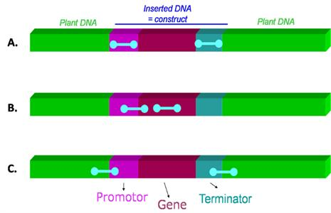
Figure 4: Different types of PCR target regions A) common regulatory elements (such as promoters, terminators) B) gene-specific or construct-specific (junction between two genetic elements within the construct) C) event-specific (junction between the inserted construct and the plant genome) Source: National Institute of Biology
PCR is sensitive, specific and versatile, and can be used to simultaneously screen a sample for LMO content, identify the specific LMO gene or event present and, when used in a real-time PCR platform, quantify the amount of LMO present in the sample. Multiplex and matrix approaches can also be used for multi-target detection. A disadvantage of a PCR based approach, however, is that it requires specialized expertise and equipment
Comparison between protein- and DNA-based methods for LMO detection
Both protein- and DNA-based approaches to LMO detection are useful as each one serves different purposes.
Protein-based methods, such as lateral flow strip tests and ELISA, are simple, time efficient (several minutes to a few hours), and convenient for a small number of samples. The lateral flow strip test is useful for LMO testing at the point of sampling. However, protein-based detection of LMOs requires a different test for the detection of individual LMO traits and cannot be used to simultaneously distinguish between different LMO events that may be present in a single sample. In contrast, western blots and PCR approaches, while more specific and sensitive, may require more steps and time (several hours to days) and rely on specialized laboratory equipment and expertise.
Protein-based methods are only suitable for detecting LMOs that are designed to produce a protein from the DNA inserted. However they are not suitable for detecting inserted genetic elements that do not produce a protein, such as regulatory sequences or LMOs that were designed to silence the expression of target genes through RNAi.
Protein-based methods rely on the specificity of the antigen-antibody interaction therefore, any changes in the tertiary structure of the target protein renders the method ineffective. Such conformational changes are sometimes introduced during sample processing if the samples are subjected to heat and/or chemical treatment. The detection capability in protein-based methods is also affected by the expression level of the target protein which can vary between different parts of the LMO or different stages of its life cycle, and can be influenced by external factors such as climate and soil conditions. In addition, some LMOs have been specifically designed to express a transgenic protein in a specific tissue and may not be necessarily present in the part of the organism being tested.
In contrast, DNA is more stable as compared to proteins so detection continues to be possible even if the sample has been exposed to heat and/or chemical treatment. DNA is also present in all cells and therefore any part of the organism can be used for testing. Furthermore, PCR methods are more versatile than protein methods, and PCR can be used to screen a sample for the presence of several potential LMOs simultaneously with relatively easily. PCR can also be applied qualitatively, to detect specific genes or events, and quantitatively, to determine the quantity of a particular LMO event in a sample.
Challenges in LMO detection and new technology developments
There are several challenges that need to be considered when applying available technologies to LMO detection. Below is a brief overview of some of the key considerations.
Availability of validated methods
It is therefore important that criteria to test the performance of the methods is harmonized internationally to make results comparable throughout the world taking into account the availability of resources in different countries. The development of harmonized performance criteria should aim at simplifying and increasing the accessibility to LMO detection technologies in countries with less capacity and fewer resources. Thus a significant challenge for LMO detection is to ensure that methods are validated and meet the necessary minimum performance criteria for quality control purposes.
Implementation of a Quality System
An important consideration in the application of LMO detection is that standardized operating procedures (SOPs) are used. This means that the LMO detection laboratory is required to develop and maintain the necessary quality control measures to ensure the reliability, sensitivity and reproducibility of the methods in use.
Access to detection methods and reference material
Another challenge in LMO detection is the difficulty face by laboratories to get access to sequence data of the genetic elements that have been inserted into the LMOs in order to design specific detection systems. Some countries require notifiers to provide a detection method, however this is not always the case. Furthermore, some LMO detection laboratories do not have access to reference material for the specific LMO event in order to be able to verify the detection method that is being used.
Gaps in National Biosafety Frameworks
In light of the challenges faced with access to detection methods and reference material, it may be worthwhile for regulatory systems to consider the inclusion in the requirements for LMO developers, to provide sufficient reference material of each notified LMO to the national competent authority laboratory or the designated test laboratory Furthermore, since it is costly to develop and validate a new method for LMO analysis, developers could be asked to provide a method for the detection of the LMO event, the necessary sequence information so that the method can be verified or to cover the costs of method verification by the laboratory performing LMO detection as part of the regulatory requirements of a country.
Novel approaches for simultaneous detection of multiple LMOs
The increase in LMO research and commercialization is resulting in a continuous increase in the number of LMO events that laboratories must detect. In addition, the potential presence of unapproved LMO events is also increasing, and detection laboratories are faced with the challenge of having to potentially detect multiple LMOs that are present in a single sample, some of which may be approved, while others may have not yet been authorised or are illegal, according to the Party’s regulatory context. One approach to address this challenge is to use a suitable screening strategy such as following a matrix approach in order to simultaneously detect multiple genetic elements that are commonly used in an attempt to widen the screening capabilities. When used in conjunction with bioinformatics software, the matrix results can be used to identify the potential LMOs that are present in the sample. This approach can be customized to include as many LMOs as the laboratory is required to detect, but it is primarily applicable to PCR-based methods.
Emerging technologies for LMO development and detection methods
New and emerging technologies for developing LMOs are proving to be a challenge for the detection and identification of the LMOs. For example, new gene silencing technologies include the use of double stranded RNA (dsRNA) molecules to confer desirable traits to LMOs. In such cases, a transgenic protein is not produced, and therefore only DNA-based detection methods can be used. Furthermore other LMOs are being developed through emerging new plant breeding techniques where the resulting LMO includes a genetic modification that cannot be readily detected or resembles naturally occurring genetic elements.
On the other hand, the continuous development of new technologies makes LMO detection more readily accessible, especially in countries with fewer resources. For example, digital PCR and other chip-based technologies will soon enable the routine detection of LMOs in the field with portable devices. While many countries may consider the development of a framework for LMO detection to be a burden, the technology may also be applied to other purposes such as human, plant and animal pathology, amongst other uses.
Pipeline for the development of LMOs
The pipeline for the development of an LMO and its subsequent commercialisation and release into the environment is a long, multi-step process that is follows the research and development process, in order to obtain an LMO with the desired traits, as represented in figure 5.
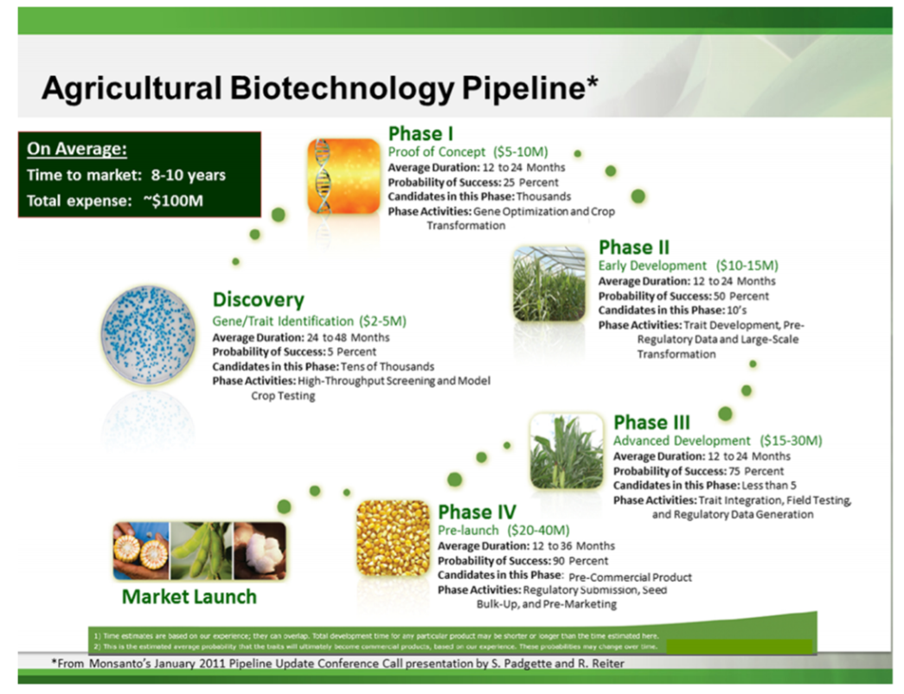
Figure 5 - Example of a commercial pipeline process to develop transgenic events, which includes several phases to market launch. Source: http://pubs.acs.org/doi/pdf/10.1021/jf400685y
The first of these steps is the identification of a desired trait and the isolation of the genetic information that is responsible for imparting this trait in the organism.
This is followed by further research and development in order to optimise the genetic construct that will be used to transform the recipient organism. This first phase includes the testing of the optimal promoter and terminator sequences as well as the stability of the construct.
Once the recipient organism is transformed, the selection of the biologically relevant and higher preforming events takes place. In the case of developing LM plants this includes testing the events under greenhouses and field testing conditions. Introgression breeding can be used to develop the best preforming plant varieties that will eventually be commercialised. Once the optimal plant variety is selected, the production of seed for distribution can take place.
The final stages of the LMO development pipeline consist of conducting regulatory studies or analyses in order to provide scientific evidence on the biosafety measures that may be required for adequate handling and responsible use of the LMO. This involves generating the data required to obtain regulatory approval of the LMO. The type of data that is required varies from country to country, but normally includes information on the stability of the genetic construct, nutritional equivalence as compared to the parental organism, allergenicity testing and risk assessment studies. Once completed the necessary data is submitted to the relevant competent national authorities that are responsible for regulating the import and/or cultivation of LMOs, in order to obtain approval.
The first engineered organism that was considered an LMO, produced in 1978, was a strain of Escherichia coli that produced biologically active human somatostatin. it was produced using recombinant DNA techniques. Subsequently, other proteins such as insulin were produced at a commercial scale using similar methods.
In 1996, the first genetically modified seeds of the FLAVR SAVR™ Tomato were authorized in the United States for use as in commercial agricultural applications. According to the International Service for the Acquisition of Agri-biotech Applications (ISAAA), the worldwide area cultivated with LM crops has been growing steadily since 1996, and in 2016, the cultivation of LM crops accounted for 185.1 million hectares.
The most common LMOs currently being cultivated are LM canola, maize, cotton and soybean. These varieties have been modified to exhibit herbicide tolerance and insect resistance. Research has shown that the amount of time it takes to develop and commercialise LM plants new traits in each of these crops is on average 11.7, 12.0, 12.7 and 16.3 years, respectively. The introduction of new traits, including agronomic and quality traits, into other crops, such as potato and rice, amongst others, is also taking place at faster rates, as shown in figure 6.
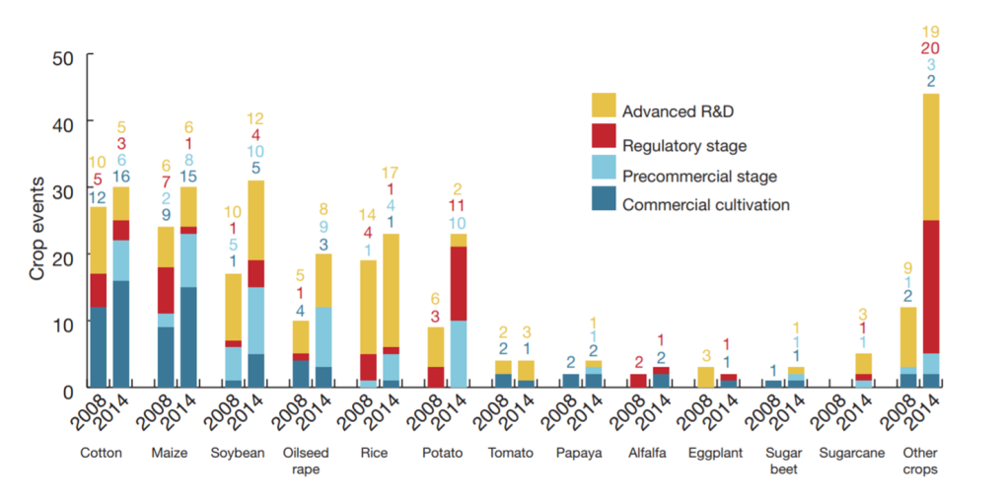
Figure 6: GM crop events in the market and at the precommercial, regulatory and advanced R&D stages in 2008 and 2014, illustrated by crop. Source: https://sites.biochem.umass.edu/vierlinglab/files/2015/04/2016nbt.3449Status-of-GMO-crops.pdf
Amongst the agronomic traits which have been introduced include tolerance to the herbicide dicamba, as found in MON-877Ø8-9 soybean as well as tolerance to abiotic stress and increased yield, as observed in Droughtgard™ Maize, MON-8746Ø-4 and MON-87403-1 which is maize modified to obtain increased ear biomass. Furthermore, the introduction of quality traits has also seen a rise in the rate of development. Examples of such crops include the ArcticTM Apple OKA-NBØØ1-8 and OKA-NBØØ2-9 which were modified to resist to enzymatic browning, as well as pineapple which was modified for altered color and reduced ripening FDP-ØØ114-5.
Beyond the LMOs that have been developed for agricultural applications, there are also several LMOs that have been developed for industrial and pharmaceutical purposes. For example, in 2009, a goat that produces a recombinant human antithrombin was the first LM animal to be approved for commercial production. In addition the AquAdvantage® Salmon, is an organism modified to grow to market size in half the normal amount of time. This application has been recently approved in the USA in 2015 and Canada in 2016.F
Considerations for National Strategies towards the detection and identification of LMOs
A country that is working towards establishing provisions for the detection and identification of LMOs in their system may need to take into account several considerations. First, assessing their existing capacities in terms of infrastructure, technical expertise, the availability of equipment needed to perform the testing procedures. Establishing the effective communication channels amongst the relevant authorities also facilitates the efficient implantation of relevant provisions. A possible strategy for the efficient sampling, detection and identification of LMOs may be initiated by the country by defining each of the following parameters in order to establish the scope and procedure of LMO testing within the country:
- The national objectives and sampling targets;
Possible targets may include the environmental monitoring and sampling at points of entry for the monitoring of transboundary movements of authorised LMOs and/or the detection and control of unauthorised LMOs.
- The parameters that may be monitored and controlled;
Possible parameters include maintaining a suitable documentation system that traces the transboundary movement of material that may contain LMOs, and if established in the regulation, and relevant for the decision-making process, quantify the amounts present. Depending on the intended control level, the required analytical capability may be qualitative (presence/absence) or quantitative (e.g. if certain threshold require different measures.). The resources (financial, human) that can be made available in the foreseeable future.
Besides the resources required for laboratory testing capacities, eventually, countries may also need to develop adequate capacities to sample LMOs, including training of their lab technicians, and border control officers and field inspectors. Adequate sampling is critical for the detection pipeline, in that it determines the quality of the results and the overall outcomes of the system to monitor, detect and/or identify LMOs. Taking the importance of sampling into account, where resources are limited, efforts may be more efficiently allocated if they are focused on sound field sampling combined with basic yet reliable, qualitative laboratory capacities.
References
IUCN (2003) An Explanatory Guide to the Cartagena Protocol on Biosafety. Available at http://bch.cbd.int/database/record-v4.shtml?documentid=41476 (access August 2017).
Mirkov TE (2003) The molecular basis of genetic modification and improvement of crops. In: Chrispeels MJ, Sadava DE (eds.) Plants, Genes and Crop Biotechnology. Jones and Bartlett Publishers, 2nd edition.
North Carolina State University (website) Available at http://www.ces.ncsu.edu/ (access August 2017).
National institute of biology, Slovenia (Website) Available at http://www.nib.si/eng/index.php/aktualno/project/272-gmoseek-better-control-of-genetically-modified-organisms-gmos-for-an-improved-european-food-safety.html (Access August 2017)
Technical Tools and Guidance for the Detection and Identification of LMOs (Website) Available at http://bch.cbd.int/protocol/cpb_detection/toolsandguidance.shtml (Access August 2017)
Parisi C., Tillie P., Rodriguez-Cerezo E. (2016) The global pipeline of GM crops out to 2020 Nature Biotechnology, 34 (1) ,pp.31-36.
McDougall, P. (2011). The cost and time involved in the discovery, development and authorisation of a new plant biotechnology derived trait. Crop Life International. Available at: https://croplife.org/wp-content/uploads/pdf_files/Getting-a-Biotech-Crop-to-Market-Phillips-McDougall-Study.pdf (Access August 2017)
ISAAA. 2016. Pocket K No. 1 Questions and Answers About Genetically Modified Crops: A Pocketful of Information. ISAAA: Ithaca, NY. Available at http://www.isaaa.org/resources/publications/pocketk/1/ (Access August 2017)
http://pubs.acs.org/doi/pdf/10.1021/jf400685y
ISAAA. 2017. Pocket K No. 16: Biotech Crop Highlights in 2016. ISAAA: Ithaca, NY. Available at http://www.isaaa.org/resources/publications/pocketk/16/ (Access August 2017)
James C (2016) Global Status of Commercialized Biotech/GM Crops: 2016. ISAAA Brief No. 52. ISAAA: Ithaca, NY. Available at http://www.isaaa.org/resources/publications/briefs/52/download/isaaa-brief-52-2016.pdf (Access August 2017)
Mirkov TE (2003) The molecular basis of genetic modification and improvement of crops. In: Chrispeels MJ, Sadava DE (eds.) Plants, Genes and Crop Biotechnology. Jones and Bartlett Publishers, 2nd edition.
OECD (1986) Recombinant DNA Safety Considerations. Available at http://www.oecd.org/dataoecd/43/34/40986855.pdf (Access August 2017)
Stein A.J., Rodríguez-Cerezo E. (2009). The global pipeline of new GM crops: implications of asynchronous approval for international trade. Technical Report EUR 23486 EN. Luxemburg: European Communities. Available at http://ftp.jrc.es/EURdoc/JRC51799.pdf (access August 2017).
Arne Holst-Jensen, Yves Bertheau, Marc de Loose, Lutz Grohmann, Sandrine Hamels, Lotte Hougs, Dany Morisset, Sven Pecoraro, Maria Pla, Marc Van den Bulcke, Doerte Wulff, Detecting un-authorized genetically modified organisms (GMOs) and derived materials, Biotechnology Advances, Volume 30, Issue 6, 2012, Pages 1318-1335, ISSN 0734-9750, http://www.sciencedirect.com/science/article/pii/S0734975012000377 (access August 2017).
Willems, et. al. (2016) Statistical framework for detection of genetically modified organisms based on Next Generation Sequencing, Food Chemistry https://www.sciencedirect.com/science/article/pii/S0308814615011073
Zel J, Milavec M, Morriset D, Plan D, Van den Eede G, Gruden K (2012) How to reliably test for GMOs, Springer briefs in food health and nutrition. http://www.springer.com/us/book/9781461413899
Zel et. al. (2012) Op cit.

Adapted from IUCN (2003).
A transformation cassette comprises a group of DNA sequences (e.g., parts of a vector and one or more of the following: a promoter, the coding sequence of a gene, a terminator, other regulatory sequences), which are physically linked and often originated from different donor organisms. The transformation cassette is integrated into the genome of a recipient organism through methods of modern biotechnology to produce an LMO. A transformation cassette may also be called “expression cassette” (mainly when a specific expression pattern is aimed at), “DNA cassette” or “gene construct”.
In the context of genetic modification, a vector is an organism (e.g., virus) or a DNA molecule (e.g., plasmid, nucleic acid cassettes) used to assist the transfer of genetic material from a donor organism to a recipient organism.
A nucleic acid sequence in an LMO that results from the application of modern biotechnology as described in Article 3 (i) (a) of the Protocol.
Text adapted from Technical tools and guidance written by Chris Viljoen, Sarah Agapito-Tenfen, and Gretta Abou-Sleymane
JRC GMO-Matrix application. http://gmo-crl.jrc.ec.europa.eu/jrcgmomatrix/
Please refer to information depicted in Annexes I, II and III of the Cartagena Protocol.

