AHTEG Sub-group – Organization of work (August – September 2015)
During previous exercises, the Sub-group identified the following general issues to be prioritized during the revision of the Guidance, including the need to:
• Better explain the intended audience of the Guidance
• Better define the scope of application (i.e. for field trial and/or full release of LMO)
• Clarify when the ‘points to consider’ are relevant and why
• Link between the five steps of risk assessment and among the sections of the Guidance
• Clarify that risk assessors can draw on knowledge and experience gained from non-LMO risk assessments
• Improve the language of the Guidance
• Clarify consistency with the Protocol if needed
• Describe the role of the different actors in a risk assessment and mechanisms of communication
• Provide “real-life” examples of LMO risk assessment and/or effects
• Further elaborate on issues related to human health during environmental risk assessments
Guided by the above and working on the basis of the comments provided through the testing of the Guidance (category E) and an assessment of the comments done by the Sub-group, the current task aims at drafting concrete text proposals to address substantive changes to the Guidance, as appropriate.
To facilitate the current task, the Sub-group agreed to organize its work in the following manner:
- The Secretariat will divide the Guidance into five sections to be distributed as Word files;
- Each member of the Sub-group will work on one of the five sections of the Guidance within each given cycle in accordance with the schedule proposed by the Secretariat in a separate document. The sections will be rotated amongst each member, in such a manner that at the end of the 5 review cycles all members will have worked on the entire Guidance;
- During the first review cycle, members of the Sub-group will take into account (i) the general issues prioritized by the Sub-group for the improvement of the Guidance (see above), (ii) the comments provided through the testing of the Guidance relevant to his/her assigned section, and (iii) the assessment done by the Sub-group during the previous exercise. Where possible/appropriate each Sub-group member will make concrete text proposals to the relevant section of the guidance;
- During review cycles 2 to 5, members of the Sub-group will build upon the work done by other members of the Sub-group, while taking into account the elements in paragraph 3(i)-(iii) above;
- After the 5 review cycles are concluded, the Sub-group will work together and review the entire document (details about this step will be provided later).
The following background documents are being provided by the Secretariat as a basis for this exercise:
Word documents containing text of Guidance divided into 5 sections | Excel documents containing comments from the testing which are relevant to the sections of the Guidance and assessments the Sub-group
Section1(pages5-11)_text.doc | Section1(pages5-11)_comments.xls
Section2(pages11-15)_text.doc | Section2(pages11-15)_comments.xls
Section3(pages16-20)_text.doc | Section3(pages16-20)_comments.xls
Section4(pages22-32)_text.doc | Section4(pages22-32)_comments.xls
Section5(pages33-60)_text.doc | Section5(pages33-60)_comments.xls

Practical information:
 When working on a section of the Guidance:
- In order to maintain the original formatting and line numbers, all Word documents contain the entire text of the Guidance, however, only the text within each of the relevant section is visible. To see the text of each section, please go to the pages indicated in the title of the document.
- Make sure you use the corresponding excel file containing the comments relevant to that section.
- Remember to turn on “Track Changes” in the text document by clicking on “Track Changes” under the Review tab (see image below)
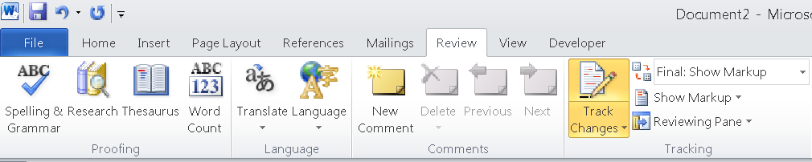
- Whenever possible, and taking into account the comments by other members of the Sub-group, please make concrete text proposals directly to the text of the Guidance. Your changes to the text should appear like this in the “track changes” mode (see image below):
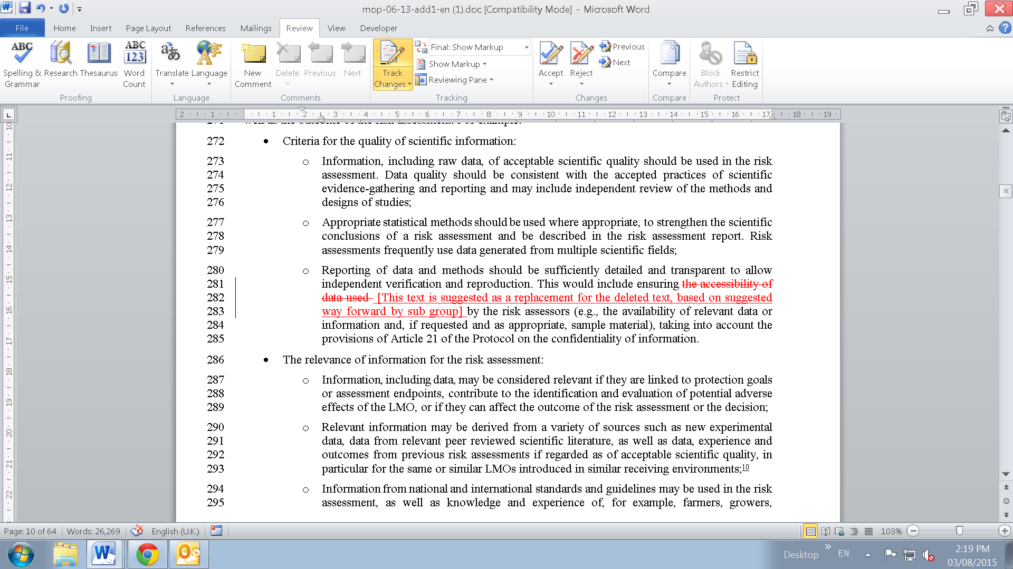

- If making direct proposals to the text of the Guidance is not feasible, or where you feel it is necessary to provide more clarification to other members of the Sub-group, please use the “Comment” function of Word. To make a comment, please highlight the relevant text, click on the icon marked as “New Comment”…
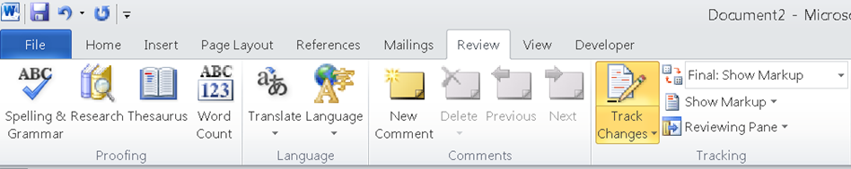
… and type your comment in the balloon (see below).
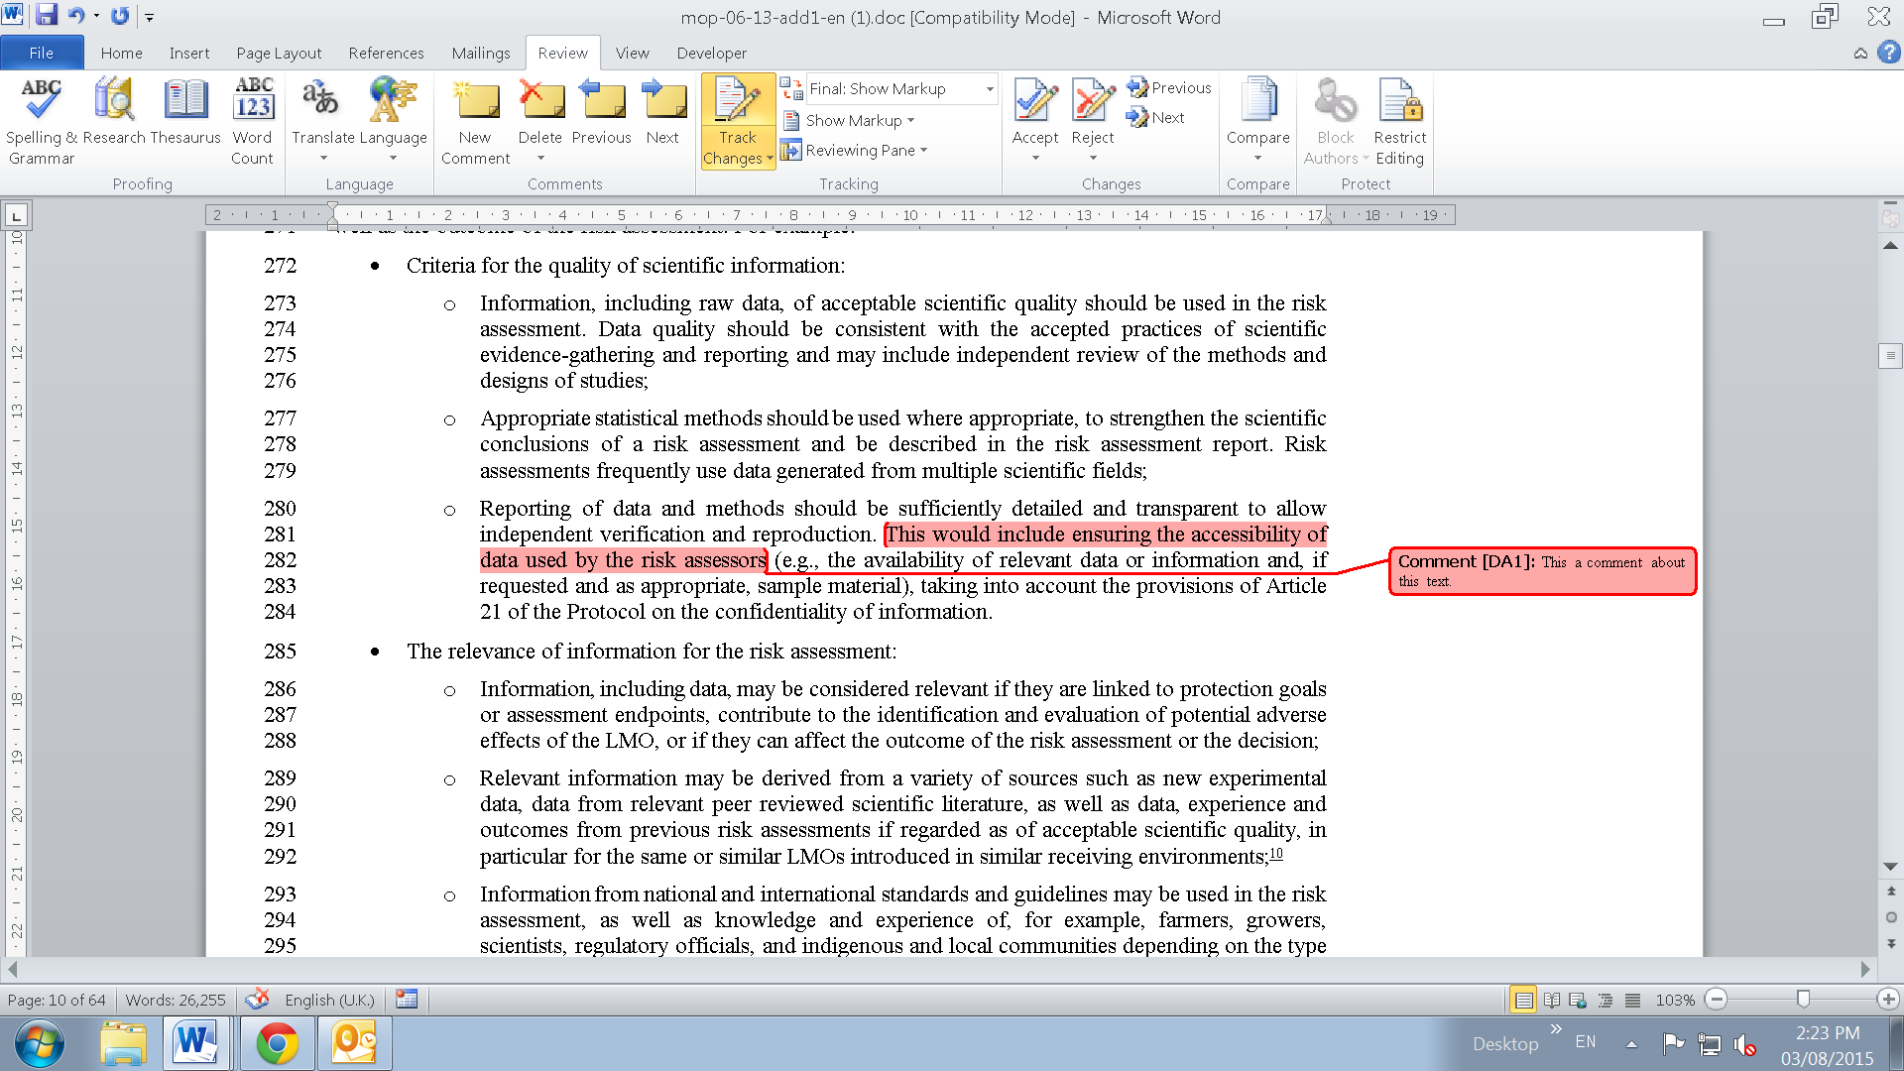
When you finish working on a section of the Guidance:
- Please save the file of the section you worked on in the online forum by adding your initials (the first letters of his/her names). After each review cycle, a set of initials will be added to the file name. For example:
Original File: Section1_text.doc
First review cycle: Section1_text_FA.doc
Second review cycle: Section1_text_FA_AL.doc
Third review cycle: Section1_text_FA_AL_AM.doc
…

Good luck and keep up the excellent work!

